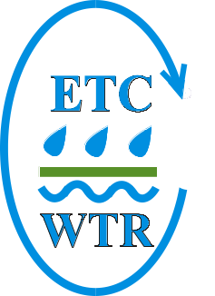 | EUROPEAN TOPIC CENTRE ON WATER | 

FINAL REPORT

Additional Subvention under the 2002-2003 Budget for the European Topic Centre on Water for the “In-depth study of the monitoring of the New Independent States (presently EECCA)”
Ref. No. 3212/B2002/RO/EEA.51304

As part of

Task 3: Preparation of other specific reports and support to the activities of the WGEM
Of the

TACIS Grant agreement with the European Environment Agency: ‘Strengthening environmental information and observation capacity in the New Independent States’

Authors:
Tim Lack (WRc)
Peter Whalley (WRc)
Janoś Fehér (Vituki Consult)

December 2003

Contents
1. Introduction 1
1.1. Project Background 1
1.2. Background to EUROWATERNET 1
1.3. Project Synopsis 2
1.3.1. Overall Objective 2
1.3.2. Specific objectives 2
1.3.3. Planned outputs 3
1.3.4. Project activities 3
1.3.5. Project Team 3
1.4. Project Benefits 4
1.4.1. Benefits to EECCA States 4
1.4.2. Added Value to Tacis 4
1.5. Organisation of Report 4
2. Project Implementation Time Frame 6
3. Project Activities (18 September 2003 – 1 December 2003) 7
3.1. Project Organisation 7
3.2. Tasks undertaken 8
3.2.1. Identification of Project Co-ordinators 8
3.2.2. Briefing meeting for Project Co-ordinators 8
3.2.3. Identification of Water National Reference Experts 8
3.2.4. Planning Workshop 9
3.2.5. Missions to Countries 9
3.2.6. Meta-data collection 9
3.2.7. Reporting 10
3.2.8. Final Workshop 10
3.3. Outputs 10
4. Project Results 12
4.1. Current State of Monitoring Networks 12
4.1.1. Introduction 12
4.1.2. Monitoring Stations 12
4.1.3. Determinands 13
4.1.4. Monitoring Resources 14
4.2. Existing Databases and Data flows 14
4.3. Available Pressure or Proxy Pressure Data 14
4.4. Comparison of EUROWATERNET Station Selection Criteria 14
4.4.1. EUROWATERNET-Basic Station Definitions 14
4.4.2. Gap Analysis 15
4.5. Selection of EUROWATERNET Stations - Summary 16
4.6. Preliminary Needs Assessment 20
5. Project Budget 21
6. Problems Encountered 21
7. Effectiveness of Project 21
8. Recommendations for Future Co-operation and Sustainability 22
8.1. Recommendations for future co-operation 22
8.2. Sustainability 22
Annex 1 Planning Workshop Report 24
Annex 2 Mission Reports 28
Annex 3 – EUROWATERNET Meta-data Required 96
Annex 4 National Expert Reports 103
Annex 5 Final Workshop Report 143
Annex 6 Country Summary Reports 154
Annex 7 Summary of meta-data returns 174
Annex 8 Assessment of EECCA Country meta-data 177
Annex 9 Recommended EUROWATERNET – Country Maps 180

Executive Summary
Background

This work was carried out under the funding of the TACIS grant agreement with the European Environment Agency (EEA) to support the activities of the UN ECE Working Group on Environmental Monitoring and Assessment (WGEM). The views expressed in the report are those of the authors and do not necessarily represent the views of the EEA or the UN ECE WGEM,

The environmental problems of the Eastern Europe, Caucasus and Central Asian countries (EECCA) formally referred to as the New Independent States (NIS) are of a scale and complexity that calls for an organised response at national and Inter-State levels.

The current environmental monitoring systems and reporting capacities do not meet current needs and it is impossible to evaluate fully the current environmental situation of these countries, which is of particular concern for development of appropriate remedies. Furthermore, ongoing monitoring systems cannot easily be integrated into international programmes. This is particularly important when seen in the context of preparing for the 4th pan-European assessment of the state of Europe’s environment, which is to be presented to environment ministers at their next meeting in Belgrade in 2007. Like the 3rd assessment report, presented to ministers at their meeting in Kyiv in 2003, the next report will be based on indicators. This means that there are strict criteria to be met regarding quality, consistency, comparability and timeliness of data used to construct the indicators. It is likely that profound changes will have to be made at the national level in what is measured, how it is measured and reported in order to meet the requirements of international reporting and assessment.

EECCA countries recognise the need to upgrade the quantity, quality and comparability of environmental data, indicators and information dissemination systems as demonstrated by setting up of, and involvement of the EECCA in the UN ECE ad hoc Working Group on Environmental Monitoring (WGEM).

To achive this, the agreed process was to implement EUROWATERNET across the EECCA countries. Eurowaternet is the process by which the EEA gets the data and information it needs:
- It samples existing national monitoring and information databases;
- It compares like-with-like;
- It has a statistically stratified design ‘tailor-made’ for specific issues and questions; and,
- Has a known power and precision.

Objectives
The specific objectives of this project were to:
- provide an overview of the inland surface water monitoring activities in the EECCA,
- make an inventory of existing water databases,
- make a comparison of existing monitoring networks with EUROWATERNET criteria, and
- make a selection of basic stations for a EUROWATERNET in each of the EECCA.

Activities
The project assessed the information and monitoring systems for inland waters in the EECCA countries. In addition, it has made proposals for filling the gaps in monitoring and information, establishing integrated national data banks for inland waters, and improving co-operation and data exchange between countries covered by EUROWATERNET and EECCA. The project covered the following activities:

- Inventory of current surface water monitoring networks in EECCA for national and international purposes;
- Inventory of existing databases and description of data flows;
- Inventory of available pressure or proxy pressure data;
- Comparison with the EUROWATERNET station selection criteria – identification of gaps in monitoring and information;
- Selection of EUROWATERNET – Basic stations;
- Proposals on extending the Basic EUROWATERNET stations to fully representative stations.

Outputs
The key outputs from this project are:
- Database of monitoring stations for surface waters (rivers and lakes) and where available information on groundwaters and transitional, coastal and marine waters;
- Information on databases used in the EECCA countries;
- Information on catchment pressures for each monitoring station – essential for selection of EUROWATERNET stations;
- Recommended monitoring stations for EUROWATERNET basic network;
- Preliminary needs assessment for undertaking EUROWATERNET monitoring;
- Recommendations for future investments in support of this network;
- A network of National Experts across all EECCA countries with a strong understanding of the needs of the EEA and the benefits of EUROWATERNET which will assist with the 4th European Environmental Assessment in 2007.

Recommendations
- Continue to build capacity of national monitoring systems to “fill the gaps” between current situation and the requirements of EUROWATERNET. In particular, the need for new monitoring stations to improve geographic coverage, to include small rivers and ‘clean’ rivers.
- Support the countries in the development of national databases and the establishment of a National Information Centre (NIC
- Encourage the countries to begin the process of validated electronic data transfers from the national to the European level (essential for the 4th assessment of Europe’s environment)
- Support the development of EECCA policy-relevant indicators
- Priority investments should be directed at ensuring that determinands required under the EUROWATERNET Basic network (see Annex 7) can be achieved.
- Longer-term investments can be directed at the more extensive list of determinands (including priority substances) required under the fully-representative EUROWATERNET network
- Establishment of National Reference Laboratories for water monitoring in each EECCA Country.

Introduction

Project Background
The environmental problems of the Eastern Europe, Caucasus and Central Asia countries (EECCA) formally referred to as the New Independent States (NIS) are of a scale and complexity which calls for an organised response at national and Inter-State levels. Such a development requires an appropriate and comprehensive provision of information on progress and prospects in the state of the environment.

The current environmental monitoring systems and reporting capacities do not meet current needs and it is impossible to evaluate fully the current environmental situation of these countries, which is of particular concern for development of appropriate remedies. Furthermore, ongoing monitoring systems cannot easily be integrated into international programmes.

EECCA recognise the need to upgrade the quantity, quality and comparability of environmental data, indicators and information dissemination systems as demonstrated by setting up of, and involvement of the EECCA in the UN ECE ad hoc Working Group on Environmental Monitoring and Assessment (WGEM).

EECCA would benefit from a co-operative effort at the regional level to address common problems in improving their reporting capacities, and to help them better integrate into the international environmental networks. This is particularly important when seen in the context of preparing for the 4th pan-European assessment of the state of Europe’s environment, which is to be presented to environment ministers at their next meeting in Belgrade in 2007. Like the 3rd assessment report, presented to ministers at their meeting in Kyiv in 2003, the next report will be based on indicators. This means that there are strict criteria to be met regarding quality, consistency, comparability and timeliness of data used to construct the indicators. It is likely that profound changes will have to be made at the national level in what is measured, how it is measured and reported in order to meet the requirements of international reporting and assessment.

Background to EUROWATERNET
Key concepts of EUROWATERNET

Eurowaternet is the process by which the EEA gets the data and information it needs:
- It samples existing national monitoring and information databases;
- It compares like-with-like;
- It has a statistically stratified design ‘tailor-made’ for specific issues and questions; and,
- Has a known power and precision.

EUROWATERNET includes
- surface inland and groundwaters
- transitional, coastal and marine waters
- quality and quantity in terms of:
- pressures
- state
- impact

This is in recognition of the EEA’s approach to assessments – to make use of the DPSIR causal chain, which is a framework that acknowledges the Driving Forces that give rise to Pressures on the environment, giving rise to the current State of the environment and Impacts on it and its users. Responses are the policy actions and programmes of measures taken by countries to improve or protect the State.

EUROWATERNET contains

- a Basic network (which includes reference, representative and flux stations)
- an Impact, policy related, network (which includes stations impacted by pollution discharges)
- together, Basic + Impact = Fully Representative network

Representative of types and numbers of water body within a country, and the different pressures placed upon them.
Knowledge of the statistical certainty of the answer - e.g. how confident we are that there are real changes in relation to policies and measures.

Project Synopsis

Overall Objective
The task on in-depth study of the monitoring situation in specific areas/inland surface waters was part of Task number 3 in the TACIS/EEA grant agreement project to support and extend the activities carried out by the UN ECE WGEM.

The long-term objective of the full grant agreement project was to help integrate EECCA environmental information and management systems into the main stream of European practice and thus help countries in creating sound and comparable conditions for economic transition.

A short-term objective of the project is to strengthen environmental information and observation capacity and networks in order to provide good, reliable and relevant information on the state of the environment in EECCA as a basis for improved policy making and public awareness. This will be reflected in a higher quality 4th pan-European assessment report in 2007. Another short-term objective is to enhance co-operation between existing environmental networks.

Under the co-ordination of the WGEM the focus was on the establishment of task forces and networks in the EECCA. The Network of National Contact Points was used to provide responses to the requests for the various WGEM tasks:
- Support to the development of the Kiev assessment report and develop recommendations to fill in identified gaps in EECCA countries,
- In-depth studies of the monitoring situation in specific areas/inland surface waters,
- Tools and guidelines to develop in support of monitoring and reporting
- Remote sensing - contribution to improved monitoring and reporting systems.

Specific objectives
The specific objectives of this project were to:
- provide an overview of the inland surface water monitoring activities in the EECCA,
- make an inventory of existing water databases,
- make a comparison of existing monitoring networks with EUROWATERNET criteria, and
- make a selection of basic stations for a EUROWATERNET in each of the EECCA.

Planned outputs
The key outputs of this project were to be:
- Validated database for each EECCA on current state on monitoring networks for inland surface waters.
- Report on monitoring networks for each EECCA for inland surface waters (as first priority), and groundwater, transitional, coastal and marine waters, water quantity monitoring networks and sectoral water use monitoring (where appropriate and available) as a second priority.

Project activities
The project is an activity in Task 3 on Preparation of other specific reports and support to the activities of the WGEM of grant agreement project. The project covers the following 12 EECCA countries: Armenia, Azerbaijan, Belarus, Georgia, Kazakhstan, Kyrgyzstan, Moldova, the Russian Federation, Tajikistan, Turkmenistan, Ukraine, and Uzbekistan.

The project assessed the information and monitoring systems for inland waters in the EECCA countries. In addition, it has made proposals for filling the gaps in monitoring and information, establishing integrated national data banks for inland waters, and improving co-operation and data exchange between countries covered by EUROWATERNET and EECCA. The project covered the following activities:

- Inventory of current surface water monitoring networks in EECCA for national and international purposes;
- Inventory of existing databases and description of data flows;
- Inventory of available pressure or proxy pressure data;
- Comparison with the EUROWATERNET station selection criteria – identification of gaps in monitoring and information;
- Selection of EUROWATERNET – Basic stations;
- Proposals on extending the Basic EUROWATERNET to a fully representative network.

The key beneficiaries of this project are the Ministries of Environment in each country and the EEA and its stakeholders through the provision of a basic EUROWATERNET network capable of providing the required monitoring information needed to produce indicators as the basis for the 4th pan –European assessment report.

The project commenced in August 2002 and was completed by December 2003.

Project Team
The project was directed by Tim Lack (Manager of ETC/Water at WRc) and Peter Whalley (WRc) was the Project Manager, supported by Janos Feher of Vituki Consult (the Hungarian partner of ETC/Water). The project was managed at the EEA with inputs from Nicolas Perritaz, Alexey Kostin, Peter Kristensen and Peter Bosch. Missions were undertaken by teams from WRc and Vituki Consult within the framework of the ETC/Water.

Project Benefits

Benefits to EECCA States

- Development of a network of enthusiastic monitoring and assessment experts in the EECCA countries who are aware of the values of the EEA’s EIONET network and have an understanding of the development and deployment of indicators for environmental reporting and assessment – this is the basis for future investment in the EECCA countries;
- Preliminary development of a data transmission network – this is the vehicle for efficient data exchange;
- Integration of monitoring networks with rest of Europe – this drives international cooperation;
- Better assessment of monitoring needs relative to DPSIR framework – this drives monitoring development;
- Closer linkage between monitoring and policy assessment – this drives policy development;
- Strengthening of institutions involved – closer integration with European equivalents;
- Identification of future needs for investment – value for money for donor organisations.

Added Value to Tacis

- ETC-Water team designed the existing EUROWATERNET – so there were no problems with comparability or flexibility of approach when needed;
- ETC Water team has experience of implementation of EUROWATERNET (and other relevant environmental monitoring activities) in Accession countries which may be applicable to EECCA;
- Additional effort (outside budget) on gathering information on groundwater and coastal waters as well as inland surface waters;
- Additional effort (outside budget) on a preliminary assessment of needs – monitoring, laboratory analyses and information management.

Organisation of Report
The main focus of this project was on gathering meta-data on surface water monitoring networks and, where possible, collecting information on groundwater and, transitional, coastal and marine (TCM) waters.

The main part of this report contains a summary of the tasks undertaken and the a summary of the meta-data (described above) collected.

This report contains:
- Background to the project (Section1)
- Project timeframe (Section 2)
- Summary of the key activities undertaken in this project (Section 3);
- Summary of the current state of water quality monitoring (Section 4.1);
- Summary of the existing databases and data flows (Section 4.2);
- Summary of available pressure or proxy pressure data (Section 4.3);
- Comparison of the expectations of EUROWATERNET station selection criteria and the current situation (gap analysis) (Section 4.4);
- Summary of selected stations for inclusion in EUROWATERNET (Section 4.5);
- Preliminary needs assessment covering human resources (staff training), capital equipment (e.g. analytical instruments), infrastructure enhancements (e.g. laboratory buildings and additional monitoring stations) and consumables (Section 4.6).
- The project budget summary (Section 5)
- Problems encountered (Section 6)
- Assessment of the effectiveness of the project (Section 7)
- Recommendations for future enhancements to the Basic EUROWATERNET established (Section 88.1)

Supporting information is given in Annexes.

Project Implementation Time Frame

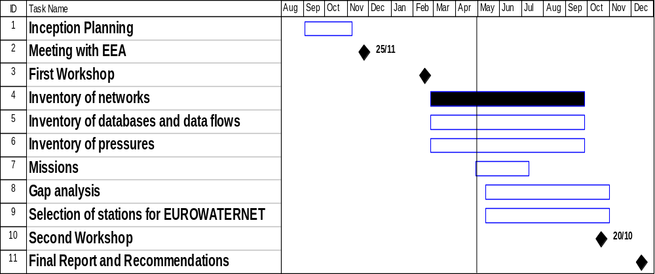

Project Activities (18 September 2003 – 1 December 2003)

Project Organisation
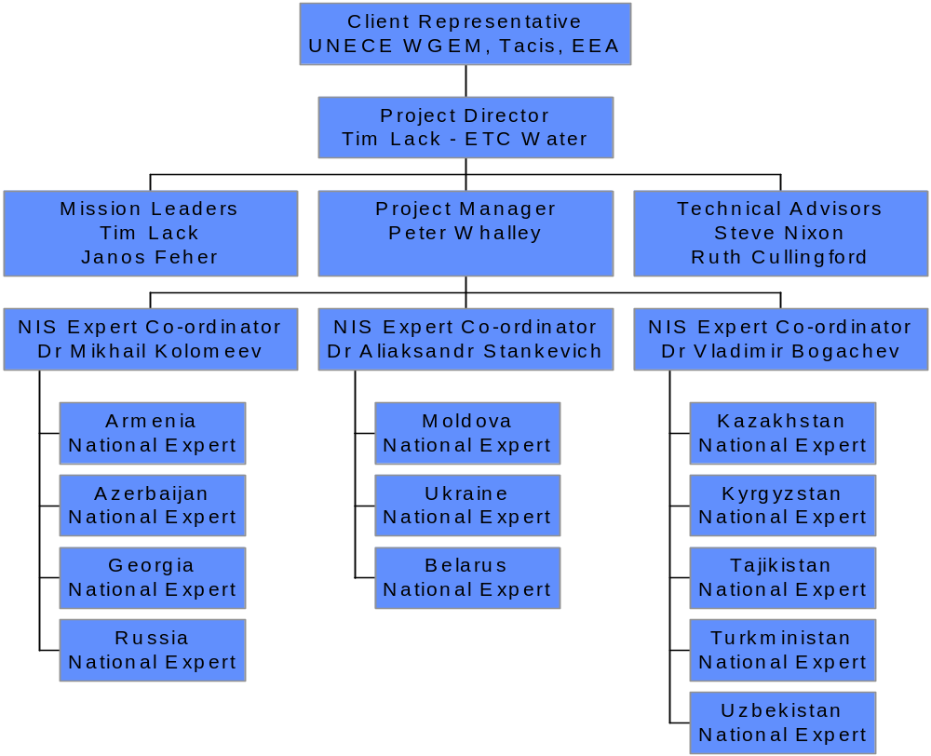

The management of this project was as illustrated above. The Expert Co-ordinators were identified following a request for CVs made at the UN ECE WGEM meeting in Geneva (August 2002). National water experts were identified by the National Contact Points in each country with the assistance of the Expert Co-ordinators.

Detailed terms of reference were prepared for the Expert Co-ordinators and the National Experts explaining their roles and responsibilities within this project.

The main responsibilities of the Expert Co-ordinators include:
- Participation at a kick-off meeting held in Obninsk, Russian Federation (November 2002)
- Assistance with the identification and communication with National Experts;
- Participation in a briefing workshop for National Experts held in Obninsk (February 2003);
- Ensuring that information requested by the ETC/Water team were translated and communicate to the National Experts;
- Ensuring that the National Experts monthly reports on progress were prepared, translated and passed to the ETC/Water team;
- Participating in the Missions to the countries by the ETC/Water team;
- Validating the meta-data returned by the National Experts before transmission to the ETC/Water team;
- Participating in the final workshop in Budapest (October 2003) and summarise the conclusions of group discussions on high priority needs and means to achieve sustainability of the EUROWATERNET network in the longer term.

The main tasks of the National Experts included:
- Participation at the initial briefing workshop in Obninsk;
- Collect the meta-data required and to populate the spreadsheets provided with this data;
- To facilitate the missions to their countries by the Expert Co-ordinator and the ETC/Water team;
- To participate in the final workshop in Budapest;
- To finalise the meta-data following the workshop.

Tasks undertaken

Identification of Project Co-ordinators
Three EECCA Project Co-ordinators were appointed to co-ordinate the activities of the EECCA National Experts. The CVs presented to the Project were obtained following the UNECE WGM meeting in Geneva (August 2002). The EECCA Co-ordinators were:
- Dr Mikhail Kolomeev (Typhoon, Obninsk, Russian Federation). Dr Kolomeev was responsible for co-ordinating the National Experts from Russian Federation, Armenia, Azerbaijan and Georgia.
- Dr Aliaksandr Stankevich (Central Research Institute of Complex Utilisation of Water Resources (CRICUWR). Minsk, Belarus.) Dr Stankevich was responsible for co-ordinating the National Experts from Belarus, Ukraine and the Republic of Moldova.
- Dr Vladimir Bogachev (CAREC, Almaty, Kazakhstan). Dr Bogachev was responsible for co-ordinating National Experts from Kazakhstan, Kyrgyzstan, Tadjikistan, Turkmenistan and Uzbekistan.

Briefing meeting for Project Co-ordinators
A meeting was held at Typhoon, Obninsk, (13 November) between the Project Director (Tim Lack), the Project Manager (Peter Whalley) and the three Project Co-ordinators. The purpose of this meeting was to brief the Project Co-ordinators on the background of the project, their roles and responsibilities and to agree contractual arrangements for this Project. The Project Co-ordinators were given copies of relevant documentation including EEA’s Technical Guidelines for Implementation of EUROWATERNET in both Russian and English.

Identification of Water National Reference Experts
National Contact Points (NCPs) and the Project Co-ordinators have worked together to identify National Experts to assist with this project in each country. Terms of References for these experts and a summary of the expected tasks were distributed to the National Experts by the Project Co-ordinators. The National Experts or their appointed deputy, were contacted to participate in the Planning Workshop. A list of the National Experts and their contact details are presented in Annex 1.

Planning Workshop
A Planning Workshop with representatives from EECCA countries was held in Obninsk between the 19 and 21 February 2003. Prior to the formal workshop detailed discussions were held with the Project Co-ordinators to ensure the success of the meeting. The purpose of this meeting was to brief the National Experts on the details of their task and to offer an opportunity for these experts to seek additional clarification on their tasks. In addition the meeting offered an opportunity for experts from the different countries to share experiences of monitoring.

Representatives from 11 EECCA countries were present. Uzbekistan was unable to identify a National Expert in time for this meeting (an expert was later appointed and he was briefed by the Project Co-ordinator). Of these participants, eight were the appointed National Experts (deputies were sent from Belarus, Moldova and Kazakhstan).

Outputs from Workshop
The following key outputs were achieved from the planning workshop:
- Agreement on monthly reporting requirements;
- Agreement on objectives of the Missions;
- Proposed dates for Missions;
- Distribution of EUROWATERNET information templates;
- Agreement from the National Experts to undertake the data collection, facilitate the Missions and to participate in the Second Workshop leading to their signing of the sub-contract for this project.
Notes from the Planning Workshop are provided in Annex 1.

Missions to Countries
All missions were undertaken by a team of three experts (including the Project Co-ordinator) plus the National Expert.

For administrative reasons it was not possible to undertake missions to Uzbekistan and Turkmenistan. However the National Experts from these countries were able to participate in the workshops and to provide the data requested.

The objectives of the Missions were:
- To support the National Expert with information gathering and assessment;
- To meet appropriate ministry representatives;
- To meet the National Contact Point;
- To initiate the process of identifying future needs for equipment and training to enable a fully representative EUROWATERNET to be introduced following the completion of this project.
Mission reports are presented as Annex 2.

Meta-data collection
During the first workshop, details of the meta-data required for this project were presented. All experts were provided with PC disks containing spreadsheets to be completed for surface waters (rivers and lakes), groundwater and, transitional, coastal and marine waters. Guidance on the data required for EUROWATERNET was provided in a manual, which is available on the EEA’s web site (http://reports.eea.eu.int/TECH07/en/tech07.pdf). A Russian translation of this manual was also available and provided to the National Experts.

Each set of spreadsheets (rivers, lakes, etc.) had three sections:
- Physical characteristics of the monitoring location (monitoring station identification, geographic co-ordinates, catchment area, etc.);
- Quality information. Meta data detailing the number of samples collected in 2001 and the total number of samples in the 1990 – 2000 period for each of the required EUROWATERNET determinands;
- Pressure information. This information gave percentages for the different types of land use up-stream of the monitoring station to give an indication of the overall nature of the upstream catchment (for example, to confirm that a station which is defined as a ‘reference’ station has minimal human impacts)

The spreadsheets issued for completion also contained explanations of the terms used and the information required. A copy of this information is provided in Annex 3. The Expert Co-ordinators also provided a Russian translation of this information.

In addition to the meta-data on monitoring stations information on databases used in each country was also requested.

Finally, a complete database of all the meta-data received was produced using MS Access. This is available on a CD which is attached with this report.

Reporting
Following the Planning Workshop, the National Experts were requested to complete a standard monthly report (shown in Annex 1 – report of the Planning Workshop) describing key aspects of the data collection process and progress to completion. These reports, sent via the Expert Co-ordinators were of assistance in preparing the project’s interim report and ensuring that any issues of data collection could be discussed in detail during the Missions.

In addition, a number of National Experts provided a report on monitoring in their countries. These are presented in Annex 4.

Final Workshop
A final workshop was held in Budapest, 20 –22 October 2003. Budapest was selected to overcome currency restrictions in the EECCA countries to enable the project team to reimburse the participants and to pay their final fee for completing the required tasks. The objective of this workshop was:
- To present the preliminary conclusions from the review of river monitoring stations identified by National Experts for inclusion in EUROWATERNET.
- To review the river stations selected by ETC-Water Experts;
- To prepare ‘gap’ analysis between the information provided and the information needed for a basic EUROWATERNET, leading to agreed additional data to be delivered.
- To identify country needs to enable EUROWATERNET to be implemented;

Following this meeting National Experts were invited to review the meta-data provided and to re-submit this information to ETC-Water following validation to be included in this final report.

This meeting was well attended with 11 out of the 12 EECCA National Experts present. Unfortunately the National Expert of Tajikistan was unable to attend owing to difficulties getting a flight from Moscow to Dushanbe. A report on this Workshop is included in Annex 5.

Outputs
The key outputs from this project are:
- Database of monitoring stations for surface waters (rivers and lakes) and where available information on groundwaters and transitional, coastal and marine waters;
- Information on databases used in the EECCA countries;
- Information on catchment pressures for each monitoring station – essential for selection of EUROWATERNET stations;
- Recommended monitoring stations for EUROWATERNET basic network;
- Preliminary needs assessment for undertaking EUROWATERNET monitoring;
- Recommendations for future investments in support of this network;
- A network of National Experts across all EECCA countries with a strong understanding of the needs of international reporting and assessments using indicators and the benefits of EUROWATERNET as the main data flow process which will be necessary for 4th pan-European Environmental Assessment in 2007 and subsequently.

Project Results

Current State of Monitoring Networks

Introduction
Throughout the EECCA countries there has been a long history of monitoring. In some cases stretching back about 100 years for hydrological measurements. Water quality monitoring began in the late 1970s. In almost all countries there has been a significant decline in the level of water quality monitoring over the last decade.

A summary of the EECCA countries monitoring capacity and responsibilities of different institutions is presented in Annex 6. This information has been collected from monthly reports provided by the National Experts, missions to the countries (Annex 2) and country reports provided by the National Experts. These summary country reports were circulated to the National Experts during the final Workshop enabling any errors to be corrected.

Monitoring Stations
The focus of environmental monitoring in the former Soviet Union was significantly biased towards monitoring larger rivers and lakes with an emphasis on upstream/downstream monitoring of a discharge point. Whilst this is an appropriate approach for a pollution monitoring and control objective, it does not provide a good representative network for describing the overall quality of all types of water body in the country which is the basis of state of the environment reporting (as exemplified in the Water Framework Directive).

Therefore, EUROWATERNET requires a monitoring network, which is representative of a range of river types (small, medium, large etc.) and locations, which are ‘representative’ of the catchment. The stations should provide a good geographical coverage and should include refernce stations that are in regions which have minimal human impact (if at all possible). Discussions are underway with the European Commission on the convergence of EUROWATERNET requirements with those of the Water Framework Directive.

Monitoring ‘Points’, ‘Posts’ and ‘Stations’
In surveying the monitoring stations in the EECCA countries, some confusion existed over the terminology used. The diagram below represents the terminology for monitoring ‘stations’ in the EECCA countries. As can be seen a ‘station’ is a centre that is responsible for managing the monitoring at a number of locations, or ‘posts’. It is typical that there are a number of monitoring ‘points’ for each monitoring post, these often being ‘paired’ upstream and downstream locations of a discharge. A EUROWATERNET ‘Station’ is equivalent to the monitoring ‘point’ in this representation

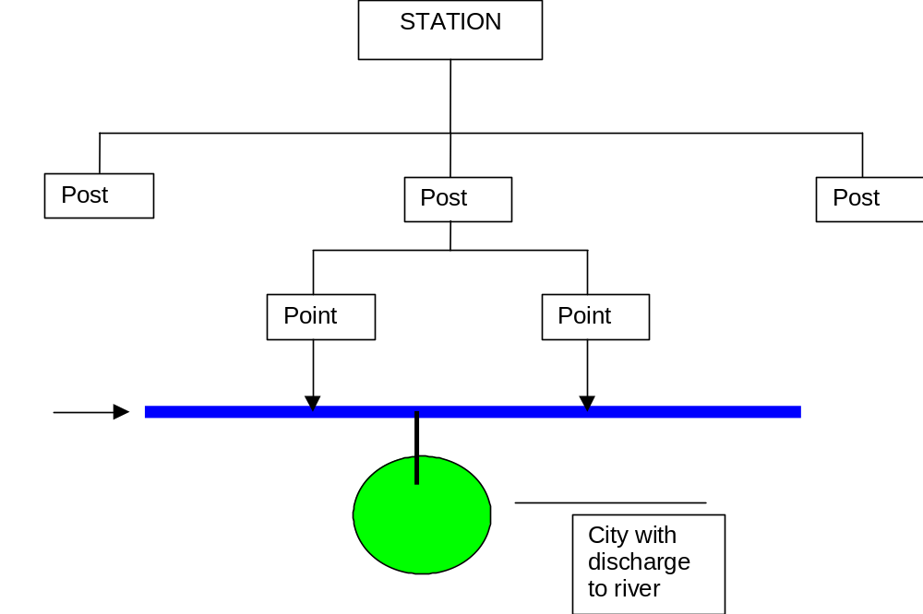

The guidelines developed and tested for the rest of Europe regarding the density of monitoring stations (i.e. 1 river monitoring station per 1000 km² of land area) may not be appropriate to some of the EECCA countries due to the presence of steppe, desert, high mountain etc. However, most of the EECCA countries have a lower than desirable monitoring density for rivers and lakes. The shortfall is on monitoring the smaller bodies of water.

Determinands
Typically the former Soviet Union’s monitoring programme identified about 30 –35 determinands and these were sampled for and analysed as routine. Many of these determinands are not relevant to the EUROWATERNET Basic system (and may not even be relevant at all for modern management of water quality) and, more importantly, a number of key determinands required by EUROWATERNET were not covered (e.g. total organic carbon, chlorophyll a and some species of nitrogen). These ‘missing’ determinands will need to have a high priority for targeting future investments.

There was minimal (if any) routine monitoring for biological species.

Monitoring Resources
In all the EECCA countries, well skilled staff are available to undertake routine sampling, analysis and data interpretation programmes. However financial resources have significantly reduced the number of staff currently employed and had an impact on the amount of monitoring work currently undertaken. There is a spectrum of capabilities in the EECCA countries. In Russian Federation and Belarus there is a high capacity to carry out national monitoring and relatively little investment is required. At the other end, Armenia, Georgia, Kyrgyzstan, Moldova and Tajikistan, there is need for considerable capacity building.

In some EECCA countries (e.g. central Asian Republics, Caucasus) there is a need for significant investments in the laboratories to enhance both the structure of the buildings and the support equipment and consumable items (e.g. glassware, ovens, refrigerators, pure water supplies, gases, standard reagents etc).

Existing Databases and Data flows
There is a wide range of data management and processing capability across the EECCA countries. This ranges from a modern GIS-based approach in Belarus to paper-only systems in some of the other countries. A summary of the situation of the data management capabilities is presented in the summary country reports in Annex 6.

Available Pressure or Proxy Pressure Data
Information on pressures within a catchment is important to enable the station type (e.g. reference, representative etc.) to be verified. Most of the EECCA countries have been able to provide an initial estimate of the pressures and these are summarised in the following tables. The information provided is included in the EUROWATERNET database for the EECCA countries.

Comparison of EUROWATERNET Station Selection Criteria

EUROWATERNET-Basic Station Definitions
Reference stations: in catchments with little or no human activity and with the percentage of natural landscape higher than 90%.

Representative stations: reflect the majority of rivers or lakes in a region/area with human activities in the catchment consistent with the region’s/areas activities. The water quality at these stations would be influenced by diffuse sources of pollution and/or point sources depending on the human activities upstream.

Flux stations: should include all monitoring stations currently being used for assessment of international, transboundary loads or loads entering Europe's Seas.

Largest, Most Important stations: should include the nationally most important or well-known rivers/lakes. Some are likely to be monitored for the EU Exchange of Information Decision and/or UN ECE Convention on Transboundary Waters (Helsinki Convention).

A list of the meta-data collected for rivers, lakes, groundwater and transitional, coastal and marine water bodies is presented in Annex 7.

EUROWATERNET- Size categories Rivers (upstream catchment areas)

- Small <50 km²
- Medium 50 - 250km²
- Large 250 - 1000 km²
- Very large 1000 - 2500 km²
- Largest >2500 km²

EUROWATERNET- Size categories Lakes (surface areas)

- Small 0.1 – 1 km²
- Medium 1 – 10 km²
- Large 10 – 100 km²
- Very large 100 km²

Gap Analysis
The following table summarises the meta-data provided by each EECCA country against the information required by EUROWATERNET-Basic for rivers and lakes. A summary of meta-data provided for rivers, lakes, groundwater, transitional, coastal and marine waters is given in Annex 3. A detailed country-by-country assessment of this information is provided in Annex 8.

EUROWATERNET CRITERIA | AM | AZ | BY | GE | KZ | KG | MD | RU | TJ | TM | UA | UZ
Geographic spread
Information on physical characteristics
Representative of all sizes
Representative stations
Reference stations
Flux stations
Pressure data
Catchment areas
Water quality determinands

Lakes
EUROWATERNET CRITERIA | AM | AZ | BY | GE | KZ | KG | MD | RU | TJ | TM | UA | UZ
Geographic spread
Information on physical characteristics
Representative of all sizes
Representative stations
Pressure data
Catchment areas
Water quality determinands

Key
Information satisfies EUROWATERNET
Information part satisfies EUROWATERNET
Information does not satisfy EUROWATERNET

Selection of EUROWATERNET Stations - Summary
ETC-Water has made an initial selection of monitoring stations to be included in EUROWATERNET from the candidate stations provided by the National Experts. This initial selection (together with any issues surrounding the meta-data provided) was discussed in detail at the final workshop. Following the advice and guidance provided at the workshop the National Experts re-submitted their data correcting errors and misunderstandings where possible to give a final ‘validated’ meta-data set.

Whilst the primary focus of this project was obtaining meta-data on inland surface waters (rivers, canals and lakes), some information was also obtained for groundwaters and transitional coastal and marine waters. Meta-data for groundwaters was provided by Azerbaijan and a limited data set was provided by Belarus. Information on groundwaters is known to be difficult to obtain due to the state confidentiality surrounding this resource. Data on transitional, coastal and marine waters was provided by Georgia and Ukraine. A summary of the meta-data provided is given in Annex 3.

Maps showing the distribution of river and lake monitoring stations are presented for each country in Annex 9

Summary of EUROWATERNET-Basic

Rivers

Summary | AM | AZ | BY | GE | KZ | KG | MD | RU | TJ | TM | UA | UZ
Target for representative plus reference stations | 30 | 87 | 208 | 70 | 2717 | 199 | 34 | 4256 | 143 | 488 | 604 | 447
Number of rivers/tributaries
Total Number of stations | 28 | 34 | 129 | 38 | 136 | 21 | 44 | 150 | 44 | 35 | 382 | 13
Number of stations selected:
Representative (R) | 24 | 19 | 129 | 37 | 23 | 23 | 32 | 89 |  | 3 | 315 | 7
Reference (B) | 1 | 2 |  | 1 | 8 | 8 |  | 18 |  | 1 | 2 | 1
Flux (F) |  | 7 | 11 | 3 |  |  | 4 | 22 |  | 31 | 80
Impact (I) |  |  |  |  |  |  |  |  |  |  |  | 5
Largest (L) | 3 | 8 | 76 |  | 2 | 2 | 8 | 21 |  |  | 63
Number of stations on:
Small rivers | 2 |  | 2 | 2 | 6 | 2 |  | 7 | 1 |  | 7
Medium rivers | 3 | 12 | 10 | 6 | 7 | 7 | 11 | 10 | 12 | 1 | 27
Large rivers | 9 | 5 | 26 | 11 | 28 | 4 | 6 | 25 | 10 | 3 | 77
Very large rivers | 7 | 5 | 14 | 5 | 14 | 1 | 8 | 24 | 9 |  | 67
Largest | 7 | 12 | 77 | 14 | 71 | 6 | 19 | 84 | 11 | 4 | 204
No. without catchment area | 0 | 0 | 0 | 0 | 10 | 1 | 0 | 0 | 1 | 27 | 0 | 13
Pressure information available? | P (28) | Y | Y | Y | N | P (12) | P (43) | Y | N | N | Y | N

Lakes

Summary | AM | AZ | BY | GE | KZ | KG | MD | RU | TJ | TM | UA | UZ
Target for representative plus reference lakes | 17 | 49 | 119 | 40 | 1553 | 113 | 19 | 2432 | 82 | 279 | 345 | 256
Number of reservoirs | 7 |  | 7 |  |  |  | 3
Number of lakes | 1 | 5 | 18 | 1 | 5 | 15 | 2 |  | 10 | 3 |  | 9
Total Number of stations | 24 | 5 | 25 | 4 | 7 | 15 | 7 |  | 10 | 3 | 130 | 9
No. without catchment area | 0 | 0 | 5 | 0 | 3 | 1 | 2 |  | 1 | 3 | 0 | 9
Pressure information available? | P (8) | N | P (19) | Y | N | P (14) | Y |  | N | N | Y | N

Groundwater
Summary | AM | AZ | BY | GE | KZ | KG | MD | RU | TJ | TM | UA | UZ
Number of groundwater bodies identified | 0 | 11 | 13 | 0 | 0 | 0 | 0 | 0 | 0 | 0 | 0 | 0
Number of stations reported |  | 1517 | 13
Physical characteristics reported? |  | Y | Y
Chemical quality reported? |  | Y | Y
Pressure information reported? |  | Y | N

Transitional, coastal and marine waters

Summary | AM | AZ | BY | GE | KZ | KG | MD | RU | TJ | TM | UA | UZ
Number of stations reported | N/A | 0 | N/A | 12 | 0 | N/A | N/A | 0 | N/A | 0 | 121 | 0
Physical characteristics reported? |  |  |  | Y |  |  |  |  |  |  | Y
Chemical quality reported? |  |  |  | Y |  |  |  |  |  |  | Y
Pressure information reported? |  |  |  | Y |  |  |  |  |  |  | Y

Preliminary Needs Assessment
As an addition to the requirements of this project, a preliminary needs assessment was conducted to identify short-term priority issues that need addressing to ensure the implementation of EUROWATERNET and the sustainability of the outputs of this project. This information was obtained from missions, reports provided by the National Experts and from the final project workshop.

Four areas were identified as requiring investments: human resources development (training etc.), capital equipment (e.g. laboratory and transport), infrastructure (buildings, new monitoring stations etc.) and consumables.

- Human Resources Development
Training needed:
- Institutional strengthening for Director/Manager level to support all activities at lower levels
- New analytical methods (e.g. ISO) on new equipment
- Laboratory management for QA/QC techniques
- Biological monitoring
- Database management and maintenance
- GIS

- Capital Equipment
- Field Sampling Equipment (e.g. portable pH, DO and conductivity meters)
- Vehicles for sampling
- Laboratory equipment (largely analytical)
- Computers and printers

- Infrastructure
- Laboratories
- Additional monitoring stations
- Accreditation

- Consumables
- Reagents/gases
- Glassware
- Fuel

Project Budget
 |  |  | Agreed Budget (May 2003) |  | Estimated Final Spend (Nov 2003)
Expense | Unit | Unit rate | No. Units | Cost | No Units | Cost
Project Co-ordinators | Sum | - | - | 45000 | - | 45000
Experts | Sum | - | - | 60000 | - | 60000
Snr Experts | Days | 750 | 132 | 99000 | 166 | 124500
Technical Experts | Days | 560 | 71 | 39760 | 100 | 56000
Per diem -project | Nights | 249 | 377 | 93873 | 270 | 67230
Flights / int. train (estimate) | No | 78 | 1000 | 78000 | 73 | 40000
Other (Conference facilities) | Sum |  |  | 2827 |  | 2827
TOTALS |  |  |  | 418,460 |  | 395,557

Problems Encountered
There were no significant problems encountered with this project that reduced the final outputs. Minor problems encountered included:
- Currency restrictions in EECCA countries – this made it difficult for the Consultant to reimburse travel expenses and to pay fees at workshops;
- Difficulties in obtaining a visa for Turkmenistan. The visa application for the Consultants was rejected. However the National Expert was able to provide the information required which was supplemented by a detailed report.
- Only a small number of the National Experts spoke and wrote sufficiently good English to allow effective communication without an interpreter. Although not an insurmountable problem, it was a barrier to be overcome.

Effectiveness of Project
- The project achieved its specific objectives (Section 1.3.2) and the planned outputs (Section 1.3.3) were delivered.
- Added value was provided through a preliminary needs assessment to help focus future priorities and actions.
- Through the project activities (Section 1.3.4), primarily the workshops and missions, a network of motivated and expert senior staff was developed which will act as the foundation for future activities.
- Acknowledgement of the success and value of the project was endorsed by the National Contact Points at the meeting of the UNECE WGEM, Geneva, 13-14 November.
- Information gathered from the project is used to make recommendations for future co-operation and sustainability (Section 8).

Recommendations for Future Co-operation and Sustainability

Recommendations for future co-operation
In general, future co-operation should focus on three main priorities, the first two run in parallel and the third follows:

- Carry out a thorough needs assessment (based on the preliminary one reported herein at Section 4.6) focused on the resources needed to make an effective contribution to the 4th pan-European Assessment Report scheduled for 2007.

  - Priority investments should be directed at ensuring that determinands required under the EUROWATERNET Basic network (see Annex 7) can be achieved.
  - Longer-term investments can be directed at the more extensive list of determinands (including priority substances) required under the fully-representative EUROWATERNET network
  - Establishment of National Reference Laboratories for water monitoring in each EECCA Country.
  - Pick-up the outstanding missions to Turmenistan and Uzebikistan in order to validate the contributions of the National Experts

- At the invitation of the countries, design an optimum monitoring network, which will satisfy all the requirements of international monitoring and reporting and support the development of EECCA policy-relevant indicators.

  - Continue to build capacity of national monitoring systems to “fill the gaps” between current situation and the requirements of EUROWATERNET. In particular, the need for new monitoring stations to improve geographic coverage, to include small rivers and ‘clean’ rivers.
  - Strengthen monitoring capacity in groundwater and transitional, coastal and marine waters.
  - Increase knowledge of the indicator development process and the use of indicators in policy assessment and policy improvement.

- Carry out operational testing of the network in terms of data flows from national to European level, data quality checking and validation and database management and maintenance.
  - Support the countries in the development of national databases and the establishment of a National Information Centre (NIC) to coordinate regional activities
  - Encourage the countries to begin the process of validated electronic data transfers from the national to the European level (essential for the 4th assessment of Europe’s environment)
  - Strengthen data management and handling by increasing knowledge in EECCA of the EEA’s REPORTNET tools.

Sustainability
This project has identified that there is a wide spectrum among the EECCA countries in terms of resource availability and allocation to environmental monitoring and assessment. At the top end, countries such as Russian Federation and Byelarus appear to be allocating sufficient resources to allow the development of EUROWATERNET equivalent networks. At the lower end, countries such as Armenia, Georgia, Tajikistan and Kyrgyzstan appear to be so starved of resources that the environmental monitoring network is in danger of collapse if it already has not done so. Laboratories are lacking modern equipment, glassware and consumables and there is barely the means to sample and analyse.

It is clear that in the short term, donor funding is required to prevent further deterioration. Sustainability can only be ensured through a combination of donor funding and allocation of state budget. In the longer term one would be hopeful that with the institution of pollution monitoring a revenue could be developed based on charges to discharge, charges to abstract and financial penalties for non-compliance with standards, that would be fed back through to the pollution monitoring and regulatory authorities. A number of European models are available which could be appropriate to the EECCA countries.

Annex 1 Planning Workshop Report

In-depth study of the monitoring situation in specified areas (inland surface water) of the New Independent States

Summary Report on Workshop 1 – Planning
Typhoon, Obninsk, Russian Federation
19 – 21 February 2003

Summary

Purpose of meeting:
To brief the National Local Experts on the project and their roles on information collection and collation.

The expected outcomes of the meeting were:
1. To have in place, a team of experts from each of the NIS who have the knowledge to complete the inventories of water monitoring and the understanding of the information needs of the EEA to begin the implementation of EUROWATERNET in their countries.

2. The team will be supported by 3 Expert Co-ordinators who have a similar understanding and also understand their roles in managing and monitoring the activities of the National Experts and reporting to the Project Manager.

3. Preliminary arrangements (dates and duration, persons to be met and institutes to be visited) to be made with each National Expert for the missions which are expected to take place in spring/summer 2003.

Participants:
A list of the participants is presented as Annex 1. The agreed list of National Experts confirmed by the participants is presented as Annex 2.

Programme:
The programme, distributed before the meeting, is attached as Annex 3. In addition, all National Experts, or their representatives, were given a copy of a sub-contract agreement to participate in this project. Additional time was allocated to discussing in detail the required inputs and expected outputs from the National Experts. A copy of the Terms of Reference for the National Experts is attached is attached as Annex 4.

Presentations

In addition to the formal presentations, an interactive discussion was held on the information required for the inventory of the monitoring stations. Copies of the templates to be completed for rivers, lakes, groundwaters and transitional, coastal and marine networks were issued on paper and disk. All National Experts were also provided with electronic copies of the data for their country provided for the Kiev Report process.

Discussion

Outputs Required from National Experts
All information and reports will be passed through the Co-ordinator responsible for a specific country as a quality check and to produce an English translation (where required).
- Monthly Reports – each National Expert will provide a brief report on the progress on a monthly basis. The first report will be due on the 28 March 2003. A copy of the required information is presented in Annex 5.
- Inventory of monitoring stations – information for all current monitoring programmes to be collected as discussed. It is possible that this information will reside in more than ministry

Programme
Tuesday 18 February
Briefing meeting with Expert Co-ordinators and ETC project team to discuss the detail of the Workshop programme.

Wednesday 19 February
 | Activity |  | Time
 | Introduction:  Welcome  Proposed Programme  Administrative Arrangements | Whalley  Kolomeev | 1400
 | Background to Project:  EEA  EUROWATERNET  UN ECE WGEM | Lack | 1430
 | Questions / Discussion |  | 1630

Thursday 20 February
 | Introduction to day’s activities | Whalley | 0900
 | Summary of this Project:  Objectives  Information needs  Outputs  Timescales  Main Activities  Responsibilities  Workshops  Missions  Reports | Whalley | 0930
 | Questions and Discussion | All | 1130
 | Lunch |  | 1230
 | Overview of information to be collected:  Summary of information needed  Sources of information  Existing information sources  Questions | Feher | 1400
 | Questions / explanations / discussions | All | 1600
 | Dinner | All | 1930

Friday 21 February

 | Introduction to Morning’s activities | Whalley | 0900
 | One-to-one discussions between Local National Experts and Expert Co-ordinators on specific needs in country and to identify possible Mission dates | All | 0915
 | Concluding Remarks | Lack | 1145
 | Lunch and depart | All | 1200

Annex 2 Mission Reports
In-depth study of the monitoring situation in specified areas (inland surface water) of the New Independent States

Country Visit Report
Yerevan, Armenia
23– 27 June 2003

Purposes of country visit:
- To support the National Local Expert with information gathering and assessment;
- To meet appropriate ministry representatives;
- To meet the National Contact Point;
- To initiate the process of identifying future needs for equipment and training to enable a fully representative EUROWATERNET to be introduced following the completion of this project.

Country visit programme:
The detailed country visit programme can be found in Annex 1.

Summary of country visit

1 Brief description of the organisations

The Ministry of Nature Protection of Armenia (MNP) has two organisations responsible for monitoring of water resources:
- Hydrometeorology and Environmental Monitoring Agency (HEMA): It is responsible for collecting and analysing meteorological data (into Hydromet system), hydrological and water quantity data for surface waters, and forwarding the information to other interested organisations. HEMA prepares water registers and yearly water cadastres.
- Environmental Monitoring Centre (EMC): This is a newly established organisation. It will be responsible for monitoring of air quality, soil quality and surface water quality (within the HEMA). Groundwater monitoring will be the task of this institute, as the statute of the new institute prescribe.

In the field of water management, there are two other organisations, which exist for more than one year:
- Water Resources Management Agency - WRMA (leader: Alfred Nersesyan). The Agency belongs to the MNP. It controls water management and protection through water use permissions for different water uses. This is a centralised organisation, and there is a plan to establish regional offices under this Agency. The WRMA is responsible for preparation of water quality management concept, and co-ordinating, managing water resources usage issues. There is a small working group within the Agency, which is responsible for transboundary type of measurements.
- State Committee of Water System (leader: Martirozyan Gagic). This is a governmental organisation, but the State Committee does not belong to the MNP. It has regional offices in 5 regions of Armenia.

There are several ongoing international projects, financed by different organisations:
- TACIS: training course on analyses, monitoring, sampling. The project focuses on transboundary issues (with Azerbaijan and Georgia), and supplied a surface water analytical laboratory with modern equipments for Armenia.
- Two USAID projects: for the development of regional and transboundary co-operation;
- World Bank (1999-2001): „Integrated Water Resources Management Program (IWRMP)”, in order to regulate water management issues. Within this program, i) water resources of the country were evaluated; ii) principles of water policy were developed, iii) a program for institutional reforms of the management of water resources was recommended; iv) the outline of water supply and demand management was suggested; v) a concept of river basin management was also proposed, including introduction of annual and long-term planning procedures for water resources. Based on the recommendations of the program, a document titled “Concept Paper on the RA Water Resources and Water Systems Management Reformation” was prepared, and accepted by the Government of Armenia according to Decree No. 92 dated 9 February 2001.

2 Sampling facilities

Due to the re-organisation of the responsible institutes, nowadays only hydrometeorological and water quantity data are collected regularly, while water quality measurements are very rare. Air monitoring is good, but the water monitoring has lots of problems such as old laboratory equipments.

Groundwater is used as only source for drinking water supply (100%) in Armenia. During the Soviet regime groundwaters were monitored regularly, till 1992. Since then, the groundwater monitoring is very rare, practically not existing.

Water quantity
Characterisation of water quantity has started more than 100 years ago. There are 33 rivers of the country, and 100 hydrological measurement sites. 13 of them were supplied with new equipments, financed by a USAID programme.
Water level is measured two times a day. At a lesser frequency, 25-30 times a year discharge measurements are made at each hydrological measurement sites. The daily data consist of water level, water temperature, air temperature, and precipitation. At each post, an observer logs the data on corresponding registers, which are sent to Hydromet and corresponding river basin hydrological stations via telephone or radio.

Water quality
Measurements of water quality have started almost 40 years ago. On 33 rivers there are 131 water quality-monitoring sites, but they are not at the same locations where the hydrological sites located. 51 sites were monitored regularly till 2002. Since then only 3 stations operate in the northern part of the country. Since 2002 in the central area of the country water quality samples are taken only at one site, on the river Getar, but not regularly (1-3 times/year). Analyses are carried out, but these low frequency of sampling does not allow to prepare time series, and does not provide comparable, reliable information.
Standardized sampling method is applied when taking samples: Samples were taken manually by responsible person, who took samples to the competent laboratory (central or northern). Data were collected and treated manually.

Groundwater
The Hydrogeologycal Department of the Geological Agency is responsible for monitoring the quality and quantity of groundwater. Since 1992 the monitoring is not regular. There are large gaps in the analyses of groundwater status. As groundwater is the only source for drinking water supply, sometimes the Medical Service of the Ministry of Health carries out control measurements, but these are not regular. Individual water supply companies also measures groundwater quality and quantity, but these data are not gathered, analysed and published.

There are few organisations (such as Environmental Centre of the Academy of Science), which investigate environmental issues, independent from the governmental institutes. These investigations are not regular.

The MNP’s future plan is to establish a network of monitoring stations, and would like to improve the water monitoring up to European level including increased sampling points and increased number of measured parameters.

3 Laboratory systems

There are two main laboratories of the HEMA, where the collected samples are analysed:
- the central laboratory, it has not been operating since January 2003;
- and one in the northern part of the country.

The current equipment and standards are from the Soviet times. In the visited central laboratory there are old glasswares, one GC, column chromatographers, old spectrophotometers, etc. There is only one PC in the central laboratory. They use the PC to create time-series and reports, etc., based on the results of the analyses. The central laboratory is in very poor condition in general.
The TACIS project purchased the following equipments for the central laboratory:
- Hand-held probe for temperature, conductivity, turbidity, pH, dissolved oxygen;
- Sampling equipment with cool boxes;
- Glasswares;
- Atomic spectrometer.
It has to be mentioned that although the above-mentioned equipments are in some rooms of the laboratory, but locked-up. They are not in use, because of some unsolved financial (tax and duty) issues.
There is no quality assurance provided by any independent institute. During the Soviet regime standards were received from Moscow in order to get comparable information from the laboratories. These kinds of standards are still used, the Head of the Laboratory prepares them, but there are no control analyses performed.

4 Data processing and information management facilities

The absence of an integrated approach towards the management of water resources had caused a chaotic state in water resources protection, management and use.
Results of the analysis of air and water samples are collected by the Department of Information, within the EMC. Data are stored only on paper, no computerized database exist in the country neither for rivers, nor lakes, nor groundwaters.

5 Reporting

The Hydrometeorology and Environmental Monitoring Agency prepares booklets (short reports) in every month, in Armenian and Russian languages, summarising the results of water resources analyses by regions. Every year a yearly report is published in both languages (Armenian and Russian) and in English, as well. In the yearly report there are summary tables by rivers and by parameters also, and it contains a map with the location of the water quality and quantity monitoring stations. Both type of reports (short and yearly) are forwarded to the Ministry, to the government, and to the President of the State. The public could get information from the Ministry, based on respectable requests only.

The HEM Agency accumulates data from the different organisations (listed in the 1st point), and prepares hydrological yearbooks, that contain the water cadastre, and summarising reports about a) the surface water quality and quantity, b) water usages, c) water transport d) and water balance (last one was published in 2001). In every 5th year they prepare a five-year summary report, as well.

6 Training needs and equipment needs

Local experts mentioned that sampling and laboratory equipments are in stressing need. They also would like to get trainings for ‘field’ workers and maybe for decision makers, as well. In the country report, prepared by the country expert in this project detailed long-term plan on sustainable/ manageable water monitoring network will be formulated.

Without completeness, the following immediate needs were identified during the country visit:
- Set up a monitoring network for the drinking water system of Yerevan
- Improve the equipments of the water laboratories
- Develop and set up national electronic databases (PCs, software, training,etc).

Annex 1 Country Visit Programme

5. visit: Yerevan, Armenia
Expert Co-ordinator: Mikhail Kolomeev
ETC / Water Experts: János Fehér and Mrs Adrienn Kiss
Date | Flight | Who | Visit programme
23 June 2003, Monday | Budapest – Istanbul  MA 200  Dep: 12.55pm  Arrv: 15.50pm  Moscow – Yerevan  Y8-509  Dep:. 13.40pm  Arrv: 17.10pm | JF and AK  MK
24 June, Tuesday | Istanbul – Yerevan  S7 5012  Dep: 01.10am  Arrv: 05.25am on Tuesday 24 June | JF, AL  JF, AK, MK  and Ashot Gabrielyan | Program for visit in Armenia  Visit to the Environment Monitoring Centre  Meeting with R.Torosyan, Head of EMC
25 June, Wednesday |  | JF, AK, MK  and Ashot Gabrielyan | Visit to the Hydrometeorology and Environmental Monitoring Agency  Meeting with Gennadi Kojoyan, Head of the Agency
26 June Thursday |  | JF, AK, MK  and Ashot Gabrielyan | Visit to the Ministry of Nature Protection.  Meeting with S.Papyan, First Deputy Minister
27 June 2003, Friday | Yerevan – Vienna  OS 642  Dep: 5.50 am  Arrv: 6.25 am  Vienna – Budapest  OS 5713  Dep: 10.25 am  Arrv: 11.10 am  Yerevan – Moscow  Y8-510  Dep:. 9.45am.  Arrv: 11.35am | JF, AK  MK

Annex 2 Country Visit Participants

I. Officials visited by the project experts:

Mr Rudolf TOROSYAN
Head of Environmental Monitoring Centre
of the Hydrometeorology and Environmental Monitoring Agency of the MNP
29 Komitas Street
Yerevan 375012 Armenia
Tel: (374-1) 272-007, Fax: (374-1) 151-959

Mrs Satenik Ter. MINASYAN
Chief Engineer, Head of The Central Laboratory
Environmental Monitoring Centre of the Hydrometeorology and Environmental Monitoring Agency of the MNP
29 Komitas Street
Yerevan 375012 Armenia
Tel: (374-1) 272-007, Fax: (374-1) 151-959

Mr Gennadi KOJOYAN
National Contact Point
Head of Hydrometeorology and Environmental Monitoring Agency
of the Ministry of Nature Protection
54 Leo Street
Yerevan 375002 Armenia
Tel: (374-1) 53 20 01, Fax: (374-1) 53 35 75
Email: armhydromet@metco.am
www.hydromet.am

Mr Simon PAPYAN
First Deputy Minister
Ministry of Nature Protection
Government Building 3, Republic Square
Yerevan, 375010, Armenia

Ms Ruzanna DARTYAN
Head of Projects Division of the International Co-operation Department
Ministry of Nature Protection
Government Building 3, Republic Square
Yerevan, 375010, Armenia
Tel: (374-1) 52 00 99, Fax: (374-1) 58 54 69
Email: interdept@rambler.ru, interdept@yahoo.com

II. Project experts

National Local Expert in Armenia
Ashot GABRIENLYAN
Senior Specialist
Environmental Monitoring Centre
29 Komitas St.
Yerevan 375012
Armenia
Tel: +3741 272 007 +3741 530 815 (Home)
Fax: +3741 538 187
E-mail: ashot@nature.am

ETC / WATER Experts

János FEHÉR
Chairman & General Director
VITUKI CONSULT Rt
H-1095 Budapest,
Kvassay Jenõ út 1.
Hungary
Tel: +36-(1)-2165810
Fax: +36-(1)-2152245
Email: feher.janos@vituki-consult.hu

Adrienn KISS
Research Associate
VITUKI CONSULT Rt
H-1095 Budapest,
Kvassay Jenõ út 1.
Hungary
Tel: +36-(1)-2165810
Fax: +36-(1)-2152245
Email: kiss.adrienn@vituki-consult.hu

Expert Co-ordinator

Mikhail KOLOMEEV
SPA TYPHOON
82, Lenin str.
Obninsk, Kaluga reg
249038, Russia
Tel: +7-08439-44950
Fax: +7-08439-40704
Email: mk@feerc.obninsk.org

In-depth study of the monitoring situation in specified areas (inland surface water) of the New Independent States

Country Visit Report
Baku, Azerbaijan
28 April – 2 May 2003

Purposes of country visit:
- To support the National Local Expert with information gathering and assessment;
- To meet appropriate ministry representatives;
- To meet the National Contact Point;
- To initiate the process of identifying future needs for equipment and training to enable a fully representative EUROWATERNET to be introduced following the completion of this project.

Country visit programme:
The detailed country visit programme can be found in Annex 1.

Summary of country visit

1 Brief description of the organisations

Ministry of Ecology and Natural Resources (MENR) is responsible for ecology, hydrometeorology, forestry, fisheries and geology issues. Within the MENR the Hydrogeology and Engineering Geology Sector is responsible for the monitoring of groundwater.

Ministry of Health is responsible for the drinking water monitoring.

The surface water monitoring network was set up during the former Soviet Union time. 90% of these stations still operates today. Small rivers are also monitored.

There is a currently ongoing project on transboundary monitoring to enhance the co-operation of the region financed by the US.

2 Sampling facilities

Surface waters:
Each monitoring station has a responsible person living close to it. Water level is measured daily, while water quality samples are taken only 6-7 times a year in case of small/medium rivers.

In case of large rivers 1 sample per month is taken. Each day along with the water level measurement (3 times a day), visual observation is done on the rivers, and if extreme condition (e.g.: oil) is identified than an extra sample is taken. Samples are taken to the laboratory within 24 hours. Each sampler person has a written guidebook, and they get training every year.

No sediment and biological samples are taken. Waste water emissions are monitored irregularly by some laboratories.

Groundwater:
All groundwater bodies are explored in Azerbaijan and the exploitable amount of water is calculated. All information is available for groundwater including the geology and the influence of the Caspian Sea on the groundwater level.
There are approximately 1500 wells in the country. Most of them are monitored since 1940’s. There was an interruption in chemical analysis in 2000 for about one year. Groundwaters are investigated by stratas both for quality and hydrodynamics parameters. There are huge areas where saltwater intrusion happen.
Monitoring network is not unifromly distributed in the country. When the network was set up, many different information on e.g. location of plants, industries, etc. were considered to monitor mostly the impact of pollution sources. Nowadays there no available resources to improve the network. Furthermore, some of the existing wells cannot be used by the state organozations for regular monitoring, because today they are locaced on private land.
There is a section within the Hydrogeological Division to monitor the groundwaters. One or two geologists are responsible for each groundwater body, who are living in the region. These wells are surveillance monitoring wells for which the following information are available:
- Groundwater level and temperature - measured 3 times a month;
- Quality of the well (depth of the well) - measured every three months or once per year;
- In case of pressure wells, discharge and piezometric level are measured three times a month;
- Water quality is measured once a year.

Drinking water:
No regular sampling carried out nowadays. Occasional samples are taken by regional departments after the treatment plant at some taps. There are 4 sampling points along the main supply pipe (between Kura river and Baku), where at least one sample is taken per month. In Baku, there are 11 districts with 5 sampling points per district. Sampling is done in case of surface waters by using a bato-meter, and in case of the pipe, bottles are used. In sampling and laboratory analysis, the Soviet methodologies and standards are used.

For the Absheron region (the larges, most developed part of the country which includes the capital Baku), the privatised Absheron Regional Water Company carries out both the sampling and laboratory analysis for the Absheron Water Supply Company, which is still state owned. Sampling is done at least ones per month from the three sources of drinking water: 3 stations on reservoir Jeron Butom, 1 station on Kura river (intake point), a few stations along the main supply pipe that takes water to Baku (180 km long, gravitational) and 4 wells for groundwater monitoring.
There are 50 regions in Azerbaijan, but most of them are very small and there is no drinking water supply for villages. Only larger towns have public water supply system.
3 Laboratory systems

Surface waters:
There is only one laboratory called Environmental Monitoring Centre under the Ministry of Ecology and Environment making the analysis of all samples. Laboratory equipments and standards are from the Soviet times. This equipment is checked by the Government each year (independent check). Calibration curves and external standards are used in analysis. The capacity of the laboratory is approximately 500-600 samples per year.
There is currently an ongoing project (which will finish by the end of 2003) to develop complex laboratories that would deal with waste water, fresh water and atmospheric sample analysis (by the reorganising of the currently operated laboratories). This project aims to decrease the time between sampling and analysis.

Groundwater:
Samples are taken into the central laboratory located in the building of the Hydrogeological Division. Pesticides are not measured.

Drinking water I.:
Regional laboratories carry out the analysis, and the Central laboratory (located in the building of the Ministry) does only control measurements. Analyses are done for 20 chemical and 2 bacteriological parameters. In case of accidents, toxic analyses are also carried out. Bacteriological analysis is carried out in a special Epidemiological Centre.

There are two laboratories for the Aspheron Region. One of them is for drinking water and the other is for waste water. These have high quality equipments financed by the USA and UN. They measure all necessary parameters. There is also a hydrological laboratory for surface water samples, as well.

4 Data processing and information management facilities.
Surface waters:
The analytical records are collected in the MENR and stored only in paper format. The laboratory results are checked (visually) and if something strange is observed, the laboratory is called to explain it. If the Laboratory cannot explain the irregular results, a new sampling and analysis is required.

Groundwater:
Results of the laboratory analysis are given to the Hydrogeology and Engineering
Geology Sector of the Ministry of Ecology and Natural Resources (Mr. Musaev and Mr. Alekperov). Data are compiled into tables and stored only in paper form.

Drinking water:
From regional laboratories results are sent to the government service. If water is not suitable, the Environmental Hygiene Department of the Ministry of Health make a decision on what to do. The results are collected in paper format and stored as a database. Information is freely available, but only upon request.

Absheron Regional Water Company provides data to Absheron Water Supply Company every 3 months. There is a huge database of the company, but it is not publicly available.

5 Reporting
There were annual reports in the Soviet times on water quality and another booklet on the actual measured values.

There is a non-public monthly report on all aspect of environment (water, soil, air, etc.) for decision makers (approximately 20 pages, started in September 2002).

There is a plan to make an assessment report in 2003 for Azerbaijan with the similar structure to the EEA’s Europe’s Third Assessment Report. The plan is that a copy would be sent to EEA each year (a short version in English), although the responsible person for the coordination of the report making has not been identified, yet.

In case of drinking water, no publications are done.

6 Training needs and equipment needs

There are needs for:
- Transboundary monitoring, because Kura River gives 75% of water use, and 50% of drinking water usages. 50% of surface water resources come from upstream countries.
- Monitoring the drinking water for Baku.
- More regional laboratories with improved equipments.
- National electronic databases (PCs, software, training)
- Sampling and analysis equipments for pesticides.

Annex 1 Country Visit Programme

Date | Activity | Visiting experts
Monday  28 April | Travel to Baku, Azerbaijan | János Fehér  Attila Lázár  Mikhail Kolomeev
Tuesday  29 April | - Visit to National Monitoring Department of the Ministry of Ecology and Natural Resources of Azerbaijan Republic  Meeting with National Contact Point Mr Gilindj  Hadjiyev  - Visit to the Laboratory of the Environment Monitoring Centre  Meeting with Mr Baktiar Hasanov, Acting  Director of EMC | JF, AL, MK and National Local expert Ms Matanat Avazova
Wednesday  30 April | 1. Visit to the Hydrogeology and Engineering  Geology Sector of the Ministry of Ecology and Natural Resources  Meeting with Dr. Adishirin B. Alekperov, Head of Sector  and Nariman Musaijev, Leader of Hydrogeological Division  2.Visit to the Absheron Regional Water  Company  Meeting with Mr Ahmed Mamedov, Vice-  Director | JF, AL, MK and National Local expert Ms Matanat Avazova
1 May | 1. Visit to Ministry of Ecology and Natural Resources  Meeting with Issa Alizev, Head of International Cooperation Department  2. Visit to The Centre of Epidemology and Hygiene of Azerbaijan Republic  Meeting with Ms Leyla Tagzade, Head of Environmental Hygiene Department | JF, AL, MK and National Local expert Ms Matanat Avazova
2 May | Departure from Baku, Azerbaijan to Tbilisi, Georgia | JF, AL, MK

Annex 2 Country Visit Participants

I. Officials visited by the project experts:

Dr. Adishihir B. ALEKPEROV
Head of Sector
Hydrogeology and Engineering Geology Sector
Ministry of Ecology and Natural Resources of Azerbaijan Republic
Natewan 16,
Biladjary, Baku, Azerbaijan
Tel: +994-(12)-307353
Fax: +994-(12)-309949

Issa ALIYEV
Head of International Cooperation Department
Ministry of Ecology and Natural Resources of Azerbaijan Republic
370073 Azerbaijan, Baku, B. Agnyev str. 100a
Tel: +994-(12)-924173
Fax: +994-(12)-925907
e-mail: ialiyev@iglim.baku.az

Gilindj HADJIYEV
National Monitoring Department of the Ministry of Ecology and Natural Resources of Azerbaijan Republic
50, Moscow str.
Baku, 370033
Azerbaijan
Tel: (994-12) 414 203 (office)
Fax: 994-12 415 123

Baktiar HASANOV
Environment Monitoring Centre of the Ministry of
Ecology and Natural Resources of Azerbaijan Republic

Ahmed MAMEDOV
Vice-Director
Absheron Regional Water Company
67, Tbilisi Avenue
370112, Baku, Azerbaijan
Tel: +994-(12)-314767/(301)
Fax: +994-(12)-300114
e-mail: ahmed@bakinter.net

Nariman MUSAIJEV
Leader of Hydrogeological Division
Hydrogeology and Engineering Geology Sector
Ministry of Ecology and Natural Resources of Azerbaijan Republic
Natewan 16,
Biladjary, Baku, Azerbaijan
Tel: +994-(12)-307353
Fax: +994-(12)-309949

Ms Leyla TAGZADE
Head of Environmental Hygiene Department
Centre of Epidemiology and Hygiene of Azerbaijan Republic

II. Project experts

National Local Expert in AZERBAIJAN
Ms Matanat Avazova
National Monitoring Department of the Ministry of Ecology and Natural Resources of Azerbaijan Republic
50, Moscow str.
Baku, 370033
Azerbaijan
Tel: (994-12) 414 203 (office), (994-12) 912 404 (home)
Fax: 994-12 415 123
E-mail: mehtiyev@iglim.baku.az

ETC / WATER Experts

János Fehér
VITUKI CONSULT Rt
H-1095 BUDAPEST,
Kvassay Jenõ út 1.
Hungary
Tel: +36-(1)-2165810
Fax: +36-(1)-2152245
e-mail: feher.janos@vituki-consult.hu

Attila Lázár
VITUKI CONSULT Rt
H-1095 BUDAPEST,
Kvassay Jenõ út 1.
Hungary
Tel: +36-(1)-2165810
Fax: +36-(1)-2152245
e-mail: lazar.attila@vituki-consult.hu
Expert Co-ordinator

Mikhail Kolomeev
SPA TYPHOON
82, Lenin str.
Obninsk, Kaluga reg
249038, Russia
Tel: +7-08439-44950
Fax: +7-08439-40704
e-mail: mk@feerc.obninsk.org

In-depth study of the monitoring situation in specified areas (inland surface water) of the New Independent States

Country Visit Report
Minsk, Belarus
14 – 17 June 2003

Purposes of country visit:
- To support the National Local Expert with information gathering and assessment;
- To meet appropriate ministry representatives;
- To meet the National Contact Point;
- To initiate the process of identifying future needs for equipment and training to enable a fully representative EUROWATERNET to be introduced following the completion of this project.

Country visit programme:
The detailed country visit programme can be found in Annex 1.

Summary of country visit

1 Brief description of the organisations

Surface waters: The Regional (oblast) Branches of the Ministry of Natural Resources and Environmental Protection (Brest- , Grodno- , Vitebsk- , Mogilev-, Gomel- , Minsk – region and Minsk urban) Committees are the responsible organizations for conducting environmental monitoring. The Ministry is responsible for the preparation of annual national reports, and other documents and publications about the state of environment in Belarus. Other Ministries involved in other kind of monitoring activities in the frame of National Monitoring Systems (i.e.: Ministry of Health) prepare and present information to the Ministry of NREP. Sub-Department of the Organization of Analytical Control and Monitoring of the Ministry of Natural Resources and Environmental Protection (Minpriroda) of the Republic of Belarus is responsible for the preparation of normative and methodological materials and instructions for regional organizations which are involved in environmental monitoring. Radiation monitoring has started only after Chernobyl event.
Water Environmental Report of Belarus and other publications are prepared by Scientific Organizations such as the Central Research Institute of Complex Use of Water Resources (CRICUWR) and Belarusian Scientific “Ecology” Research Centre. The National Report “Environmental Condition in the Republic of Belarus” was prepared in 2002. The organizational structure of the Ministry of Natural Resources and Environmental Protection of the Republic of Belarus is shown on Figure 1 at the end of this report.

The surface water monitoring network in Belarus which is part of the National Monitoring Systems is presented in the Figure 2 (rivers and lakes). The monitoring network includes 129 monitoring sites in rivers and 25 monitoring sites on lakes.

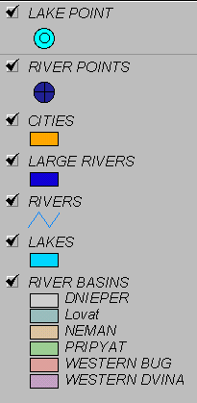

Figure 2. Surface Water National Monitoring Network in Belarus

Groundwater:
The Belarus Geological Survey (Belgeologia) and Belarusian Scientific and Research -Geological Prospecting Institute under the Ministry of NREP is responsible for monitoring of groundwater. There is no current international co-operation (research, data exchange) between Belarus and any other countries. However, it might change, because Poland has a proposal to monitor the groundwater bodies on a transboundary basis, and Belarus fully agrees on this issue.
Groundwater information is confidential in Belarus (as in Russia and Ukraine). There is no proper legislation how to handle groundwater information internationally.

Bathing Waters: Ministry of Health monitors recreational areas measuring bacteriological parameters. Monitoring of these waters is not regular, but varies from year to year depending on the actual situations.

Transitional coastal and marine waters: Belarus has no coastal and marine waters.

2 Sampling facilities

Surface waters:
Belarus preserved its monitoring systems since the Soviet times. Based on the information from Analytical Control and Monitoring Sub-department of the Ministry of Natural Resources and Environmental Protection of Belarus, the surface water monitoring has some laboratory equipment problems to measure some of the requested parameters. Although the list of measured parameters in Belarus includes up to 56 water quality parameters, some Eurowaternet required parameters are not measured at all. The Minpriroda would like to improve the surface water monitoring up to European level including increased number of sampling points and additional parameters. The frequency of the sampling varies from 4 to 12 time per year.

There are approximately 10 000 lakes and reservoirs in Belarus, but the professional literature deals only with 1 000. Out of these, only a few of them are monitored regularly by the national monitoring network.

In Belarus, 2% of available surface water and 7% of groundwater resources are used. Therefore, surface water monitoring network is not very dense (big part of the resources are not used at all).
There are some automated sampling and monitoring stations on rivers, but they are in experimental phase only. They would need more funds to finalize the equipment and test it in real conditions. This monitoring station – developed by CRICUWR - would measure DO, mineralization, carbon, oil, and ammonium.

Groundwater:
There are approximately 3000 wells in Belarus, out of that 136 are used as monitoring wells. It is difficult to find hydrological information for each well. No scientifically proved boundaries of groundwater bodies were identified yet.
The national monitoring network has three levels: national (all information is collected in the National Information Centre), regional and local (monitoring intakes, land fills, etc. – anything that can cause negative impact on groundwater. This level is poorly developed. Its information exists mainly on paper.) Sampling results are gathered into the State Register.

3 Laboratory systems

Surface waters:
Belarus has very well equipped laboratory systems with good QA/QC system. It was partially upgraded by the Word Bank and by the investment of Belarus State. All laboratories have the same quality of equipments.
There are three levels of laboratories:
- Central Analytical Laboratory,
- Committee (Oblast) laboratories (6 regional (Oblast) laboratories + some city laboratories Minsk, Novopolotsk, Pinsk, Mozyr),
- Local (Rayon) laboratories (which report to Oblast laboratories).
Each monitoring site is used by each level of laboratory. These laboratory systems measure different lists of parameters. Measure parameters are for example: Zn, Cu, Fe, Mn, BOD5, COD, DO, NH4, NO2, NO3, N, P, phenols, chrome (3’, 6’) etc., depending on the type of monitoring site. Some analytical laboratories have modern computers, but there is no universal computer software for data analysis, data storage and data exchange. Intercalibration for surface waters is carried out in the frame of international projects (i.e. TACIS, GEF etc.). Laboratories are accredited by national standards.

Central Analytical Laboratory (CAL): It was established in 1997 with the financial help of World Bank. Mostly American equipments were purchased. It has 7 employees. The CAL has capacity to measure basic parameters, but currently they do only the more expensive analyses for heavy metals, suspended matter, zoobentos, pesticides, poliaromatic substances, volatile compounds. Waste water, surface water, drinking water, sludge and groundwater samples are measured. It is accredited on national level only. This laboratory co-ordinates the national intercalibration exercise including the standard sample preparation for other, lower-level laboratories. A British expert assessed the intercalibration process of Belarus on the basis of ISO 5725 and it was concluded that it meets the requirements. Suspended solids are sampled once a year on 3 monitoring points. Pesticides are measured in soil and water. Data are stored on paper, but computer software is currently under development/installation to store all laboratory data. The lab has also software for chromatograph analysis, ‘WINLAB 32 ICP for Examine Spectra’. This lab does not calculate the cost of the sample analyses. All 7 employees have high education (university degree).

Urban Committee Laboratory of Minsk: It is accredited nationally. They analyse air, waste water, drinking water, soil samples. They have new equipments: Kanel 130P (Russian), PV1251C-Solar (Belarus - new) and CF-46 (Soviet - old) spectrophotometers, AQUA-OXY ad BODetector (portable, Estonian), Ionometer I-30 (Soviet for pH), AH1 (Russian infrared spectrometer for oil), Tecator Kjeltec System 1026 Distilling Unit (for total N – measured only at 1 station just below Minsk), ovens, MSI-Pro and P20-2 (for air pollution of cars only in emergency situations, Ukrainan), CVET-500M (gas chromatograph, Russian), Simaa 6000 (Perkin Elmer, for heavy metals from air and water). 7 employee work in this lab who have high, university education (3 for water, 3 for air and the head of the Laboratory). This Laboratory is under the supervision of the Ministry of Environment. Therefore, it has no right to analyse private (non-governmental) samples. Lab employees carry out both sampling, sample preparation and analyses.

Groundwater: no information.

Drinking water: The Ministry of Health has its own, separate laboratory network for the analyses of drinking water samples.

4 Data processing and information management facilities.
Surface waters:
The main purpose of the data analyses is to publish the “State Water Cadastre” annual report assessing the changes in the environment (surface waters, groundwater).
The Ministry of Natural Resources and Environmental Protection is responsible for updating the database and reporting.
Data are stored in the Minpriroda and its brunches. Scientific organizations involved in data assessment such as CRICUWR and Belarusian Scientific and Research – Geological Prospecting Institute (BelNIGRI). Special software is available to carry out different assessments:
- Software for oil pollution modelling: one-dimensional model, but in the cross section calculations the model can be considered as two or three dimensional. It calculates pollution wave (including the thickness of the oil film on the water surface and the concentration) along the major rivers over time, because no cross section information is available for small rivers. The software also used for NO3 pollution modelling.
- Modelling flood events: it provides forecast for 10 days ahead in relation to precipitation and discharge. The flooded areas can be presented on map.
- Modelling of groundwater pollution: In case of accidental pollution in rivers, this software could calculate the propagation of pollution with the surface water, and the long-term spreading of pollution in the adjacent groundwater bodies.
- Dnepr river basin software calculates and shows average water quality concentrations for a given period for all stations. This software is still under development under the GEF project.
- Transboundary Information Exchange System (TIES) under a TACIS project (financed by GEF and UNDP). It is an internet based system for regular data exchange amongst Belarus, Poland and Ukraine. There are two access levels: public and expert. It has a specific protocol to what, when and how should be uploaded to the server. It contains information on biodiversity (protected areas, species, etc.), legislation, hot-spots and water quality. This webpage is available only in Russian language. After the TACIS project, the CRICUWR will maintain the system.

Availability of data (e.g. freely available, confidential, purchasable): row data are not accessible for free distribution. Results of data assessment are usually published. The database include data from 1989 to 2001.

Groundwater: no information

Drinking water: no information

5 Reporting
The head of the International Co-operation Department stated that there is a need to develop an internet based website for the Ministry of Natural Resources and Environmental Protection (NREP) and a data exchange portal between Belarus and the EU.

The Ministry of NREP prepared 3 main annual publications:
- State Water Cadastre;
- Quality of Surface Water;
- Environmental Conditions in the Republic of Belarus.

The water cadastre is summarised in the “Blue Book of Belarus” that is like a dictionary listing all water objects including rivers and lakes.

6 Training needs and equipment needs

Needs: There is a need to analyse biological samples and the upgrade computer software of the laboratories. Some of the measuring devices could also be improved.

Notes:
- János Fehér asked Belarus experts to provide status data as an addition to the physical data of monitoring sites, for some years to further improve the final product of the project. ETC representatives were informed that this request has to be discussed with the national NCP before answering to the request.
- The Deputy Environmental Minister of Belarus asked ETC representatives whether there was a possibility to prolong the project to complete all tasks in full details (e.g.: future plans of the country).

About Eurowaternet exercise in Belarus:

Rivers:
Most information related to all aspects of the 129 river monitoring stations (physical characteristics, quality, pressure) are prepared. Unfortunately, the water quality sites have no precise names and coordinates in most of the cases. Therefore, names, co-ordinates and river kilometres were assigned to these stations in relation to hydrological monitoring sites. (70 hydrological monitoring sites in Belarus that measure water level and discharge only).
There are several parameters required by EWN Basic that are not measured by the Belarus National Monitoring Network: i.e.: Chl-a, COD, Organic N, TIN, TOC, and TON. However, there are other parameters measured that are not required by EWN Basic (a total to 57 parameters depending on the monitoring sites).
Pressure information is provided in the Excel tables except the column called ‘Nature’.
Probably there will be no selected reference sites in Belarus because the monitoring network was set up to detect the effect of pollution sources and not to assess the background situations of waters.

Lakes:
Most data related to physical characteristics on reservoirs have already been processed. Pressure information will be filled in during the next coming weeks. There are 25 lake stations on 25 lakes or reservoirs. Not all parameters are measured, which are required by Eurowaternet. Not measured parameters are: TON, TOC, transparency, Chl-a, alkalinity. There is a need for training and for some portable probes.

Groundwater:
Groundwater information collection in Belarus is currently not possible, because of the law on the protection of groundwater information. If the law is modified to provide information to international projects, the tables will be filled with relevant groundwater information (probably in the next phase of this project).

Annex 1 Country Visit Programme

Date | Activity | Visiting experts
Saturday  14 June | Travel to Minsk, Belarus | János Fehér  Attila Lázár
Sunday  15 June | Meeting with Belarus local expert Vladimir Korneev and expert co-ordinator Aliaksandr Stankevich.  Discussion of the country report and data collection work for Belarus. | JF, AL
Monday  16 June | 1. Visit to the Central Research Institute for Complex Use of Water Resources Ministry of Natural Resources and Environmental Protection,  ½ Slavinsky Str., Minsk, 220086 Belarus  - Visit to the Ministry of Natural Resources and Environmental Protection.  - Meeting with Aliaksandr Rachevsky, Head of Sub-department of International Relations  - Meeting with A. Apatcky, Deputy Minister  - Meeting with Svetlana Utockina, Head of Sub-department of Monitoring and National Contact Point of NIS project.  - Visit to Central Analytical Laboratory.  - Meeting with L. Scripnichenko, Head of Laboratory. | JF, AL, AS and National Local expert Vladimir Korneev
Tuesday  17 June | - Visit to Urban Committee of Natural Resources and Environmental Protection of Minsk  Meeting with Natalya Aleynikova  Departure from Minsk to Budapest | JF, AL, AS and National Local expert VK  JF, AL

Annex 2 Country Visit Participants

I. Officials visited by the project experts:

Mr. Alexander N. Apatsky
Ministry of Natural Resources and Environmental Protection
of the Republic of Belarus,
Deputy Minister
10, Kollektornaya Str.
Minsk 220048
Republic of Belarus
Tel.: (375) 172-203986
Fax.: (375) 172-205583

Mrs. Svetlana Utochkina
Ministry of Natural Resources and Environmental Protection
Head of Sub-Department of the Organization of Analytical Control and Monitoring
10, Kollektornaya Str.
Minsk 220048
Republic of Belarus
Tel./fax: (375) 172-204776

Mr. Alexander Rachevsky
Ministry of Natural Resources and Environmental Protection
Head of Sub-Department of international relations
10, Kollektornaya Str.
Minsk 220048
Republic of Belarus
Tel.: (375) 172-204328
Fax: (375) 172-204771
Email: minproos@mail.belpak.by

Mrs. Ludmila Scripnichenko
Ministry of Natural Resources and Environmental Protection
Central Analytical Laboratory of the Minpriroda
Director
10 Kollctornaya Street
Minsk 220048
Republic of Belarus
Tel.: (375) 172-898762
Fax: (375) 172-205583
Email: mpr-lab@yandex.ru

Prof. Eduard Kovalenko
Central Research Institute for Complex Use of Water Resources
Ministry of natural Resources and Environmental Protection of the Republic Belarus
Hydrologist, Ecologist
½ Slavinsky street
Minsk 220086
Email: cricuwr@infonet.by

Aliaksandr V. Pakhomau
Central Research Institute for Complex Use of Water Resources
Ministry of natural Resources and Environmental Protection of the Republic Belarus
Senior Researcher, GIS Specialist
½ Slavinsky Street
Minsk 220086
tel.: (375) 172-635331
fax.: (375) 172-642734
Email: ecogis@open.by

Pavel Afanasiev
Central Research Institute for Complex Use of Water Resources
Ministry of natural Resources and Environmental Protection of the Republic Belarus
Hydrologist
½ Slavinsky Street
Minsk 220086
tel.: (375) 172-635331
fax.: (375) 172-642734

Natalya Aleynikova
Head of the Analitical Laboratory of the Minsk Committee
of the Natural Resources and Envintonmental Protection
Minsk, Plehanova str. 18.
tel. (+375-172) 45-89-45
e-mail: priroda@mail.belpak.by

Andrew Dementiev
Secretary of the national office of the GEF project "Dnipro
River Basin Envinronmental Programme",
Minsk, Komsomolskaya str. 16.
tel. (+375 172) 23-56-62
e-mail: ecoinv@home.by

II. Project experts

National Local Expert in Belarus
Mr. Vladimir Korneev
Central Research Institute for Complex Use of Water Resources
Ministry of natural Resources and Environmental Protection of the Republic Belarus
Chief of Department
½ Slavinsky Street
Minsk 220086
tel.: (375) 172-634833
fax.: (375) 172-642734
email: cricuwr@infonet.by
v_korneev@yahoo.com

Expert Co-ordinator

Aliaksandr Stankevich
Central Research Institute for Complex Use of Water Resources
Ministry of Natural Resources and Environmental Protection
½ Slavinsky Str.
Minsk 220086
Republic of Belarus
Tel: +375 17 2634833
Fax: +375 17 2642734
e-mail: cricuwr@infonet.by

ETC / WATER Experts

János Fehér
VITUKI CONSULT Rt
H-1095 BUDAPEST,
Kvassay Jenõ út 1.
Hungary
Tel: +36-(1)-2165810
Fax: +36-(1)-2152245
e-mail: feher.janos@vituki-consult.hu

Attila Lázár
VITUKI CONSULT Rt
H-1095 BUDAPEST,
Kvassay Jenõ út 1.
Hungary
Tel: +36-(1)-2165810
Fax: +36-(1)-2152245
e-mail: lazar.attila@vituki-consult.hu

Supreme Council

Administration of the President
Ministry of Emergency Situation
Situation
Ministry of Health

Ministry of Agriculture
Concern ‘Belmeliovodchoz’
Committee on land use, geodesics and cartography
Committee of Building Policy

Annual Report
“State Water Cadastre”
Annual Report “Quality of Surface Water”
Public relations
Public organizations
Scientific institutions
Central Scientific and Research Institute of Complex Use of the Water Resources (CRICUWR);
Belarusian Scientific and Research Center ‘Ecology’;
Belarusian Scientific and Research – Geological Prospecting Institute;
Institute of Problems of Natural Resources and Ecology of the Academy of Sciences of Belarus.

Ministry of Natural Resources and Environmental Protection of the Republic of Belarus (is response for the Environment National Monitoring Systems)
Sub-Department of analytical control and monitoring organization
Regional Branches of the Ministry and their analytical laboratories
Central Analytical Laboratory (Minsk)
Fig. 1 National System of Environmental Monitoring in Belarus
Council of Ministers
Ministry of Housing and Municipal Services

Ministry of Forestry

Belarusian Geological Prospecting Expedition (Belgeologia)
Annual National Report “Environmental Condition in the Republic of Belarus”
Other monitoring activities in the frame of Environment National Monitoring System

In-depth study of the monitoring situation in specified areas (inland surface water) of the New Independent States

Country Visit Report
Tbilisi, Georgia
2 May – 6 May 2003

Purposes of country visit:
- To support the National Local Expert with information gathering and assessment;
- To meet appropriate ministry representatives;
- To meet the National Contact Point;
- To initiate the process of identifying future needs for equipment and training to enable a fully representative EUROWATERNET to be introduced following the completion of this project.

Country visit programme:
The detailed country visit programme can be found in Annex 1.

Summary of country visit

1 Brief description of the organisations involved in monitoring

Surface waters:
In Georgia the current monitoring networks for rivers, lake and transitional, coastal and marine waters, which are under responsibilities of different institutions, are as follow:
- Rivers – 38 stations, under responsibility of State Hydrometeorological Department.
- Lakes – 4 stations on one lake, under responsibility of State Hydrometeorological Department.
State Hydrometeorological Department has two main laboratories in Kutaisi and in Tbilisi (central) and one in Batumi. These laboratories provide analysis after sampling. State Monitoring Centre within Hydromet enters data into database. Hydromet sends data to Ministry of Environment annually, but sometimes this reporting activity seems to be not working properly.

There are three current projects (TACIS, DAI and NATO) supporting creation of some new monitoring stations. The TACIS project is to purchase the following equipments for Hydromet:
- Hand-held probe for temperature, conductivity, turbidity, pH, dissolved oxygen;
- Sampling equipment with cool boxes;
- BOD cooled incubator;
- Two refrigerators;
- Two ovens (105 ºC);
- Cold vapour kit for Hg, Hydride kit for As, Se;
- Perkin Elmer GC with Autosampler, FID and ECD for organochlorine pesticides.

The department has 40 years of experience in monitoring, but since the Soviet times, the monitoring activities were decreased significantly. Especially the analytical equipments are limited. Good records are available until the early 90’s. Since then the pollution sources have changed (former main pollution sources do not exist any more, but new ones were built).
The monitoring system was developed in the Soviet times. So-called monitoring and control stations were distinguished. Monitoring stations are located in the surface water at well-mixed zones, whereas control stations are in the plume of pollution sources. However, no control stations are under operation of the Ministry of Environment.
Only calculated results are available on heavy metals and organic compounds (investigation of the potential sources of pollution, than estimation of the possible pollution and finally the potential pollution load to the river). Four lake monitoring stations are operated, but all of then situated on only one lake.
So far no inventory of the pollution sources and cadastre of surface waters were elaborated.
There is a currently ongoing project on the Kura river (financed by USA) with the objective to classify the sections of the river in all states (Turkey, Georgia, Azerbaijan) where it flows.
Georgian experts have a need to carry out a project on the harmonisation of the regional standards of NIS countries with EU standards (Turkey, Armenia, Georgia, Azerbaijan).

Groundwater:
State Geological Department is responsible for groundwater.
No operational groundwater monitoring stations exist since 1992. Although, it is possible to use about 30 old monitoring stations for renovation of monitoring activity.
Records of groundwater monitoring exit on paper until 1992.

Transitional, Coastal and Marine waters:

On transitional, coastal and marine waters there are 12 stations under responsibility of Ministry of Environment and Natural Resources Protection of Georgia. The measurements are taken by the Conventional Inspection of Black Sea Protection of the Ministry of Environment. They are located in Batumi and have one laboratory. Inspection sends data to the Ministry four times in year.

Other:
Ministry of Environment is responsible for the monitoring of water, soil, air, and waste.
State Department of Land Management is responsible for the land use information, but they provide information only on regional and not catchment level.
State Statistical Department holds the data on population.
Monitoring of drinking water quality is the responsibility of the Ministry of Health.

2 Sampling facilities
No equipment development happened during the last 20 years. Probably the Soviet standard equipments are still used. Only very limited monitoring stations are operated (42 stations for surface water). The sampling is sometimes not reliable due to lack if interest of those who carry out the sampling, because of the very low salaries (~10 USD per month).
No groundwater monitoring is operated.

3 Laboratory systems

The Central Laboratory is under the State Hydrometeorological Department. Furthermore, local experts operate three more regional laboratories. These regional laboratories used to do all analysis, but today there is no information about what is their capacity. Today, they mainly do minor analysis and the more difficult ones are done in the Central Laboratory.

4 Data processing and information management facilities.
At present, there is no comprehensive database on environment, but there is a plan under development to set up an environmental data centre.

There are two kind of so called databases (State Water Cascade and Water Quality Data for Coastal Zone of Adjaria) from which information are available:
Name of database | State Water Cascade, vol VI., Annual Data of Surface Water Quality | Water Quality Data for Coastal Zone of Adjara
Organisation responsible for database | State Hydrometeorological Department,  Ms. Tina Stavilia (Deputy Head) | Conventional Inspection for Black Sea Protection,  Ms. Mzia Mushkudiani (Head of the laboratory)
Database storage | Paper, PC | Paper
Availability of data | Purchasable, non-purchasable depending on which organisation apply for | Freely available
Regions covered by database | Georgia (expect Abkhazia from 1992) | Adjara (Georgia)
Number of years of data | 1930-2002 | Since 1986
Description of process whereby data is transferred from local to central locations | After sampling, samples are delivered to laboratories of Tbilisi, Kutaisi, Batumi, Sokhumi (till 1992). After the analysis data are delivered to the Pollution monitoring Centre of Environment, State Hydrometeorological Department. | After sampling, samples are delivered to laboratory of Conventional Inspection for Black Sea Protection (Batumi). After analysis of samples, data are delivered to Conventional Inspection for Black Sea Protection for assessment and they deliver data to the Ministry of Environment of Georgia if it is required or in case of emergency.

5 Reporting

Since the Soviet times, monitoring is “collapsed” and today no reliable assessment could be done. Therefore Georgia plans to re-design the monitoring system in a sustainable way that could provide the necessary information for the State.

The local experts whom we met explained that it would be very essential to establish a united database centre for rivers, lakes, ground waters and TCM, preferably under Ministry of Environment. It would allow better information management and the monitoring network under the Ministry of Environment.

All staff would need to be trained for the purpose to arise their awareness on the importance of monitoring water bodies and about the whole spectrum of the issue from sampling and finishing it with reporting and decision-making.

6 Training needs and equipment needs

Local experts mentioned sampling and laboratory equipments as stressing need, plus they would like to have trainings for ‘field’ workers and maybe for decision makers. However, these will be officially outlined later. They will also assess the long-term sustainability of their ‘needs’.

Preliminary (not complete) list of needs for Hydromet identified by the local experts visited:
Sampling facilities
Cars (Niva) 3
Boats 9
Equipment
Atomic adsorption spectrometer (for analysis heavy metals)
Lamps for Cd, Pb, Ni, Zn, As, Hg
Spectrophotometer
Desk top 1
Generators 2
Water stills 4
Necessary glassware
Chemicals

Annex 1 Country Visit Programme

Date | Activity | Visiting experts
Friday  2 May | Travel from Baku, Azerbaijan to Tbilisi, Georgia | János Fehér  Attila Lázár  Mikhail Kolomeev
Friday  2 May | Visit to National Monitoring Centre of State Hydrometeorological Department  Meeting with  - Mr Nugar Buachidze, Head of National Monitoring Centre  - Ms Tina Stvilia, Deputy Head of National Monitoring Centre  - Mr Alexander Tsikaridze, Deputy Head of National Monitoring Centre | JF, AL, MK , National Local expert Dr Ivane Tsiklauri and Prof. Yuri Tsaturov, Head of UN ECE WGEM
Saturday  3 May | Visit to Ministry of Environment and Natural Resources Protection of Georgia  Meeting with  - Mr Ramaz Chitanava, Adviser to the Minister, Head of Monitoring Unit within MoE  - Ms Nino Sharashidze, Senior Specialist of Environmental Policy Department, Member of Ad Hoc WG on Environmental Monitoring | JF, AL, MK, National Local expert Dr Ivane Tsiklauri and Prof. Yuri Tsaturov, Head of UN ECE WGEM
Sunday  4 May | Meeting with National Local expert Dr. Ivane Tsiklauri | JF, AL, MK
Monday  5 May | Visit to the Ministry of Environment and Natural Resources Protection of Georgia  Meeting with Mr Zaal Lomtadze, Deputy Minister | JF, AL, MK and National Local expert Dr Ivane Tsiklauri
Tuesday 6 May | Departure from Tbilisi, Georgia to home country | JF, AL, MK

Annex 2 Country Visit Participants

I. Officials visited by the project experts:

Mr Nugzar BUACHIDZE
Head of National Monitoring Centre
State Hydrometeorological Department
150a Agmashenebeli avenue
Tbilisi, Georgia
Tel: +995-(32)-959533

Mr Ramaz CHITANAVA
Advisor to the Minister
Head of Monitoring Unit
Ministry of Environment and Natural resources Protection
68a M Kostava St
0171 Tbilisi, Georgia
Tel: +995-(32)-334082
Fax: +995-(32)-333952
email gmep@access.sanet.ge

Mr Zaal LOMTADZE
Deputy Minister
Ministry of Environment and Natural resources Protection
68a M Kostava St
0171 Tbilisi, Georgia
Tel: +995-(32)-334082
Fax: +995-(32)-333952
email gmep@access.sanet.ge or zl@access.sanet.ge

Ms Nino SHARASHIDZE
Senior Specialist and Member of the Ad Hoc WGEM
Environmental Policy Department
Ministry of Environment and Natural resources Protection
68a M Kostava St
0171 Tbilisi, Georgia
Tel: +995-(32)-334082
Fax: +995-(32)-333952
email gmep@access.sanet.ge

Ms Tina STVILIA
Deputy-Head of National Monitoring Centre
State Hydrometeorological Department
150a Agmashenebeli avenue
Tbilisi, Georgia
Tel: +995-(32)-959533

Mr Alexander TSIKARIDZE
Deputy-Head of National Monitoring Centre
State Hydrometeorological Department
150a Agmashenebeli avenue
Tbilisi, Georgia
Tel: +995-(32)-959533
II. Project experts

Yuri S. Tsaturov
First Deputy Head
Russian Federal Service for Hydrometeorology and Environment Monitoring
12, Novovagan’kovsky Street,
123242, Moscow, Russian Federation
Phone: +(095)-252-2429
Fax: (095)-255-2400
Telex: 411117 RUMS RF
Email: tsaturov@mecom.ru

National Local Expert in Georgia
Dr. Ivane Tsiklauri
Department of Environmental Policy
Ministry of Environment and Natural resources Protection
68a M Kostava St
0171 Tbilisi, Georgia
Tel: +995-(32)-334082
Fax: +995-(32)-933952 or +995-(32)-943670
email gmep@access.sanet.ge

ETC / WATER Experts

János Fehér
VITUKI CONSULT Rt
H-1095 BUDAPEST,
Kvassay Jenõ út 1.
Hungary
Tel: +36-(1)-2165810
Fax: +36-(1)-2152245
e-mail: feher.janos@vituki-consult.hu

Attila Lázár
VITUKI CONSULT Rt
H-1095 BUDAPEST,
Kvassay Jenõ út 1.
Hungary
Tel: +36-(1)-2165810
Fax: +36-(1)-2152245
e-mail: lazar.attila@vituki-consult.hu

Expert Co-ordinator

Mikhail Kolomeev
SPA TYPHOON
82, Lenin str.
Obninsk, Kaluga reg
249038, Russia
Tel: +7-08439-44950
Fax: +7-08439-40704
e-mail: mk@feerc.obninsk.org
In-depth study of the monitoring situation in specified areas (inland surface water) of the New Independent States

Country Visit Report
Kazakhstan
22- 25 June 2003

Purposes of country visit:
- To support the National Local Expert with information gathering and assessment;
- To meet appropriate ministry representatives;
- To meet the National Contact Point;
- To initiate the process of identifying future needs for equipment and training to enable a fully representative EUROWATERNET to be introduced following the completion of this project.

Project Team

Ermek Murtazin - Director of the Centre for Environmental Pollution Monitoring (Expert)
Vladimir Bogachev - CAREC (Expert Co-ordinator)
Tim Lack - ETC/Water
Peter Whalley ETC/Water

Meetings

Almaty - KAZHYDROMET
23/6/03
Tursynbek Kudekov - Director General of the KAZHYDROMET
Erdos Kubalkov - Chief Engineer of the KAZHYDROMET

- There are 208 monitoring stations in Kazakstan, of these 180 also monitor water quality
- Two centres of monitoring in KAZHYDROMET; geo-monitoring/water quality and water quantity.
- Data is sent monthly from each Oblast to KAZHYDROMET in Almaty.
- Difficult to exchange information between Ministries.
- Ministry of Geology responsible for groundwaters. Some information is available in KAZHYDROMET. But most is subject to state security.
- Previously monitoring of the Caspian was the responsibility of the Hydromet in Azerbaijan. Now, KZ has 3 monitoring stations on the Caspian; Atray, Tiulenii (island) and Aktoul data available since 1991.
- Centre of water cadastre. Main responsibility is to collect all data and produce the yearbooks.
- KZ is divided into 4 river basins:
- Irtysh (includes the Tobol, Ishym) - East of KZ draining North to Russia
- Ural - (includes the Emba) in the west draining to the Caspian.
- Sydariya - South west draining to the Aral sea North Basin
- Balkash - in the south east which receives water from KG and China.
- Data available on PD and CD since 1995. Usual 32 Soviet determinands. Analysis done in each oblast. Monitoring usually monthly. Yearbook contained basic statistics on results for monitoring stations. It takes a year to prepare yearbook.
- The Ministry of Agriculture works with the KAZHYDROMET on a Water Resources Committee.
- Get information on water balance of Caspian from Russia.
- Laboratory - very basic equipment. More than 40 samples per month. Analysis for the Almaty oblast is approximately 25 samples per month. New Shimadzu AAS with lamps for 12 metals provided by Japanese aid. Lab also contained an HP HPLC and spectrophotometer.
- Most of the 14 Oblasts have laboratories.

Astana - Ministry of Environment
24/6/03

Mr Sapar Bazarbayev - Chief Monitoring Department, Ministry of Environment (formally, Ministry of Environmental Protection and Natural Resources). National Contact Point

- Water quality / hydrology is responsiblity of the KAZHYDROMET. They are also working on Cadastre which is published annually. They are the main water quality organisations
- There are 129 hydro stations, each has one or two hydro-chemical profiles giving a total of 155 sampling points.
- Now have 48 new stations including trans-boundary stations. The focus is on trans-boundary as KZ has recently signed Helsinki Convention.
- Use the former Soviet 7 class classification system. All based on hydro-chemical determinands.
- Stations were selected by the KAZHYDROMET in the 1980s, over 300 stations were surveyed, resulting in 129 stations.
- The monitoring is limited to impacted rivers - there are no class one rivers monitored.
- KAZHYDROMET is the only organisation monitoring rivers in KZ.
- A recent change in Government in KZ resulted in a change of ministerial responsibility. The Ministry of Environmental Protection and Natural Resources is now called the Ministry of Environment; responsibility for Natural Resources is now in other ministries. In addition the Environmental Fund is now closed and distributed to other ministries.
- Ministry of Environment has state responsibility for monitoring quantity and quality. It also has local responsibility for wastewater control. Exceeding of limits can result in penalties. Fines can be ten times the consent charges. Sampling of wastewater is under supervision of a state expert.
- Some rivers getting better some worse; for the latter the ministry tries to tighten limits.
- Local labortoratories undertake analysis under a state certification.
- KAZHYDROMET is a state enterprise with input from stakeholders. Ministry of Environment provides funds for monitoring activities to the KAZHYDROMET.
- Ministry of Environment holds information on trends in water quality on KZ rivers.
- No direct contact between the MoE and the Ministry of Agriculture except through the Water Resources Committee.
- The Central Epidemiological Committee under the Ministry of Health is responsible for public health monitoring. But there is no network. Drinking water quality is monitored at the point of use; bathing waters are not monitored.
- Radiological monitoring is the responsibility of the KAZHYDROMET (Murtazin)
- Have protection zones along rivers preventing certain agricultural practices. If farmers break these conditions then fines are an option.
- No maps of catchment indicating land use are available. A GIS system is under development at the MoE.
- Map and Information Centre (MoE)
- A range of maps (not GIS based - rastor) were available on PC.
- Maps showing water use for KZ split into; Agricultural, Industrial, domestic, fisheries and others. Intention is that information will be transfered to GIS.
- Land Use Agency negotiates with MoE and Ministry of Agriculture over land use changes. This independent Agency is based in Almaty.
- There are no maps on river catchment, but these are expected in the future.

Water Resources Committee
24/6/03
Mr Serik Akhmetov -Head

- Responsibility for regulating protection of water uses
- Concept of MoE on water quality monitoring and joins all Ministries through the water Cadastre contains information on all waters.
- Administration of the cadastre is the Water Resources Department which pays the KAZHYDROMET.
- Committee has network to monitor irrigation but the has fallen into disrepair. There is a state enterprise to undertake this but it is no longer functional.
- Jacob Gibb have been undertaking a Tacis to optimise water resources in river basin. A pilot basin in the centre of the country has been selected and if the approach is appropriate this will then be applied throughout the country. A workshop held two weeks earlier made recommendations about the establishment of new laboratories . These laboratories will be under the Committee.
- The Committee has a responsibility for the ecological quality of the rivers in addition to quality and quantity.
- The Committee gives permission for new abstractions and four bodies are involved in this process;
- MoE
- Epidemiological Centre
- Centre for Fisheries
- Geological Committee
- There is a KZ Water Code regulating the consumption of water and defining the limits for each Oblast.
- KAZHYDROMET assist to set the limits on the basis of their data. However there is no system in place to record the actual abstracted quantities.
- A system will be set up to monitor abstractions but the issue is, who will pay for it'.
- Abstractors pay the Oblast for local abstraction, the Oblasts use the money for any purpose. A mechanism will be established to ensure than the money will be used for environmental purposes.

Central Asia Regional Environment Centre (CAREC)
25/6/03

Victor Prodedovich - Deputy Director
Surayo Pulatova - Librarian
Alexandr Nikolayenko - Information Manager
Russell Frost - Tacis Consultant

- CAREC began in August 2000
- Supported by a number of projects, including 15 from Tacis over the medium to long term.
- Information on all reports is available on CD and web.
- They have a GIS for KZ, UZ, TM which includes river network and land use. Lanad use information was pre-1991.
- The Deputy Director would like to meet a representative of the EEA, to develop links with a view to invite EEA onto the Board of CAREC. TJL recommended contact with David Stanners at EEA.
In-depth study of the monitoring situation in specified areas (inland surface water) of the New Independent States

Country Visit Report
Kyrgyzstan
26 June – 4 July 2003

Purposes of country visit:
- To support the National Local Expert with information gathering and assessment;
- To meet appropriate ministry representatives;
- To meet the National Contact Point;
- To initiate the process of identifying future needs for equipment and training to enable a fully representative EUROWATERNET to be introduced following the completion of this project.

Project Team
Mrs Irina Gorshkova - Chief of Section of Water Resources and Analytical Control, Ministry of Environment and Emergencies (Expert)
Dr Vladimir Bogachev - CAREC (Expert Co-ordinator)
Tim Lack ETC/Water
Peter Whalley ETC/Water

Meetings
Lake Issyk Kul Bio-sphere Project
26/6/03
Mrs Raihan Jeenbaeva - Project Co-ordinator
- Project started in 1996 under GTZ funding. Mrs Jeenbaeva has been co-ordinating it from then.
- Area of reserve 43,000 square km. With a range of eco-systems: Lake, wetland, desert, steppe, meadow, forest, sub-alpine and 43,000 square km of glacier, providing run-off water for KG, UZ, KZ, China and the Aral sea.
- RAMSAR site.
- Pressures: Gold and Uranium mining. 470,000 populations with 3 STW in a critical condition in Balykchy, Cholpon-Ata and Karakol.
- 100+ rivers enter lake. Some of which are polluted. There is no outlet from the lake. Other rivers are over abstracted for irrigation.
- 1 million tourists are estimated to visit the lake
- Currently no routine monitoring of lake(last monitoring in 1998).
- GTZ support to end in 2004

Ministry of Environment and Emergencies
26/6/03
Mr Omor Rustembekov

- Within the Ministry of Environment there is a Department of Environment and Natural Resources, supported by an Agency of Environmental Pollution Monitoring (responsible for emission monitoring). This structure started in 2000. A separate division, the Hydromet, is responsible for monitoring the state of the air and water environment. An Agency of Geology and Mineral Resources is responsible for monitoring Groundwaters.
- Databases for this Project have been completed by the Hydromet and the Agency for Geology and Mineral Resources under the direction of the Ministry of Environment.
- KG is divided into 7 Oblasts. Information available is only from the Chu Oblast in the period 1991 - 2000.
- Until 1991 there were a total of 63 stations. Now only 12 are functional.
- A 'monitoring station' usually consists of two sampling points - upstream and downstream of a discharge or town.
- The Chu river is a trans-boundary river with KZ. A joint monitoring programme is undertaken with KZ every two years.
- The 12 monitoring stations are on the Chu (4), its tribs. (7) and a canal connecting the river.
- Previously there were 14 lake monitoring stations on Issyk Kul and 1 on the lower Bishkek reservoir.
- Approximately 31 determinands are listed for monitoring. No biology and no chlorophyll monitored.
- The funding from the Ministry is only sufficient for the Chu Oblast.
- Other oblasts are monitored on a 'paid by project basis'. It is hoped that additional funds can be found for future monitoring.
- Example of a project paying for monitoring is an ADB funded project on the river Mailysuu flowing into the Narin which is a tributaries of the Sidaria discharging into the North Aral Sea. The project is led by Chemonics International Inc and Finnish Environment Institute. 'Kyrgystan Republic Environmental Management Capacity Building Project' -- final report in December 2002. Project is aimed at evaluating the river as a potential drinking water source. The catchment contains 18 tailing ponds from Uranium mines and a further 10 waste dumps together with large population.
- There used to be two Hydromet laboratories. At present the one in Osh is not functional. All analysis completed by the Hydromet in Bishkek

Hydromet - Bishkek
27/6/03

- Larisa Titova - Head of Pollution Monitoring
- Ludmila Kanygina
- Sole income is from State budget, pre-93 this provided for 69- 65 staff. Now 19 (4 admin, 6 technical and 9 post-graduate)
- The Hydromet is divided into 3 divisions:
- Climate monitoring
- Metrics and instrumentation
- Environmental pollution monitoring
- The Environmental pollution monitoring division is itself divided into 3 sections:
- Surface waters
- Radiation
- Atmospheric
- There are divisional offices in Osh and Cholpot Ata.
- Main duties are the routine monitoring of surface waters and air, validation and analysis of the data and provising that information to the following: Ministries of Environment, Health and Agriculture, the National Statistical Committee and others such as construction companies. There is no charge for providing the data.
- For surface waters, the usual Soviet list of 32 determinands was measured up to 1993 on 54 water bodies totalling 63 sampling stations, in 4 major basins.
- Issyk Kul
- Chu
- Talas (trans-boundary with KZ)
- Narun basin which is a tributary of the Syrdaria - alleged to be the source of the Aral Sea.
- Approximately 40,000 analyses performed on 1,000 samples pa taken monthly up to 93. Situation now is 2 - 4 samples pa in the Chu basin.
- A Soviet developed river typology in 4 levels based on size and pressures.
- Up to 1993, 12 samples a year were used to classify rivers in to one of 7 classes. Since 93 there have been insufficient samples taken to continue the classificcation.
- Lake Monitoring - Issyk Kul up to 93 there were four samples taken per year. Sampling began in the 1970s.
- Samples taken at approximatly 30 locations at different depths. Focus was on WW pressure impact.
- Apparently only change in water quality over 20 years was a reduction of oils. This was attributed to the suspension of oil shipments between two railheads.
- Secchi disc depth in winter appears unchanged at between 28 - 30 metres and in summer 20 - 25 metres.
- Lake is 652 metres deep.
- 10 rivers were also monitored flowing into the lake.
- Commercial fishing on the lake stopped in 2001. Now only private fishing by licence.
- 5 g/l Na in the lake.
- Trout from lake Sevan (Armenia) were introduced in the 1970s as an experiment. Evidence that indigenous fish (chebachok) are much small than in the past.
- There has been no history of measuring trends in water quality on a year-on-year comparison. Historically all data was sent to Rostov on Don.
- Laboratory - No sign of routine analysis underway. Lab is poorly equipped with very limited instrumentation. Most of the existing instruments (predominately spectrophotometers) were of old Soviet manufacture and spares were reported to be difficult to obtain. In the past pesticides were analysed by a thin-layer chromatography method but this is no longer analysed due to the cost of standards. Sample bottles were a variety of wine, oil and water bottles.

Agency of Geology and Mineral Resources
27/6/03

Galina Georgiedna Tolstylina - Senior Expert

Issyk Kul Lake Observation Laboratory
30/6/03
Chabunin Gennadi - Head

- Monitoring station is part of Hydromet.
- Monitoring of Lake since 1970s
- Monitoring not active (1991 - 2002 no monitoring)
- Used to complete 4 sampling programmes per year. Each cruise lasted 20 days.
- In 2001, 2 sampling cruises were completed - spring and autumn.
- Sampling cruise cost approximately 2000 USD.
- In 1998 2 sampling programmes were completed following a cyanide spill..
- Since 1989 this laboratory ha the capacity to analyse 16 of 32 determinands. The rest being sent to the Hydromet in Bishkek. However no evidence of analytical capability remained in the laboratory now.
- 20 staff on meteorology and hydrology - not involved in monitoring, but undertaking 'research'. Salery approximately 12 USD per month.
- Have two research vessels with small on-board laboratory capability.
- Had 4 lake offices associated with this laboratory at; Chalpon Ata; Tanga; Balykchy and Koidaray, near Karakol. There used to be 7 offices round the lake.
- Lake level has reduced by 3 metres since the 1920s, but has increased by 40 cms in the last year.
- The Academy of Science laboratory (on same site) has investigated phyto and zoo-plankton. But has not functioned since 1990s.
- Secchi disc depth is at its maximum (35 m) and at its minimum in August (15 m).
- Thermal stratification - 20 C at surface to 4 C at bottom. The lake is iso-thermal 4 -5 C IN February.
- Boat trip on lake Issyk Kul on the Meltur ('Beautiful'). Ship is 28 m overall length 6 m beam with a 150 T displacement. Equipment - winch, Secchi disc, reversible thermometers, Hydrobios water sampler, grab sampler and sediment corer.

Lake Issyk Kul Biosphere reserve local office - Chalpon Ata
- Responsible for inventorying all environmental data and adding to GIS.
- 3 Staff in Cholpon Ata and 50 in Balykchy.
- Expecting a visit from USAID and GEF LAKENET and they are hoping for support to continue the GTZ initiated project.

In-depth study of the monitoring situation in specified areas (inland surface water) of the New Independent States

Country Visit Report
Chisinau, Republic of Moldova
22-24 July 2003

Purposes of country visit:
- To support the National Local Expert with information gathering and assessment;
- To meet appropriate ministry representatives;
- To meet the National Contact Point;
- To initiate the process of identifying future needs for equipment and training to enable a fully representative EUROWATERNET to be introduced following the completion of this project.

Country visit programme:
The detailed country visit programme can be found in Annex 1.

Summary of country visit

1 Brief description of the organisations

The Ministry of Ecology, Construction and Territorial Development is the responsible governmental organization for conducting environmental monitoring. The Ministry is responsible for the preparation of annual national reports, and other documents and publications about the state of environment in Moldova.
Water Environmental Report of Moldova and other publications are prepared by Scientific Organizations such as the National Institute of Ecology. The organizational structure of the Ministry of Ecology, Constructing and Territorial Development of the Republic Moldova is shown on Figure 1 at the end of this report.

Surface waters:
The monitoring surface water network includes 45 monitoring sites on rivers and 6 monitoring sites on reservoirs.

State Service Hydrometeo carries out meteorological research, hydrological research, and environmental monitoring on air, surface waters and soil. In case of surface waters, its main activity is the observation of the state of water environment.

National Institute of Ecology (NIE) carries out scientific research focusing on the origin, transformation and travel of pollutants in the environment. It carries out its own monitoring, sampling and analysis to satisfy its own scientific needs. NIE prepares the reports on the state of the environment based on the Hydrometeo data.

Groundwater:
The Geological Survey of Moldova is responsible for monitoring of groundwater. However, since 1992 monitoring not conducted due to financial problem. At present this problem is actively discussed in the Ministry with the aim of restarting of groundwater monitoring.

Transitional coastal and marine waters: Moldova has no coastal and marine waters.

A small advisory group of different specialists on water issues will be created in the near future under the Ministry of Ecology to advice the Government on water related matters.

The development of international monitoring network is very important for Moldova, and it will fully support such activities. Moldova ratified 17 international conventions in relations of numerous obligatory tasks that have to be fulfilled.

Many countries help or helped Moldova to solve water supply and sanitation problems.
- The Danish Government gave 5 million USD to develop the water supply network.
- Italy, Kuwait and Japan also helped the reconstruction of WWTPs.
- Hydrometeo just recently received some financial help to improve its transboundary monitoring stations. Four automated monitoring stations were set up on the country’s two major rivers (Dniester and Prut).
- There is an ongoing Moldavian-French project to set up a data centre that will collect all water resources data.
- There is also a project financed by the World Bank on agricultural pollution reduction. The project supports creating a platform in rural area to collect manure from farms; to minimise the effect of manure on big rivers; and to use manure in agriculture activities.

Need: Moldova is looking for investors to help the country in agricultural and water management development and related projects.

2 Sampling facilities

Surface waters: There are two institutes that have monitoring networks: Hydrometeo and National Institute of Ecology. Hydrometeo carries out regular measurements assessing the state of the environment, whereas the National Institute of Ecology performs scientific measurements. These institutes run sometimes-parallel measurements on the same monitoring sites resulting in doubled data. The optimisation of it is currently ongoing.

Hydrometeo measures 18 meteorological, 20 agro-meteorological and 47 hydrological stations. 16 large rivers and 8 reservoirs are monitored. There is no monitoring on natural lakes. They take 12 samples per year (one sample per month) manually in rivers, and 4-6 times a year in case of reservoirs. The sampling days are not fixed, but the sampling hour within the day of measurement is always the same. In case of extreme conditions, extra samples are taken. There are 4 automated sampling stations on Dniester and Prut rivers near to the country border to detect transboundary pollution. These automated stations are connected to a computer server via Internet. Temperature, level, turbidity, dissolved oxygen and pH can be monitored in real-time on screen. They also operate the so-called PIAC (Principal International Alarm Centre) system, which is part of the Danube Basin accidental pollution early warning system for emergency situations. Hydrometeo has a special vehicle for field work (sampling and on-site measurements for 5 parameters). All samples are taken by a specialized team, which carries the samples to the Central Laboratory (sampling methods are nationally standardised). Hydrometeo wishes to extend its monitoring network to a fully automated network.

Moldova has limited water resources, but it is a dominantly agricultural country. Dniester and Prut rivers are the largest ones, but there are approximately 3600 small tributaries, as well. Water quality problems are severe in some small tributaries, while water quality is 2nd class in case of large rivers. Most small creeks are polluted by agricultural activities and untreated domestic waste waters. There is a need to a more frequent, extended surface water monitoring network on smaller tributaries.

Groundwater: There is no operational groundwater monitoring network currently in Moldova. Water quality of wells was measured only once, when the well was drilled. Drinking water comes from surface waters for larger cities, but in small villages from shallow groundwater wells. Mineralisation and nitrification problems occur in shallow groundwaters. There is a need for deep wells and the establishment of regular groundwater monitoring on them.

3 Laboratory systems

Hydrometeo laboratory analyses the surface water samples for 42 parameters (such as traditional physical, oxygen, nitrogen and phosphorus parameters, heavy metals, some pesticides, phenol and oil products, etc.). Monitoring of surface waters started in the 1960’s with measuring 18 parameters. These were gradually increased to the current level. The measured parameters vary seasonally.
The laboratory is accredited to Moldavian standards every three years, and receives blank samples from the Hungarian VITUKI Rt. during regular intercalibration exercise required by the Danube Basin Accidental Early Warning System. No international accreditation is available for the Hydrometeo Laboratory. Each sample is uniquely identified at entry in the logbook. Since 1993, data is stored electronically. Soviet-time data (until 1992) is still stored on paper. There was also an intercalibration exercise on sediment samples concerning pesticides with Monaco, and the result was good. Although the procedure is known, sediment is not regularly sampled.
Equipments in Hydrometeo laboratory: UV-visible spectrometer (Varian-Cary 100 Conc), Fotometr KFK-3 (Russian), Ionometer ZV-74 (Russian), GAT-15 (Russian), UNICAM 969Z AA spectrometer, UNICAM GF90 plus furnace, UNICAM VP90 vapour system, HP 7683 Series GC system.
18 employees work in this laboratory with high education background (11 in lab, 3 for sampling, and 4 for administrative tasks).

The Central Ecological Laboratory is under the National Institute of Ecology. It is a division of the Ecological Inspectorate. It investigates pollution sources of soil, water and air. It does not carry out regular freshwater monitoring, only in extreme conditions. When a sample is taken, it is analysed in the closest local office. Four times a year 20 pollution sources and 150 waste water treatment plants are monitored (traditional parameters, pesticides, chloro-organic compounds, heavy metals, etc.). It also investigates the impact of waste water treatment plants on surface water quality. Based on measurements, it recommends to the Inspectorate to search for hidden pollution sources in a specific area. 15 employees are in the Central Laboratory, and 47 employees in the country. One sample costs from 1 to 13 months-salary of an inhabitant, but the commercial price of the analyses are centrally fixed (lower than it costs).

4 Data processing and information management facilities
Within Hydrometeo, a Data Centre was set up to collect all environmental information required by a national law. This Centre is at administrative level, and up to now, is not running very well.

5 Reporting
The National Institute of Ecology is responsible for preparing all sorts of reports:
- National Report of Ecological State of the Republic of Moldova – 2002 (400 copies in Romanian and 200 copies in English)
- Annual State Report on the progress/results of National Multi-Annual Programme
- National Review of Moldova – 1998 (Part A: Social and Economic Analysis, Part B: Financing Mechanisms)

6 Training needs and equipment needs

There is a need for training and for some portable probes in case of lake monitoring.

There is a need to begin groundwater monitoring, to optimise transboundary surface water monitoring and upgrade computer softwares of the laboratories. Some of the measuring devices could also be improved.

Notes:
- János Fehér asked the national experts to provide some years of quality data as an addition for this project.

About Eurowaternet exercise in Moldova:
Until 1995, data are in paper format in Romanian and Russian. From 1993, data is available in electronic format in Romanian. Data for the years of 2000-2002 is missing, but will be provided soon by Hydrometeo.
Coordinates were corrected and now, these have an error of 5 seconds only. Elevations are above Baltic Sea level, and they were also checked and corrected where it was necessary. Long term discharge is not available for all stations (it has to be calculated or leave it as missing data). 38 river stations and 6 reservoirs stations are characterized, but all 47 river monitoring stations will be provided by the end of August. Not measured parameters are: Chlorophyll-a, total nitrogen, total organic carbon. Pressure (population density and land use) is not yet calculated. Groundwater is still missing, but some information will be received soon.

Most information related to all aspects of the 45 river monitoring stations (physical characteristics, quality (without data for period 1999-2001years), pressure (only data for density of the population and area of the forests) are already prepared. Probably there will be no selected reference sites in Moldova, because the monitoring network was set up to detect the effect of pollution sources and not to assess the background situations of waters and effects of agricultural activity.

Annex 1 Country Visit Programme

Date | Activity | Visiting experts
Tuesday  22 July | Travel to Chisinau, Moldova | János Fehér  Attila Lázár  Aliaksandr Stankevich
Wednesday  23 July | - Meeting with Dr. Nicolae Stratan, Deputy Minister, Ministry of Ecology, Construction and Territorial Development of the Republic of Moldova  - Mr. Valeriu Cazac, General Director, State Service “Hydrometeo” and Mr Gavril Gilca, General Chief, Monitoring centre on Environmental Pollution of State Service “Hydrometeo”  - Visit to National Institute of Ecology (NIE)  - Visit to the Central Monitoring Laboratory of the National Environmental Inspectorate | JF, AL, AS, and National Local experts Ms Maria Sandu and Vladimir Brega
Thursday  24 July | - Visit the Cricova enterprise  Departure from Chisinau to Budapest | JF, AL, AS, and National Local expert VB  JF, AL
Friday  25 July | Departure from Chisinau to Minsk | AS

Annex 2 Country Visit Participants

I. Officials visited by the project experts:
Dr. Nicolae Stratan
Vice-Minister
Ministry of Ecology, Construction and Territorial Development of the Republic of Moldova
Srt. Cosmonautilor 9,
MD-2005, Chisinau
MOLDOVA
Tel. (3732) 22-86-12
Fax. (3732) 22-62-53
E-mail: Nstratan@mediu.moldova.md

Mr. Valeriu Cazac
Director
State Service Hydrometeo
Ministry of Ecology, Construction and Territorial Development
Str. Grenoble 193,
MD-2043, Chisinau, Ghimet
Tel. (3732) 77-35-11
Fax. (3732) 77-36-36
E-mail: cazac@hidromet.meteo.md

Ms. Natalia Berghi
Chief of International Division
State Service Hydrometeo
Ministry of Ecology, Construction and Territorial Development
Str. Grenoble 193,
MD-2043, Chisinau, Ghimet
Tel. (3732) 77-35-29
Fax. (3732) 77-36-36
E-mail: berghi1976@hotmail.com

Mr. Gavril Gilca
General Chief of Monitoring Centre on Environmental Pollution
State Service Hydrometeo
Ministry of Ecology, Construction and Territorial Development
Str. Grenoble 259,
MD-2072, mun. Chisinau
Tel. (3732) 76-68-55
Fax. (3732) 77-36-11
Mobile: (3732) 919-10-29
E-mail: gilca@hidromet.meteo.md

Mr. Copacinschi Gheorghe
Director
Central Laboratory
State Ecological Inspectorate
Ministry of Ecology, Construction and Territorial Development
str. Gh. Tudor 3,
MD-2028, Chisinau
Tel./fax. (3732) 22-28-15
E-mail: ecolablES@mediu.moldova.md
II. Project experts
National Local Expert in Belarus
Dr Maria Sandu
Deputy Director of the National Institute of Ecology
Head of Water Ecosystems
5 Str Gh. Tudor
MD-2028
Chisinau
Republic of Moldova
+373-2-72-18-03
fax +373-2-21-11-34
email ineco@moldova.md
email sdumaria@mail.md

Mr Vladimir Brega
National Institute of Ecology
Head of Water Ecosystems
5 Str Gh. Tudor
MD-2028
Chisinau
Republic of Moldova
+373-2-72-18-03
fax +373-2-21-11-34
email ineco@moldova.md
email sdumaria@mail.md

Expert Co-ordinator
Aliaksandr Stankevich
Central Research Institute for Complex Use of Water Resources
Ministry of Natural Resources and Environmental Protection
½ Slavinsky Str.
Minsk 220086
Republic of Belarus
Tel: +375 17 2634833
Fax: +375 17 2642734
e-mail: cricuwr@infonet.by

ETC / WATER Experts
János Fehér
VITUKI CONSULT Rt
H-1095 BUDAPEST,
Kvassay Jenõ út 1.
Hungary
Tel: +36-(1)-2165810
Fax: +36-(1)-2152245
e-mail: feher.janos@vituki-consult.hu

Attila Lázár
VITUKI CONSULT Rt
H-1095 BUDAPEST,
Kvassay Jenõ út 1.
Hungary
Tel: +36-(1)-2165810
Fax: +36-(1)-2152245
e-mail: lazar.attila@vituki-consult.hu

Supreme Council

Administration of the President
State Ecological inspection
Situation
Central Analytical Laboratory
Municipal analytical laboratory

Annual Report for
Ministry of Ecology, Constructing and Territorial Development
Brief Reports for International organizations
Public relations
Public organizations
Scientific institutions

National Institute of Ecology

Ministry of Ecology, Construction and Territorial Development of the Republic Moldova (which is response for the Environment National Monitoring Systems)
State Service “Hydrometeo”,
Department “ Centre for analyzes and information support”
Department “Centre of the Climate”
Fig. 1 National System of Environmental Monitoring in Moldova
Council of Ministers
Department of the Hydrology
Annual National Report “Environmental Condition in the Republic Moldova”
Other monitoring activities in the frame of Environment National Monitoring System

In-depth study of the monitoring situation in specified areas (inland surface water) of the New Independent States

Country Visit Report
Russia
23- 25 July 2003

Purposes of country visit:
- To support the National Local Expert with information gathering and assessment;
- To meet appropriate ministry representatives;
- To meet the National Contact Point;
- To initiate the process of identifying future needs for equipment and training to enable a fully representative EUROWATERNET to be introduced following the completion of this project.

Project Team

Mikhail Kolomeev, Expert Co-ordinator
Alexandre Chekhovtsov - Expert, Ministry of Natural Resources
Tim Lack - ETC-Water
Peter Whalley - ETC-Water

Roshydromet - Russian Federal Services for Hydrometeorology and Environmental Monitoring
23 July 2003
Dr Dzhumshid Dzhangiov - Deputy Director of the Environmental Pollution Monitoring Department
Dr Elena Dmitrivstia - Specialist on Inland water monitoring.

- Roshydromet and Ministry of Natural Resources collaborated in the preparation of the Kiev Report. They have also collaborated for this project.
- Expert (Alex) has been working on topic for 18 years. Currently employed by MNR - previously by Roshydromet. Has worked with Hydro-chemical Instituted (Rostov on Don). Currently has data on 155 river, TCM and lake stations.
- System has changed since USSR times, number of stations has decreased. Refocused to take account of international reporting with an emphasis on trans-boundary monitoring.
- MNR responsible for water treatment, consents, licensing, abstraction, limit setting, industrial discharges. Responsible for monitoring 'in-pipe'.
- Roshydromet responsible for all surface water monitoring. Independent from MNR. Characterised as independent Government Institute reporting to its Minister.
- There is a new water act covering human health as well as environment. MNR is responsible for this.
- MNR also responsible for air quality and waste monitoring.
- Bathing waters: MNR not responsible for monitoring but co-ordinates activities wit Ministry of Health.
- Monitoring of fish resources managed under MNR through a committee.
- Roshydromet is also responsible for hydro-biology. A small programme covering 200 stations (whole Russia) - data collected by institute of Global Climate and Ecology.
- Hydro-chemical and hydro-biology stations combined. Fewer hydro-biology stations. No current monitoring programme.
- Organisations of Roshydromet:
  - 3 levels:
    - Federal
    - Inter-regional
    - Local
  - Local has 89 centres whole of Russia). Each centre has its own laboratory responsible for sampling and analysis. Data is collated and sent to Hydro-chemical Institute in Rostov. In addition there are specialised laboratories (e.g. Typhoon, Hydrobiology Institute) who also provide inputs to Hydro-chemical Institute. A condensed report on data is provided to Roshydromet.
  - Inter-regional . 22 centres. Data obtained locally is also provided to this group of organisations.
- Groundwaters - the responsibility is under the MNR through Institute with ecpertise for groundwater monitoring. Formally under Ministry of Geology.
- A request was made to provide a strategy on how to implement EWN in Russia.

National Centre for Ecological Programmes, Ministry of Natural Resources
23 July 03
Alexandre Chekhovtsov - Expert, Ministry of Natural Resources
- Main objective of this office is information and analytical interpretation.
- A partner organisation is based in Novosbruk
- 45 staff work in Centre producing the annual reports and state of the environment reports in Russia. Contributed to by 40 ministries
- Latest published report is for 2001. 2002 under preparation.
- 1739 monitoring stations in the whole Russia, with approximately 800 in 'European' Russia. From this 200 stations have been selected for analysis including:
  - Border stations;
  - Reference stations;
  - 'representative' station;
  - (stations with long time data sets)
- Network created in the 1970s based on hydrological network which was established > 100 years ago.
- The objectives of the network are:
  - surveillance of water bodies to give background information;
  - assessment of anthropogenic impacts on the status to determine trends;
  - To provide recommendations on water use and conservation.
- Covers all water types and sizes;
- New stations operated on basis of pressures.
- Different sampling frequency - 4 categories of monitoring stations:
  - Category 1: Daily. Limited number of determinands. Currently 12 active monitoring stations. Based on significant risk.
  - Category 2. Once every 10 days. More determinands and dependent on the potential risk of contamination. Covers oils and metals. 29stations currently monitored.
  - Category 1 and 2 are also monitored monthly or quarterly depending on risk.
  - Category 3: Monthly monitored stations. 575 all 32 parameters.
  - Category 4: every 3 months based on hydrological seasons. 878 stations. Generally in areas of low anthropogenic inputs. May be viewed as 'reference' stations?
  - Also , 84lake stations and 161reservoirs.
  - When frozen - sampling is done through ice for category 1 and 2 stations where possible.
  - No systematic monitoring of sediments or biota.
  - In Soviet times biology was monitored in 5 - 10 % of stations by the Hydro-biology Institute (based in Rostov). Special reports were prepared each year. Covering bacteria plankton, phytoplankton, zooplankon, periphyton and zoobenthos. Last report was 1989.
  - Data analysis: Year book covers year-on-year trends, 5%, 95% ile and nin, max, mean of data.
  - Combined hydro-chemical and hydrological databases to enable time of travel pollutant calculations and load estimates to be made.
  - AQC: Hydro-chemical Institute controls quality and methods used in Russia. Training provided to laboratories. An annual report is prepared on the performance of each laboratory and monitoring network covering the number of samples/analyses performed. Report also highlights any deficiencies in the laboratory's performance. Both internal and external quality controls are performed - the Hydro-chemical Insitute distributes standards for analysis and prepares split samples for analysis.. This system has been preserved.
  - Hydro-chemical Institute used to undertake this service for the whole of the Soviet Union. There is now a gap in providing this service in the other EECCA countries.
  - Database - Quality of surface waters in Russian Federation.
  - Stored within Hydro-chemical Institute, (Special department dealing with database and reporting - still functional). Database is computer based.. This falls under the Roshydromet.
  - Data is available by purchasing the annual report (250 Rub).
  - Database covers all Russian Federation
  - Water quality data is available since the 1970s. Water quantity for > 100years.
  - Summary (based on information collected to date) of river size and number of monitoring stations:
< 50km2 | 6
50 - 250 | 10
250 - 1000 | 25
1000 - 2500 | 24
>2500 | 85
Total | 150

Ministry of Natural Resources
24 July 03
Olga Novoselova, Deputy Head, Department of Environmental Monitoring, Ministry of Natural Resources, (National Contact Point)
Lubov Stepanova, Deputy Director, Department of International Environmental Co-operation

The NCP was briefed on project and overall performance of data gathering
- ON reported that Tacis/GTZ project on monitoring in Kaluga and Perm will provide final report in the next week. The findings may be relevant to this project.
In-depth study of the monitoring situation in specified areas (inland surface water) of the New Independent States

Country Visit Report
Tajikistan
27– 30 July 2003

Purposes of country visit:
- To support the National Local Expert with information gathering and assessment;
- To meet appropriate ministry representatives;
- To meet the National Contact Point;
- To initiate the process of identifying future needs for equipment and training to enable a fully representative EUROWATERNET to be introduced following the completion of this project.

Project Team

Tajinisso Nasyrova Vice-Minister, Ministry of Nature Protection of the Republic of Tajikistan (RT) – National Expert
Tim Lack – ETC-Water
Peter Whalley ETC-Water

Ministry of Nature Protection
28/7/03
Timur Nazarov - Chief of the Science –Technical Progress and Standards Department, Ministry of Nature Protection of RT
Khamid Rasulov – Chief of Anti-Hail Service, Ministry of Nature Protection (of RT)
Oxana Temnova - Main specialist of the International Department of Anti-Hail Service

- Hydromet is one of the organisations under the MNP
- MNP is responsible for controlling water resources, air and waste.
- Monitoring of rivers, lakes and glaciers is responsible of Hydromet.
- Monitoring of groundwaters is responsibility of Ministry of Geology
- Within MNP is Central ANalytical Laboratory.
- Hydromet has laboratory for quality and quantity
- MNP has 8 special inspectorates for quality control of resources
- MNP is only responsible for quality and quantity information on trans-boundary. Although Tadjikistan has yet to sign the Trans-boundary convention.
- Approximately 57% of all water resources in Central Asia originate in Tadjikistan
- 8476 glaciers
- 947 rivers
- 1300 lakes
- 7 reservoirs
- 4 regions in Tajikistan each with its own laboratory plus main laboratory in Dushanbe
- Swiss funding is assisting the Hydromet and the MNP laboratory is receiving equipment from ADB

Meeting at Hydromet – Dushanbe
28/7/03
Makhmad Safarov - Deputy of the chief , " The main office on Hydrometeorology and Environment state Supervision (Main Tajik Hydrometeorology);
Vokhid Khamidov–Leading specialist, Main Tajik Hydrometeorology
Irina Bravicheva - Deputy of the laboratory, Main Tajik Hydrometeorology
Mirzo Azizov - Chief of Hydrometeorological station “Khushjeri”, Main Tajik Hydrometeorology;
Sulton Abdulmamadov - Chief of the Department of Hydrology, Main Tajik Hydrometeorology;

- There are 4 regions each with its own laboratory:
  - Sujol
  - Gorniy Badakshan
  - Khatoln
  - Rrp

Representation of Monitoring stations, posts and points

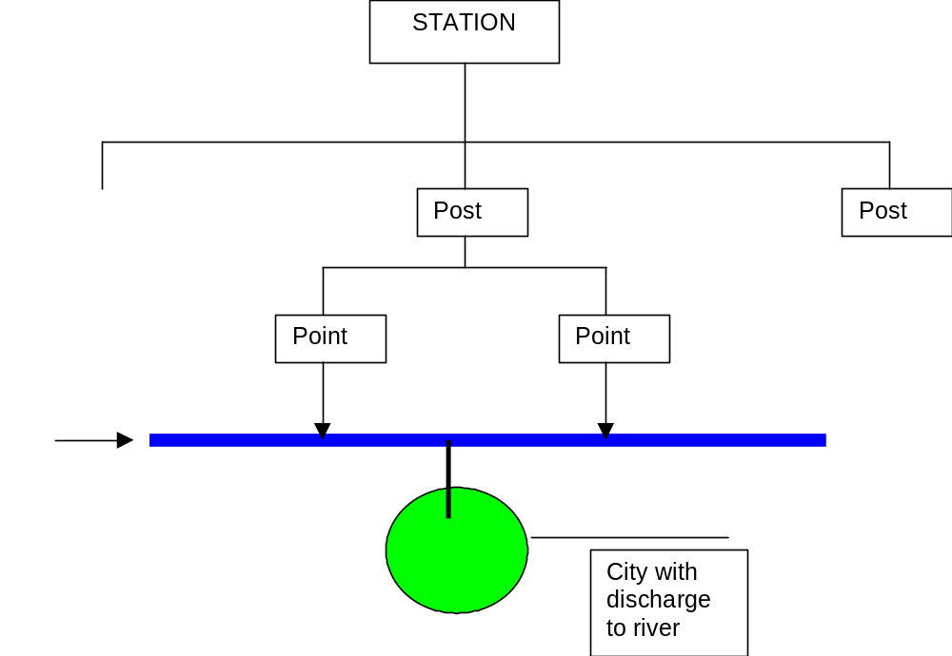

- 26 Stations
- 52 or 53 posts
- 104 or 106 points of which 46 hydrochem monitoring points are functional from 26 posts
- (NB - EUROWATERNET is only interested in monitoring points)
- Main function of Hydromet is to provide forecasting information. 58 hydrometeorlogical stations and 97guage stations
- 31 substances monitored (USSR system). But no BOD due to lack of reagents. There is no biological monitoring except for microbiology.
- Problems: lack of reagents, equipment and fuel for vehicles.
- Hydromet monitors water quality in rivers, the MNP monitors discharge point. If Hydromet detect high levels in rivers they inform MNP who send inspectors to collect samples from potentially polluting dischargers.
- All laboratories within Hydromet are considered by the Deputy Chief to be in poor condition. Have well qualified staff.
- Hydromet has prepared a number of project proposals seeking international finance to support their activities, including 'Equipment and materials for monitoring the surface waters in Tadjikistan' 200 k$
- Hydromet used to have 947staff but now have 700. In laboratory (Centre for Environment Monitoring) there used to be 45 staff but now 14. The laboratory was split into two sections water, soil and refiation, and air monitoring. Plus a department of information. This sends all data to the MNP
- AQC is under the responsibility of the MNP's Central Laboratory.
- Hydromet Laboratory
  - Used Merck test kits for range of parameters. All analysis are now completed using test kits.
  - Old USSR equipment (e.g. spectrophotometers) but there are problems obtaining spares and budget limitations on maintaining equipment.

Visit to Monitoring Station in Varzob region.

Saw number of monitoring points, hydrometeorology stations and discussed procedures.

Ministry of Geology
29 July 2003
Alexandr Akhmedov - Chief of the Main Geology Office under the Government of the Republic of Tajikistan;

- Ministry divided into tow sections covering the North and South of the country
- Responsible for monitoring of underground waters and prepares the groundwater cadastre.
- Makes measurement on abstracted water quantity and quality and reported has large laboratory in Dushanbe and regional laboratories in Kalaikhum and Panjakent.
- Main problems - fuel / transport and old equipment.
- Would like support for new equipment (proposals are available) and for mobile laboratory.
- 900 drilled wells.
- International organisations (e.g. UNICEF) are developing groundwater resources for hand-pumped wells, but were reported bit to be obtaining analysis of water quality
- Groundwater contaminated with heavy metals and pesticides, drilling to scond horizon at 150 metres gives better quality.
- In south (Khaton) - main use of groundwater is agriculture but 25 - 30 % of the population use for drinking.
- In Dushanbe about 40% of the population use it for drinking.
- Wells need to be reconstructed after 20 years.
- Data on water quality stored in the Ministry of Geology
- Ministry of Geology used to get 73 M$ from USSR per year, now recieve 150k$
- Ministry of Geology is providing bulk water supply to regional water companies, for example, Dushanbe Water Canal Company who distribute to domestic users. Ministry of health responsible for final water quality checking.
- Industrial users abstract direct from groundwaters.

Ministry of Nature Protection - Central Laboratory
29 July 2003

Chief Bashir Suriev

- Central Laboratory has 30 staff. There are 5 regional laboratories.
  - Khujan
  - Kurgam-tyube
  - Kulyab
  - Khorugh
  - Tursunzade
- 75% work on water, 20% atmosphere and 5% on soil and radioactivity
- All main laboratory equipment dates from the USSR
- Three main analytical techniques:
  - classical chemical analysis
  - spectrophotometric methods
  - chromatography
- ADB has provided test kits, computers and Toyoto cars for all laboratories.
- ADB equipment provided following needs assessment by Seatec International and Helsinki Consulting (final report 2002). 'Development of Institutional capacity for environmental monitoring'
- Main problems:
  - Insufficient cars for collecting samples
  - Need of new analytical equipment and reagents.
- This year laboratory will receive some reagents and glassware from WB for an Agricultural reconstruction project. The lead organisation (private) will pay the Central Laboratory for analysis.
- The building currently housing the laboratory is not owned by the MNP and the ADB would not invest in improvements needed.
- Hydromet identifies potential polluters and the MNP Central laboratory investigates by monitoring in waste streams and 50 metre up-stream and down stream of discharge to confirm identity of polluter.
- Fines are paid into a special fund in MNP to assist with environmental improvements of dischargers
Laboratory Tour
All laboratories were reported to be in the process of redevelopment. All needed significant structural repair and attention is also required for the services.
Laboratories contained range of old equipment (balances still, fume hoods incubators etc).
Hach test kits (15 parameters) have been provided.
A USSR GC was in operation for the analysis of organo-chlorine pesticides.
A total of 20 pcs have been provided to MNP by the ADB
Proposals in Russian were provided for establishing three regional laboratories, primarily aimed at trans-boundary monitoring were provided.
In-depth study of the monitoring situation in specified areas (inland surface water) of the New Independent States

Country Visit Report
Kiev, Ukraine
3 June – 6 June 2003

Purposes of country visit:
- To support the National Local Expert with information gathering and assessment;
- To meet appropriate ministry representatives;
- To meet the National Contact Point;
- To initiate the process of identifying future needs for equipment and training to enable a fully representative EUROWATERNET to be introduced following the completion of this project.

Country visit programme:
The detailed country visit programme can be found in Annex 1.

Summary of country visit

1 Brief description of the organisations involved in monitoring

Surface waters:
The State Ecological Monitoring Department of the Ministry of Environmental Protection of Ukraine is responsible for the preparation of normative and methodological materials and instructions for regional organizations doing environmental monitoring (how to monitor, handle emergency situations, information flow, etc.). Furthermore, this department prepares the annual Environmental Report of Ukraine and other publications such as the document that was presented in May 2003 on the Kiev Conference called: National Report of Ukraine on harmonization of society’s life in natural environment. This department co-ordinates all sampling-reporting activities of the 30 regions of Ukraine. (Radiation monitoring was started after Chernobyl event).
The organizational structure of the Ministry of Environmental Protection is shown on Figure 1 at the end of this report.

Groundwater:
The State Geological Survey under the Ministry of Environmental Protection is responsible for monitoring groundwater, but it is a completely separate branch within the Ministry from surface water monitoring unit. Unfortunately no one was available from this department and no further information was provided on groundwater monitoring during the country visit.

Transitional coastal and marine waters:
The monitoring is controlled by an institute located in Sevastopol.

2 Sampling facilities
Mr. Kolotusha, Deputy Director of the State Ecological Monitoring Department of the Ministry of Environmental Protection of Ukraine said that air monitoring is good, but the water monitoring has lots of problems such as old laboratory equipments. The MEP would like to improve the water monitoring up to European level including increased sampling points and increased number of measured parameters.
In the Hydromet network there are 18 sampling points along the River Dnepr (3 samples per month). However, in autumn, winter and spring, there are only 5 stations monitored on the river. In case of other stations, 4-12 samples are taken per year.

3 Laboratory systems

The Central Geophysical Observatorium monitors rivers and lakes, analysing samples for a maximum of 41 parameters depending on the type of monitoring sites, including 4 heavy metals (Zn, Cu, Fe, Mn), plus BOD, COD, DO, N, P, phenols, etc. They have 35 good computers, but they have no modern softwares (only such which are operating under DOS operational system) nor new laboratory equipments (only equipments from the late 1980s). There are 12 regional laboratories that analyse the samples of 240 surface water monitoring stations (15 reservoirs, 7 lakes, 218 river stations).
It was said that each laboratory (hydrochemical, hydrobiological, radiation, ..) takes samples for itself, but later on we were informed that these activities are already harmonized in some way.
Intercalibration is carried out among the regional laboratories and there is a Central Laboratory located in Charcow in the Ukrainian Scientific Research Institution of the Ecological Problems that manages these activities. Laboratories are accredited only against national standards. None of the laboratories are accredited internationally. The capacity of the Central Geophysical Observatorium is approximately 2-3000 samples per year.

4 Data processing and information management facilities.
In case of surface waters, there is an information exchange amongst regional monitoring organizations.
In the State Ecological Monitoring Department of MEP there is an electronic (emergency response) database containing data and information about 5 regions (out of 30):
- Water quality parameters (39 parameters);
- Equipments;
- Responsible organizations and persons with address, phone number, etc.;
- Laboratory equipments available at the laboratories;
- Frequency of sampling and the location of sampling sites (e.g. river);
- Software generated maps showing the location of the sampling points (using ArcView 3.1)
- It was said that time series could be generated for any parameters.

Although this database will have information on surface waters, waste water treatments plants, air, groundwater etc., not all tables were filled up with data at the time of the country visit. This database works only at the State Ecological Monitoring Department of MEP in a small network (5 computers), therefore there might be a need to expand this database into a National Environmental Data Centre.

Hydromet data are stored only in DOS (text) format. However, it is possible that there can be slight differences among tables; therefore they might not easily convertible into Excel format.

5 Reporting

The State Ecological Monitoring Department of MEP prepares all reports on the environment (with the participation of all relevant organizations):
- Annual State of Environment Report
National Report of Ukraine on Harmonization of Society’s Life in Natural Environment (for the Kiev Conference)

6 Training needs and equipment needs

Notes:
- Ukrainian national experts asked whether 1 or 2 more national experts could participate in the Budapest workshop.
- János Fehér suggested to the Ukrainian expert to provide some quality information as an addition (for at least one year) to further improve the final product of the project and to enable the project to support the needs of the countries with some general status information.

About Eurowaternet exercise in Ukraine:

Lakes:
No data on reservoirs have been processed yet. These will be done in the next coming weeks. There are 16 lake stations (8 belongs to Hydromet network, and 8 belongs to the State Water Economy Committee network). All general information was collected except the areas of watersheds in some cases, where there is no definite incoming tributary of the lake (i.e. in case of mountainous lakes in remote areas, where the lake is fed by springs or surface runoff only). Not all parameters are measured which are required by Eurowaternet (not measured parameters are: TON, TOC, transparency, Chl-a, alkalinity). There could be a need for training and for some portable probes, such as to measure conductivity. A special program was developed to calculate the land used information. Pasture data are not available. Agricultural land use is not very stable in Ukraine, because agricultural activities are changing year by year. JF suggested to perform an expert judgment on the approximate long-term average distribution of land uses.

TCM waters:
120 stations exist. Only a few parameters (8) are measured by the State, which are required by EWN. (Not measured parameters are: BOD, Chl-a, COD, PO4-P, Organic N, TN, TP, TOC, TON). So far not all processed data were entered into the excel tables of these project. (It will be done in the coming weeks). Tide is not observed and registered, and there is no data on the mixing characteristics either. For this later one, mathematical calculations could be only done. (JF suggested looking for some Monographs on the coastal marine zones, because these might have some useful, missing information.)

Rivers:
196 stations will be processed in this project questionnaire (out of the total 224 stations exit today in the Hydromet network) by the local national expert. There are several parameters required by EWN Basic, but not measured currently in the Hydromet network, such as: Chl-a, COD, NH4-N, Organic N, TIN, TOC, and TON. However, there are other parameters that are not required by EWN Basic. A total of 35-41 parameters are measured depending on the monitoring station. The State Water Economy Committee has also running a monitoring network on rivers with 306 stations in total. At these stations BOD and COD are measured, but not measured the following parameters, such as: NH4, O2 saturation, Organic N, TN, TOC, TON. There is some overlapping between the two monitoring networks (or at least some stations are very close to each other).
There is an improvement in the physical and pressure data processed into the tables since the last monthly report.
Probably there will be no selected reference stations in Ukraine, because the monitoring networks were set up to detect pollution and not to monitor relatively clean waters. To overcome on this situation, the networks should be either re-designed or new stations should be set up.

List of contacts
Name | Organisation | Address
Mr. Aleksandr Stankevich | Central Research Institute for Complex Use of Water Resources  Ministry of natural Resources and Environmental Protection of the Republic Belarus  Expert co-ordinator of the project | ½ Slavinsky street  220086, Minsk  tel.: +375 17 263 4833  fax.: +375 17 264 2734  email: cricuwr@infonet.by
Mr. Eugen Varlamov | Ukrainian Scientific Research Institution of Ecological Problems  Head of Laboratory  National expert of the project | Bakulin street 6  661166, Kharkiv  tel./fax.: +38 0572 45 4087  Email: e_varmalov@rambler.ru  varl@niiep.khakov.ua
Mr. Stanislav Kolotusha | Ministry of Environmental Protection of Ukraine,  State Ecological Monitoring Department  Deputy Director | Golden Gate street 6.  Building G  252001 Kiev  tel.: (044)-228-6385  fax.: (044)-229-8383
Ms. Tatiana Nikolaevna Babenko | Ministry of Environmental Protection of Ukraine,  Central Geophysical Observatory  Deputy Director | Nauki av., 39, building 2  03028, Kiev  tel.: (044) 265-6920  fax.: (044) 265-6969  email: merlinw@gda.freenet.kiev.ua
Ms. Aleksandra Nikitenko | Ministry of Environmental Protection of Ukraine,  Central Geophysical Observatory  Head of Water Laboratory | Nauki av., 39, building 2  03028, Kiev  tel.: (044) 265-6920  fax.: (044) 265-6969
Mr. Pavlo Yakovlev | UNDP/GEF  Dnipro Basin Environment Programme  Administrative Assistant | 36/7 Shovkovychna street, office 1  01024, Kiev  tel./fax.: (380-44)253-8776  email: yakovlev@dnieper-gef.kiev.ua  http://www.dnipro-gef.net

Annex 1 Country Visit Programme

Date | Visit programme | Visiting experts
3 June 2003, Tuesday | Travel from Budapest and Minsk to Kiev | János Fehér,  Attila Lázár and  Aliaksandr Stankevich
4 June, Wednesday | Visit to the Ministry of Ecological Resources  Meet with Stanislav Kolotusha  Deputy Director  State Ecological Monitoring Department of the Ministry of Ecological Resources  Visit to Central Geophysical Observatory of the Ministry of Environmental Protection of Ukraine.  Meet with Ms. Tatiana Nikolaevna Babenko, Deputy Director and  Ms Aleksandra Nikitenko, Head of Water Laboratory | JF, AL, AS  and Eugen Varlamov
5 June, Thursday | Visit to Ukrainian GEF Office.  Meet with Pavlo Yakovlev  UNDP/GEF  Dnipro Basin Environment Programme  Presentation on the progress of the data collection and report preparation by E.Varlamov.  Discussion. | JF, AL, AS  and Eugen Varlamov
6 June 2003  Friday | Preparation of the country visit report  Departure from Kiev | JF, AL  AS

ETC / WATER Experts

János Fehér
VITUKI CONSULT Rt
H-1095 BUDAPEST,
Kvassay Jenõ út 1.
Hungary
Tel: +36-(1)-2165810
Fax: +36-(1)-2152245
e-mail: feher.janos@vituki-consult.hu

Attila Lázár
VITUKI CONSULT Rt
H-1095 BUDAPEST,
Kvassay Jenõ út 1.
Hungary
Tel: +36-(1)-2165810
Fax: +36-(1)-2152245
e-mail: lazar.attila@vituki-consult.hu

Supreme Council

State Ecological Inspection
Other services

Ministry of Emergency Situation
Situation
Ministry of Health
Protection
Administration of the President
State Geological Service
State Service Hydromet
Council of Ministers
Ministry of Agricultural Policy

Ministry of Ecology and Natural Resources
Department of Ecological Monitoring

Public organizations

State Water Economy Committee

State Committee of Land Uses
Land uses

State Committee of Forest Uses

Forest uses

National Space Agency

State Committee of Building Policy

Governmental information analytical system for emergency
situation

Monitoring centers of the other states

Public relations

Regional Centre of Environmental Monitoring

Fig. 1 System of environmental monitoring (state level)

Annex 3 – EUROWATERNET Meta-data Required

RIVERS – Physical Information

Station ID | Station Identifier unique at national level, used to link each station's characteristic data with its quality and pressure data.
Station Name | National Station Name.
Station Type | Station Type may fall under more than one category of: B = Reference, R = Representative, F = Flux, L = Largest, Most Important.
Longitude | Longitude (X) - international geographic co-ordinates of the monitoring station in decimal degrees.
Latitude | Latitude (Y) - international geographic co-ordinates of the monitoring station in decimal degrees.
Altitude | Altitude in metres (m) of the station location.
Catchment Area | Catchment Area upstream of the monitoring station in square kilometres (km²).
Mean Long Term Discharge | Mean Long Term Discharge at the moitoring station in cubic metres per second (m³/s).

Rivers – Quality Information

Station ID |  | Station Identifier unique at national level, used to link each station's characteristic data with its quality and pressure data.
Determinand | Number of Samples in Latest Year 2001 | Number of Samples taken during Latest Year 2001: do not leave field blank, use zero if determinand not monitored.
 | Total Number of Samples in Period 1990 - 2000 | Total Number of Samples taken during the Period 1990 - 2000: do not leave field blank, use zero if determinand not monitored.

Rivers – Pressure Information

Station ID | Station Identifier unique at national level. Same ID used in Physical Characteristic table.
Population Density | Population Density in upstream catchment measured as capita per square kilometre (capita/km²).
Urban | Percentage (%) of Urban land in upstream catchment.
Wetland | Percentage (%) of Wetland in upstream catchment.
Nature | Percentage (%) of Natural land in upstream catchment.
Forest | Percentage (%) of Forest in upstream catchment.
Total Agriculture | Percentage (%) of Total Agricultural land in upstream catchment.
Arable | Percentage (%) of Arable land in upstream catchment.
Pasture | Percentage (%) of Pastural land in upstream catchment.
Other Agriculture | Percentage (%) of Other Agricultural land in upstream catchment.
Other | Percentage (%) of Other land use in upstream catchment.

LAKES - PHYSICAL CHARACTERISTICS

Station ID | Station Identifier unique at national level, used to link each station's characteristic data with its quality and pressure data.
Station Name | National Station Name.
Station Type | Station Type may fall under more than one category of: B = Reference, R = Representative, L = Largest, Most Important.
Lake/Reservoir Name | National Lake/Reservoir Name
Longitude | Longitude (X) - international geographic co-ordinates of the monitoring station in decimal degrees.
Latitude | Latitude (Y) - international geographic co-ordinates of the monitoring station in decimal degrees.
Surface Area | Surface Area of the lake in square kilometres (km²).
Mean Depth | Mean Depth of the lake in metres (m).
Maximum Depth | Maximum Depth of the lake in metres (m).
Residence Time | Average water Residence Time in years.
Catchment Area | Catchment Area upstream of the monitoring station in square kilometres (km²).
Altitude | Altitude in metres (m) of the station location.
Volume | Volume of water in lake in million cubic metres (million m³).

LAKES – QUALITY

Station ID |  | Station Identifier unique at national level, used to link each station's characteristic data with its quality and pressure data.
Determinand | Number of Samples in Latest Year 2001 | Number of Samples taken during Latest Year 2001: do not leave field blank, use zero if determinand not monitored.
 | Total Number of Samples in Period 1990 - 2000 | Total Number of Samples taken during the Period 1990 - 2000: do not leave field blank, use zero if determinand not monitored.

LAKES – PRESSURES

Station ID | Station Identifier unique at national level. Same ID used in Physical Characteristic table.
Population Density | Population Density in upstream catchment measured as capita per square kilometre (capita/km²).
Urban | Percentage (%) of Urban land in upstream catchment.
Wetland | Percentage (%) of Wetland in upstream catchment.
Nature | Percentage (%) of Natural land in upstream catchment.
Forest | Percentage (%) of Forest in upstream catchment.
Total Agriculture | Percentage (%) of Total Agricultural land in upstream catchment.
Arable | Percentage (%) of Arable land in upstream catchment.
Pasture | Percentage (%) of Pastural land in upstream catchment.
Other Agriculture | Percentage (%) of Other Agricultural land in upstream catchment.
Other | Percentage (%) of Other land use in upstream catchment.

Groundwater – Physical Characteristic Information

Station ID | Station Identifier unique at national level, used to link each station's characteristic data with its quality and pressure data.
Station Name | National Station Name.
Name of Groundwater Body | Name of Groundwater Body.
Main Aquifer Type | Main Aquifer Type: use codes F = Fractured, K = Karst, P = Porous.
Area | Area of groundwater body in square kilometres (km²).
Maximum Length | Maximum Length of groundwater body in kilometres (km).
Maximum Width | Maximum Width of groundwater body in kilometres (km).
Number of Horizon | Number of Horizon in which groundwater body is situated: 1 - 10 (1 = top horizon).
Annual Precipitation | Estimate of mean long term Annual Precipitation - mean value or range (min-max) values in millimetres (mm).
Geological Period | Stratigraphy or Geological Period of the aquifer (use keywords below).
Petrographic Description | Petrographic Description of the dominant component of the geological units of the groundwater body (use keywords below).
Thickness | Thickness of the groundwater body - mean value or range (min-max) values in metres (m).
Overlying Strata | Description of the Overlying Strata and soil.
Depth to Groundwater | Depth to Groundwater body - mean value or range (min-max) values in metres (m).
Main Recharge | Source of Main Recharge of groundwater body (use keywords below).
Hydraulic Conductivity | Hydraulic Conductivity of groundwater body as mean kf-value or range (min-max) kf-values in metres per second.
Annual Groundwater Level Amplitude | Annual Groundwater Level Amplitude - range between lowest and highest groundwater levels. Annual mean value or annual range (min-max) values in metres (m).

Groundwater – Quality Information

Station ID |  | Station Identifier unique at national level, used to link each station's characteristic data with its quality and pressure data.
Determinand | Number of Samples in Latest Year 2001 | Number of Samples taken during Latest Year 2001: do not leave field blank, use zero if determinand not monitored.
 | Total Number of Samples in Period 1990 - 2000 | Total Number of Samples taken during the Period 1990 - 2000: do not leave field blank, use zero if determinand not monitored.

Groundwater – Pressure Information

Station ID | Station Identifier unique at national level. Same ID used in Physical Characteristic table.
Population Density | Population Density in groundwater area measured as capita per square kilometre (capita/km²).
Urban | Percentage (%) of Urban land in groundwater area.
Wetland | Percentage (%) of Wetland in in groundwater area.
Nature | Percentage (%) of Natural land in groundwater area.
Forest | Percentage (%) of Forest in groundwater area.
Total Agriculture | Percentage (%) of Total Agricultural land in groundwater area.
Arable | Percentage (%) of Arable land in groundwater area.
Pasture | Percentage (%) of Pastural land in groundwater area.
Other Agriculture | Percentage (%) of Other Agricultural land in groundwater area.
Other | Percentage (%) of Other land use in groundwater area.
Water Abstracted | Is Water Abstracted from groundwater body - if so, give details on purpose and annual quantities.
Artificially Recharged | Is groundwater body Artificially Recharged - if so, give details on purpose and annual quantities.
Main Infrastructures | Are there Main Infrastructures influencing the dynamics of the groundwater body - if so, give detail.
Aquatic Ecosystems | Are there Aquatic Ecosystems associated with the groundwater body - if so, give detail.

Transitional, Coastal and Marine – Physical Characteristics Information

Water Body Type | Water Body Type: T = Transitional water, C = Coastal water, M = Marine water (see definitions below).
Station ID | Station Identifier unique at national level, used to link each station's characteristic data with its quality and pressure data. A station may be a geographically fixed location. A station may also be a broader area in which actual sampling locations may vary from survey to survey. A station may be an area with a defined salinity range within which samples have to be taken. Areas will be recorded and reported as a discrete sampling location.
Station Name | National Station Name.
Station Type | Station Type may fall under more than one category of: B = Reference, R = Representative.
Water Body Name | Water Body Name.
Catchment Name | Catchment Name of major river catchment/basin draining into transitional or coastal waters.
Mainland Coast | Distance from nearest Mainland Coast in kilometres (km).
Closest Coast | Distance from Closest Coast in kilometres (km) if different from above.
Longitude | Longitude (X) - international geographic co-ordinates of the monitoring station/area in decimal degrees.
Latitude | Latitude (Y) - international geographic co-ordinates of the monitoring station/area in decimal degrees.
Matrix | Matrix of environmental compartments monitored at station - W = Water, B = Biota, S = Sediment.
Salinity | Minimum, Mean and Maximum Salinity values measured in practical salinity units (psu).
Temperature | Mean annual Temperature measured in degress Celsius (ºC).
Mean Tidal Range | Mean Tidal Range at the transitional or coastal station measured in metres (m).
Mean Annual Depth | Mean Annual Depth in metres (m).
Residence | Residence time of transitional or coastal water body in days.
Mixing Characteristics | Mixing Characteristics at transitional water station- FM = Fully Mixed, PM = Partially Mixed, VS = Vertically Stratified.

Transitional, Coastal and Marine – Quality Information

Station ID |  | Station Identifier unique at national level, used to link each station's characteristic data with its quality and pressure data.
Determinand | Number of Samples in Latest Year 2001 | Number of Samples taken during Latest Year 2001: do not leave field blank, use zero if determinand not monitored.
 | Total Number of Samples in Period 1990 - 2000 | Total Number of Samples taken during the Period 1990 - 2000: do not leave field blank, use zero if determinand not monitored.

Transitional, Coastal and Marine – Pressure Information

Station ID | Station Identifier unique at national level. Same ID used in Physical Characteristic table.
Population Density | Population Density in upstream catchment of the transitional water or within the River Basin District to which coastal water has been assigned as capita per square kilometre (capita/km²).
Urban | Percentage (%) of Urban land in upstream catchment of the transitional water or within the River Basin District to which coastal water has been assigned.
Wetland | Percentage (%) of Wetland in upstream catchment of the transitional water or within the River Basin District to which coastal water has been assigned.
Nature | Percentage (%) of Natural land in upstream catchment of the transitional water or within the River Basin District to which coastal water has been assigned.
Forest | Percentage (%) of Forest in upstream catchment of the transitional water or within the River Basin District to which coastal water has been assigned.
Total Agriculture | Percentage (%) of Total Agricultural land in upstream catchment of the transitional water or within the River Basin District to which coastal water has been assigned.
Arable | Percentage (%) of Arable land in upstream catchment of the transitional water or within the River Basin District to which coastal water has been assigned.
Pasture | Percentage (%) of Pastural land in upstream catchment of the transitional water or within the River Basin District to which coastal water has been assigned.
Other Agriculture | Percentage (%) of Other Agricultural land in upstream catchment of the transitional water or within the River Basin District to which coastal water has been assigned.
Other | Percentage (%) of Other land use in upstream catchment of the transitional water or within the River Basin District to which coastal water has been assigned.
Sewage Discharge | Direct Sewage Discharges to the water body - Yes/No.
Industrial Discharge | Direct Industrial Discharges to the water body - Yes/No.
Other Discharge | Other Discharges (direct) to the water body - Yes/No.
Oil Extraction | Water body impacted by Oil Extraction - Yes/No.
Gas Extraction | Water body impacted by Gas Extraction - Yes/No.
Spoil | Water body impacted by dredged Spoil disposal ground - Yes/No.
Waste | Water body impacted by Waste disposal ground - Yes/No.
Landfill | Water body impacted by leachate from Landfill disposal site - Yes/No.
Mariculture | Water body impacted by Mariculture - Yes/No.
Fishing | Water body impacted by commercial Fishing activities - Yes/No.
Marina | Water body impacted by presence of a Marina - Yes/No.
Port | Water body impacted by Port facilities - Yes/No.
Other | Water body impacted by any Other activities - Yes/No.

EUROWATERNET – Basic Determinands

Eurowaternet – Basic determinands

Rivers
- BOD5
- BOD7
- Chlorophyll a
- COD
- Dissolved Oxygen
- Nitrate
- Nitrite
- Organic Nitrogen
- Orthophosphate
- Oxygen Saturation
- pH
- Total Ammonium
- Total Inorganic Nitrogen
- Total Nitrogen
- Total Organic Carbon
- Total Oxidised Nitrogen
- Total Phosphorus

Lake Determinands
- Alkalinity
- Ammonia nitrogen
- BOD5
- BOD7
- Chlorophyll a
- COD chromate method
- COD manganate method
- COD unspecified
- Conductivity
- Nitrate nitrogen
- Nitrate and nitrite nitrogen (oxidised nitrogen)
- Nitrite nitrogen
- Orthophosphate
- Oxygen concentration
- Oxygen saturation
- pH
- Secchi depth transparency
- Total nitrogen
- Total organic carbon
- Total phosphorus
Annex 4 National Expert Reports
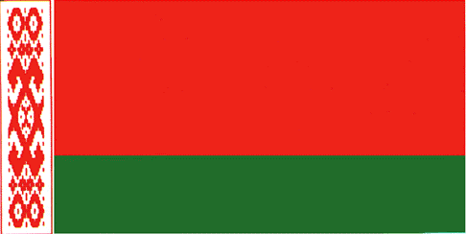

Republic of Belarus

Final report

In-depth study of the monitoring situation in specified areas (inland surface water) of the New Independent States

Draft No 1

Prepared by National Expert Vladimir Korneev
Edited by Expert Coordinator Aliaksandr Stanckevich

August, 2003

Contents

1. | Organizations involved in the Monitoring and Assessment Practise……… | 3
2. | Description of the National Monitoring Network…………………………………. | 6
2.1. | National System of Monitoring……………………………………………………… | 6
2.2. | Other types of Monitoring……………………………………………………………. | 9
3. | Sampling facilities and laboratory system……………………………………….. | 10
4. | Data processing, information management facilities and reporting………… | 11
5. | State of water quality of the main rivers in Belarus……………………………. | 14
6. | About EUROWATERNET exercise in Belarus…………………………………… | 16
 | References……………………………………………………………………………… | 17
 | Attachments (in electronic format):
 | Rivers_Belarus.xls (all information incl. physical characteristics, quality, pressure) on river monitoring sites
 | Lakes_Belarus.xls (all information incl. physical characteristics, quality, pressure) on lakes monitoring sites
 | Groundwater_Belarus.xls (part of information incl. physical characteristics and quality) on 13 groundwater monitoring sites

1 Organizations involved in the Monitoring and Assessment Practise

The state management of water resources use, protection, and restoration is carried out by the Council of Ministers of the Belarus, Parliament (House of Representatives), bodies of the state executive power (regional administrations) and other state bodies. The Competence’s of the Council of Minister are: establishes rates of taxes on using of natural resources including a water supply from underground and surface water sources, rates of taxes for emissions of polluting substances including of sewage within the limits of the established limits in water reservoirs, water -currents, underground horizons (normative cleared, clean, insufficiently cleared and non cleared).
The authorized bodies of the state executive power in the area of water resources use, protection, and restoration are as follows: the Ministry of Natural Resources and Environment Protection of the Republic of Belarus (MNREP), their local bodies and other state bodies according to the legislation.
Ministry of Natural Resources and Environmental Protection is responsible for:
- Of the National Monitoring Program and National Monitoring network;
- State control of the activity of the water users in the field of environment,
- Control of the nature protection legislation and norms of the ecological safety,
- Establishing limits on special water use for each water users (together with regional administrations),
- Control of water users on performance of the sanction of a special water use,
- Realization of the State scientific policy in the field of environmental protection,
- Organization of the environmental monitoring including air, ground, surface and underground waters monitoring,
- State ecological expertise,
- Issuing and cancellation of the special sanctions on outlets and sewage disposals,
- Expertise of burial grounds location,
- International cooperation in the field of environmental protection,
- Building legal basis for water monitoring and assessment,
- Use and development of the State Water Cadastre database.
The Ministry is responsible for the preparation of annual national reports, and other documents and publications about the state of environment in Belarus.
Sub-Department of the Organization of Analytical Control and Monitoring of the Ministry of Natural Resources and Environmental Protection (Minpriroda) of the Republic of Belarus is responsible for the preparation of normative and methodological materials and instructions for regional organizations which are involved in environmental monitoring. Radiation monitoring has started only after Chernobyl event.
The main institutions involved in the water resources management in the surface water monitoring included in organizational structure of the MREP are:
1. Central analytical laboratory (Minsk);
2. The Regional (oblast) Brunches of the Ministry of Natural Resources and Environmental Protection (Brest- , Grodno- , Vitebsk- , Mogilev-, Gomel- , Minsk – region and Minsk urban) Committees with the local analytical laboratories are the responsible organizations for conducting environmental monitoring and for the official policy of the MNREP including regular control of water resources quality and water users supervision via regional (rayon) inspectorates.
3. The Department on hydrometeorology, including the Republican hydrometeorological center, the Center of radiation monitoring and environment control.

Other ministries involved in water management and policy and in other monitoring activities in the frame of National Monitoring Practise prepare and present information to the Ministry of Natural Resources and Environmental Protection. The list of these organizers includes:

Ministry of Health Protection - is responsible for the monitoring of the sanitary conditions of drinking water intakes and recreational waters.
Ministry of Housing and Municipal Services - is carrying out water resources management by means of operations of a water supply system and the water sewage system and waste water treatment plants, sources of water supply etc.
Ministry of Emergencies - including the Republican Centre of Forecasting and Reacting on the Emergency (Minsk). The competence of the Ministry - activities on preventing and liquidation of emergency situations.
Ministry of Agriculture. The competence of this Ministry related to water recourses - water supply for farming purposes.
Ministry of Forestry carries out the control of a condition, use, reproduction and protection of woods, develop the State Wood Cadastre.
State committee on land use, geodesics and cartography. Their competencies are - questions of the account of land, carries out the state land cadastre, control of use and protection of the land.
Concern “Belmeliovodchoz” - response organization on construction of melioration systems in rivers basins, waterways and channels, damming reservoirs.

Scientific institutions involved in water resources management

Central Research Institute of Complex Use of Water Resources (CRICUWR) – is the main scientific organization related to water resources. In Institute developed database of the Water Cadastre which includes data about water users. Institute develop publication in Belarus related to annual integrated assessment of water resources. The Institute has developed the legislation about water protection buffer zones.
Belorussian Scientific and Research Centre «Ecology» - is one of the main organization responsible for preparation and publication legislative documents related to environment protection and other publications related to results of the assessment of environmental.
The Belarus Geological Survey (Belgeologia) and Belarusian Scientific and Research -Geological Prospecting Institute under the Ministry of NREP is responsible for monitoring of groundwater.Belorussian Scientific and Research Geologically-Prospecting Institute (BelSRGPI).
Institute of the Problems of Natural Resources and Ecology of the Academy of Sciences of Belarus (IPNRE NASB) – running the separate technological projects in the field of environment protection.

Water Environmental Report of Belarus and other publications are prepared by Scientific Organizations such as the Central Research Institute of Complex Use of Water Resources (CRICUWR) and Belarusian Scientific “Ecology” Research Centre. The National Report “Environmental Condition in the Republic of Belarus” was prepared in 2002.

Population and ecological organizations can be considered as users of ecological information as well.

The organizational structure of the National System of Environmental Monitoring in Belarus is shown on Figure 1.

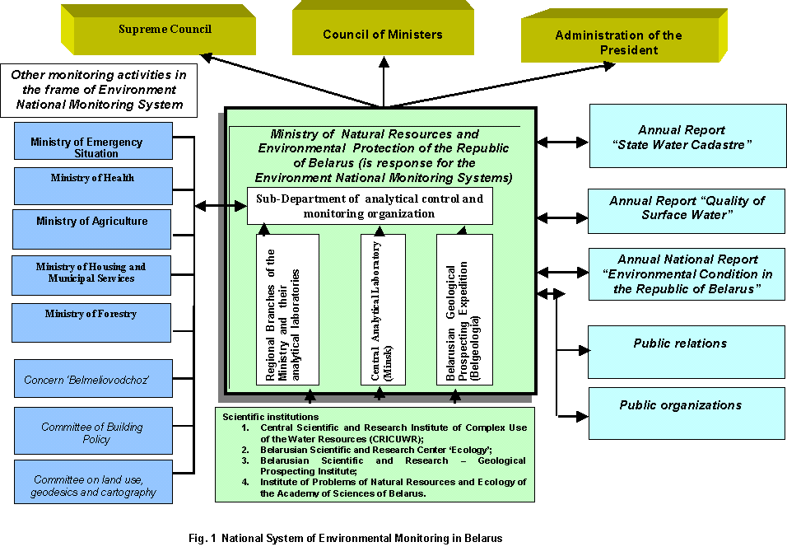

2. Description of the National Monitoring Network

The Republic of Belarus is fairly well supplied with water resources. The available natural water resources are quite sufficient for meeting the current and future needs for water. Water resources of the Belarus range up to 57,9 km³ in an average year, of which 34 km³ are formed within the country. Rivers of the Black Sea basin and rivers of the Baltic Sea basin account respectively for about 55% and 45% of annual water discharge. A major portion of river flow (about 59%) is formed within the country. Water inflow from the territories of neighboring countries (Russia and the Ukraine) reaches 41%. Part of the river flow is accumulated in lakes and water-collecting areas of the republic (6,7 km³ and 3,1 km³ , respectively) [4]. Belarus has more than 10,000 lakes with the total area of about 150,000 ha, 130, 000 reservoirs with the total area of 80,000 ha and over 20,000 rivers with the total length of 90,600 km.
The national monitoring network of surface waters in the Republic of Belarus includes:
- a set of stations of the Ministry of Natural Resources and Environmental Protection involved in the National Monitoring Systems;
- a set of temporary surveillance of the Ministry of Health Protection and the Ministry of Housing and Communal Services.
In Belarus, 2% of available surface water and 7% of groundwater resources are used. Therefore, surface water monitoring network is not very dense (big part of the resources are not used at all).

2.1. National System of Monitoring

The surface water monitoring network in Belarus which is part of the National Monitoring Systems is presented in the Figure 2 (rivers and lakes). The monitoring network includes 129 monitoring sites in rivers and 25 monitoring sites on lakes.
Figure 2. Surface Water National Monitoring Network in Belarus

Rivers. There are 129 river monitoring stations in Belarus. The distributions of a river monitoring stations due to EUROWATERNET classification
Table 1. Amount of monitoring stations National System of monitoring
Country | Area  (km²) | Amount of stations/  1 station per  1,000 km² | Control stations | Representative stations | Stations on the larges rivers due EUROWATERNET classification | Monitoring  stations of pressure (transboundary impact)
Belarus | 207600 | 129 | -- | 52 | 70 | 7

Table 2. Distributions of river monitoring stations situated on main rivers in depth from density river network*
Region  (River basin) | Length of river, km  (on the territory of Belarus) | Catchments area, km²  (on the territory of Belarus) | Control stations (planed amount) | Representative stations
1. Western Dvina | 334 | 33150 | Can be developed in frame of National Monitoring Strategy with use of EU recommendations incl. EUROWATERNET | 12
2.Western Bug | 154 | 9990 | -:- | --
3.Neman | 459 | 34610 | -:- | 6
4.Vilia | 276 | 11030 | -:- | 4
5.Schara | 325 | 6730 | -:- | 2
6.Dnepr | 696 | 67460 | -:- | 12
7.Berezina | 613 | 24500 | -:- | 7
8.Soj | 483 | 21700 | -:- | 5
9.Pripyat | 561 | 50900 | -:- | 5
10.Ptich | 421 | 9470 | -:- | 1
Total |  |  |  | 54

* - other station are situated on small rivers with total amount of these station 75.

Table 3. Distributions of an river monitoring stations due to EUROWATERNET classification
Name of classification | Brief description | Total amount of stations
Small river | Catchments Area: less than 50 km² | 2
Middle river | Catchments Area: from 50 km² to 250 km² | 10
Large river | Catchments Area: from 250 km² to 1000 km² | 26
Very large river | Catchments Area: from 1000 km² to 2500 km² | 14
Largest river | Catchments Area: more than 2500 km² | 77
Summary |  | 129

The area of Belarus is 207,6 thousands km². The requirement of EUROWATERNET is one monitoring river station per 1 thousands km². Due to this requirement in Belarus should be about 207 monitoring stations. Really their amount is 129. Probably there are not enough for the small rivers.
All big rivers in Belarus are transboundary. Therefore the tasks of transboundary monitoring and water quality assessment incl. pollution loads from- and into- different countries which situated in the river basins are very actual. The Belarus preserved its monitoring systems since the Soviet times. Therefore the distribution of monitoring stations not enough for the developing of transboundary monitoring systems and for the complex ecological assessment due to EUROWATERNET requirements and other European legislative norms and frame documents. Therefore the transboundary monitoring network will be and should be developed probably in other Projects. Also the control stations should be add to system of representatives stations. Also the control stations should be add to system of representatives stations.

Lakes. There are 25 lake monitoring stations on 25 lakes or reservoirs in Belarus. The distributions of lake monitoring stations due to EUROWATERNET classification

Table 4. Distributions of lakes monitoring stations due to EUROWATERNET
classification
Name of classification | Brief description | Total amount of stations
Small lake | Surface Area: from 0,1 km² to 1 km² | 4
Middle lake | Surface Area: from 1 km² to 10 km² | 4
Large lake | Surface Area: from 10 km² to 100 km² | 17
Very large lake | Surface Area: more than 100 km² | --
Summary |  | 25

The requirement of EUROWATERNET for the basic monitoring network in lakes is one lakes per 1750 km². Due to this requirement, total amount of lakes and their distribution and also value of area of Belarus there are should be about 118 lake monitoring stations. Therefore probably the amount of lake monitoring station in Belarus not enough for the representative assessment. The correct decision in frame of this project very problematic and can be received in the next projects probably. Therefore the control stations should be add to system of representatives stations.
Also in Belarus international lakes there are present and there are no monitoring stations on them. Therefore the task of monitoring of international lake and water quality assessment is actual due to Helsinki Convention and other European frame documents.

Groundwater: There are approximately 3000 wells in Belarus, out of that 136 are used as monitoring wells. Really in 2001 y. the monitoring on 100 hydrogeological monitoring posts was made [1]. It is difficult to find hydrological information for each well.
The Belarus Geological Survey (Belgeologia) and Belarusian Scientific and Research -Geological Prospecting Institute under the Ministry of NREP is responsible for monitoring of groundwater. There is no current international co-operation (research, data exchange) between Belarus and any other countries. However, it might change, because Poland has a proposal to monitor the groundwater bodies on a transboundary basis, and Belarus fully agrees on this issue.
The national monitoring network has three levels: national (all information is collected in the National Information Centre), regional and local (monitoring intakes, land fills, etc. – anything that can cause negative impact on groundwater. Sampling results are gathered into the State Register.

The general results about underground water (their volumes, state on hydrological and hydrochemical parameters) are published in the annual report “State Water Cadastre. Water resources, their use and quality of waters for the…. Y” [1]

Groundwater information is confidential in Belarus. There is no proper legislation how to handle groundwater information internationally.

2.2. Other types of Monitoring

Bathing waters and sources of drinking water.
Ministry of Health monitors recreational areas measuring bacteriological parameters. Monitoring of these waters is not regular, but varies from year to year depending on the actual situations. The regional brunches of Ministry makes regular sanitary Control of water. The Ministry is the main body, which takes care of sampling and analysis on bacteria, viruses and parasites. For example – in 2001 y. total amount of samples is different permanent monitoring point consists 14774. These monitoring points are not related to the National Monitoring Network. The samples are analysed also for various chemical parameters.

Systems of a local monitoring. The main water users incl. Waste Water Treatment Plants and big industry water users independently carry out monitoring of their outlets on chemical parameters and are reported to the Regional Branches of MNREP. All enterprises and organizations effecting water intake, use and discharge present to the authorities of the Ministry of natural resources annual statistic reports on the volumes of water taken, used and discharged and on the amount of pollutants contained in the discharged waters.

Transitional coastal and marine waters: Belarus has no coastal and marine waters.

3. Sampling facilities and laboratory system

Sampling facilities

Surface waters:

Belarus preserved its monitoring systems since the Soviet times. Based on the information from Analytical Control and Monitoring Sub-department of the Ministry of Natural Resources and Environmental Protection of Belarus, the surface water monitoring has some laboratory equipment problems to measure some of the requested parameters. Although the list of measured parameters in Belarus includes up to 56 water quality parameters, some Eurowaternet required parameters are not measured at all. The MNREP would like to improve the surface water monitoring up to European level including increased number of sampling points and additional parameters.
The periodicity of surveillance at the permanent surface waters monitoring network envisages the following frequencies of surveillance: daily, weekly, monthly, season, yearly and less frequent. Normally the permanent surveillance stations of the national monitoring network carry out monthly control of the surface waters quality or 7 times a year (during main phases of the hydrological regime) at the watercourses and 4 times a year at the reservoirs.
There are some automated sampling and monitoring stations on rivers, but they are in experimental phase only. They would need more funds to finalize the equipment and test it in real conditions. This monitoring station – developed by CRICUWR - would measure DO, mineralization, carbon, oil, and ammonium.

Groundwater:
The sampling facilities of the monitoring of groundwater is make has three levels: national (all information is collected in the National Information Centre), regional and local (monitoring intakes, land fills, etc. – anything that can cause negative impact on groundwater. This level is poorly developed. Its information exists mainly on paper.) Sampling results are gathered into the State Register.

Laboratory systems

Surface waters:
Belarus has very well equipped laboratory systems with good QA/QC system. It was partially upgraded by the Word Bank and by the investment of Belarus State. All laboratories have the same quality of equipments. Inspectorate laboratories analyse mainly macropollutants and heavy metals. In general, all routine methodologies are performed well according to strict “accredited” protocols with quality assurance/quality control (QA/QC) features comparable to Western standards. With few exceptions, the staff of laboratories consists of university graduates, the laboratories are well designed, organised and there is enough room to expand in terms of new instrumentation and methodologies. Performance of laboratories is regularly controlled by Belstandard’s inter-laboratory tests.
There are three levels of laboratories:
- Central Analytical Laboratory,
- Committee (Oblast) laboratories (6 regional (Oblast) laboratories + some city laboratories Minsk, Novopolotsk, Pinsk, Mozyr),
- Local (Rayon) laboratories (which report to Oblast laboratories).

The list of the laboratories and their distribution on the territory of Belarus is presented in table 5 and figure 3.

Table 5. List of laboratories of the Ministry
Of Natural Resources and Environmental
Protection

No | Name of laboratory | 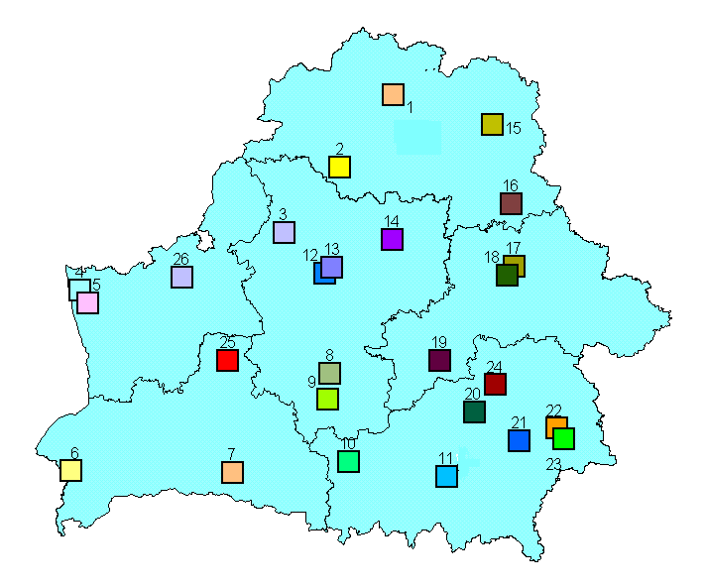  Figure 3. Schema of the MNREP laboratories
1 | Novopolotsk
2 | Dockshicy
3 | Molodechno
4 | Grodno (urban)
5 | Grodno (region - oblast)
6 | Brest
7 | Pinsk
8 | Sluck
9 | Soligorsk
10 | Gytkovichy
11 | Mozyr
12 | Minsk (urban)
13 | Minsk (region – oblast)
14 | Borisov
15 | Vitebsk
16 | Orsha
17 | Mogilev (urban)
18 | Mogilev (region-oblast)
19 | Bobruisk
20 | Svetlogorsk
21 | Rechica
22 | Gomel (urban)
23 | Gomel (region-oblast)
24 | Globin
25 | Baranovishy
26 | Lida

Each monitoring site is used by each level of laboratory. These laboratory systems measure different lists of parameters. Measure parameters are for example: Zn, Cu, Fe, Mn, BOD5, COD, DO, NH4, NO2, NO3, N, P, phenols, chrome (3’, 6’) etc., depending on the type of monitoring site. Some analytical laboratories have modern computers, but there is no universal computer software for data analysis, data storage and data exchange. Intercalibration for surface waters is carried out in the frame of international projects (i.e. TACIS, GEF etc.). Laboratories are accredited by national standards.

Brief description of the laboratories based of examples of the Central Analytical Laboratory (CAL) and Urban Committee Laboratory of Minsk.

Central Analytical Laboratory (CAL): It was established in 1997 with the financial help of World Bank. Mostly American equipments were purchased. It has 7 employees. The CAL has capacity to measure basic parameters, but currently they do only the more expensive analyses for heavy metals, suspended matter, zoobentos, pesticides, poliaromatic substances, volatile compounds. Waste water, surface water, drinking water, sludge and groundwater samples are measured. It is accredited on national level only. This laboratory co-ordinates the national intercalibration exercise including the standard sample preparation for other, lower-level laboratories. A British expert assessed the intercalibration process of Belarus on the basis of ISO 5725 and it was concluded that it meets the requirements. Suspended solids are sampled once a year on 3 monitoring points. Pesticides are measured in soil and water. Data are stored on paper, but a computer software is currently under development/installation to store all laboratory data. The lab has also software for chromatograph analysis, ‘WINLAB 32 ICP for Examine Spectra’. This lab does not calculate the cost of the sample analyses. All 7 employees have high education (university degree).

Urban Committee Laboratory of Minsk: It is accredited nationally. They analyse air, waste water, drinking water, soil samples. They have new equipments: Kanel 130P (Russian), PV1251C-Solar (Belarus - new) and CF-46 (Soviet - old) spectrophotometers, AQUA-OXY ad BODetector (portable, Estonian), Ionometer I-30 (Soviet for pH), AH1 (Russian infrared spectrometer for oil), Tecator Kjeltec System 1026 Distilling Unit (for total N – measured only at 1 station just below Minsk), ovens, MSI-Pro and P20-2 (for air pollution of cars only in emergency situations, Ukrainan), CVET-500M (gas chromatograph, Russian), Simaa 6000 (Perkin Elmer, for heavy metals from air and water). 7 employee work in this lab who have high, university education (3 for water, 3 for air and the head of the Laboratory). This Laboratory is under the supervision of the Ministry of Environment. Therefore, it has no right to analyse private (non-governmental) samples. Lab employees carry out both sampling, sample preparation and analyses.

Groundwater: results of publication about general assessment of ground water pollution allow to describe quality of this water as lightly polluted and in some case polluted.

Drinking water: The Ministry of Health has its own, separate laboratory network for the analyses of drinking water samples.

4. Data processing, information management facilities and reporting
Surface waters:
The main purpose of the data analyses is to publish the “State Water Cadastre” annual report assessing the changes in the environment (surface waters, groundwater).
The Ministry of Natural Resources and Environmental Protection is responsible for updating the database and reporting.
Data are stored in the MNREP and its brunches. Scientific organizations involved in data assessment such as CRICUWR and Belarusian Scientific and Research – Geological Prospecting Institute (BelNIGRI). Special software is available to carry out different assessments:
- Software and data base of the State Water Cadastre incl. all information about water quality (detail data and mean for the year).
- Software for oil pollution modelling: one-dimensional model, but in the cross section calculations the model can be considered as two or three dimensional. It calculates pollution wave (including the thickness of the oil film on the water surface and the concentration) along the major rivers over time, because no cross section information is available for small rivers. The software also used for NO₃ pollution modelling.
- Modelling flood events: it provides forecast for 10 days ahead in relation to precipitation and discharge. The flooded areas can be presented on map.
- Modelling of groundwater pollution: In case of accidental pollution in rivers, this software could calculate the propagation of pollution with the surface water, and the long-term spreading of pollution in the adjacent groundwater bodies.
- Dnepr river basin software calculates and shows average water quality concentrations for a given period for all stations. This software is still under development under the GEF project.
- Transboundary Information Exchange System (TIES) under a TACIS project. It is an internet based system for regular data exchange amongst Belarus, Poland and Ukraine. There are two access levels: public and expert. It has a specific protocol to what, when and how should be uploaded to the server. It contains information on biodiversity (protected areas, species, etc.), legislation, hot-spots and water quality. This webpage is available only in Russian language. After the TACIS project, the CRICUWR will maintain the system.
Availability of data (e.g. freely available, confidential, purchasable): row data are not accessible for free distribution. Results of data assessment are usually published. The database include data from 1989 to 2001.

Groundwater: Belarusian Scientific and Research – Geological Prospecting Institute (BelNIGRI) is response organization for the data collection about quantitative and qualitative parameters of ground waters. Data are available but not accessible.

Drinking water: Information is available in the Ministry of Health Protection.

Reporting

The Ministry of NREP prepared 4 main annual publications:
- State Water Cadastre. Water Resources, Their Usage and Water Quality [1];
- State Water Cadastre. The annual data about quality of surface waters [2];
- Environmental Conditions in the Republic of Belarus. Annual ecological bulletin [5].
- National System of Monitoring Republic of Belarus. Results of observations for **** year. Annual report [6].

The water cadastre in general and other relevant information is summarised in the “Blue Book of Belarus” [3] that is like a dictionary listing all water objects including rivers and lakes.

5. State of water quality of the main rivers in Belarus

In 1999-2001, the majority of rivers in Belarus have been classified as moderately polluted on the basis of data of surface water monitoring conducted by the MNREP. The most polluted river in the country is still Svisloch (second tributary of Dnepr) at a section below sewage disposal of the Minsk urban and industrial region.
Amount the rivers in Belarus, the great stress due to wastewater experiences: the Svisloch River below Minsk, the Neman River below Grodno, the Berezina River below Rechica, Western Dvina River below Novopolotsk, the Pripyat River below Mozyr. These river sites have no water resources sufficient for wastewater dilution to standards of fish farming and public water consumption. In 2000, the annual volume of waste-water generated in Belarus was 1302 million m3. 129 million m3 of them were storages, including (million m3) : raw of insufficiently treated – 25, reference treated – 884, reference-pure – 264 [4].
The mean year concentration on the list of priority parameters of EUROWATERNET requirements for the describing of a state of water quality indicate in excess of the maximum permissible concentration in 1 – 5 times in representative monitoring sites situated below industrial and urban centres of a main cities. This sites accumulate values of anthropogenic pressure of the main
In the figure 4 the distribution of representative monitoring stations situated below industrial and urban centres of a main cities is presented. In table 6 the mean year concentrations on EUROWATERNET-parameters in this monitoring sites for the 1999-2001 are presented. The cells marked with violet color, show excess above the maximum permissible concentration accepted in Belarus for fish farming.

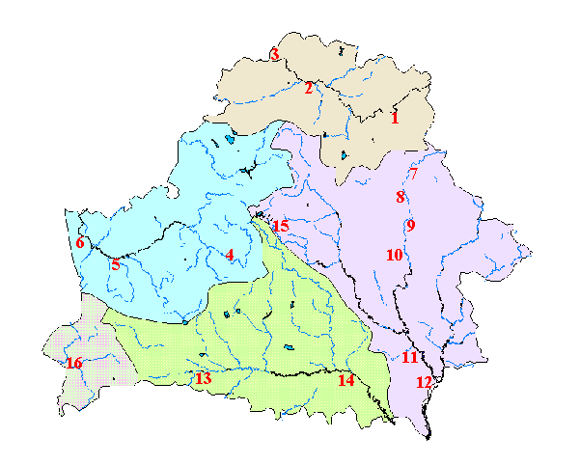

Figure 4. Distribution of representative monitoring stations situated below industrial and urban centres of main cities

Table 6. Mean year concentrations in monitoring sites situated below main cities of Belarus
No | Name of City, River | DO  (mg/l) |  |  | BOD₅  (mg/l) |  |  | NH₄  (mg/l) |  |  | NO₃  (mg/l) |  |  | Phosphates  P mg/l
No | Name of City, River | 1999 | 2000 | 2001 | 1999 | 2000 | 2001 | 1999 | 2000 | 2001 | 1999 | 2000 | 2001 | 1999 | 2000 | 2001
1 | Vitebsk  (1,3 km  downstream)  Western Dvina  River | 10,07 | 9,61 | 9,73 | 2,35 | 5,49 | 2,06 | 0,43 | 0,99 | 0,42 | 0,019 | 0,006 | 0,009 | 0,016 | 0,034 | 0,007
2 | Novopolotsk  (15,5 км  downstream)  Western Dvina  River | 10,41 | 9,18 | 9,91 | 2,18 | 2,83 | 2,16 | 0,47 | 0,85 | 0,50 | 0,020 | 0,016 | 0,011 | 0,015 | 0,013 | 0,005
3 | Verchnedvinsk  (5,5 km  downstream)  Western Dvina  River | 9,46 | 8,13 | 9,21 | 1,79 | 2,32 | 1,94 | 0,39 | 1,04 | 0,49 | 0,020 | 0,011 | 0,007 | 0,018 | 0,018 | 0,012
4 | Stolbcy  (0,6 km  downstream)  Neman River | 10,78 | 9,71 | 9,56 | 3,93 | 2,01 | 2,63 | 0,50 | 0,36 | 0,58 | 0,019 | 0,014 | 0,022 | 0,022 | 0,032 | 0,022
5 | Mosty  (5,3 km  downstream)  Neman River | 10,78 | 10,59 | 10,43 | 3,45 | 2,75 | 3,59 | 0,72 | 0,65 | 0,55 | 0,009 | 0,028 | 0,028 | 0,022 | 0,026 | 0,017
6 | Grodno  (10,6 km  downstream)  Nieman River | 10,67 | 10,51 | 10,55 | 4,47 | 3,05 | 3,68 | 0,66 | 0,76 | 0,73 | 0,018 | 0,023 | 0,036 | 0,027 | 0,024 | 0,022
7 | Orsha  (0,5 km  downstream)  Dnepr River | 10,21 | 7,94 | 8,79 | 2,29 | 1,84 | 1,79 | 0,10 | 0,11 | 0,45 | 0,021 | 0,013 | 0,015 | 0,127 | 0,161 | 0,107
8 | Shklov  (2 km  downstream)  Dnepr River | 11,44 | 8,86 | 9,52 | 2,27 | 2,38 | 1,63 | 0,20 | 0,12 | 0,44 | 0,015 | 0,027 | 0,012 | 0,094 | 0,079 | 0,152
9 | Mogilev  (25,6 km  downstream)  Dnepr River | 11,14 | 8,56 | 9,56 | 2,47 | 1,63 | 2,15 | 0,25 | 0,16 | 0,50 | 0,022 | 0,027 | 0,014 | 0,092 | 0,086 | 0,164
10 | Bychov  (2 km  downstream)  Dnepr River | 11,34 | 9,14 | 9,62 | 2,44 | 1,99 | 2,12 | 0,23 | 0,14 | 0,51 | 0,016 | 0,028 | 0,015 | 0,105 | 0,122 | 0,138
11 | Rechica  (5,6 km  upstream)  Dnepr River | 9,96 | 10,81 | 9,42 | 4,15 | 3,70 | 2,09 | 2,53 | 2,01 | 1,14 | 0,020 | 0,011 | 0,027 | 0,830 | 1,130 | 0,078
12 | Loyev  (8,5 km  downstream)  Dnepr River | 8,89 | 10,89 | 9,74 | 2,33 | 2,06 | 1,76 | 2,34 | 2,03 | 0,97 | 0,041 | 0,018 | 0,016 | 0,025 | 0,060 | 0,068
13 | Pinsk  (3,5 km  downstream)  Pripyat River | 7,89 | 7,66 | 8,08 | 2,64 | 2,36 | 2,38 | 1,72 | 3,39 | 0,96 | 0,024 | 0,037 | 0,021 | 0,216 | 0,368 | 0,071
14 | Mozyr  (1,0 km  downstream)  Pripyat River | 7,90 | 12,90 | 9,94 | 2,12 | 2,64 | 2,88 | 0,66 | 0,68 | 0,58 | 0,012 | 0,013 | 0,044 | 0,040 | 0,049 | 0,025
15 | Minsk  (10 km  downstream)  Svisloch River  (2-nd tributary of  Dnepr) | 7,49 | 6,66 | 6,51 | 6,30 | 5,70 | 6,09 | 2,99 | 1,88 | 5,07 | 0,168 | 0,087 | 0,154 | 0,393 | 0,427 | 0,501
16 | Brest  (in the City)  Muchavec River  (1-nd tributary of Dnepr) | 7,84 | 7,27 | 8,71 | 2,16 | 3,04 | 2,93 | 0,56 | 0,67 | 0,58 | 0,013 | 0,036 | 0,031 | 0,035 | 0,033 | 0,012

6. About EUROWATERNET exercise in Belarus:

Rivers:

All information related to all aspects of the 129 river monitoring stations (physical characteristics, quality, pressure) are prepared and attached to this report. Unfortunately, the water quality sites have no precise names and coordinates in most of the cases. Therefore, names, coordinates and river kilometres were assigned to these stations in relation to hydrological monitoring sites. (70 hydrological monitoring sites in Belarus that measure water level and discharge only). Coordinates of 129 hydro chemical stations have been specified in relation to hydrological monitoring sites. There are several parameters required by EWN Basic that are not measured by the Belarus National Monitoring Network: i.e.: Chl-a, COD, Organic N, TIN, TOC, and TON. However, there are other parameters measured that are not required by EWN Basic (a total to 57 parameters depending on the monitoring sites).
Probably there will be no selected reference sites in Belarus because the monitoring network was set up to detect the effect of pollution sources and not to assess the background situations of waters.

Lakes:

All information related to all aspects of the 25 lake monitoring stations (physical characteristics, quality, pressure) are prepared and attached to this report. Passes in tables mean that this lake is not natural and it has not catchments aria.
Not all parameters are measured, which are required by EUROWATERNET. Not measured parameters are: TON, TOC, transparency, Chl-a, alkalinity. There is a need for training and for some portable probes.

Groundwater:

Groundwater information is confidential in Belarus (as in Russia and Ukraine). There is no proper legislation how to handle groundwater information internationally.
Groundwater information collection in Belarus is currently not possible, because of the law on the protection of groundwater information.
However a few part of information was prepared about 13 groundwater monitoring stations (physical characteristics) and also attached to this report. This information was prepared for the Summit of the Minister of Natural Resources which was held in Kiev in May, 2003.

Proposals:

The next directions of activities:
- revision of the Surface Water National Monitoring Network;
- strenghtenin, developing and implementation of the byoindicator methods;
- to analyse biological samples and the upgrade computer software of the laboratories and some of the measuring devices could be improved;
- to develop an transboundary monitoring systems with neighboarding countries;
- modernixation of the data collection, data storage and data exchange systems;
- to develop new projects to complete all tasks related to EUROWATERNET recommendation for the optimisation of the national monitoring network and assessment of water quality status on representative list of indicators and assessment of anthropogenic pressure;
- develoing of the modern data base with use of GIS – technologies;
- developing of the river and lake contol station system.

References

- State Water Cadastre. Water Resources, Their Usage and Water Quality (for 1999,2000,2001), Minsk, 2000,2001,2002
- State Water Cadastre. The annual data about quality of surface waters (for 1990-2000.
- Blue Book of Belarus (Bodies of Water of Belarus). Minsk, 1994, 415 p.
- State of Environment in the Republic of Belarus. National Report. Minsk. 2002.
- Environmental Conditions in the Republic of Belarus. Annual ecological bulleten. Minsk. 2002
- National System of Monitoring Republic of Belarus. Results of observations for **** year. Annual report. Minsk 2002.

Explanatory note

To the Ukrainian part of the project

« The profound studying of a network of monitoring of surface waters in the new independent countries »

The national expert from Ukraine Varlamov Е.

Work on studying and the analysis of a network of monitoring of surface waters in Ukraine according to requirements and criteria of network EUROWATERNET conduct according to the task.

The review of the general condition of water objects and networks of supervision over surface waters in territory of Ukraine.
The territory of Ukraine (603,7 t.sq.км) borrows a southern part of East European plain and differs, basically, quiet character of a surface. Only in a southwest part and to Crimea there are mountains which height seldom exceeds 2000 m. The greatest extent of territory from the north on the south of 800 km, from the west to the east of 1300 km.
In territory of Ukraine pools of the rivers of the Western Bug, Danube, Dnestr, Southern Bug, average and bottom current of Dnepr, Severski Donets, Priazovye and the rivers of Crimea are located. Within the limits of Ukraine 4011 rivers in length more than 10 km. are totaled over 70 thousand rivers and ручьев in the general extent 248 t.км, from which. From the general number of the rivers in length more than 10 km. of 55 % have the area of a reservoir up to 100 sq.км. On the rivers with the areas of pools from 100 up to 500 sq.км it is necessary about 35 %, from 500 up to 1000 sq.км-4,9 % and more than 1000 sq.км-5,2 %. In Ukraine it is taken into account over 26 thousand lakes, ponds and water basins by the general area 11203 sq.км.
Now in territory of Ukraine there is ramified enough network of items of supervision over a condition of the environmental natural environment. Supervision over a condition of superficial waters are carried out, according to tasks in view, a number of the ministries and departments such as, the Ministry for ecology and natural resources (in structure of which supervision conduct: the State hydrometeorological service, the State ecological inspection, State geological service), the State committee of a water management, Ministry of Health, the Ministry for extreme situations, the State committee of housing and communal services.
The most organized networks of stations (points) of supervision are in structure of State hydrometeorological service (Hydromet), the State committee of water management (Gosvodhoz), State ecological inspection (SEI), the State geological service.
The network of supervision SEI totals over 500 stations of supervision over superficial waters and carries out the control over 40 and more parameters with frequency of sampling 4-12, however she is not included in the report since for present time inventory of this network is not lead, stations have no the general coding, given supervision collect at a regional (regional) level and the incorporated databank (electronic or printed) about quality indicators are not present. Carrying out of such work (carrying out of inventory and creation of a data base) demands the certain means which now are not present.
State the geological service carries out supervision over a condition of bowels of the ground, including underground sources of water and has a network of supervision, however access to this information is limited and demands the special sanction, the information within the framework of the offered tables in the generalized kind in the open publication practically is not present.
Therefore at the given stage this material to prepare to the expert it is not obviously possible.
Ministry of Health carries out the periodic control of superficial waters over bacteriological parameters in zones of rest and a stable network has no.

Results of inventory of a network of monitoring of surface waters in the country of the most corresponding to criteria of network EUROWATERNET.
SEI the Ministry for ecology and natural resources has advanced enough network and analytical laboratories provided with more modern and qualitative analytical equipment in comparison with laboratories Hydromet and Gosvodhoz and which in the subsequent, under condition of carrying out of inventory, and formations of a data base of accumulation of results of supervision can enter codification structure of a uniform network of supervision and to give the qualitative information.
Are most organized now and can be considered at the first stage on conformity to criteria of network EUROWATERNET of a network of supervision over surface waters of Ukraine in systems Hydromet and Gosvodhoz which have corresponding codification and the centralized accumulation of the information for the long-term period. Within the framework of work the inventory information on these networks, as base at present is prepared and submitted.
. The general data on the considered networks are resulted in tables RIVERS, LAKES - PRESSURES, TRANSITIONAL, COASTAL AND MARINE.
Supervision over a hydrological mode and chemical compound of surface waters of the rivers are carried out at 384 stations (items), from them 192 - Hydromet and 192 - Gosvodhoz. The hydrological mode and a chemical compound of the seas is observed at 121 stations (posts) Hydromet. On lakes and water basins of supervision are conducted at 130 stations from them 43 - and 87 - Gosvodhoz. A divergence in the data submitted in a progress report and final are caused by that during work the accessory of stations and some stations located on river water basins have been specified, are transferred in the category lake.
All stations work on standard for the department to programs of realization of supervision.
Periodicity of supervision (sampling) at stations is various and can change from 2 up to 12 times one year.
During the considered period of time at separate stations, for example in Berdyansk a gulf, supervision were carried out not on a regular basis and even with break in some years.
Under the list of controllable parameters there are divergences between offered by network EUROWATERNET and national programs. National programs are much wider, but during too time do not provide supervision of some parameters of network EUROWATERNET.
So in the rivers and lakes under program Hydromet about 40 parameters, under program Gosvodhoz up to 30 are observed, under program EUROWATERNET it is required - 17, in the seas Hydromet observes - 20 parameters,under program EUROWATERNET is required - 16.
The basic parameters of programs of supervision of surface waters of the rivers and reservoirs in Ukraine such - temperature, the hydrogen parameter, the dissolved oxygen, % of saturation by oxygen, BOD-5, the weighed substances, chromaticity, a transparency, dioksid carbon, rigidity, calcium, magnesium, hydrocarbonates, sulfates, chlorides, sodium, kaliy, phosphates, phosphorus the general, a mineralization, nitrogen group, phenols, mineral oil, , Cr six-valent, iron the general, copper, zinc, hydrogen sulphide, nitrogen the general, Caesium - 137, Strontium - 90 and others, at various stations can be the observable parameters.
From tables of the appendix it is visible, that frequency of selection in various different and not always meets the requirements, that is caused by the certain economic and technical difficulties in the organization of process of selection and delivery of tests.
A number of the data for tables Physical Characteristics and Pressures, in a kind of their absence in the generalized kind is received by settlement way with use GIS-system and specially developed program, and also from popular references. In this connection the data on mid-annual temperatures, salinity, depths in some cases are resulted average and can have identical characteristic value for a lot of sea stations of supervision, however it answers the generalized characteristic of stations.
The generalized data on stations of the control of river waters are resulted in table 1. In photos 1 and 2 are submitted transboundary riv. Ubort and Stviga.
The generalized data on stations of the control of waters of lakes and water basins are resulted in table 2. In photos 3 and 4 are submitted lake Svitjaz in the Kiev water basin.
The generalized data on stations of the control of waters of the seas are resulted in table 3.
Table 1.

The country | The area  (Thousand sq.km.) | Total number stations on the rivers | Total number rivers in length over 10 km. |  | Control stations | Representative stations | Stations on the largest rivers | Stations of monitoring transboundary loadings
Ukraine | 603,7 | 384 | 4011 |  | 121 | 196 | 98 | 80
The largest rivers | Catcment area sq.km. | Stations on the largest rivers | Total number rivers in the basin | Total number stations on the rivers of the basin
The western Bug | 13364,1 | 6 | 6 | 13 | 6 | 9 | 6 | 7
Danube | 46445,3 | 8 | 13 | 44 | 3 | 7 | 8 | 11
Tisa | 22203,3 | 12 | 11 | 28 | 6 | 18 | 12 | 19
Dnestr | 73955,7 | 17 | 20 | 31 | 8 | 24 | 17 | 4
Southern Bug | 52688,4 | 13 | 18 | 31 | 5 | 17 | 13
Pripyat (inflow of Dnepr) | 109011 | 4 | 12 | 38 | 6 | 20 | 4 | 7
Desna (inflow of Dnepr) | 76083,6 | 9 | 12 | 26 | 14 | 7 | 9 | 6
Dnepr | 549143 | 8 | 47 | 133 | 12 | 32 | 8 | 6
Severskiy  Donets | 73589 |  | 15 | 54 | 26 | 24 | 21 | 6

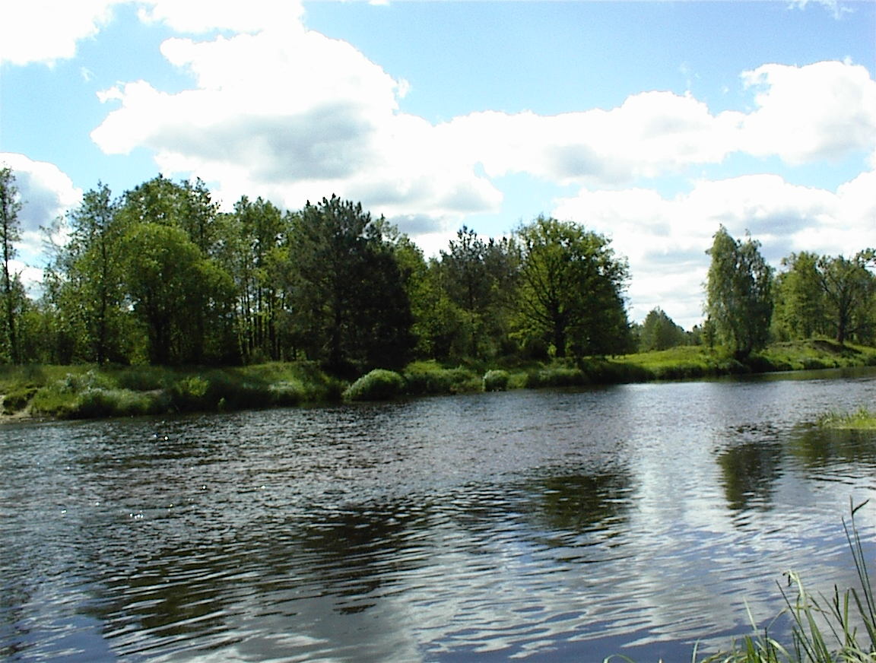

Photo 1
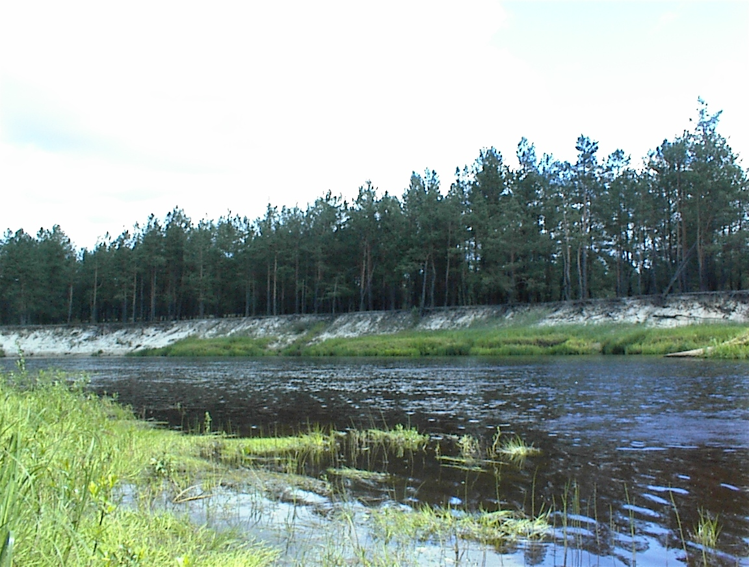

Photo 2

Table 2.

The country | The area  (Thousand sq.km.) | Total number stations on the lakes | Total number contolled lakes and reservour | Small lakes and reservour | Medium lakes and reservour | Largelakes and reservour | Very  Large lakes and reservour
Ukraine | 603,7 | 130 | 62 | 14 | 22 | 14 | 10
Number stations on the lakes
 |  | 130 |  | 14 | 25 | 20 | 71

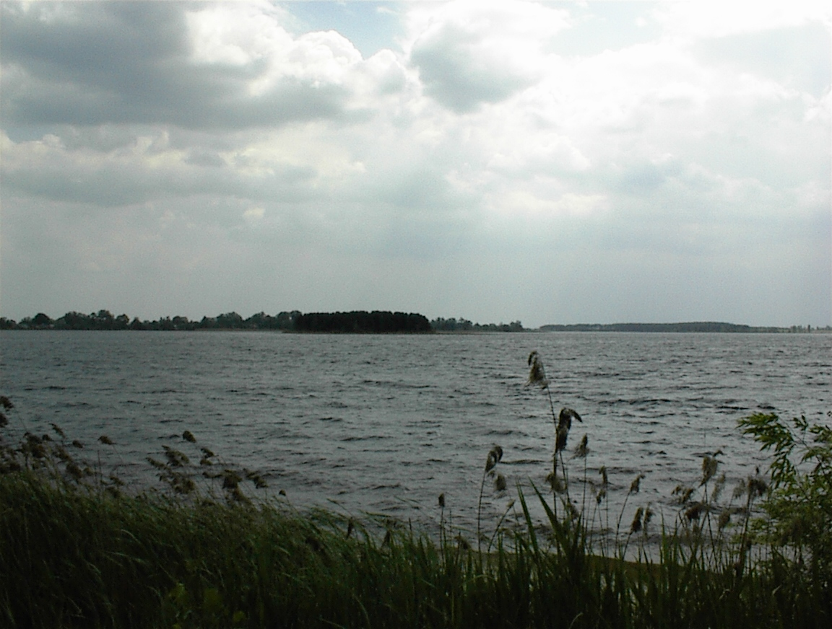
Photo 3
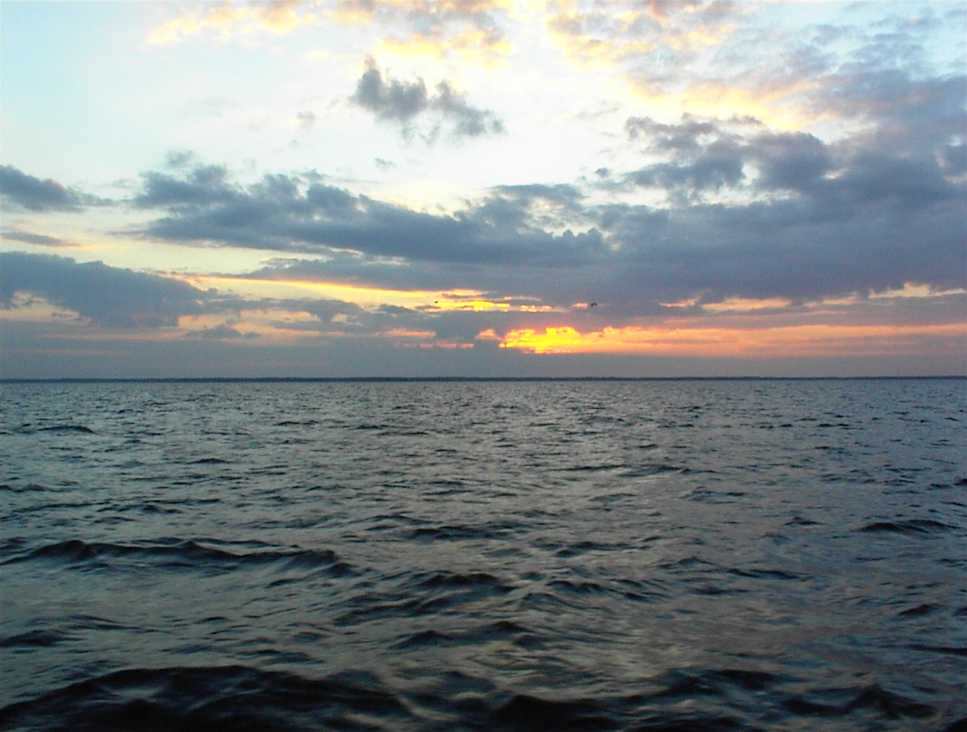
Photo 4
Table 3

The country | The area  (Thousand sq.km.) | Total number stations on the seas | C | M | T | B | R
Ukraine | 603,7 | 121 | 35 | 37 | 49 | - | 121
Black  sea |  | 87 | 35 | 26 | 26 | - | 87
Azov Sea |  | 34 |  | 11 | 23 | - | 34

Criteria of types of stations (B, R, L) it is resulted according to their accepted value in each concrete department (Hydromet, Gosvodhoz).
The analysis of the considered network of supervision has shown, that stations of supervision of to the full meeting the requirements all criteria EUROWATERNET now are not present. It is caused by that networks were created when the basic requirement was maintenance with the information on maintenance of industrial potential and the population water resources, instead of the control of a natural condition. Therefore posts of supervision (station) settled down near to industrial units and an industrial water-fence.
Now stations completely meeting the requirements showed to control stations are not present.
From a real-life network of stations approximately meeting the requirements control it is possible to define units and only after more detailed studying an ecological situation around of them and their technical opportunity.
All stations named TRANSBOUNDARY correspond to carried out functions to this requirement and the location.
As a whole non-uniform distribution of stations on territories of the state, overlapping in one point of stations of various departments and absence of stations on significant spaces is observed.
It is in part caused by functions assigned on various departments. Hydromet observes hydrological parameters and background hydrochemical parameters, Gosvodhoz - hydrochemical parameters under requirements to places of water-fences, SEI - qualitative structure of waters in posts and places of dump of sewage. In the subsequent, under condition of creation of the incorporated databank at management of the Ministry for ecology and natural resources, reception of the generalized qualitative information is possible.
It is possible to count the most important stations located in (in territory of Ukraine) the rivers of Dnepr, Desna, Danube, Dnestr, Pripyat, Severski Donets and in the ostuary of the rivers Dnepr, Danube, Dnestr, Pripyat, Severski Donets, Southern Bug. In photos 5 and 6 it is submitted a part riv. Dnepr in area Kherson.

As a whole in view of requirements and conditions of networks EUROWATERNET it is necessary to lead work on optimization of a network and by its results to reconsider the approach to arrangement of stations and distribution of functions of the control over various departments and to expand a network of stations to necessary quantity.

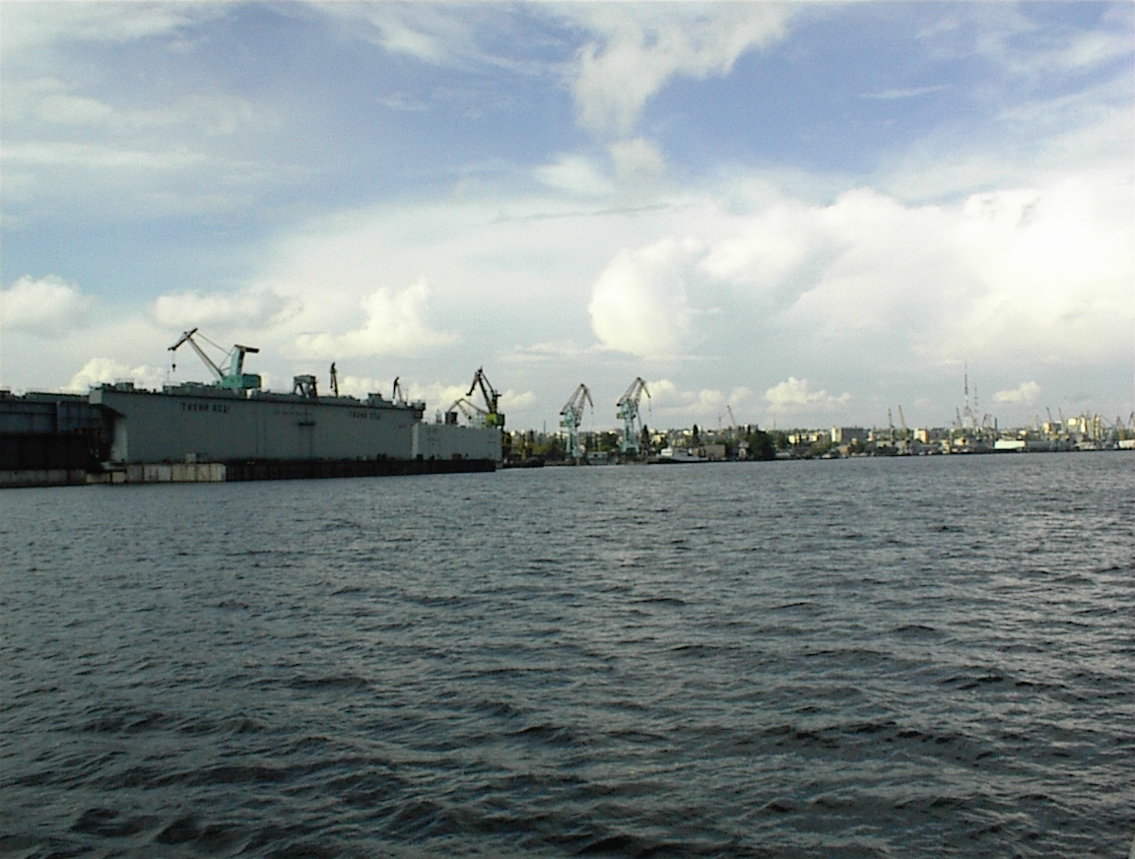
Photo 5
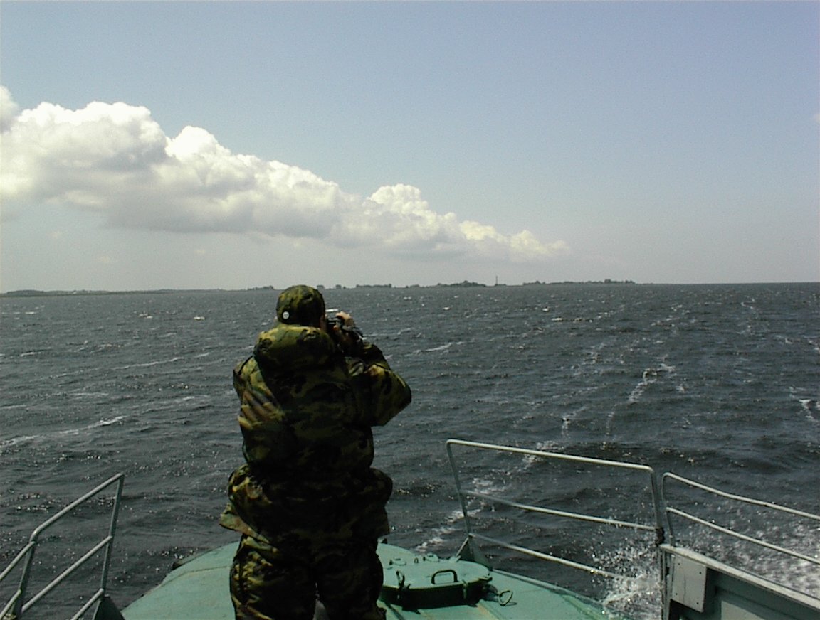
Photo 6

One of the most important conditions of reception of the qualitative information on a condition of an environment and including surface waters adequate to the international standards is corresponding technical maintenance of a network of supervision and analytical laboratories conducting researches and providing the initial information. In a photo 7 one of regional laboratories is shown.
The considered network of supervision of superficial waters and analytical laboratories of Ukraine providing carrying out of analytical researches of tests selected on stations (items) of supervision basically is equipped with the equipment for carrying out of necessary researches, but frequently this equipment morally and is physically obsolete and cannot provide required with the European quality standards and accuracy.
There are problems with selection and delivery of tests, sometimes on this procedure there leave some days. In photos 8 and 9 it is shown process of sampling on riv. Pripyat,

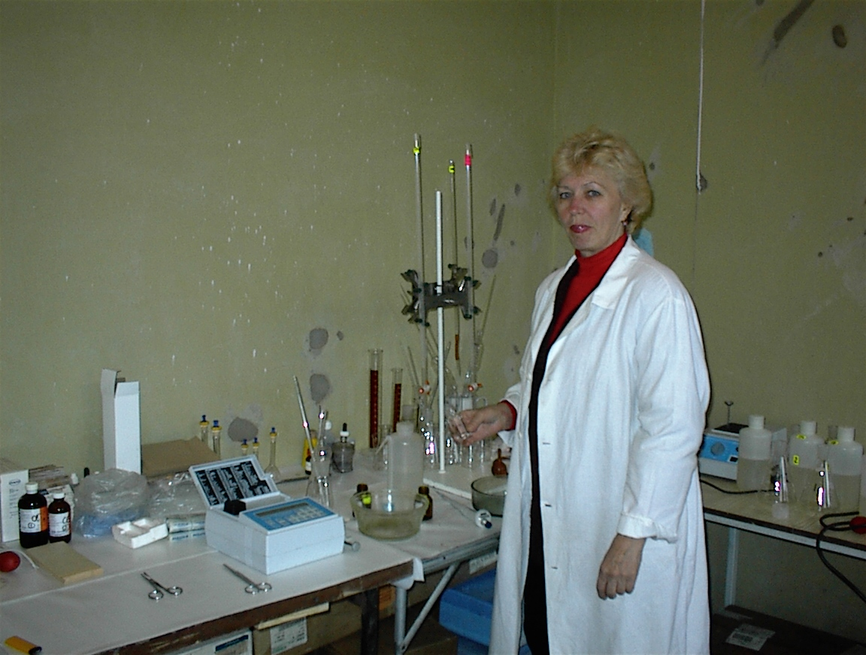
Photo 7

For selection and deliveries of tests to a place of carrying out of researches are used ships, motor transport, and sometimes and post transfers. Taking into account the significant territory size, distances of stations from analytical laboratories can be hundreds kilometers and the absence of necessary transport makes the basic complexity even greater.
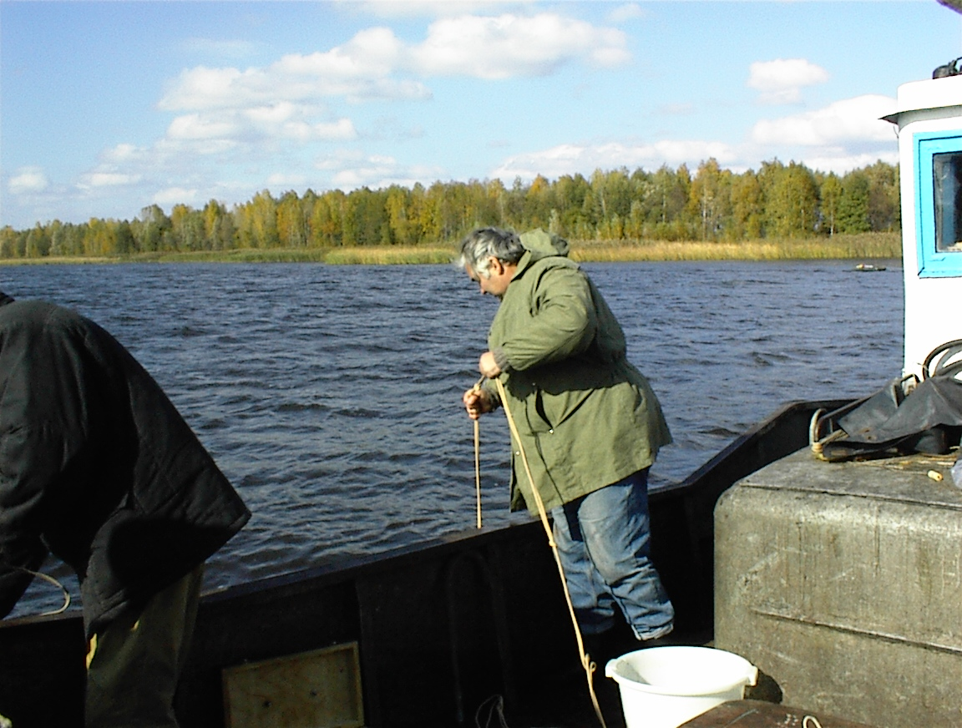
Photo 8
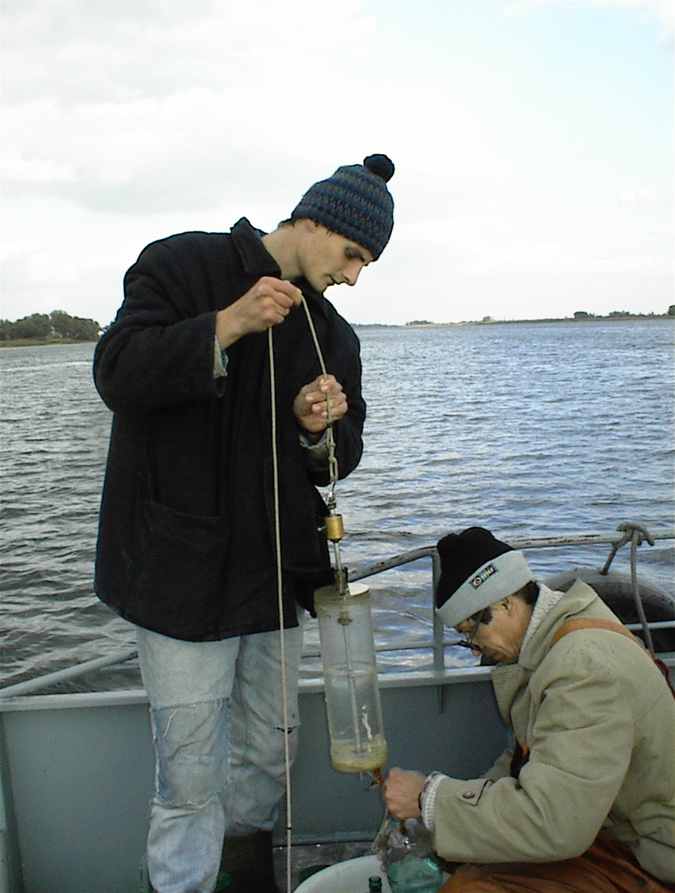
Photo 9

Except for the data resulted in tables, in Ukraine « the National report on a condition of the environmental natural environment » annually prepares and issued (National report on the state of environment in Ukraine), responsible for gathering and preparation of materials is Ministry for ecology and natural resources . Hydromet form the collection on basins of the rivers “ the Long-term data on a mode and resources of surface waters of a land », Gosstat Ukraine form the year-book of the statistical data « Resources of the Ukraine ”, his structure has a section for protection and rational use of water resources (Water resources protection and use) . For the available information for the interested establishments by inquiry of department prepare and transfer on a commercial basis. The easy approach to such information is not present. Are published as materials by results of the international expeditions and projects in which are resulted qualitative characteristics of researched water objects, for example the monography « the Ecological condition transboundary sites of the rivers of basin of Dnepr in territory of Ukraine » prepared at support of the grant submitted by the International center of researches and development, Ottawa (Canada) and at financial support of the Program of development of the United Nations Organization..
Estimation of the monitoring system of quality of the data received as a result of monitoring
The monitoring system of quality of the data received in laboratories of the Ministry of ecology and natural resources of Ukraine (Hydromet) at realization of monitoring of surface waters, is based on positions of a lot of normative and methodical documents.
The general approach to creation of the monitoring system provides the following measures:
- Normalization of allowable errors of definition of structure and properties;
- External quality control of measurements of structure and properties;
- Intralaboratory quality control of definition of structure.
The monitoring system of quality of the data which positions are regulated by working normative documents, can provide the multilateral and full control of received results.
The base metrological service of the Ministry and services of Gosstandart of Ukraine constantly conduct work on certification of new and already used techniques, take root into work and techniques ДСТУ ISO. Therefore the majority monitoring definitions are carried out by the standardized techniques having specifications of errors of definitions.
All laboratories which are carrying out monitoring of waters are accredited and on a regular basis checked on conformity to required conditions of performance of definitions, including presence and state checking of means of measurements, security by techniques, the state standard samples
for graduation of devices, presence and observance of terms of application of working reactants, conformity of conditions on workplaces and qualifications of the personnel. Ministry and his services on a regular basis carries out interlaboratory experiments with the purpose of revealing tendencies of an output of analytical process in laboratories from under the control.
Gosvodhoz has the uniform monitoring system of quality of measurements.
As a rule, internal quality control of measurements will consist from:
- The control of correctness of application of techniques of performance of measurements;
- Operative quality control of measurements;
- Quality control of measurements in case of replacement of the equipment, reactants.
At the operative control it is checked:
- Convergence of results of measurements;
- Reproducibility of results of measurements;
- Stability characteristics.
At detection of excess even one specification of the control, carrying out of measurements by such technique the reasons of infringement of a course of the analysis stop, found out, necessary measures then the operative control is repeatedly carried out take.

Conclusions
For maintenance of requirements showed to networks EUROWATERNET by quantity of stations participating in a network, it is necessary for structure and quality of the information received and transmitted to a network to lead optimization of existing networks and to develop recommendations on its improvement and, if necessary, creation of new stations (especially control).
It is necessary to lead inventory of technical and methodical maintenance of an existing network of supervision, to create databanks of equipment and on the basis of the analysis of the received information to develop the program of optimization of technical and methodical maintenance in view of requirements showed to network EUROWATERNET, with minimization of expenses and the maximal feedback.
As skilled inclusion in network EUROWATERNET it is possible to offer stations located in ostuary the rivers Dneprs, Danube, Pripyat and on transboundary sites of these rivers.

Report of the Local Expert
of the Republic of Moldova for the project
“In-depth study of the monitoring situation in specific areas (inland surface water) of the New Independent States”

Local experts:
Responsible: Dr. Maria Sandu
Expert Associate: Dr. Vladimir Brega

Chisinau 2003, 24 August

Preface

1. Introduction, data and information sources
1.1 Sources of data and information
1.2 Presentation of results
2. Surface water quality monitoring
3. Summary descriptions of surface water monitoring activities in Rep Moldova and international monitoring programs to which Moldova takes part.
4. Monitoring programs
4.1 Chemical and physical assessment of river water quality
4.2 Biological assessment of river quality
4.3 Monitoring of lakes
4.4 Monitoring of surface water acidification
4.6 Organic micropollution, radioactivity and microbiology

References
Appendix I: Tables summarizing the monitoring programmes of Moldova
The Republic of Moldova is situated in the Southeastern part of Europe. In the North, East and South it borders with Ukraine, in the West – with Romania. The surface of the country is 33.8 thousand square kilometers and its population is 4.3 million inhabitants. The territory of the country stretches from North to South on a distance of 350 kilometers and from West to East – 150 kilometers.
The mean annual temperature ranges from 8.2 to 10.2 ºC and precipitation is 450-620 mm per year. The Codry region, the central part of the country is most abundant in precipitation. Waters and streams of the country relate to the Black Sea basin. The main rivers are Dniester and Prut. On a small stretch, in the South, there is an outlet to the Danube river.
Due to the relief and pedoclimatic elements, two types of vegetation prevail: forest and steppe. The relief is represented by plains and elevations, the latter being concentrated mainly in the central part of the country. The altitudes vary between 5 in the district of Guirgulesti and 429 meters near the district of Balanesti.
The forest cover degree is 9.6%.
Main natural areas: Codru (Străşeni) 51 km²; Plaiul Fagului (Undheni) 56,42 km²; Iagorlîc (Dubăsari) 8,74 km²; Lower Prut (Vulcăneşti) 16,9 km²; Pădurea Domnească (Glodeni) 6,032 km².
The deciduous forests are represented by oak, ash, hornbeam and elm. The steppe vegetation has maintained only in the form of isolated fragmented spots.

MONITORING OF SURFACE WATER AND ACIDIFICATION OF RIVER AND LAKES IN THE REPUBLIC OF MOLDOVA
All Moldovan rivers are part of the Black Sea basin and constitute 4 flowing basins, of which, two largest - basins of Dnestr and Prut rivers. There are 3621 large and small rivers, permanent and temporary streams, of which only 9 are longer than 100 km.
There are 57 lakes with a total surface of 62,2 km², with a majority of small lakes of less than 0,2 km2. Besides natural lakes, there are about 3500 ponds and reservoirs, with a total volume of 1,8 km3 and a total surface area of 333 km² (only 10 of all basins have a volume of above 1 million m³). the main lakes In R. Moldova are small lakes of 1,16 – 6,26 km²: Fontan (1,16); Roşu (1,6); Rotunda (2,08); Dracele (2,65); Bîc (3,62); Beleu (6,26). The ecologic monitoring of these lakes is not conducted. According to table 2, a regular ecological monitoring is carried out for the following water reservoirs: Costeşti, Dubăsari, Ghidighici şi Dnestrovsc serviced by the Hydrometeo. Monitoring of water pollution in Moldova is revealed in the chart and is a component of Ecological Monitoring integration System (see annex). Hydro-Meteorological Service Laboratory is mainly responsible to environmental analyses.
Though Republic of Moldova has not taken part in Trends in inter-comparisons the International Co-operative Programme on Assessment and Monitoring of Acidification in Rivers and Lakes, experimental data were obtained in different scientific centers by methods in compliance with international standards. At the same time, the Hydro-Meteorological Service Laboratory participated in one intercomparisons trend - Danube Pollution Reduction Programme.
Monitoring of surface water pollution in Moldova is being performed along 12 rivers (including Prut, Dnestr, Danube) and 5 reservoirs.
Operating through only 44 stations on rivers, and 7 on lakes and reservoirs, both Laboratory of Hidrometeo Service and the National Institute of Ecology perform a constant monitoring that includes over 40 hydro-chemical and 5 hydro biological indexes (see tabl. 1). The analyses and researches have been carrying out since 1965. However, our materials with respect to acidification of rivers and reservoirs are not systematized and the analyses were focused on assessment of surface water quality.
Draughts having registered during the last ten years lead to a partial drying-up of small in-land rivers and lakes. Furthermore, both high density of population and intensive agriculture lead to higher anthropogenic loads on water streams and pools that make difficult the data processing with respect to acidification of rivers and reservoirs.

BREIF DATA ON MONITORING OF SURFACE WATER IN REPUBLIC OF MOLDOVA

Rivers
Number of stations in Network of the Department of Hydrometeorology Centre of the Ministry of Ecology, Construction and Territorial Development of the Republic of Moldova) 41
Number of stations in Network of National Institute of Ecology of the Ministry of Ecology, Construction and Territorial Development of the Republic of Moldova (At the same time, the Institute has partly conducted analyses at 41 stations of Hydrometeorology Center for 1990-2003) 3
Number of stations in Network (e.g. Ministry of Health) -
TOTAL NUMBER OF STATIONS 44

Number of stations where information has been collected on:
Physical Characterization 44
Quality 44
Pressure Information 44

Lakes
Total number of stations 7
Number of stations where information has been collected on:
Physical Characteristics 7
Quality 7
Pressure Information X

Ground waters
Total number of stations X
In 1990-2001, monitoring of groundwaters was not conducted. Responsible for water quality has been “Acva Proiect”, a state organization which has carried out the quality assessment at the phase when the certain new establishments are put in operations and on exceptional basis.
Number of stations where information has been collected on:
Physical Characterisation X
Quality X
Pressure Information X

Transitional, Coastal and Marine
Total number of stations -

Routine surveillance of quantitative and qualitative characteristics in a water
- Sampling window (annual or spring, summer etc)
Sampling window is from 4 (Winter, Spring, Summer, Autumn) to 12 time per (monthly sampling)
- Matrices sampled (e.g. water, biota, sediment)
Routine Monitoring includes sampling in water (hydrochemical parameters) and hydrobiological parameters (one time per year and in some cases – one time per five years)

Data storage system (e.g. paper, Magnetic bands)
In 1970-2003 the database is stored on paper and magnetic bands; presently information is made available (transferred) on electronic basis (MS Word and Access)

PC incl. some special Software
- Data analysis
Calculation of average values, dynamic of changes and preparation to publishing annual reports “State Water Cadastre”
- Quality practices in the laboratory and data processing
All kind of control : analytical, chemical, intercalibration (in frame of international projects : Trends in inter-comparisons the International Co-operative Programme on Assessment and Monitoring of Acidification in Rivers and Lakes1999-,2001 ; 1)

On the inventory of existing databases and data flows
- Name of database
“State Water Cadastre” prepared by Hydrometeorology Centre with annual data from priority monitoring stations; “Annual National Environmental reports” prepared by National Institute of Ecology either annually or with intervals of two to five years including various statements on national assessment of the environmental state of surface waters. The reports are generally based on the information produced by the national monitoring programmes supplemented with additional information from more specific investigations.

- Organization responsible for database plus contact name and details:
Department on Hydrometeorology Centre “Hydrometeo”, (Director - V.Cazacu, Str. Grenoble 193, MD-2008 Chişinău, tel. +773533)

Central Research Institute of Complex Use of Water Resources:
- National Institute of Ecology
- Institute of Zoology of the Academy of Science
- Institute of Chemistry of the Academy of Science of RM
- Center of Preventive Sanitary Medicine

- Availability of data (e.g. freely available, confidential, purchasable).
In 1970-1998, database is available on transparent basis; presently, 1998-2000- data are not for free distribution, results of data assessment are partly published
- Regions covered by database
All territory of Moldova is covered by database
- Number of years of data (plus any gaps) 1970 -2003. But, the database included in tables of this report includes data from 1990 to 2001
- Description of the process whereby data is transferred from local to central locations
Practically for indexes as physical, pH, transparency and conductibility, the analyses of samples have been made al local stations and the results have been submitted by phone; Chemical analyses for indexes of nutrients, acidification, heavy metals, organic carbon and microbiology have been conducted in central laboratory and samples have been submitted to the central laboratory. Analyses of waters have been conducted according to former SU standards (GOST).

Sampling frequency
The sampling frequency differs substantially depending on the purpose of the monitoring programme and the variables to be measured. Frequent samples are generally taken when the purpose of a monitoring programme is to observe trends, while programmes and surveys with the purpose of assessing the general state of many waterbodies generally are based on low sampling frequency.
In 1990-2001, for A-group (see note), analyses are carried out 4 to 12 time per year both by Hydrometeo and above-mentioned research institutes but B-group as well as conductibility, total organic carbon and chlorophyll by the research institutes only. As the monitoring program provides the 1 time per month frequency of measurement for majority indexes, but the program is shortened to 4 analyses per year due to financial shortages.

Note: The water quality variables can be grouped into the following broad categories:
A:
- Basic variables (eg. water temperature, pH, conductivity, dissolved oxygen, and discharge) used for a general characterization of water quality.
- Suspended particulate matter (eg. suspended solids, turbidity and organic matter (TOC, BOD and COD)).
- Organic pollution indicators (eg. dissolved oxygen, Biochemical Oxygen Demand (BOD), Chemical Oxygen Demand (COD), ammonium).
- Indicators of eutrophication: nutrients (eg. nitrogen and phosphorus), and various biological effect variables (eg.chlorophyll a, Secchi disc transparency, phytoplankton, zoobenthos).
- Indicators of acidification (eg. pH, alkalinity, conductivity, sulphate, nitrateg)
- Specific major ions (eg. chloride, sulphate, sodium, potassium, calcium and magnesium) as essential factors in determining the suitability of water for most uses (eg. public water supply, livestock watering and crop irrigation)
- Metals (eg. cadmium, mercury, copper and zinc)
- Organic micropollutants such as pesticides and the numerous chemical substances used in industrial processes (eg. PCB,HCH, PAH).
B
- Indicators of radioactivity (eg. total alpha and beta activity, 137Cs, 90Sr)
- Microbiological indicator organism (eg. total coliforms, faecal coliforms and faecal streptococci bacteria)
- Biological indicators of the environmental state of the ecosystem (eg. phytoplankton, zooplankton, zoobenthos, fish, macrophytes and birds and animals related to surface waters).

Standard Excel-spreadsheets are attached hereto.

According to bilateral research agreement between the Republic of Moldova and Romania and in the conformity with the Bucharest Declaration “Relating to the analysis monitoring in the Prut River Basin”, Hydrometeo carries out the surveillance on water quality of the Prut River in 3 points mutually established with Water Agency, Iasi Branch by 39 indexes. Under the Convention on cooperation for protecting and sustainable using the Danube River, the monitoring of water quality of Danube River is conducted within the Republic of Moldova.
A full analysis of 15-20-aged laboratory equipment shall be provided in final report.

Exclusive results and proposals

- Within the Project, a focus was placed on the need for a fair assessment of coordinates of monitoring stations with a 5” precision (current information from database of Hydrometeo was of 0.5-5 minutes).
- Preventive analysis of monitoring data shows that Republic of Moldova needs an optimization of stations.
- There is a need for the monitoring of surface water not by the principle of quality and dynamics of pollution but in the conformity with target-programs (acidification, eutrophication etc.) simultaneously with the widening of indexes range.

Annex 5 Final Workshop Report

In-depth study of the monitoring situation in specified areas (inland surface water) of the Eastern Europe, Caucasus and Central Asia Countries

Summary Report on Workshop 2 – Review and Report

20 October – 22 October 2003

Conference Hall of Hotel Platánus, Budapest

Purpose of meeting:
- To present the preliminary conclusions from the review of monitoring stations identified by National Experts for inclusion in EUROWATERNET.
- To review the stations selected by ETC-Water Experts;
- To prepare ‘gap’ analysis between the information provided and the information needed for a basic EUROWATERNET, leading to agreed additional data to be delivered.
- To identify country needs to enable EUROWATERNET to be implemented;

The emphasis on this meeting was clearly as a ‘working’ workshop. All participants were required to contribute and present status reports on their country.

Participants:
A list of the participants is presented as Annex 1. 11 out of the 12 Countries were able to attend this workshop; unfortunately the Expert from Tajikistan (Tajiniso Nasyrova) was unable to obtain a ticket via Moscow, however she was able to send a written report.

Programme:
The programme, distributed before the meeting, is attached as Annex 2.

Presentations
Copies of the presentations given are on the EEA’s web site (http://org.eea.eu.int/TACIS/index.html)

Summary:
- Nicolas Perritaz (EEA) gave a brief overview of the EEA’s roles and responsibilities and gave a clear presentation on how this project was linked to the wider objectives of the Agency. This presentation led to a number of questions from the participants that concluded with NP stressing the importance of the network that had been established within the EECCA countries and the need to identify a clear mechanism for controlling and validating the information provided.
- The focus of this project was to collect meta-data on a monitoring stations covering rivers, lakes, groundwaters and transitional and coastal waters. The priority at this workshop was to concentrate on the rivers network as significantly more information was available. The response from all 12 countries was good; meta-data was received from all and is summarised in Annex 3.
- Following the formal presentations (see EEA’s web site) and discussions on the information provided, including clarification where necessary on the EUROWATERNET Guidelines, the workshop was split in to three groups. Each group was led by a Expert Co-ordinator. The purpose of these groups was to review the initial assessment of the report made by ETC-Water Experts on the meta-data provided and to give initial comments on the selection of stations for EUROWATERNET. Additionally the groups were asked to identify high priority needs and possible actions to ensure the sustainability of EUROWATERNET in the future. The three co-ordinators were asked to summarise the discussions in their groups. The key aspects of their presentations are given in note form in Annex 4.
- All National Experts provided a comprehensive account of their involvement in this project and their assessment of the current monitoring activities.

Concluding Remarks
Tim Lack summarised the meeting and made the following remarks:

- He thanked the National Experts and the Expert Co-ordinators for their hard work with the meta-data gathering and the assistance given to the ETC-Water Team during the Missions.
- ETC-Water have received a spectrum of responses. For several countries we can confirm the EUROWATERNET stations, identify the gaps and give advice on how those national networks can be developed in the future
- For other countries, continued support is needed on the selection of EUROWATERNET Reference and Representative stations and help with quantifying pressures
- We now have the information to put into our Final Report to provide evidence to the donors to assist in persuading them to continue funding the project over the coming years
- It was agreed that the National Experts will give positive messages to National Contact Points, Deputy Ministers and Ministers in their countries. This will ensure that our presentation in Geneva in November, to the NCPs, UN ECE, EEA/ETC and European Commission officials, we will be made to a positive and receptive audience
- DEADLINE 7 NOVEMBER!! FOR VALIDATED DATA AND RESOLVING THE QUERIES
- CONFIRM YOUR NEEDS BY SAME DATE

Annex 1 Participants

Expert | Role | Country
Ashot Gabrielyan | National Expert | Armenia
Matanat Avazova | National Expert | Azerbaijan
Vladimir Korneev | National Expert | Belarus
Ivane Tsiklauri | National Expert | Georgia
Ermek Muruzin | National Expert | Kazakhstan
Gorshkova Irina Valerianovna | National Expert | Kyrgyzstan
Maria Sandu | National Expert | Moldova
Alexandre Chekhovtsov | National Expert | Russian Federation
Mkhammet Nepesov | National Expert | Turkmenistan
Eugen Varlamov | National Expert | Ukraine
Saidazim Mirzaev | National Expert | Uzbekistan
Mikhail Kolomeev | Expert Co-ordinator | Russian Federation
Aliaksandr Stankevich | Expert Co-ordinator | Belarus
Vladimir Bogachev | Expert Co-ordinator | Kazahstan
Nicolas Perritaz | EEA | Denmark
Tim Lack | ETC-Water | UK
Peter Whalley | ETC-Water | UK
János Fehér | ETC-Water | Hungary
Attila Lázár | ETC-Water | Hungary
Adrienn Kiss | ETC-Water | Hungary
Eleina Mikhailova | Interpreter | Russian Federation

Apologies were received from:

Tajinisso Nasirova | National Expert | Tadjikistan

Annex 2 Programme

EUROPEAN TOPIC CENTRE ON WATER

DRAFT Programme for Second Workshop

‘In-depth study of the monitoring of the EECCA States – development of a basic EUROWATERNET system

20 October – 22 October 2003

Conference Hall of Hotel Platánus, Budapest

The workshop will be very informal and fixed times are not given. It is anticipated that the workshop will be completed on Tuesday afternoon, however if more time is required then Wednesday morning is available.

Monday 20 October
 | Welcome and Introduction | Lack / Feher | Morning
 | EEA – EECCA future relationships | Nicolas Perritaz (EEA) | Morning
 | Summary of Responses to EWN meta-data requests | Whalley | Morning
 | EWN Guidelines re-cap – river size and station type | Feher | Morning
 | Gap Analysis between current monitoring and EWN Basic Network | Lack | Morning
 | Introduction to afternoon session:  Distribution of maps, country reports and recommendations for EWN Stations | Whalley | Afternoon
 | Split in to 3 Groups of countries (led by Co-ordinators) to discuss and refine recommendations for EWN stations; in particular to respond to the ‘gap’ analysis presented above. The ETC – Water Project Team will join each of these three groups.  (Payment of fees, expenses etc. will occur during this session) | All | Afternoon
Tuesday 21 October
 | Presentations from Country Experts (approx 15 minutes per country) |  | Morning
 | Discussion and agreement on high priority needs assessment | Whalley | Afternoon
 | From National Monitoring to International Reporting – issues for 4th Environment Report | Lack | Afternoon
 | EECCA Indicators | Feher | Afternoon
 | Final Comments from EEA | Nicolas Perritaz | Afternoon
 | Conclusions | Lack | Afternoon
Wednesday 22 October
 | Any other business and departure |  | Morning

Annex 3 Summary of meta-data provided

- EUROWATERNET – Rivers

Country | Physical Characteristics | Quality | Pressures
Armenia | Yes | Yes | Yes
Azerbaijan | Yes | Yes | No
Belarus | Yes | Yes | Yes
Georgia | Yes | Yes | Yes
Kazakhstan | Yes | No | No
Kyrgyzstan | Yes | Yes | Yes
Moldova | Yes | Yes | Yes
Russia | Yes | Yes | Yes
Tajikistan | Yes | Yes | No
Turkmenistan | Yes | Yes | No
Ukraine | Yes | Yes | Yes
Uzbekistan | Yes | Yes | No

- EUROWATERNET – Lakes

Country | Physical Characteristics | Quality | Pressures
Armenia | Yes | Yes | Yes
Azerbaijan | Yes | Yes | No
Belarus | Yes | Yes | Yes
Georgia | Yes | Yes | Yes
Kazakhstan | Yes | Yes | No
Kyrgyzstan | Yes | Yes | Yes
Moldova | Yes | Yes | No
Russia | No | No | No
Tajikistan | Yes | No | No
Turkmenistan | No | Yes | No
Ukraine | Yes | Yes | Yes
Uzbekistan | Yes | Yes | No

- EUROWATERNET – Groundwaters

Country | Physical Characteristics | Quality | Pressures
Armenia | No | No | No
Azerbaijan | Yes | Yes | Yes
Belarus | Yes | Yes | No
Georgia | No | No | No
Kazakhstan | No | No | No
Kyrgyzstan | Yes | Yes | Yes
Moldova | No | No | No
Russia | No | No | No
Tajikistan | No | No | No
Turkmenistan | No | No | No
Ukraine | No | No | No
Uzbekistan | No | No | No

- EUROWATERNET – Transitional, Coastal and Marine

Country | Physical Characteristics | Quality | Pressures
Armenia
Azerbaijan | No | No | No
Belarus
Georgia | Yes | Yes | Yes
Kazakhstan | No | No | No
Kyrgyzstan
Moldova
Russia | No | No | No
Tajikistan
Turkmenistan | No | No | No
Ukraine | Yes | Yes | Yes
Uzbekistan

Annex 4 Expert Co-ordinators Summary of Needs

- Mikhail Kolomeev (Expert Co-ordinator for Russian Federation, Armenia, Azerbaijan and Georgia)
- All countries have a monitoring programme stemming from the Soviet era which was established in the mid-1970s, ‘if this was still operational then there would be no problem supplying information’
- What measures should be taken to improve the situation?
- In Russia and Azerbaijan monitoring is still progressing at a similar level to the Soviet times.
- Transmission of data to EWN rather than a completely new system of monitoring.
- Centres should be established in all countries to handle the data and then transfer to ETC
- For Georgia and Armenia. These countries are much more serious. Important to try and preserve the time series of data. Lacking in everything (even basic aspects such as transport)
- In the past the Hydrochemical Institute in Rostov-on-Don co-ordinated the technical aspects of monitoring for the whole of the Soviet Union.
- After the break up of the SU the small countries were isolated from this Institute (responsible for methods, quality issues)
- Countries still would like to have support from Rostov (obviously Russia could not deal with this at no cost)
- Skilled workers are still available in the countries and could help to re-establish monitoring capabilities if they were recalled.
- The longer the ‘gap’ with no monitoring the more expensive and difficult it will be to re-establish
- Points raised in group:
- Training: new equipment, sampling techniques, determinands methods to be used (as these have not been used before)
- Capital equipment: transport for sampling (AR and GE), equipment to measure new determinands,
- Consumables: reagents
- Infrastructure: Necessary to set up new laboratories in AR and GE. Suggestion that a centre in Rostov have responsibilities for EECCA countries.
Sustainability
- Russia and AZ – should be able to sustain the monitoring programme with their own resources. (Human resources)

Comments
GA – needs for a centre for data processing

- Vladimir Bogachev (Expert Co-ordinator for Kazakhstan, Kyrgystan, Tajikistan, Turkmenistan and Uzbekistan)
- Support to databases; the group addressed the questions on the data sent. Problems mainly arose through lack of time.
- Preliminary assessment of data: some confusion over what reference and flux stations are. This has been clarified.
- Catchment area for lake – if lake has more than one station then each station has the same catchment area.
- NEEDS:
- Similar needs to MK summarised both in terms of equipment and training.
- Methodology centre would be beneficial. As one exists (Rostov?) it should be considered. Communication very important
- Standards should be brought in to line with the EU. Could this be a component of a future project?
- Maps – there are experts in different countries with GIS systems available. Need to agree between countries about how to do this.
- SUSTAINABILITY:
- Water Resource problems are an issue in central asia. The governments of these countries are supportive of the need to monitor to protect the resource.
- Monitoring poor in TJ – but improving
- The countries show there willing to participate in EWN

Comments from UZ
- All lakes in UZ are man-made. These should be included and will be included as a separate layer in the EWN database if they are a significant resource

Comments from KG
- Not enough attention is given to countries with mountains. With a lot of small rivers from glaciers and may be ephemeral. No anthropogenic pressures. These could be considered to be Reference stations. This could reduce the level of monitoring.

- Aliaksandr Stankevich (Expert Co-ordinator for Belarus, Moldova and Ukraine)

- Agreed with almost all comments from ETC-Water report. Will make changes electronically
- Monitoring in the three countries had a lot in common. A diverse monitoring programme in each country.
- Equipment available, although this may be out of date.
- Skilled personnel available.
- Sustainability – all programmes funded from state budget therefore should be ok (for staff costs)
- Standards – a lot has to be done to be brought up to the levels of EWN
- Priority areas:
- Personnel – need to be trained in new equipment and on ISO methods
- Equipment – additional laboratory equipment will be required, especially for those parameters not measured, Chlorophyll a, TOC Organic N. Computers and software need to be upgraded. Software to support for laboratory and software concerning database etc.
- Consumables: A lot of projects have been completed by GEF, WB Tacis etc. Different equipment delivered under these projects. To continue to operate these instruments more consumables is required
- Infra-structure: Two tasks- identifying impact monitoring stations – cannot yet resolve if stations downstream of discharge are impact or representative. These stations will be left in but investigated in detail later. Need to extend monitoring to include small rivers, this will be linked to increasing the number of reference stations. Need for some laboratories in each country to be accredited and ISO recognised. These laboratories would be useful to undertake intercalibration and ensuring the quality of the information prepared. Improve the support to information management – access to primary information is not easy for experts. Often data is in hard copy and only available to limited number of people. Maybe too early to transmit data until the quality issues have been addressed. Have found that data (especially from early 90s) had error.

Ukraine comments
- For new determinands important to get equipment and training. Government’s not enthusiastic to provide equipment for ‘new’ determinands. Can see the need for external support. Similar argument for new monitoring stations (e.g. reference stations). At present have 70k $ for 300 monitoring stations so no spare cash.

Moldova
- Harmonisation to ISO standards would be very beneficial

Belarus
- All data should be validated and only then should information be gathered together.

Annex 6 Country Summary Reports

EUROWATERNET - Armenia

Summary of Responsibilities for Water Monitoring
- Ministry of Nature Protection (MNP) has two organisations responsible for monitoring water resources:
- Hydrometeorology and Environmental Monitoring Agency (HEMA) – covering water quality and quantity. Prepares water registers and annual cadastra
- Environmental Monitoring Centre (EMC) – New organisation taking responsibility for surface water quality (within the HEMA) and groundwater monitoring.
- In addition three existing organisations also have responsibilities in water management:
- Water Resources Management Agency (WRMA) – within the structure of the MNP. Central organisation with responsibility for water use and protection.
- State Committee of Water Systems. Not within the MNP.
- Hydrological Department of the Geology Agency has been responsible for groundwater monitoring (with occasional measurements also made by the Ministry of Health).
Current (Active) Monitoring Network
- Only water quantity measurements are routinely made. There are no currently water quality measurements. Groundwater (only source of drinking water) was regularly monitored until 1992. There is no monitoring of groundwaters since then.
- Water Quantity – 100 hydrological stations, 13 with new equipment supplied under USAID.
- Water Quality – 28 stations were monitored routinely since 1993. Last years only 3 stations in the north of the country and 1 station in the central area have been monitored but at a very low frequency (1 – 3 times a year).
Trans-boundary Issues
- A small group within the WRMA has responsibility for trans-boundary monitoring.
Determinands Analysed
- The standard 30 –35 determinands
Laboratory Capacity
- Two laboratories exist in the MNP; a central laboratory (has not functioned since January 2003) and a laboratory located in the North of Armenia. The central laboratory is in a poor condition. Most equipment is also in poor condition
- Equipment (field monitoring instruments, sampling equipment, glassware and an AAS instrument has been provided under a Tacis project. However this equipment has not been used due financial problems (tax and duty).
- There is no independent quality assurance. Analytical standards are prepared by the head of department but there is no analytical quality control in place.
Data Management Capacity
- Results from water analysis are collected by the Department of Information within the EMC. Data is stored on paper and there is no computerised database for monitoring information.
- Reports on water resources are published by the Hydrometeorology and EMC each month in Armenian and Russian and an annual report is also prepared in English. This information is passed to the Minister, Government and President of Armenia.
- Information is available to the public on request.
Capacity to undertake a Basic EUROWATERNET monitoring programme
- The current financial situation has resulted in a very low level of water quality monitoring being undertaken in Armenia. Until more resources are available it is unlikely that Armenia will be able to supply information required under a Basic EUROWATERNET monitoring programme.
Preliminary Needs Assessment
- Training at different levels within the monitoring system, from sample collection to decision makers in water management;
- Improvements to the infra-structure of the laboratories in Armenia;
- Two new laboratories in south region and lake Sevan region;
- Provision of monitoring equipment (and training to operate them);
- Utilisation of the equipment provided by Tacis;
- Provision of consumables to enable equipment procured to be used.
- Development of a pc-based database of water quality for Armenia;
- Design and implementation of a groundwater monitoring network (to satisfy requirements of Ministry of Health in addition to MNP)

EUROWATERNET - Azerbaijan

Summary of Responsibilities for Water Monitoring
- Ministry of Ecology and Natural Resources (MENR) is responsible for hydrometeorology, forestry, fisheries and geological resources (groundwater is monitored through the Hydrogeology and Engineering Sector within the MENR). Monitoring is conducted by the Environmental Monitoring Centre.
- Ministry of Health is responsible for drinking water monitoring
Current (Active) Monitoring Network
- The surface water monitoring network was established during the Soviet era; approximately 90% of that network is still functional.
- Small / medium rivers are monitored 6 –7 times per year. Larger rivers are monitored monthly (water quality).
- Rivers
- Lakes
- Groundwaters (monitored annually)
Trans-boundary Issues
- A current project on trans-boundary monitoring is funded by USAID to enhance co-operation in the region.
Determinands Analysed
- Typical 30 – 35 determinands
Laboratory Capacity
- Equipment in the Environmental Monitoring Centre dates from the Soviet era, but these are independently tested by the Government each year.
- Laboratory has capacity of between 500 – 600 samples per year.
- External standards used for quality control
- Laboratory in the Aspheron region focused on wastewater has modern equipment supplied by US and UN.
Data Management Capacity
- Data for surface and groundwaters are stored on paper only. Only visual inspection is used to evaluate the data.
- Azerbaijan is planning to prepare a report with a similar structure to the EEA’s Europe Third Assessment Report on an annual basis.
Capacity to undertake a Basic EUROWATERNET monitoring programme
- Need coverage extended across whole country.
- Stations and monitoring capacity are available to begin EWN data collection.
Preliminary Needs Assessment
- Improvements to the equipment and training within the laboratories (in particular for trace organics)
- Additional regional laboratories
- Establishment of a pc-based National database
- Strengthening of trans-boundary monitoring. 50% of Azerbaijan’s water resources comes from up-stream countries.

EUROWATERNET - Belarus

Summary of Responsibilities for Water Monitoring
- The regional branches of the Ministry of Natural Resources and Environmental Protection (MNREP) Committees are responsible
- Ministry is responsible for preparation of annual reports
- Other Ministries (e.g. Ministry of Health) pass information to the MNREP.
- Within MNREP a department (Minpriroda) is responsible for preparing analytical norms and other methods, and for analytical quality.
- Groundwater is monitored by the Geological Survey and Geological Prospecting Institute under the MNREP. Groundwater information is confidential in Belarus.
Current (Active) Monitoring Network
- The surface water monitoring network in Belarus consists of 129 river and 25 lake monitoring station
Trans-boundary Issues
- Belarus has trans-boundary rivers and has been involved in a number of Tacis funded projects in developing monitoring networks and a Transboundary Information Exchange System.
- Proposals exist with Poland to monitor trans-boundary groundwater bodies.

Determinands Analysed
- Up to 57 determinands are monitored depending on the monitoring station
Laboratory Capacity
- Well equipped laboratories with good QA/QC procedures. The Central Laboratory has been partially upgraded by the World Bank.
- There are three levels of laboratory (Central, Committee, and local.
- Local laboratories have the capacity for basic analyses and the Central Laboratory has the capacity for trace metals and organic analysis
Data Management Capacity
- The main purpose of the data analysis is to publish the State Water Cadastre.
- A well developed GIS system exists in Belarus
- Raw data is not available for purchase, however results of the data assessment are usually published.
Capacity to undertake a Basic EUROWATERNET monitoring programme
- Belarus has good information on the identified monitoring stations (physical characteristics, quality and pressure information)
- A number of the determinands required by the basic EWN are not measured
Preliminary Needs Assessment
- Biological monitoring capacity needs to be established.
- Upgrading of computer software
- Equipment for Committee and local laboratories
- Training for laboratory staff in the use of the new equipment and in laboratory management (including QA/QC methods) is required

EUROWATERNET - Georgia

Summary of Responsibilities for Water Monitoring
- The State Hydrometeorlogical Department is responsible for monitoring lakes and rivers. The data is sent to the Ministry of Environment and Natural Resources Protection (MENRP)on an annual basis.
- The State Geological Department is responsible for groundwaters (however there has been no monitoring of groundwater since 1992)
- TCM waters are under the MENRP responsibility.
- Ministry of Health has responsibility for drinking water
Current (Active) Monitoring Network
- 38 monitoring stations on rivers
- 4 monitoring stations on lake
- 12 TCM monitoring stations
- Historically, there were 30 groundwater monitoring stations
Trans-boundary Issues
- A current project on trans-boundary monitoring is funded by USAID to enhance co-operation in the region
Determinands Analysed
- 30 – 35 determinands
Laboratory Capacity
- A Central Laboratory exists under the State Hydrometeorlogical Department. In addition there are two regional laboratories. There is no information on the capacity or function of the regional laboratories.
- There is also one regional laboratory for TCM
Data Management Capacity
- There is no comprehensive database on the environment, but plans exist to establish data centre.
- Information is available in ‘databases’ of the State Water Cadastre and the Water Quality Data for Coastal Zone of Adjara.
Capacity to undertake a Basic EUROWATERNET monitoring programme
- There is few capacity to undertake a Basic EUROWATERNET monitoring programme
Preliminary Needs Assessment
- Training at all levels within the State Hydrometeorlogical Department and Ministry of Environment
- Equipment, consumables, software

EUROWATERNET – Kazakhstan

Summary of Responsibilities for Water Monitoring
- The Ministry of Environment (Formally the Ministry of Environmental Protection and Natural Resources) has state responsibility for quality and quantity of water and local responsibility for wastewater discharges.
- Kazhydromet responsible for water quality and quantity monitoring
- Ministry of Geology is responsible for groundwaters. However information is confidential
- The Ministry of Health (Centre Epidemiological Committee) has responsibility for drinking water quality
Current (Active) Monitoring Network
- About 180 water monitoring stations
Trans-boundary Issues
- Focus on new monitoring stations is on trans-boundary rivers. Kazakhstan is a recent signatory of the Helsinki Convention.
Determinands Analysed
- ‘Standard’ 32 determinands covered
Laboratory Capacity
- Most of the 14 Oblasts have Kazhydromet laboratories
- Laboratories operate under a ‘state certificate’

Data Management Capacity
- Monitoring is usually monthly and the information is reported to the Kazhydromet in Almaty.
- Kazhydromet is responsible for preparing yearbook and performing statistical analysis on data.
- Information on trends on water quality held by the MoE
- A GIS based system for catchment information is under development at the MoE
Capacity to undertake a Basic EUROWATERNET monitoring programme
- To specify types of monitoring stations.
- Development of a network of monitoring stations on the small rivers.
- Development of a regional network of monitoring stations in Northern Caspian sea.

Preliminary Needs Assessment
- Modernization of an network of monitoring stations and network of analytical laboratories.
- Improvement of monitoring research methods.
- Introduction of modern methods of processing and the analysis of the information.

EUROWATERNET – Kyrgyzstan

Summary of Responsibilities for Water Monitoring
- The Ministry of Environment and Emergencies of the Republic of Kyrgyzstan is responsible for environmental monitoring and pollution sources controlling.
- Hydromet that reports to the Ministry of Environment and Emergencies of the Republic of Kyrgyzstan is responsible for monitoring of surface water bodies (rivers and lakes).
- The Agency of Geology and Mineral Resources bears responsibility for groundwater monitoring.
- Monitoring of potable water is the responsibility of the Ministry of Health.

Current (Active) Monitoring Network
- 21 functional monitoring stations on rivers and channels, all in the Chu Oblast.
- 15 monitoring stations on the Issyk-Kul lake and the reservoir.
- 26 monitoring wells on the 10 groundwater sources, all in the Chu Oblast.

Trans-boundary Issues
- The Chu River is trans-boundary river with Kazakhstan. A joint monitoring program is performed every 2 years.
- The Republic of Kyrgyzstan has not ratified the Convention.

Determinands Analysed
- 24 determinands analysed
Laboratory Capacity
- There are 3 monitoring laboratories:
- Hydromet Laboratory under the Ministry of Environment and Emergencies of the Republic of Kyrgyzstan;
- Department of Environment and Nature Management;
- The Agency of Geology and Mineral Resources
- All laboratories are equipped with out-off-date equipment; high-capacity devices are required to be obtained.

Data Management Capacity
- Hydromet and the Agency of Geology and Mineral Resources have no access to computers. All documents are in paper version.
- Department of Environment and Nature Management use computer information handling and paper documents as well.

Capacity to undertake a Basic EUROWATERNET monitoring programme
- To undertake a Basic EUROWATERNET monitoring program in the Republic of Kyrgyzstan there are the following opportunities:
- base monitoring laboratories;
- some necessary devices and equipment;
- skilled staff.

Preliminary Needs Assessment
- Laboratories should be equipped with stationary and portable equipment and some material, which detailed list should be developed later.

EUROWATERNET – Republic of Moldova

Summary of Responsibilities for Water Monitoring
- Ministry of Ecology, Construction and Territorial Development is responsible for environmental monitoring.
- The State Service Hydrometeology undertakes the monitoring.
- Groundwaters is under the responsibility of the Geological Survey of Moldova.
- The National Institute of Ecology is a research organisation that conducts monitoring programmes.

Current (Active) Monitoring Network
- 16 rivers and 8 reservoirs are monitored (no natural lakes monitored).
- There is no operational groundwater network
Trans-boundary Issues
- Moldova is actively involved in a number of trans-boundary river programmes (Danube, Prut, Dneister)
Determinands Analysed
- The Hydromet undertakes analysis on 42 determinands
Laboratory Capacity
- The Hydromet laboratory has benefited from a number of Tacis (and other) programmes in providing equipment and training.
- The laboratory participates in the QualcoDanube inter-calibration programme as a check on analytical performance.
Data Management Capacity
- Data at the Hydromet has been stored electronically since 1992.
- The Ministry of Environment is responsible for the preparation of annual national reports on the state of the environment. This is based on output from the Hydromet and the National Institute of Ecology.
Capacity to undertake a Basic EUROWATERNET monitoring programme
The Republic of Moldova concentrates its monitoring on the larger rivers. There is capacity in the laboratory to begin the process of EUROWATERNET data collection.

Preliminary Needs Assessment
- Human resources.
Are needed in training courses for working with modern laboratory equipment and working with additional parameters.
- Capital equipment.
  - Additional laboratory equipment for measuring Chlorophyll-A, total organic carbon etc. (see part “quality” in developing tables about rivers and lakes)
- Consumable.
It is necessary some consumable for chemical analysis for additional parameters.
- Infrastructure.
It is necessary:
  - Monitoring Network optimization including:
    - developing a network of reference stations (essentially on an small rivers);
    - to choose of an impact stations from the list of representative stations;
    - optimization of the geographic spread of the representative stations
  - Developing of the Transboundary Informational Exchange Systems

EUROWATERNET – Russian Federation

Summary of Responsibilities for Water Monitoring
- The Ministry of Natural Resources (MNR) has overall responsibility for environmental monitoring
- The Roshydromet is responsible for monitoring all surface waters. It is ‘independent’ from the MNR
- A new water act will give MNR responsibility for health aspects in the future.
- The MNR also now has responsibility for groundwaters (formally under the Ministry of Geology).

Current (Active) Monitoring Network
- The Russian Federation has approximately 1700 stations with about 800 in the ‘European’ part of Russia. From this network about 200 stations have been selected as potential candidates for EWN.
- The network was established in the 1970s and was based on a hydrological network that has been in use for over 100 years.

Trans-boundary Issues
- Monitoring has focussed more on international and transboundary monitoring commitments compared with Soviet times

Determinands Analysed
- ‘Standard’ 32 determinands monitored at various frequencies depending on station.
- No systematic monitoring of sediments or biota. The last monitoring programme on biology was completed in 1989

Laboratory Capacity
- The Roshydromet has three levels, Federal, Regional and local. There are 89 local centres in all Russia; each has responsibility of sampling and analysis. Data is sent to Hydro-chemical Institute (Rostov)
- The Hydro-Chemical Institute is responsible for supervising AQC and methods across Russia. Training of local laboratory staff is also their responsibility.

Data Management Capacity
- The National Centre for Ecological Programmes (under the MNR) is responsible for environmental information and analytical interpretation of data. It receives reports from other ministries leading to the production of State of the Environment Reports for Russia.
- Roshydromet (and the Hydro-Chemical Centre) collate information from the local and Regional laboratories leading to the production of year books.
- Roshydromet has a computer based database for storing information.
- Data is available by purchasing the year book.

Capacity to undertake a Basic EUROWATERNET monitoring programme
Russian Federation is well placed to begin the process of supplying information for EWN.

Preliminary Needs Assessment
Determinands that are not currently monitored but required by EWN (e.g. TOC, chlorophyll a, should be included in the monitoring suite.

EUROWATERNET - Republic of Tajikistan

Summary of Responsibilities for Water Monitoring
- The Ministry of Natural Protection of the Republic of Tajikistan is responsible for monitoring and controlling surface water resources.
- The Ministry of Geology has responsibility for all groundwaters.
- Monitoring of drinking water quality is the responsibility of the Ministry of Health.
- Within the MNP the Hydromet. is responsible for routine sampling and analysis of rivers and lakes. Pollution issues are reported to the MNP who have inspectors to take specific samples from dischargers.

Current (Active) Monitoring Network
- 46 hydrochemical stations (from total of 104 hydrological stations)
- Lakes?
Trans-boundary Issues
The MNP is responsible for information on quality and quantity from trans-boundary rivers; although the Republic of Tajikistan has not ratified the Convention.
Determinands Analysed
- 31 determinands listed.
- No biological parameters measured.
Laboratory Capacity
- The MNR has its own laboratory for analysis of wastewaters, the Hydromet has a laboratory for surface water monitoring and analysis and the Ministry of Geology has a laboratory for groundwater analysis.
- Each of the 4 regions of Tajikistan (plus Dushanbe) has a laboratory, although it was reported that conditions were poor.
- Analytical quality control procedures used within the MNP (Hydromet and MNP laboratory) is under the direction of the Central Laboratory of the MNP.
- Laboratories have very limited equipment and poor building infrastructure.
- Staff within the laboratories are well qualified to undertake the required analyses however are restricted due to the poor equipment and low levels of financial resources to acquire consumables (e.g. reagents, standards, etc.)
- Some international investment has begun (focused on providing test-kits)
Data Management Capacity
- The MNP has recently received 20 PCs from the ADB.
- Very limited access to computers in the past.
Capacity to undertake a Basic EUROWATERNET monitoring programme
The laboratory capacity is too limited at present to cover a complete range of ‘Basic’ EWN determinands (e.g. no BOD). The existing monitoring network is biased to larger rivers with an historic emphasis on impact assessment monitoring.
Preliminary Needs Assessment
- Institutional strengthening of the organisation and capacity of MNP
- Provision of laboratory equipment
- Provision of basic laboratory support equipment e.g. de-ionised water, refrigerators, freezers, etc.
- Provision of consumables e.g. analytical reagents and standards, sample bottles.
- Provision of appropriate transport for collecting samples.

EUROWATERNET - Turkmenistan

Summary of Responsibilities for Water Monitoring
Four departments are responsible for water monitoring:
- Ministry of Nature Protection – responsible for rivers, canals, lakes, reservoirs and Caspian Sea
- Ministry of Water Economy – monitoring of irrigation canals and groundwaters in irrigation zones
- Ministry of Health Service and Medical Insustry – water supply responsibilities
- Turkmengeology Corporation monitors groundwaters

Current (Active) Monitoring Network
Monitoring prior to 1990 was extensive. Since then there has been a reduction in both the number of sampling posts and the frequency of monitoring.

Trans-boundary Issues
There are a number of trans-boundary rivers (previously internal to the Soviet Union). There is no co-operation on the Murgab river with Afganistan.
Determinands Analysed
Determinands are selected according to the objectives of the different monitoring programmes. 90% of all waters are used for irrigation and there is close co-operation on the information obtained with other departments.
Laboratory Capacity
The Ministry of Nature Protection has a central laboratory. Water samples from the regions are sent here. The Ministry of Water Economy has a chemical laboratory in each region. However all laboratories are poorly equipped.

Data Management Capacity
At a state level the Ministry of Nature Protection is responsible for the database on surface waters. On a monthly basis the ministry provides information on the environment. In addition the Scientific Productive Centre of environmental monitoring of the National Institute of Deserts, Flora, Fauna of the Ministry also produces hydro-chemical bulletins on pollution. The Ministy of Water Economy also prepares information on surface and groundwater resources.
Capacity to undertake a Basic EUROWATERNET monitoring programme
Only 10 out of the EUROWATERNET determinands (15) are included in the analysis of waters. Also the stations (number, distribution and location) are not directly compatible with the needs of EUROWATERNET. However data is collected that is relevant to the Network.
Preliminary Needs Assessment
- Equipment needs renewing in all laboratories.
- Introduction of new methods
- Training of staff
- Consumables
- PCs and software
Establishment of regional laboratories

EUROWATERNET – Ukraine

Summary of Responsibilities for Water Monitoring
- The Ministry of Environmental Protection (MEP) is responsible for environmental monitoring. Within this Ministry, the State Ecological Monitoring Department has operational responsibility for the monitoring or water.
- The State Geological Survey (within the MEP) is responsible for groundwater monitoring.
- Monitoring of marine waters is under the responsibility of an institute in Sevastopol
Current (Active) Monitoring Network
- Approximately 200 river stations
- 7 lakes and 15 reservoirs
- Plus within the Hydromet network there are 18 sampling points on the river Dnepr
Trans-boundary Issues
- Ukraine has involvement in a number of trans-boundary river programmes (Dnepr, Prut and Danube)

Determinands Analysed
- 41 determinands are analysed in the Central Geophysical Observatorium.
Laboratory Capacity
- The Central Geophysical Observatorium has 12 regional laboratories which are responsible for collection of samples and local analysis.
- Analytical equipment in these laboratory dates from the 1980s

Data Management Capacity
- The Central Geophysical Observatorium has new computers but no modern software.
- Within the State Ecological Monitoring Department there is an emergency response database covering the country.
- The State Ecological Monitoring Department prepares reports with input from other organisations.
Capacity to undertake a Basic EUROWATERNET monitoring programme
There is a good geographic spread of monitoring stations although the larger rivers are over represented with only 7 small rivers being monitored. The laboratories have the capacity to monitor most of the EWN determinands. Ukraine could begin the process of participating in EWN.

Preliminary Needs Assessment
- Human resources.
Are needed in training courses for working with modern laboratory equipment and using ISO standards.
- Capital equipment.
  - Additional laboratory equipment for measuring Chlorophyll-A, total organic carbon etc. (see part “quality” in developing tables about rivers and lakes)
  - Upgrade the analytical equipment? computer and special software in laboratories
- Consumable.
It is necessary some consumable for chemical analysis.
- Infrastructure.
It is necessary:
  - Monitoring Network optimization including:
    - developing a network of reference stations (essentially on an small rivers);
    - to choose of an impact stations from the list of representative stations;
    - optimization of the geographic spread of the representative stations
  - Accreditation of the 1 or 2 chemical laboratories on the level of International Standards.
  - Developing of the Informational Monitoring Systems base on the GIS – technologies
  - Developing of the Transboundary Informational Exchange Systems

EUROWATERNET - Republic of Uzbekistan

Summary of Responsibilities for Water Monitoring
- The State Committee for Nature Protection of the Republic of Uzbekistan (Goskompriroda) is responsible for monitoring and controlling pollution source and responsible for database for all Uzbekistan.
- The State Committee of the Republic of Uzbekistan for Geology and Mineral Resources (Goskomgeologia) has responsibility for all groundwater’s.
- Monitoring of drinking water quality is the responsibility of the Ministry of Health.
- The Head Department of Hydrometeorology (BOSHGIDROMET) is responsible for surface water resources (rivers and lakes)

Current (Active) Monitoring Network
- 206 hydrochemical station on the rivers
- 7 hydrochemical station on the lakes

Trans-boundary Issues
- Goskompriroda is responsible for information on quality from trans-boundary rivers; the Republic of Uzbekistan has not ratified the Convention.

Determinands Analysed
56 determinands analysed

Laboratory Capacity
- Laboratories of Specialized inspection of analytical control (ANIDI), and laboratories of the Department for Environment Pollution Monitoring (DEPM) of the Head Department of Hydrometeorology (BOSHGIDROMET). There is also laboratory in the State Committee of the Republic of Uzbekistan for Geology and Mineral Resources at the Regional Units of Hydro-meteorological.
- All the laboratories are equipped with devices and equipment the major part of which is out-of-date. Besides high-capacity devices are required to be obtained.

Data Management Capacity
- Very limited access to computers.
- The central organizations Goskompriroda, BOSHGIDROMET, Goskomgeologia have the computer equipment for receive and processing of the information. The territorial divisions require equipment for these purposes.
- There are no unified programs under receive and data processing of quality of water in Republic.

Capacity to undertake a Basic EUROWATERNET monitoring programme
- In the whole laboratory of the specified departments are capable to carry out the programs of monitoring of quality of water resources and their sources of pollution.
- Their opportunities is limitation on specific components by such as heavy metals separate proof organic pollution and others.

Preliminary Needs Assessment
- The existing network of the control is sufficient and at maintenance by their equipment by modern monitoring systems quite can execute the tasks, assigned to them, of quality of water supervision.

Annex 7 Summary of meta-data returns

Country | Data File | Final Version Supplied  (Nov 03) | Previous Version Used As Final  (Sep 03) | Comments
Armenia | Rivers | Yes |  | Catchment area values for Armenian part of catchment only. Some missing pressures.
 | Lakes |  | Yes | Forest pressures only.
 | Groundwater |  |  | No data.
 | TCM |  |  | N/A
Azerbaijan | Rivers | Yes |  | Good.
 | Lakes |  | Yes | No pressures.
 | Groundwater |  | Yes | Pressures supplied in ranges.
 | TCM |  |  | No data.
Belarus | Rivers | Yes |  | Longitude/latitude back to front.
 | Lakes |  | Yes | Some missing pressures.
 | Groundwater |  | Yes | Few characteristics, no pressures.
 | TCM |  |  | N/A
Georgia | Rivers | Yes |  | Station ID 85023.1 location incorrect.
 | Lakes |  | Yes | Good.
 | Groundwater |  |  | No data.
 | TCM |  | Yes | Good.
Kazakhstan | Rivers |  | Yes | Some missing station IDS, station IDs 19213, 19201, and 11008 have incorrect location, no quality data, no pressures.
 | Lakes |  | Yes | Some missing characteristics, station ID 230596 has incorrect location, no pressures.
 | Groundwater |  |  | No data.
 | TCM |  |  | No data.
Kyrgyzstan | Rivers |  | Yes | Good.
 | Lakes |  | Yes | Some missing characteristics.
 | Groundwater |  |  | No data.
 | TCM |  |  | N/A
Moldova | Rivers |  | Yes | Good.
 | Lakes | Yes |  | Good.
 | Groundwater |  |  | No data.
 | TCM |  |  | N/A
Russia | Rivers | Yes |  | Good.
 | Lakes |  |  | No data.
 | Groundwater |  |  | No data.
 | TCM |  |  | No data.
Tajikistan | Rivers |  | Yes | Longitude/latitude wrong way around, no pressures.
 | Lakes |  | Yes | Longitude/latitude wrong way around, no quality data, no pressures.
 | Groundwater |  |  | No data.
 | TCM |  |  | N/A
Turkmenistan | Rivers | Yes |  | Longitude/Latitude converted from degrees/minutes/seconds, all stations except 11007 have longitude/latitude wrong way around, few catchment area values, some Russian text included, no pressures.
 | Lakes | Yes |  | Longitude/Latitude converted from degrees/minutes/seconds, longitude/latitude wrong way around, no catchment area, no pressures.
 | Groundwater |  |  | No data.
 | TCM |  |  | No data.
Ukraine | Rivers | Yes |  | Some Russian text included, few discharge values.
 | Lakes | Yes |  | Good.
 | Groundwater |  |  | No data.
 | TCM | Yes |  | Few physical characteristics, station ID 139805070 longitude/latitude wrong way around.
Uzbekistan | Rivers | Yes |  | Station ID longitude/latitude incorrect, no catchment area values, no pressures.
 | Lakes | Yes |  | No catchment area values, no pressures.
 | Groundwater |  |  | No data.
 | TCM |  | Yes | No data.

Annex 8 Assessment of EECCA Country meta-data

Armenia
- Reasonable geographic coverage
- Looks feasible to select 30 - 40 Representative stations from the 107 for Eurowaternet Basic network
- Can we improve the pressure data?
- Analytical laboratories barely functional

Azerbaijan

- Stations do not cover whole country but they appear to be well spread in the major river catchments.
- Can we select Reference stations e.g. in mountainous areas?
- We accept ALL stations into Eurowaternet and identify possible new stations to fill the gaps.

Belarus

- Good geographic spread but the focus is biased to the largest rivers (only 2 stations on small rivers)
- Propose to take all stations into Eurowaternet network

Georgia

- Geographic spread poor – stations appear to be on just 2 main rivers
- Most rivers (97%) are <10km long (small) but there are only 2 stations on small rivers.
- Propose to accept all stations into Eurowaternet provisionally

Kazakhstan

- Largest rivers over-represented and smallest rivers under-represented.
- No Pressure information
- Network probably not adequate but around 33 stations may be start of Eurowaternet Basic network

Kyrgyz Republic

- Poor geographic representation
- 21 stations selected - all Representative
- There are no Flux stations
- There no Reference stations
- Propose to accept all 21 stations into the Eurowaternet network provisionally

Republic of Moldova

- Stations seem to be concentrated on the largest and transboundary rivers with not many stations in the “interior”.
- Recommend to accept all stations into the Eurowaternet network provisionally
Russian Federation

- Good geographic spread but small number of stations compared with ideal situation and there is a bias towards the Largest size rivers.
- Propose to accept the stations into Eurowaternet network

Tajikistan

- Stations have not been classified into types (i.e. Representative, Reference, Impact or Flux).
- River size distribution OK except that small rivers are under-represented.
- There is no pressure data.
- Cannot designate the Eurowaternet stations until the type classification has been done.

Turkmenistan

- 13 of the 16 river stations are on the largest and most important rivers and appear to be Flux stations
- There are no stations on small rivers
- There is no pressure data
- Not a representative network so would be unwise to include in Eurowaternet at present

Ukraine

- Reasonable geographic spread of stations.
- Largest rivers are over-represented, there are only 7 stations on small rivers.
- Accept all stations into Eurowaternet network

Uzbekistan

- 13 stations on 4 rivers are provided
- Stations are not classified according to size but it appears that the largest rivers dominate
- There is no pressure information.
- Cannot yet be accepted for Eurowaternet network until stations are classified according to size

Annex 9 Recommended EUROWATERNET – Country Maps

Target is a guildeline based on European figure of 1 station per 1000 km² of catchment. The target may not necessarily be relevant to countries with significant areas of desert and steppe and high mountains.
Approximately 800 monitoring stations are active in ‘European’ Russia. National Experts in Russia selected appropriate stations to be offered as candidates for EUROWATERNET
P – partial data provided (number of stations)
Clarification needed if stations marked ‘R’ refer to rivers of reservoirs
P – partial data provided (number of stations shown)

