Topic report ??/2003

Hazardous substances in the
European Marine Environment:
Trends in metals and POPs

Norman Green (Task Leader)
Birger Bjerkeng
Ketil Hylland
Anders Ruus
Brage Rygg
Norwegian Institute for Water Research

EEA Project Manager: Anita Künitzer



Table of contents
1. Summary 4
2. Introduction 8
2.1 Definition of hazardous substances 8
2.2 Chemical policies for European waters and seas 9
2.3 Objectives of report and data used 10
2.4 Structure of this report 12
3. The Seas of Europe 14
3.1 Baltic Sea 14
3.2 Norwegian Sea 15
3.3 Greater North Sea 15
3.4 Bay of Biscay, Iberian West Coast and Gulf of Cadiz 15
3.5 Celtic Seas 16
3.6 Mediterranean Sea 16
3.7 Black Sea 16
4. Impact of hazardous substances 18
4.1 Impacts of metals 18
4.1.1 Cadmium 18
4.1.2 Mercury 18
4.1.3 Lead 19
4.2 Impacts of DDT, lindane and PCB 20
4.2.1 DDT 21
4.2.2 Lindane 22
4.2.3 PCBs 22
5. Sources and inputs of Hazardous substances (driving forces and pressures) 23
5.1 Sources 23
5.1.1 Cadmium 23
5.1.2 Mercury 24
5.1.3 Lead 24
5.1.4 DDT 25
5.1.5 Lindane 25
5.1.6 PCB 26
5.2 Inputs 26
6. Spatial and temporal coverage of data 30
6.1 Riverine input and direct discharges 30
6.2 Atmospheric deposition 31
6.3 Concentrations in organisms 31
6.4 Validation of data on concentrations 31
6.5 Spatial coverage for concentrations in biota 33
6.6 Temporal coverage for concentrations in biota 35
6.7 Data analysis 36
7. Present levels and trends (state) of hazardous substances 39
7.1 Regional time trend assessments 39
7.2 "Low" and "High" concentrations of contaminants 41
7.3 Local assessment of concentrations and time trends 44
7.3.1 Cadmium 44
7.3.2 Mercury 46
7.3.3 Lead 48
7.3.4 DDT 49
7.3.5 Lindane 51
7.3.6 PCB 52
8. Responses/measures 54
8.1 Overall EU chemicals policy 54
8.2 EU policy on hazardous substances in water 55
8.2.1 Dangerous Substances Directive 55
8.2.2 Water Framework Directive 56
8.3 Specific EU policies on the six hazardous substances (marketing, use, emissions, food stuff limit values, environmental concentrations) 57
8.4 International policies 58
9. Future development 59
9.1 Do we have sufficient data for this judgement? 59
9.2 Do we have sufficient limit/target values and statistical trend methods to check the effective implementation of reduction measures? 60
9.3 Recommendations 61
10. Conclusions 62
11. Glossary 65
12. References 67

Annex: Available data sets on concentrations in biota

Summary
The European Union has defined "Hazardous substances" as substances or groups of substances that are toxic, persistent and liable to bio-accumulate; and other substances of groups of substances which give rise to an equivalent level of concern. Hazardous substances in marine organisms may affect human health through consumption of fish and shellfish. They also have deleterious effects on marine ecosystem function and bioaccumaluate in the food chain. Lethal and sub-lethal effects such as endocrine disruption are known to occur. The long-term effects of these persistent substances in the European marine environment are not adequately known.

The main objective of this report is to evaluate the causes, levels, trends and impacts of hazardous substances in European coastal waters, and to identify how the assessments can be improved.

A list of 33 hazardous substances has been identified the EU Water Framework Directive that went into force in 2000, and replaces an earlier list defined by the Dangerous Substances Directive from 1976. Based on the availability of data provided by countries and Marine Conventions to EEAs working database MARINEBASE only riverine and atmospheric inputs and concentrations mussels and fish for six substances were assessed. Four of these, cadmium, mercury, lead and lindane, are on the Water Framework Directive's list of hazardous substances; whereas the remaining two, DDT and PCB, are addressed by the Stockholm Convention on Persistent Organic Pollutants (POPs Convention).

Input and concentration data and information for cadmium, mercury, lead, DDT, lindane and PCB from the marine conventions (HELCOM, OSPAR, UNEP/MAP) and EEA National Reference Centres were examined. The data available for the project was scarce and, with the exception of some regions, inadequate for fully assessing the state and trends of hazardous substances at a European level. The input data did not adequately represent all member states. Of special concern for concentrations in mussels and fish was the lack of data from the Black Sea, most of the Mediterranean, the Iberian Coast, Bay of Biscay, as well as the coasts bordering the western and eastern North Sea.

Driving forces and pressures
Emission sources and emission patterns differ between various hazardous substances. The main sources for cadmium, mercury and lead are waste disposal and industrial activities, for DDT and lindane most likely leaching from soil, and for PCB disposal of products containing PCB.

No emission data to water or air on hazardous substances were available for this assessment. Future assessments of emissions will be based on data from the European Pollution Emission Register (EPER) under the IPPC Directive for which a database is being developed during 2003. Pressure assessment in this report is therefore based on literature review and data on riverine inputs and direct discharges to seas as well as atmospheric deposition.

The direct discharges and riverine inputs of cadmium, mercury, lead, lindane and PCB into North-East Atlantic indicate decreasing trends (1990-1999). These trends are based on an aggregation of all available annual data sets. However, no assessment of direct and riverine inputs the Baltic Sea, Black Sea or Mediterranean Sea was possible due to the lack of data.

The atmospheric inputs of cadmium, mercury and lead to the North Sea indicate as well decreasing trends in the period 1987-1995.

State and impact
The assessment of levels and trends of concentrations in coastal waters and the identification and presentation of hot spots in a series of maps is the focus of this report. The concentrations in marine organisms indicate decreasing trends for all six hazardous substances in mussels in the North-East Atlantic and the Mediterranean Sea.

Decreasing trends for concentrations in fish in the North-East Atlantic and Baltic Sea are less obvious. Decreasing trends are indicated for cadmium in Atlantic and Baltic Sea fish, for lead in Atlantic fish, for DDT and PCBs in Baltic fish. No general trend is evident for mercury in fish, for lead in Baltic fish and for DDT in Atlantic fish.
An increasing trend is indicated for PCB levels in Atlantic fish since 1990.

Assessments of local levels and trends as presented in a series of maps show:

Cadmium:
Levels of cadmium for mussels (both Mytilus edulis and M. galloprovincialis) in the period 1995-1999 (2001 for Black Sea) indicate that concentrations were elevated in the estuaries for large rivers, in areas with point discharges and in some harbours. No "High" concentrations were found for any fish.
At seven locations increasing trends in cadmium concentrations of mussels and fish were observed, and these were different from the observed hot spots. A total of 286 temporal trends has been analysed statistically on station-by-station basis, of which only 27 were significant, 20 down and 7 up.

Mercury:
Levels of mercury in blue mussels in Europe in the period 1995-1999 were somewhat over background levels in most areas. The general picture indicates a diffuse exposure of coastal mussel populations to mercury, presumably mainly atmospheric, but with no real hot-spots. Levels were at background concentration in fish in the North-East Atlantic and Baltic Sea.
Only four coastal locations showed increasing trends in mercury concentrations of mussels and fish. A total of 278 temporal trends has been analysed on a station-by-station basis, of which only 20 were significant, 16 down and 4 up.

Lead:
Levels of lead in the period 1995-1999 revealed that concentrations were at background levels in blue mussels from areas removed from local or regional sources, but concentrations of the metal were above background level along the most of European coasts.

At several locations levels of lead in blue mussels were above the limits for human consumption indicating several hot spot areas. Lead concentrations were generally low in the liver of Atlantic cod and in the herring muscle in the Baltic Sea.
At nine coastal locations increasing trends in lead concentrations of mussels were observed, and these were in most cases different from the observed hot spots. A total of 266 temporal trends had been analysed on a station-by-station basis, of which only 39 were significant, 30 down and 9 up.

DDT:
Concentrations of DDT in blue mussels in the period 1995-1999 were low in the North-East Atlantic and Baltic Sea. Levels were generally "Low".

No increasing trends were observed except for fish at one location. A total of 178 temporal trends had been analysed, of which only 15 were significant, and 13 were down.

Lindane:
Data availability was limited to the Mediterranean and Black Sea. Levels of lindane in mussels along the French Mediterranean coast in the period 1995-1999 indicated low concentrations.

No increasing trends were observed. A total of 25 temporal trends (all mussel stations from the French Mediterranean coast) had been analysed, of which 7 were significant, all down.

Polychlorinated Biphenyls (PCB₇):
Levels of PCB₇ in blue mussel in the period 1995-1999 reflect the general exposure pattern for this group of substances and also indicates that long-distance atmospheric transport is less important in temperate parts of Europe than regional or local sources. Concentrations of PCB₇s in mussels in the North-East Atlantic are at several locations at “high levels” (more than 10 times above OSPAR background reference concentrations). Concentrations in fish in the Baltic Sea and northern North-East Atlantic Ocean show only one hot spot.

Time trend analysis showed no increasing trends. A total of 208 temporal trends had been analysed, of which only 18 were significant, all down.

Responses
Measures on the six substances cover marketing, use, emission, foodstuff limit values, environmental concentrations and are quite comprehensive. The substances are regulated for several years already. This is reflected in the overall decrease of concentrations of these substances in inputs and marine organisms.

EU has placed cadmium, mercury, lead and lindane on their list priority substances for the Water Framework Directive with the target at cessation or phasing out of discharges, emission and losses by 2020. Though DDT and PCB are not on this list, they are given priority in the OSPAR Marine Convention, which has the same target as the EU. HELCOM has also adopted the same target for hazardous substances. The recent POPs Convention prohibits the production and use of PCBs and restricts the production and use of DDT. Parties to the Convention for the protection of Mediterranean Sea against pollution have identified substances or groups of substances whose discharge dumping or land-based discharge is prohibited or limited (Barcelona Convention and protocols). Parties to the Convention on the Protection of the Black Sea against Pollution have identified similar groups of substances and have protocols to reduce pollution of these harmful substances.

Several other hazardous substances than the six assessed ones are listed by EU Water Directives and Marine Conventions but are not in the same way regulated regarding marketing, use, emissions, food stuff limit values etc. The data availability of these other substances is too poor for present assessments, but trends for these substances might be less positive as in the present assessment.

Recommendations
Recommendations to improve the availability of data for future assessments of hazardous substances in the coastal and marine environment are given including the following:
- Development of a European database for atmospheric deposition as well as riverine and direct discharges,
- Harmonised European methods for calculating input loads as well as harmonizing monitoring,
- Development of improved method for time trend analyses,
- Development of a European spatial and temporal monitoring for hazardous substances in sediment and biota,
- The need for information on local emission sources,
- Development of limit values or environmental standards as basis for classification and assessments,
- Developing a environmental quality classification system covering coastal and marine waters, and
- Investigation of the usefulness of biological effects methods for European monitoring and assessment.

Introduction
For several years, EEA has been working on maps of selected hazardous substances in coastal waters. An EIONET review by EEA member countries on proposed maps had been undertaken in November 2000 and several comments for changes had been received from EIONET. The EIONET workshop in November/December 2000 gave further comments as did the Inter-Regional Forum workshop in June 2001. DG Environment comments were received in September 2001. Based on these comments and updated data sets from annual data collections, the European Topic Centre on Water has undertaken a new assessment in 2002 and a report has been produced around the new maps. This report covers the assessment of the information presented in the maps as well as aggregated information on overall trends and their relations to impacts, sources of pollution and reduction measures.

Definition of hazardous substances
Within existing legislation, no consistent use is made of the terms ‘hazardous substances’, ‘dangerous substances’, harmful substances’, ‘priority substances’. This report uses the term ‘hazardous substances’. ‘Hazardous substances’ are substances or groups of substances that are toxic, persistent and liable to bio-accumulate; and other substances or groups of substances which give rise to an equivalent level of concern (EU Water Framework Directive 2000/60/EC Article 2). A first list of 33 chemicals have been identified as "priority substances" (2455/2001/EC). Of these, 11 are identified as priority substances and 14 are subject to a review for identification as possible priority substances. This will replace in future the List I of 129 "Dangerous substances" of the Dangerous Substances Directive 76/464/EEC. Parties to the Convention for the protection of Mediterranean Sea against pollution (Barcelona Convention) have identified substances or groups of substances whose discharge is prohibited or limited (UNEP/MAP, 1995a (Barcelona Convention), UNEP/MAP,1995b (Mediterranean Dumping Protocol), UNEP/MAP, 1996 (Mediterranean Land-based Sources Protocol)). Parties to the Convention on the Protection of the Black Sea against Pollution (Bucharest Convention) have identified similar groups of substances (BSC 1992). The Bucharest Convention has protocols to reduce pollution of these harmful substances.

Hazardous substances may affect organisms by inhibition of vital physiological processes (acute toxicity), or they may have properties that cause illness that may ultimately threaten populations (chronic toxicity). For example, they may be carcinogenic or have the ability to induce impairment of reproduction. Their persistence, often in combination with other characteristics such as high lipophilicity, of many substances renders them subject to bioaccumulation. In aquatic organisms, bioaccumulation is the process that causes an elevated chemical concentration in the organism relative to the ambient water. This process involves all exposure routes. Many synthetic contaminants, such as pesticides and PCBs concentrate in the fatty tissues of organisms. This present a particular problem for marine organisms with high fat content such as mammals.

Exposure to excessive loads of hazardous substances can result in a series of undesirable effects to the ecology of the seas and health of human populations. As mentioned hazardous substances are often toxic and persistent and may bioaccumulate, that is, organisms may acquire higher concentrations in their tissues than in the ambient water. The substances may biomagnify, increasing in higher concentration in organisms at higher trophic levels. Humans may be affected by the bioaccumulation of hazardous substances through consumption of affected marine organisms.

Chemical policies for European waters and seas
The future European chemical policy is outlined in a white paper (COM(2001) 88) which is aimed to achieve by 2020 that chemicals are only produced and used in ways that do not lead to a significant negative impact on the human health and the environment. The white paper refers to all chemicals that exist and aims to improve the present slow risk assessment of existing and new chemicals. Substances that are produced or imported in high quantities will undergo more intensive toxicity testing than those of low quantities. All substances exceeding production volumes of more than 1 ton will only be registered together with basic information (estimated 30 000 chemicals). Substances exceeding production volumes of 100 tons will undergo evaluation of toxicity testing programmes (estimated 5 000 chemicals) and for substances with certain hazardous properties (carcinogenic, mutagenic and reprotoxic substances and POPs) authorization will be required (estimated at 1 400 chemicals). This future chemical policy should give an overall protection from hazardous substances of the environment and human health.
Specific measures to reduce riverine inputs, direct discharges and atmospheric deposition of a selection of hazardous substances and to protect the marine environment are being taken as a result of various initiatives on different levels: UN Global Programme of Action for the Protection of the Marine environment against Land-Based Activities; Dangerous Substances Directive (76/464/EEC); Water Quality Framework Directive (2000/60/EU); OSPAR Convention 1998 for the Protection of the Marine Environment of the North-East Atlantic; Helsinki Convention 1992 on the Protection of the Marine Environment of the Baltic Sea Area (HELCOM); Mediterranean Action Plan (MAP); Convention on the Protection of the Black Sea Against Pollution, as well as AMAP, the Arctic Monitoring and Assessment Programme and conferences on the protection of the North Sea (e.g. NSC, 2002). The target of these initiatives is a substantial reduction of the input of hazardous substances to coastal waters, thereby improving the biological state.
The Water Framework Directive (2000/60/EC) has the aim of cessation of hazardous substance discharge/emissions by 2020 with the ultimate goal to of achieving concentration in the environment near background values for naturally occurring substances and close to zero for manmade synthetic substances. Similar goals have also been outlined by OSPAR, HELCOM and North Sea conferences. No similar target has been formulated for the Mediterranean Sea or the Black Sea.
Summarising, the main EU policy objectives are:
- To achieve levels of water quality that does not give rise to unacceptable impacts on, and risks to, human health and the environment (1600/2002/EC), i.e. to achieve levels of contamination that do not exceed Environmental Quality Standards (EQS))
- Enhanced protection and improvement of the aquatic environment, inter alia, through specific measures for the progressive reduction of discharges, emissions and losses of priority substances and ensure the progressive reduction of pollution of groundwater and prevent its further pollution, and the cessation or phasing-out of discharges, emissions and losses of the priority hazardous substances. (2000/60/EC, Article 4)
- By 2020, to ensure that chemicals are only produced and used in ways that do not pose significant threats to human health and the environment. (COM(2001)264, p.11)
- To eliminate pollution of the waters by the dangerous substances in the families and groups of substances in List I of the Annex and to reduce pollution by the dangerous substances in the families and groups of substances in List II. (76/464/EEC)
- To achieve a situation where the use and levels of pesticides in our environment do not give rise to significant risks to, or impacts on, human health and nature. This will include an overall reduction in the risk associated with the use of pesticides. (1600/2002/EC, chap. 5.5)
- To substantially reduce operational discharges from oil installations and ships and eliminate illegal discharges from these sources by 2010. (EU Marine Strategy, COM reference).

Objectives of report and data used
This report cannot deal with all hazardous substances nor with all substances of the different policy lists for cessation of hazardous substances, simply because the data and information are not available. The assessment presented here will therefore focus on six substances, three heavy metals (cadmium, mercury and lead) and three organic substances (lindane, DDT and PCB₇) for which the data availability is best.

The main objectives of this report are:
- to evaluate the inputs and concentrations of six selected hazardous substances in Europe's marine and coastal waters on the basis of existing data and information, and to present the information on maps and time trend graphs,
- to evaluate the causes for trends and elevated levels of these six hazardous substances,
- to identify gaps in information.

Data for the following six hazardous substances and media have been collected and analysed:

- Cadmium input and concentrations in the North-East Atlantic (including the North Sea) and in the Baltic, and in mussels in the Mediterranean in the period 1985-1999.
- Mercury input and concentrations in the North-East Atlantic (including the North Sea) and in the Baltic, and in mussels in the Mediterranean in the period 1985-1999.
- Lead input and concentrations in the North-East Atlantic (including the North Sea) and in the Baltic, and in mussels in the Mediterranean in the period 1985-1999.
- DDT concentrations in the North-East Atlantic (including the North Sea) and in the Baltic 1985-1999.
- Lindane input in the North-East Atlantic (including the North Sea) and in the Baltic, and concentrations in mussels in the Mediterranean in the period 1985-1999.
- PCB₇ input and concentrations in the North-East Atlantic (including the North Sea) and in the Baltic in the period 1985-1999.

Cadmium, mercury, lead, and lindane are on EU’s list of priority substances for the Water Framework Directive (2455/2001/EC). Even though DDT and PCB are not, these substances are on the OSPAR list of 15 chemicals for priority action (OSPAR 1998a) and characterised as "severely hazardous" on UNEP's list of 31 chemicals in need of strict control (cf. www.pic.int). Furthermore, protocols have been agreed to prohibit the discharge of organohalogens, which includes PCBs, in the Mediterranean (CPM 1995b, 1996) and Black Sea (CPB 1992b, 1992c). DDT and PCBs, are banned or restricted by the Stockholm Convention on Persistent Organic Pollutants (POPs Convention).

Input data
As a part of the work programme for EEA, the Norwegian Institute for Water Research (NIVA) had compiled a European marine database on water quality parameters called MARINEBASE (EEA, 2001a). This database includes input data for cadmium, mercury, lead, lindane and PCB (1990-1999) from the 1998 OSPAR Summary Report on Riverine Inputs and Direct Discharges (RID) supplemented with data provided by OSPAR for the years 1997-1999. The data concern the North-East Atlantic. No data on inputs of DDT were available. For the Baltic Sea, HELCOM (1998) could only provide data on 1995 inputs. The OSPAR's Comprehensive Atmospheric Monitoring Programme (CAMP) concern input data of cadmium, mercury and lead (1987-1995) but only cover the North Sea. There was no input data or time series data available for the Mediterranean. For the Black Sea, a short series of input loads from priority point sources in Romania were taken from a report of the Black Sea Commission (BSC, 2002).

Concentration data
The report comprises an evaluation of hazardous substances data, which were made available through collection from Marine Conventions and National Reference Centres. Due to quality assurance issues and to get adequate geographical and temporal representation mussels (blue mussel - Mytilus edulis, Mediterranean mussel - M. galloprovincialis) and fish (Atlantic cod - Gadus morhua, herring - Clupea harengus and flounder - Platichthys flesus) were selected as state indicators matrices. Most of the data collected are from Commission of the Convention for the Protection of the Marine (OSPAR) and Baltic Marine Environment Protection Commission (HELCOM), provided through International Council for the Exploration of the Seas (ICES) as data centre for OSPAR and HELCOM. France and Greece provided data selected for the Mediterranean. Romania provided data selected for the Black Sea. The data are stored in EEAs working data-base MARINEBASE (EEA, 2001a).

Concentrations of hazardous substances in blue mussels and fish constitute time integrating state indicators for coastal water quality. An advantage to using biota concentrations as indicators, as opposed to using water or sediment, are that they are of direct ecological importance as well as being important to human health and commercial interests involved in harvesting marine resources. Mussels are attached to shallow-water surfaces, thus reflecting exposure at a fixed point (local pollution). They are also abundant, robust and widely monitored in a comparable way. Mussels are, however, restricted to the coastal zone. Atlantic cod is a widely distributed and commercially important fish species in the North Atlantic. It is a predator and as such will also to some extent reflect contamination levels in its prey. Herring is a commercially and ecologically important species both in the Baltic and the North-East Atlantic. Flounder is found in some of the most highly contaminated estuaries and is a common species along most European coasts.

Structure of this report
The structure of the report generally follows the DPSIR assessment framework, where D = Driving forces, P = Pressures, S = State, I = Impacts and R = Responses. The DPSIR framework for hazardous substances in the marine environment is illustrated in Figure 2.1. The data analysis of this report covers pressure and state indicators, while driving forces impact and responses have been assessed by literature review.

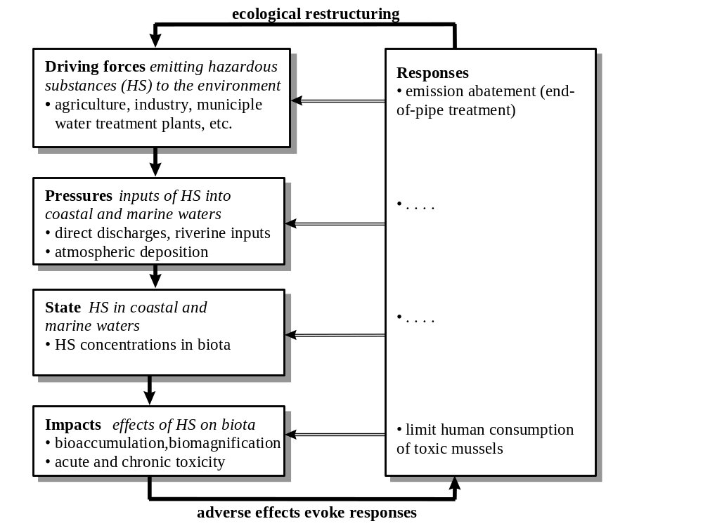

Figure 2.1 DPSIR assessment framework for hazardous substances (HS) in coastal waters. (Revised from EEA, 2001b).

In chapter 3 a brief characterisation of the different European Seas is compiled concerning drainage areas, run off, major surface currents and water exchange components.

In chapter 4 the impacts of hazardous substances in the different European seas are described.

Chapter 5 deals with sources (driving forces) emissions, riverine inputs and atmospheric deposition. The current levels and recent developments of inputs are analysed.

In chapter 6 an overview of the data material used for the present report is presented, with focus on six hazardous substances and their spatial and temporal extent. The aim is to identify areas where reporting of monitoring data needs to be improved in order to better assess the state of hazardous substances and to determine the presence of trends.

In chapter 7 the present state (levels and trends) of six hazardous substances along the European coasts are assessed. The main emphasis is put on analyses of concentrations in mussels and fish from the coastal areas of countries bordering the North East Atlantic, the Baltic Sea, Mediterranean and Black Seas. Levels and time trends of hazardous substances in these regions are shown on maps in Figures 6.2-6.24.

Chapter 8 is a brief review of the important legislation to combat the described hazardous substances.

In chapter 9 some recommendations on monitoring and assessment with regard to improvement of assessments of hazardous substances in the marine environment are given.

The Seas of Europe
Hazardous substances are brought with freshwater from land via rivers, pipes and groundwater seepage to the coastal margin of the marine environment. Figure 3.1 shows the catchment areas of the different European regional seas. Offshore sources include dumping or incineration at sea, maritime transport and oil/gas production activities. Atmospheric deposition to the surface water of the seas is also an important source of contamination.

Exposure of hazardous substances is to a large extent determined by the hydrography. The sensitivity increases with the residence time and the strength of the stratification of the water column. Over time and in space contaminanted discharges are mixed with marine water bodies by water exchange, tidal currents, local coastal currents and large-scale circulation currents.

This report focuses on levels and trends of hazardous substances in mussels and fish in coastal areas. For that reason this chapter does not include a description of deep waters and deep-water current systems. A comprehensive description of water masses and current circulation patterns in the different seas can be found in OSPAR QSR 2000 for Regions I-V (2000), HELCOM (1996) and EEA/UNEP (1999).
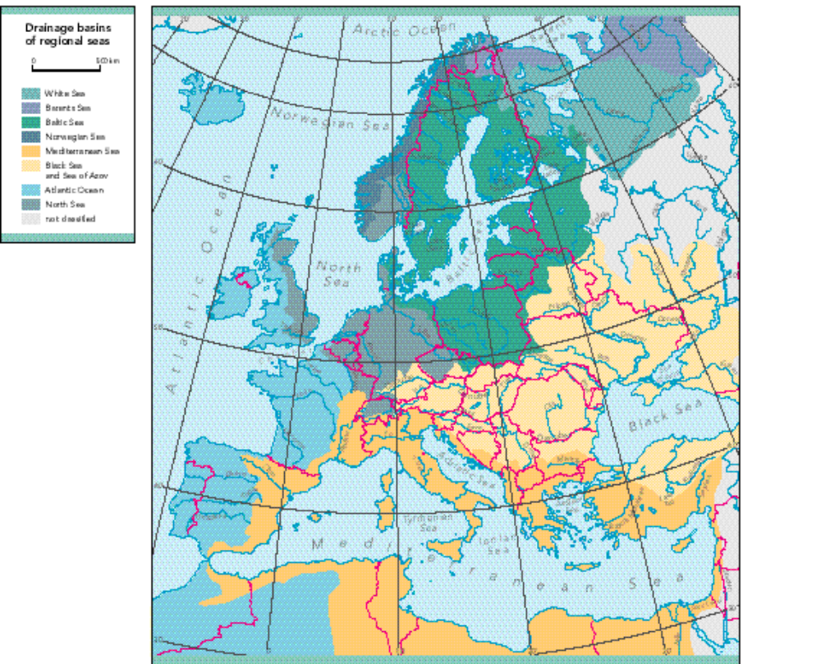
Figure 3.1 Catchment areas and drainage basins of regional seas. Source: EEA 1999.

Baltic Sea
The Baltic Sea is the largest brackish water area in the world and consists of several sub-basins separated by sills. The transition area (the Belt Sea and Kattegat) to the North Sea is narrow and shallow with a sill depth of 18 m. At irregular intervals, major inflows supply large volumes of highly saline and oxygen-rich water to the Baltic Sea. Only these inflows are able to renew the stagnant bottom water of the deep basins of the Baltic Proper.

The Baltic Sea is shallow (mean depth 52 m, maximum depth 459 m) with a water volume of 21 700 km³ and a surface area of 415 000 km², including the transition area. The overall residence time is 25-35 years. In general, ice covers the northern part for about 4-6 months, but sea ice occurs in some winters also in the rest of the Baltic Sea area.
The drainage area is 1 745 136 km² (Figure 3.1). The mean net outflow from the Baltic Sea is 15 000 m³ s⁻¹.

Norwegian Sea
The central and northern Norway borders the Norwegian Sea as the only mainland. The Norwegian catchment area covers 168 000 km² of mainly mountain areas with little anthropogenic input (Figure 3.1). Two surface current systems are running more or less parallel north-east up the coastline. The Norwegian coastal current is running near shore. When it enters the Norwegian Sea from south-west, it transports approximately 1 million m³ s⁻¹ and has a salinity that generally exceeds 30. (OSPAR 2000, QSR for Region I). The total input of the North Atlantic current in the Norwegian Sea is 8 million m³ s⁻¹ (OSPAR 2000, QSR for Region I; AMAP 1998). In addition to the water masses transported by the two current systems near and offshore there are a number of different water masses found in fjords and other estuaries along the coastline. A wide range of water characteristics are found in coastal waters, depending on estuary type, residence time, freshwater input, mixing conditions, etc.

Greater North Sea
The Greater North Sea covers approximately 750 000 km² and has a volume of about 94 000 km³. Without strict boundaries it is often divided into 7 sub-areas: the Southern North Sea, the Central North Sea, the deeper Northern North Sea, the Norwegian Trench, Skagerrak and finally the shallow Kattegat as a transition zone to the Baltic Sea and the Channel as a transition zone to the North East Atlantic. The shallow Southern North Sea includes the large Wadden Sea tidal area, the German Bight and the Southern Bight.

The catchment area for rivers discharging to the North Sea is 850 000 km² (Figure 3.1). The total run-off of freshwater is on average 300 km³ y⁻¹, however there is large year to year differences in run-off (OSPAR 2000, QSR for Region II). The most important rivers are the Rhine, Weser, Meuse, Scheldt, Seine and Elbe draining the central and northern Europe. The Thames and Humber drain east England and Göeta drains large parts of western Sweden. However, the largest fresh water source to the North Sea is the Baltic Sea (476 km³ y⁻¹).

The flushing time for the entire North Sea is estimated to be in the range between 365 and 500 days (OSPAR 2000, QSR for Region II). In periods with westerly wind low saline water, carrying hazardous substances from the rivers in the Southern North Sea, is carried up the Jutland west coast by the Jutland Coastal Current to the Skagerrak (OSPAR 2000, QSR for Region II).

Bay of Biscay, Iberian West Coast and Gulf of Cadiz
The catchment area that drains into the western Atlantic Ocean is 700 000 km² (Figure 3.1), with an average annual run-off of 180 km³. More than half of the run-off takes place in the Bay of Biscay. The four most important rivers responsible for more than half the loading are Loire and Gironde that drain into the Bay of Biscay, and Miño and Douro that drain into the Atlantic at the Iberian West Coast (OSPAR 2000, QSR for Region IV). Most of the surface waters found in the area have an Atlantic origin. Deeper water masses may also be a mixture of Atlantic and Mediterranean water masses.

Celtic Seas
This area includes the Celtic Sea located south of Ireland, Saint George's Channel, the Irish Sea and North Channel between Ireland, Wales, England and Scotland, and finally the shelf areas west of Ireland and Scotland. The total catchment area is shown in Figure 3.1.
The continental slope current, also described for the Biscay area, follows the slope edge to south-west of Ireland. On average there is a northward water movement through the Irish Sea and 30 000-100 000 m³ s⁻¹ is transported through the North Channel, but transport fluctuations are huge due to wind conditions.

Based on transport models and radionuclide distributions it is estimated that the flushing time is 150-300 days in the Bristol Channel, 1-2 years in the Irish Sea and 4.5-6 months in the Marlin Shelf area. Storm events are known to change those rates considerably (OSPAR 2000, QSR for Region III).

In addition to the water masses in the open areas there are a number of different waters found in fjords and other estuaries along the west coast of Scotland and the Scottish Islands. Wide ranges of water characteristics are found, depending on estuary type, residence time, freshwater input, mixing conditions, etc. (OSPAR 2000, QSR for Region III).

Mediterranean Sea
Data on the total size of the Mediterranean catchment area were not found. The Nile has the largest catchment area of all rivers entering the Mediterranean Sea with 335 000 km² (Figure 3.1). However, because of the construction of the Aswan dam an average of only 5 km³ water is discharged into the sea per year. Other important rivers are all located in the northern part of the Mediterranean. With a few exceptions all river systems discharging into the Mediterranean Sea are small. The Rhône, Ebro and Po have catchment areas extending to 96 000, 84 000 and 69 000 km². The discharge of freshwater from the 50 main rivers is about 255 km³ y⁻¹. Net inflow from the Black Sea amounts to 163 km³ per year.

Evaporation exceeds precipitation and freshwater load. As a result there is a net inflow of 1 700 km³ water from the Atlantic Ocean per year and the overall effect is a very high salinity in the Mediterranean Sea. The actual annual inflow of Atlantic water is much higher. Chou and Wollast (1997) estimate that 53 000 km³ pass the Strait of Gibraltar each year as a surface current. This inflow is compensated by export of high saline water from the Mediterranean Sea at the bottom. The export is estimated to 50 500 km³, giving a net water transport 800 km³ higher per year than the figure given in the Mediterranean assessment report (EEA/UNEP 1999).

The Mediterranean is divided into two basins separated by the Sicilian Channel about 150 km wide and with a maximum water depth of 400 meter. The water depth averages 1 500 meter and shelf areas are narrow and separated from the deeper parts by steep continental shelf breaks. The inflow current of Atlantic water continues as a surface current from west to east of the Mediterranean Sea. Coastal sea level variations are generally limited to tens of centimetres. Tidal amplitudes are small in the Mediterranean.

Black Sea
The drainage basin of the Black Sea extends to an area of 2 million square kilometres -five times the surface area of the sea itself. About 350 cubic kilometres of river water pour into the Black Sea per year from an area covering almost a third of continental Europe and including significant areas of seventeen countries: Austria, Belarus, Bosnia and Herzegovina, Bulgaria, Croatia, Czech Republic, Georgia, Germany, Hungary, Moldova, Slovakia, Slovenia, Romania, Russia, Turkey, Ukraine, Yugoslavia. Europe’s second, third and fourth rivers (the Danube, Dnipro and Don) all flow to the Black Sea. Isolation from the flushing effects of the open ocean, coupled with its huge catchment, have made the Black Sea susceptible to pollution (Acar, 2001).

Impact of hazardous substances
Hazardous substances can be broadly divided into the following categories: metals, persistent organic contaminants and degradable organic contaminants. The substances discussed in this report concern the two former categories. Substances in the latter category are e.g. organophospates, alkylphenols and several endocrine disrupters. They have not been included here.

Marine Conventions undertake biological effects monitoring of hazardous substances, but data are not reported regularly and assessments have not been made yet. The information presented in this chapter on the impact of the six substances is therefore based on literature review and not on data assessment.

Impacts of metals
Metals are found naturally in marine ecosystems. Human activity has increased local, regional and global fluxes of many metals, e.g. the metals included here (cadmium, mercury and lead). All three metals are non-essential (has no known biological function) and tissue levels are therefore generally not well regulated by biological functions of the bodies of marine organisms, causing bioaccumulation. Metals generally bioaccumulate in other tissues than fat (although methyl mercury may be found in fat). In vertebrates, cadmium accumulates in kidney (and liver), whereas lead accumulates in bone. Mercury may biomagnify in marine food chains, whereas cadmium and lead will not. Rather than through biomagnification, some species are at risk due to their dietary preferences. Some invertebrate species, e.g. blue mussel, may accumulate high levels of metals with no apparent adverse effects. Eider ducks that predominantly feed on mussels in some areas are however, thought to be at risk (secondary poisoning). A similar mechanism is thought to be relevant for seabirds that depend on specific fish species with high mercury levels.

Cadmium
Cadmium is widely present at low concentrations in the earth's crust, but human activities have caused a general mobilisation of the metal in aquatic and terrestrial environments. It is not needed for any organism (it is not essential) and the metal is highly toxic. The metal affects vital biological processes such as ion exchange, energy production and protein synthesis, mainly through interaction with the metabolism of essential trace metals such as zinc and calcium. In marine ecosystems, some seabird species (eating contaminated mussels) has been identified as the possibly most sensitive component through secondary poisoning (OSPAR 1996).

In humans cadmium has a biological half-life of more than 20 years. Concern about long-term exposure to cadmium also intensified after recognition of a disease (called “Itai-Itai”, painful-painful) in certain areas of Japan. The disease was a combination of severe kidney damage and painful bone and joint disease. The disease occurred in areas where rice contained high levels of cadmium due to irrigation of the soil with water contaminated with cadmium from industrial sources. The toxicity also resulted from consumption of cadmium-contaminated fish taken from rivers near smelting plants.

Mercury
Mercury has no known biological function. It is highly toxic and is considered one of the most dangerous metals in the aquatic environment due to it's toxicity and potential for bioaccumulation/biomagnification, particularly under anoxic conditions favouring the transformation of inorganic mercury into organic forms.

Organic forms of mercury affect the nervous system, whereas the inorganic forms affect a range of cellular processes. Mercury may be demethylated to varying extents in the tissues of aquatic organisms. In marine ecosystems, organisms at the top of food chains, mainly seabirds and marine mammals have been identified as being most sensitive (through secondary poisoning). The metabolism and disposition of mercury is complex - most is found as methyl mercury, which has a high affinity for sulphydryl groups in addition to being fat-soluble. In some species it will be found associated with fat, in others associated with peptides.

Mercury, as well as for DDT discussed below, is shown to be a major culprit for the decline in populations of predatory birds in the '60s and '70s. Mercury differs from other organic metals in that it is found in one organic and three inorganic forms in the environment (methyl mercury, di- and monovalent ionic mercury, metallic mercury). There is a continuous microbial transformation of inorganic to organic mercury in the aquatic environment and mercury in e.g. fish is nearly all organic mercury. Methyl mercury is one of the few environmental contaminants that has been established as embryotoxic to humans. Between 1954 and 1960, at Minimata Bay and elsewhere in Japan, many infants were born with severe neurological symptoms resembling cerebral palsy and mental deficiency. This disease was traced to the consumption of mercury-contaminated fish by the mothers. By 1970, at least 107 deaths had also been attributed to mercury poisoning, and 800 cases of “Minimata disease” were confirmed.

Apart from the known effects of mercury on birds of prey (mentioned above), lethal or harmful effects in marine and terrestrial mammals are also reported (AMAP, 1998), when concentrations exceeded from 25 to 60 mg/kg wet weight in kidneys and liver. Methylmercury is a central nervous system toxin and the kidneys are the organs most vulnerable to damage from inorganic mercury. Methylmercury is also a risk to the developing fetus since it readily crosses the placental barrier (AMAP 1998). Mercury exposure has been linked to reduced mental development in children.

The Polar Regions are affected by long-range transported mercury, and the concentration in some marine mammals seem to have increased over the previous two decades (AMAP, 1998). The levels of mercury in Arctic ringed seals and beluga whales have increased 2-3 fold over the last 20 years (Muir et al., 1997; Wagemann et al., 1996). The Arctic marine food web is often in focus regarding the risk of mercury to ecosystems. It is however important to acknowledge that impacts of mercury are not only restricted to the Polar Regions. Also in warmer waters the predatory marine mammals may be exposed to mercury levels that are health threatening. For instance, in a study of Hong Kong’s population of hump-backed dolphins, mercury has been considered a health problem (Parsons 1998).

Lead
Lead is also non-essential and toxic. Lead has high affinity for particles and is rarely found in high concentrations in seawater. Some algae are especially sensitive to lead (OSPAR 1996), but lead may affect aquatic species at different trophic levels.

In vertebrates, lead predominantly accumulates in bone and blood. Exposure to high concentrations will cause decreased synthesis of hemoglobin and eventually anemia. Severe exposure to inorganic lead may cause encephalopathy and mental retardation. Exposure to high concentrations will also cause decreased synthesis of haemoglobin and eventually anaemia. The same mechanism is used as a biomarker (ALA-D) to monitor lead exposure in fish under the Norwegian OSPAR JAMP.

Impacts of DDT, lindane and PCB
Persistent organic contaminants (e.g. DDT, lindane and PCBs) have low water solubility, high lipophilicity and are resistant to biodegradation. These properties lead to uptake and accumulation in the fatty tissues of living organisms, in some instances causing biomagnification through food chains (Figure 4.1). The highest concentrations of organic contaminants are therefore found in top predators, such as sea birds, marine mammals and polar bear (Bernhoft et al. 1997; Ruus et al. 2002). Adverse effects of these contaminants are therefore often observed in the same species. Such effects may comprise disruption of the immune system, disruption of hormone production or transport, impairment of reproduction, embryonic damage, cancer, or damage to the nerve system.

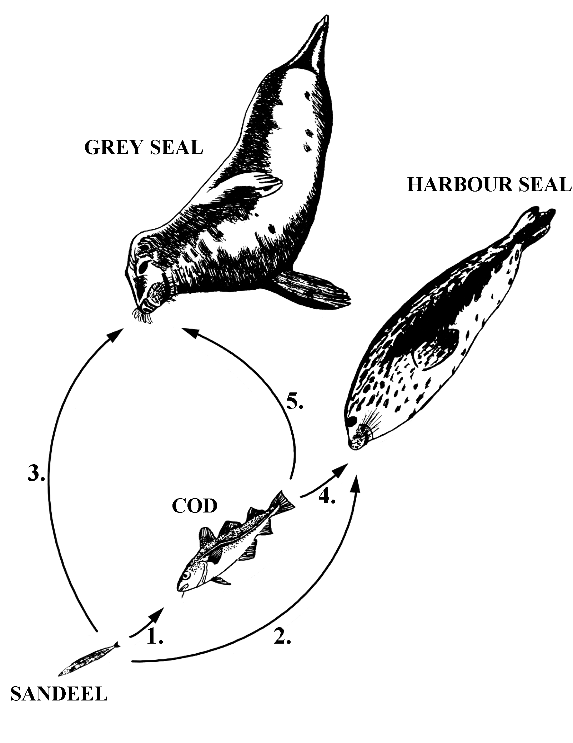

1. | Cod/Sandeel | 2. | Harbour seal/Sandeel | 3. | Grey seal/Sandeel
 | Σ PCB: 3.2 |  | Σ PCB: 28.0 |  | Σ PCB: 32.2
 | Σ DDT: 3.7 |  | Σ DDT: 36.9 |  | Σ DDT: 35.4
 | Σ CHL: 3.2 |  | Σ CHL: 33.5 |  | Σ CHL: 35.0
 | HCB: 2.1 |  | Σ HCH: 2.1 |  | HCB: 2.7
4. | Harbour seal/Cod | 5. | Grey seal/Cod
 | Σ PCB: 8.7 |  | Σ PCB: 10.0
 | Σ DDT: 9.9 |  | Σ DDT: 9.5
 | Σ CHL: 10.3 |  | Σ CHL: 10.8
 | Σ HCH: 2.5
 | HCB: 0.3

Figure 4.1 Biomagnification factors (BMFs) between levels in the studied food chain from Jarlfjord, Norther Norway (1989-1990) (Ruus et al. 1999)

The case for seals in the Baltic Sea illustrate the impact of certain persistant organic pollutants. The seal are top predators that have been adversely affected by organic contaminants. The Baltic Sea is connected to the world oceans only through three narrow and shallow straits and it takes approximately 25 years to exchange the whole water volume. This is more than enough time for particle bound contaminants to deposit on the Baltic Sea floor. The Baltic Sea has therefore become a sink for many of the hazardous substances that have been deposited in the surrounding environment through the years. Seventy million people live close to the Baltic Sea and more than 250 large rivers contribute to a substantial input of contaminants to the Baltic Sea.

Populations of seals in the Baltic Sea declined towards the 1970s and it was established that this was due to lowered reproductive success. The reason was pathological changes in the uterus, rendering the female seals infertile, and the severity of disease correlated with levels of organic contaminants in the seals (specifically PCBs; Helle et al. 1976). The high contaminant levels were likely the cause of a large disease complex with a variety of symptoms including lesions on skin, claws, intestines, kidneys and bone tissue in addition to uterus pathology. The origin for the whole disease complex was most likely the contaminants’ toxic effect on the adrenal cortex (Bergman & Olson, 1985).

DDT
A negative relationship between concentrations of p,p’-DDE and testosterone in Dall’s porpoises of the North Pacific is one such effect that has been shown (Subramanian et al. 1987, Figure 4.2). This may have consequences for the reproduction of the animals, since testosterone plays a crucial role for normal male sexual differentiation, steroidogenesis, spermatogenesis, development of secondary male sex characteristics and sexual behaviour. In other cases dioxin-like compounds have displayed anti-estrogenic effects, likely because the Ah-receptor (dioxin-receptor) blocks the normal function of the oestrogen-receptor.

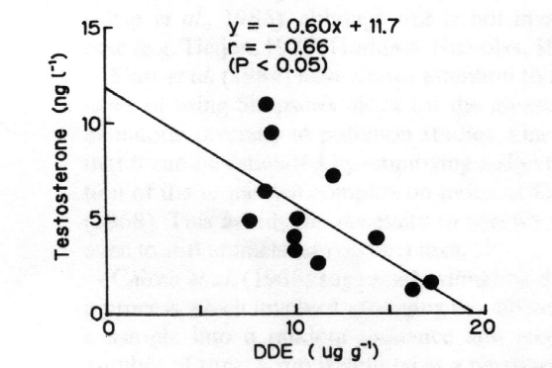
Figure 4.2 Relationship between concentrations of testosterone and p,p'-DDE in Dall's porpoises (Subramanian et al., 1987).

Besides interfering with hormone homeostasis in Dall’s porpoises, DDT and it's derivates were responsible for eggshell thinning and decreased reproductive success in birds, especially birds of prey (Figure 4.3). Endocrine disruption rendered the calcium-producing eggshell-gland of the female birds unable to produce sufficiently thick eggshells and they often broke before hatching (Ratcliffe, 1967; Hickey & Anderson, 1968). These hazardous substances thus contributed to a decline in many bird populations in industrialised areas of the Northern Hemisphere in the 1960s and 1970s.

Index for  eggshell  thickness | 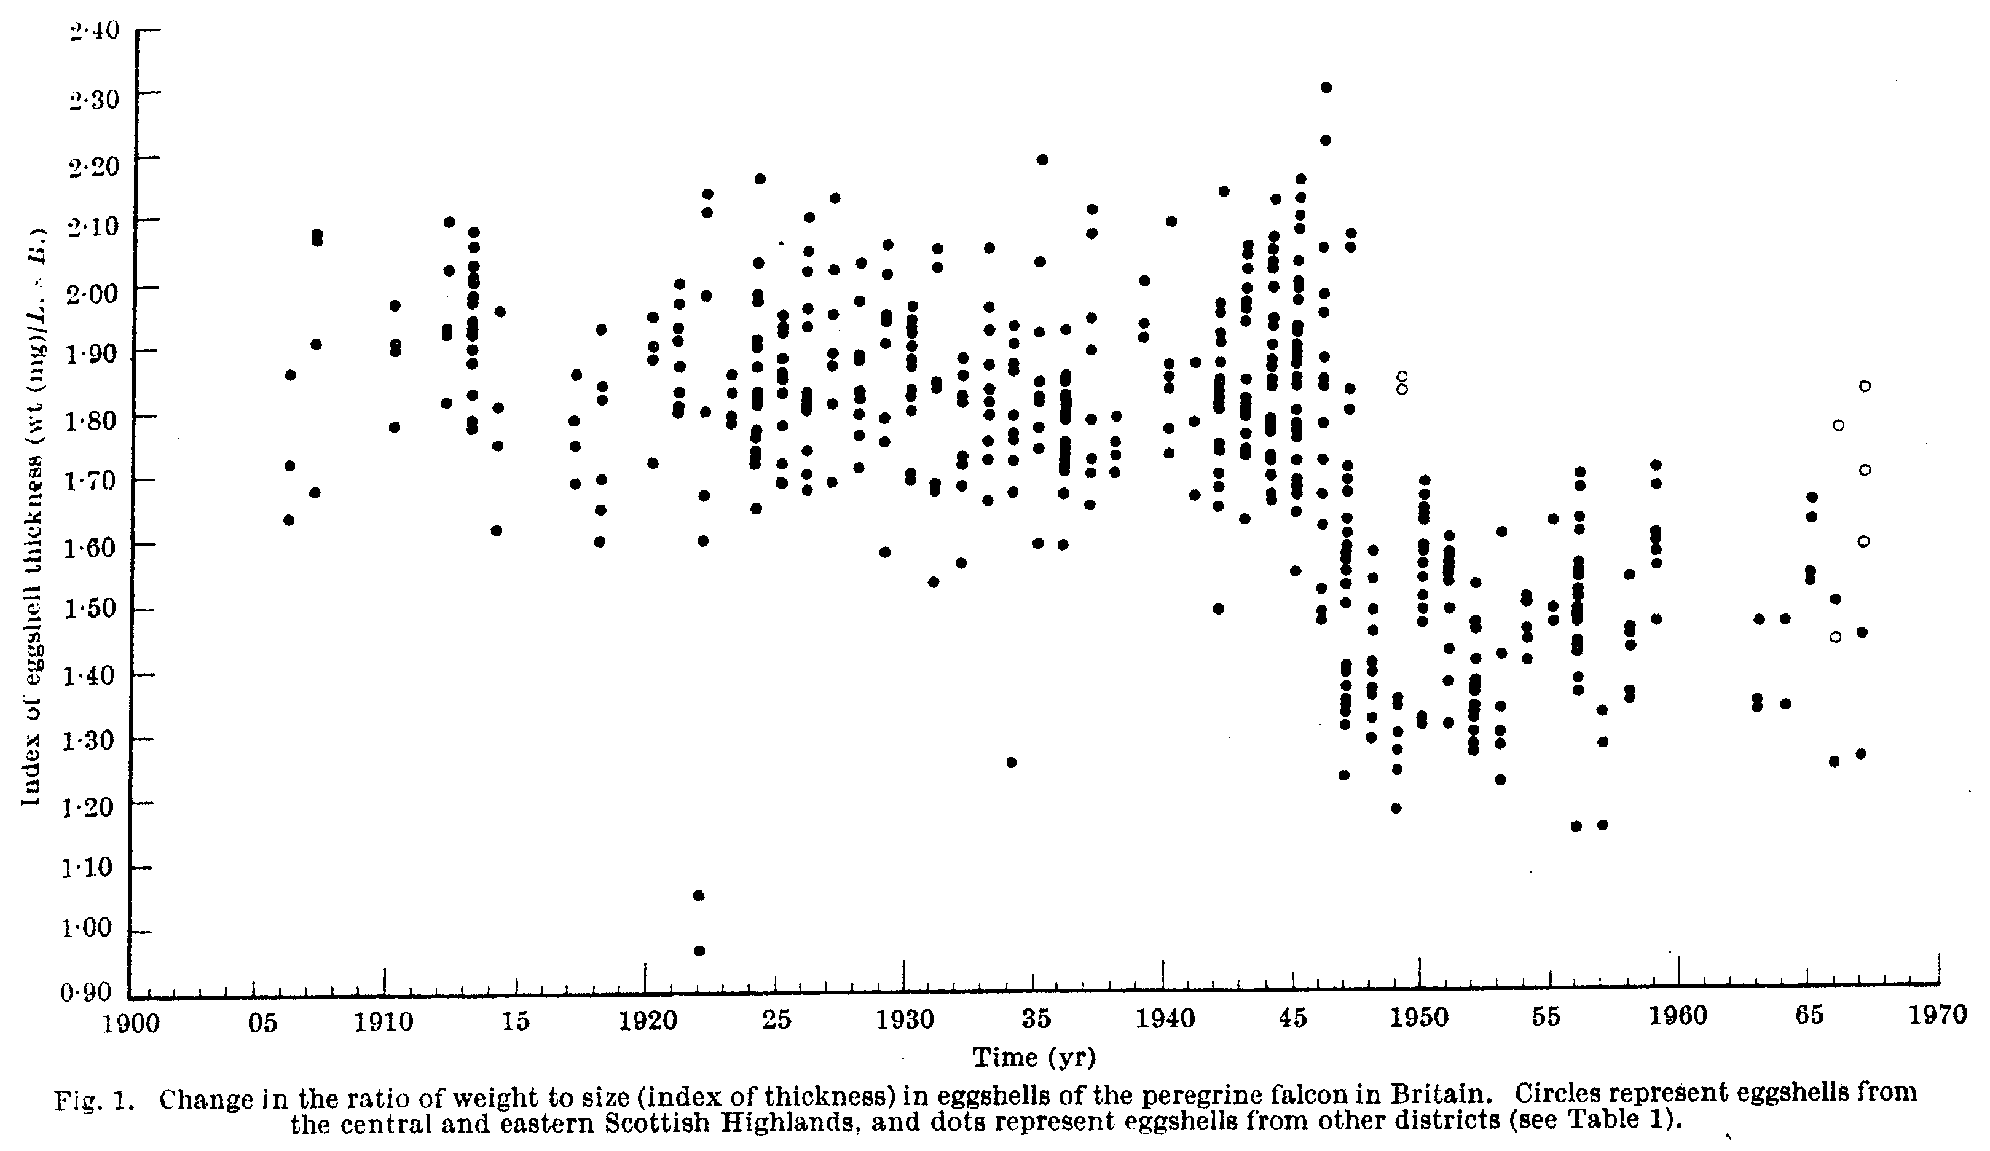
 | Year
Figure 4.3 Change in eggshell thickness from 1900 to 1967, with lower levels from about 1945 corresponding to when DDT was introduced to the environment (from Ratcliffe 1967).

Lindane
Lindane is also present in high concentrations in the fat of Arctic mammals (seals, polar bear). From the limited data available on acute and chronic toxicity, some crustacean species appear to be particularly sensitive to lindane (and of course insects in freshwater), whereas e.g. molluscs and algae do not appear to be very sensitive (OSPAR 1996). Lindane is an irritant in humans and may affect mucus membranes, immune and nervous systems following exposure.

PCBs
Due to PCBs extreme mobility and ability to bioaccumulate and -magnify in marine food webs, long-lived animals at high trophic levels appear to be most at risk from PCBs. As for DDT, PCBs are thought to be involved in the observed reproductive problems of polar bears and possibly earlier morphological aberrations in Baltic seals.

Other endocrine disrupting effects of hazardous substances are, for instance, the binding of hydroxy-metabolites of PCBs on the transport protein (transthyretin, TTR) of the thyroid hormone thyroxin. Since thyroxin is an important hormone for growth and development, this may have damaging effects on early life stages of organisms. A similar problem exists for the homeostasis of vitamin A, which is also important for the immune system, foetal development, growth and reproduction in all vertebrates. Relationships between plasma levels of organochlorines (PCBs), retinol (vitamin A) and thyroid hormones in polar bear from Svalbard have been found (Skaare et al., 2001), indicating that growth development of epithelial tissues and immune system, and reproduction are (or are at risk of being) impaired. Furthermore, PCB-contaminated fish are shown to likely induce vitamin A and thyroid hormone deficiency in seals (Brouwer et al., 1989).

Adverse effects of hazardous substances on the reproduction and of top predators in marine ecosystems are also observed in the Wadden Sea, which is recipient of water from the river Rhine. Reijnders (1986) observed lowered reproductive success in seals feeding on fish from the Wadden Sea (contaminated with high concentrations of especially PCBs), compared to seals feeding on fish from the north-east Atlantic. Furthermore suppression of immune system function (specifically natural killer cell activity) in seals fed Baltic Sea herring (also highly contaminated with PCBs) has been observed (Ross et al., 1996). During the 1988 epizootic, impaired immune system due to exposure to hazardous substances was suspected to render the animals more susceptible to the phocine distemper virus. Fairly recent results (Bernhoft et al., 2000) now also indicate contaminant-associated suppression of antibody-mediated immunity in polar bear.

Sources and inputs of Hazardous substances (driving forces and pressures)

Sources
In the current industrialised society, a vast number of chemicals are at all times in use or being produced. In addition, several substances are formed unintentionally as by-products in industrial processes or combustion. Human activities have thus drastically altered concentrations of many natural substances in the environment (e.g. metals) and added numerous new chemicals (e.g. DDT and PCB). Many substances have been investigated for their impact on the environment and the research had increased the awareness of their harmful effects, leading to restrictions on production, use, and discharges of a number of chemicals.

Considerable attention regarding environmental pollution is focused towards the marine environment. Different contaminants have reached the oceans from anthropogenic sources through direct discharge to marine waters, or indirectly by rivers and run-off from soil and atmospheric deposition. The world oceans comprise 71 % of the earth’s surface, and therefore, are also an enormous recipient of pollutants from the atmosphere. After emission to the atmosphere, many pollutants are dispersed by repeated deposition and evaporation. By oceanic and atmospheric circulation, pollutants are being subject to long-range transport even to relatively pristine areas, such as the Arctic.

The European Pollution Emission Register (EPER), which is presently being developed in connection with the IPPC Directive, will provide data on a range of hazardous substance and their emissions in future. For this report, information on emission sources has been compiled from literature. Only emission sources of the six substances dealt with in this report are considered (cadmium, mercury, lead, DDT, lindane and PCB).

Cadmium
Cadmium is referred to as "the lost metal" since recycling had been limited. The main sources are from general waste/disposal and industrial activities (NSC, 2002). Sources of the metal to the environment include mining and production, metal industry (including steel industry), coating/electroplating industry, production and deposition of batteries, burning of fossil fuels, the use of phosphate fertilisers, waste incineration, leaching from waste deposits and, finally, the use of cadmium salts as stabiliser and/or colouring agent.

Produced water (water produced with oil and gas) is a source of direct discharge of hazardous substances to marine waters and contains a variety of chemicals that have been dissolved from the geologic formations on the sea floor. The metals present and their concentrations in produced water from different sources vary considerably, depending on the age and geology of the formations which the oil and gas are produced (Collins, 1975). Cadmium was one of the metals present in North Sea produced water, and the concentrations range commonly from 0.45 to 1.0 µg/L (Neff, 2002). For comparison, typical cadmium concentrations in seawater are between 0.001 and 0.1 µg/L (Neff, 2002). However, inputs of cadmium from offshore activities (estimated at 0.1-0.2 tons/year from all sectors) are negligible in comparison with atmospheric deposition (37.5-48 tons/year), riverine and direct inputs (totally 28.6-36 tons/year) to the North Sea (cf. Borgvang et al., 2002).

Mercury
As other metals, mercury is found naturally in the marine environment. The main anthropogenic sources are from general waste/disposal and industrial activities (NSC, 2002). It is still used in various products, e.g. batteries and electronics. Furthermore, low quantities in fossil fuels and municipal waste ensure continued emissions of mercury into the atmosphere.

Mercury differs from other metals and organic contaminants in that it is found in one organic and three inorganic forms in the environment (methyl mercury, di- and monovalent ionic mercury, metallic mercury). There is a continuous microbial transformation of inorganic to organic mercury in the aquatic environment and mercury in e.g. fish is nearly only organic mercury.

Atmospheric mercury exists mainly in the form of elemental mercury vapour (Hg0) (90 to 99%), particle bound mercury (< 5%) and gaseous divalent mercury (e.g. HgCl2) (<5%) (EC, 2001). Emissions from anthropogenic sources can occur in all three forms. Atmospheric deposition occurs mainly via dry deposition or wash-out of particle bound and gaseous divalent mercury. Elemental mercury contributes to the deposition via oxidation in air or in cloud droplets. Mercury in the form of elemental vapour (Hg0) had a long atmospheric lifetime, which makes transport on hemispheric and global scales feasible. In the Northern Hemisphere, anthropogenic emissions have increased the background concentrations of mercury in air by a factor of 2-3 since before industrialisation.

In addition to diffuse inputs (sewage, run-off), important mercury inputs are atmospheric deposition (burning of fossil fuels, waste incineration) and industry outputs. Recent atmospheric deposition to the North Sea was estimated to be 10.5 tons/year, while riverine and direct inputs range between 6.8 and 8.5 tons/year (OSPAR, 1999, cf. Borgvang et al., 2002). According to Neff (2002), the global anthropogenic emissions of mercury may amount to 30 000 metric tons/year.

As mentioned, mercury undergoes transformations in the marine environment. Mercury has affinity for particles and organic material and will therefore accumulate in some sediments in coastal waters. Mercury is more volatile than other metals and atmospheric transport is an important pathway.

Lead
Lead is widely distributed in the crust of the earth, most commonly found with deposits of other metals (zinc, cadmium, silver, copper). The main anthropogenic sources are from general waste/disposal and inductrial activities (NSC, 2002).

Lead does not occur naturally in the metallic state and has a low abundance (0.002 % of the weight of the earth's crust) (EC, 1997). In the natural cycle, lead is released to the earth’s surface through several processes which include weathering of rocks, volcanic activity, and uptake and subsequent release by plants. The weathering of rocks releases lead to soils and aquatic systems. This process plays a significant role in the global lead cycle, but only rarely results in elevated concentrations in any environmental compartment. Background concentrations of lead in the air are between 0.05-0.1 µg/m3 in rural areas. Natural lead content in the atmosphere is estimated to be in the order of 0.6 ng/m3.

Lead has a great number of industrial applications, both in its elemental form and in the form of alloys and compounds. The major use of lead is in the manufacture of lead accumulators (responsible for 68% of consumption and growing in parallel with the increase in the number of automobiles), in which it is used both in the metallic form and as lead oxide. Furthermore, lead has important applications in radiation shielding (in nuclear plants and around X-ray apparatus units), in roofing and for the sheathing of electric power cables. Its corrosion resistance makes it a useful material for tank linings, piping and other equipment used in chemical processes. Due to its density, it is also suitable for ammunition and for weighting applications (e.g.car wheel weights and yacht keels).

Lead oxide are also used in several applications. It is incorporated into glass to prevent the escape of radiation from cathode ray tubes (e.g TVs computer monitors). Furthermore, organic lead salts are added to PVC as stabilizers to protect it against degradation.

It is also important to mention tetraethyl lead, which has been used in petrol. In 1972 around 400,000 tonnes of tetraethyl lead were consumed throughout the world to improve the octane rating of petrol. Since then this application has declined dramatically because of restrictions imposed thorough environmental legislation. The tetraethyl lead market now accounts for only 1% of lead use, most of which is used in developing countries.

DDT
DDT (dichlorodiphenyltrichloroethane) is a synthetic organochlorine insecticide that was first used to control insects that were vectors for human diseases at the end of World War II. After the war it found a ready market in peacetime agricultural enterprise. All use of DDT was discontinued in western European countries around 1990, although heavy use was banned two decades earlier. However, in developing countries, the need for cheap insecticides (to control mosquitoes, and hence malaria) has kept DDT in use also in later years. Furthermore, in some areas, e.g. in fruit-growing areas in western Norway, there are recent inputs of DDT, probably due to leaching from buried waste or unused canisters. In addition, there is a continued leaching from soil and river sediments in some areas. DDT has over the past 50-60 years been spread over the entire globe and is now found in all natural waters and organisms.

The original pesticide DDT (technical grade) contained up to 14 different chemicals including p,p′-DDT (1,1,1-trichloro-2,2-bis(4-chlorophenyl)ethane) and its o,p′-DDT isomer (1,1,1-trichloro-2-(2-chlorophenyl)-2-(4-chlorophenyl)ethane), as well as their dechlorinated analogues p,p′- and o,p′-DDD (1,1-dichloro-2,2-bis(4-chlorophenyl)ethane and 1,1-dichloro-2-(2-chlorophenyl)-2-(4-chlorophenyl)ethane, respectively). p,p′-DDE (1,1-dichloro-2,2-bis(4-chlorophenyl)ethylene) is the principal DDT-metabolite.

Lindane
HCH (1,2,3,4,5,6-hexachlorocyclohexane), also known as benzenehexachloride (BHC) or lindane, is a pesticide that is still used in parts of the world. In its production process, benzene and chlorine react in the presence of UV radiation forming the crude product ‘technical HCH’. This consists of 55-80 % of the α-isomer, 5-14 % of the β-isomer, 8-15 % of the γ-isomer and 2-16 % of the δ-isomer (Li et al.1996). It's insecticidal properties are mainly due to the γ-isomer. Therefore, by selective crystallisation, γ-HCH has been produced with the common name lindane. Non-agricultural use of lindane includes use for wood preservation, as an insecticide, as rodenticide and for medicinal purposes (scab and louse ointments).

Lindane is not found naturally and is toxic to vertebrates as well as to insects (the target for the pesticide). The substance has been banned from use in most western European countries (SIME 2002), but is still present in the environment due to its persistence.

Lindane was primarily used in the USA and Western Europe, while technical HCH was used in the former Soviet Union, Poland, Romania, India, China, Mexico and Brazil (Fischer et al., 1991). Technical HCH is still used in China as an insecticide on hardwood logs and lumber, seeds, vegetables and fruits, and on buildings (AMAP, 1998). The global usage of technical HCH and lindane is estimated to be 550 000 and 720 000 tonnes, respectively, between 1950 and 1993 (Voldner and Li, 1995).

PCB
Polychlorinated biphenyls (PCBs) are a group of theoretically 209 different compounds (congeners) of which 150-160 are found in the environment. It should be noted that the range of PCBs are very different substances, both with regard to physico-chemical properties and with regard to their biological activity. A distinction is commonly made between the generally more carcinogenic "dioxin-like" PCBs (non- and mono-ortho chlorinated) and the more immunotoxic "bulky" PCBs (chlorinated in ≥2 ortho positions). All PCBs are manmade, but are now found all over earth due to their persistence and relative volatility.

Since 1929 at least 1 million tons have been produced. More than half is still in the environment or in products (Tanabe 1985, 1988). Commercial PCB-products were manufactured in the USA, Japan, the former Soviet Union, and eastern and western Europe under various trade names, such as Aroclor, Clophen, Phenoclor, Santotherm and Pydraul (de Voogt and Brinkman, 1989; AMAP, 1998). The products are mixtures of several congeners with different degrees of chlorination. The PCBs have unique physical and chemical properties, such as high thermal and chemical stability and high electrical resistance. Therefore, they have been used extensively in many industrial applications, such as hydraulic fluids, cooling liquids in transformers and dielectric liquids in capacitors. They have also been applied in open systems such as plasticisers, lubricants, inks and paints. Sources of PCBs to the environment are mainly diffuse and the highest levels are generally found in estuaries and close to industrialised urban centres. There is currently a ban on the open use of PCB.

Inputs
During the period 1990-1999 decreasing input of cadmium, mercury, lead, lindane and PCB into the North-East Atlantic were observed (Figure 5.1 and Tables 5.1-5.2). There were no available data for input of DDT. Emission reduction measures in industry have contributed to the observed reductions in the input of metals (OSPAR, 2000).

The sum of direct and riverine inputs of cadmium (about 109 tons in 1990 into the North-East Atlantic) was reduced by 50% between 1990 and 1997. UK contributed most to the input in 1990 and also strongly contributed to the total decrease in input observed in the period until 1999. High cadmium inputs in 1994 and 1995 of the Netherlands probably were due to relatively high (and not representative) concentrations of suspended solids in the samples. Data from Portugal have an irregular pattern over time. Values from Spain for 1997-1999 were relatively high compared to other countries, but were lacking prior to 1997 or questionably low. These examples of gaps or poor data inhibit adequate assessment of temporal trends.

The input of mercury (about 41 tons in 1990) was reduced about 50% in 1999 compared to 1990. Germany (including former GDR) and UK contributed most to the input in 1990. Both countries also strongly contributed to the total decrease in input observed in the period until 1999.

The discharge lead in 1990 was about 2,200 tons in 1990 and was reduced to 1330 tons in 1999 almost entirely due to changes in discharges from Portugal. Portugal and UK contributed most to 1990 input. The contributions of the other countries did not show a clear decrease over the period considered. Relatively high lead inputs in 1994 and 1995 of the Netherlands probably were due to relatively high, but not representative, concentrations of suspended solids in the samples. The results of Spain in 1997 and 1998 were high, while data on 1990-1992 were lacking. This causes a bias in comparing total 1998 inputs with 1990 inputs. Inputs of Norway and UK in 1998 were high compared to those of other years.

The sum of direct and riverine inputs of lindane was about 1,800 tons in 1990 and reduced to about 900 tons by 1999. Especially Norway and UK contributed to this decrease. Taking into account the change in analysis procedure in the Netherlands from 1993 onwards, the decrease in input in 1999 compared to 1990 was much larger.

The discharge of PCB was about 3,100 tons in 1990 and was reduced by 50% by 1999. UK contributed most to the input in 1990 and strongly contributes to the total decrease in input observed.

Atmospheric inputs were also shown to decrease. A decreasing trend in atmospheric input of cadmium, mercury and lead into the North Sea was observed for the period 1987-1995. There were no available data for atmospheric inputs of DDT, lindane, or PCB. Cadmium and lead have rather short residence times in the atmosphere and were rapidly deposited. Countries bordering coastal waters (thus the OSPAR contracting parties) account for nearly the whole amount of the metal input. Due to the air transport characteristics, the relative contribution of atmospheric input varies between the sea regions studied. Emission reduction measures in industry and waste burning contributed to the reduction of atmospheric inputs of cadmium, mercury and lead.

In 1995 atmospheric inputs of cadmium and mercury into the North Sea were estimated at 22 tons and 4 tons, respectively. For lead, in 1995 the atmospheric input into the greater North Sea was estimated at 670 tons. However, the uncertainty margin in these inputs was relatively large (the inputs were probably overestimated). The sum of direct and riverine inputs into the North Sea in 1995 amounted to 56 tons, 16 tons and 1,420 tons for cadmium, mercury and lead, respectively, showing that the contribution of atmospheric inputs was significant.
Figure 5.1 Change (%) in direct riverine and atmospheric inputs of cadmium, mercury, lead, lindane and PCB to the North-East Atlantic.

Cadmium | Mercury
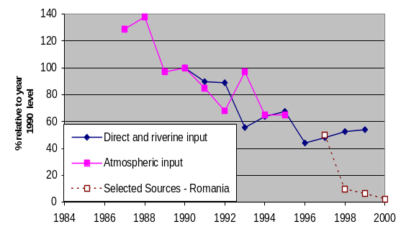 | 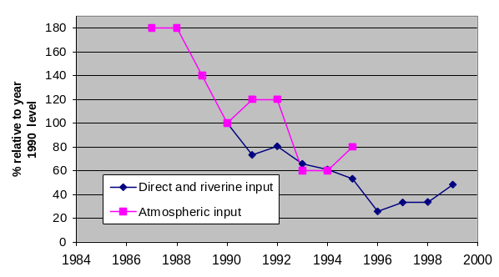
Lead | Lindane
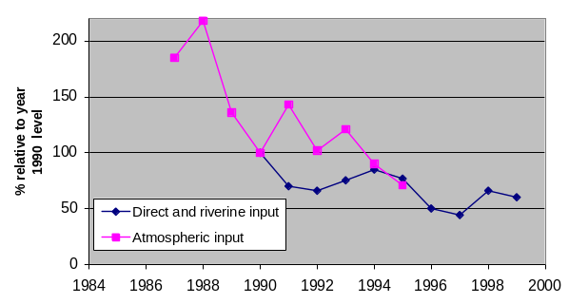 | 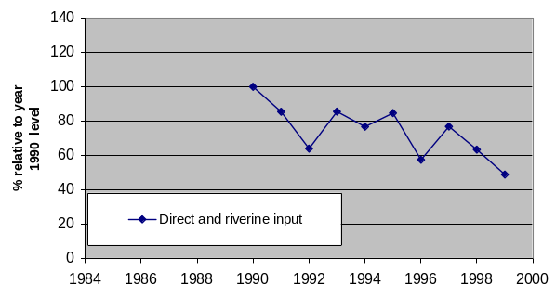
PCB
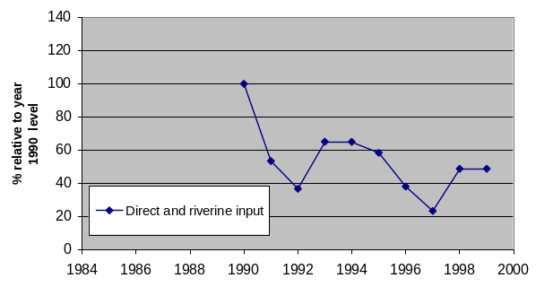 | Data source: OSPAR, HELCOM, EEA-member countries.

Table 5.1 Relative changes in direct and riverine inputs (DRI, as % of 1990) of cadmium, mercury, lead, lindane and PCB to the North-East Atlantic, and atmospheric inputs (AI) of cadmium, mercury and lead to the North Sea.

Substance/Sea | Medium | 1985 | 1986 | 1987 | 1988 | 1989 | 1990 | 1991 | 1992 | 1993 | 1994 | 1995 | 1996 | 1997 | 1998 | 1999

Cadmium
NE Atlantic | DRI |  |  |  |  |  | 100 | 90 | 89 | 56 | 64 | 68 | 44 | 48 | 53 | 54
North Sea | AI |  |  | 129 | 138 | 97 | 100 | 85 | 68 | 97 | 65 | 65

Mercury
NE Atlantic | DRI |  |  |  |  |  | 100 | 73 | 81 | 66 | 61 | 53 | 26 | 33 | 34 | 48
North Sea | AI |  |  | 180 | 180 | 140 | 100 | 120 | 120 | 60 | 60 | 80
Lead
NE Atlantic | DRI |  |  |  |  |  | 100 | 70 | 66 | 75 | 85 | 77 | 50 | 44 | 66 | 60
North Sea | AI |  |  | 185 | 218 | 136 | 100 | 143 | 102 | 121 | 90 | 71

Lindane
NE Atlantic | DRI |  |  |  |  |  | 100 | 86 | 64 | 86 | 77 | 85 | 58 | 77 | 64 | 49

PCB
NE Atlantic | DRI |  |  |  |  |  | 100 | 54 | 37 | 65 | 65 | 59 | 38 | 24 | 49 | 49
Table 5.2 Country contributions to sum of direct and riverine inputs in tonnes per year of cadmium, mercury, lead, lindane and PCB to the North-East Atlantic.
Substance/  Year | B | DK | F | D | IRL | NL | NO | P | E | S | UK | SUM | %

Cadmium
1990 | 4.30 | 0.57 | 4.70 | 8.54 | 3.39 | 10.30 | 16.21 | 9.00 | n.a. | 0.67 | 51.30 | 108.97 | 100.00
1991 | 3.90 | n.a. | 3.30 | 7.24 | 3.39 | 7.00 | 8.31 | 15.00 | n.a. | 0.34 | 49.35 | 97.83 | 89.80
1992 | 6.70 | n.a. | 4.50 | 10.55 | 2.31 | 5.70 | 7.90 | 24.00 | n.a. | 0.54 | 34.69 | 96.89 | 88.90
1993 | 3.42 | n.a. | 3.20 | 9.20 | 1.76 | 4.70 | 7.18 | 1.70 | 0.06 | 0.11 | 29.30 | 60.62 | 55.60
1994 | 3.44 | n.a. | 3.20 | 8.14 | 2.44 | 12.76 | 9.23 | 3.93 | 0.10 | 0.42 | 25.87 | 69.52 | 63.80
1995 | 3.81 | n.a. | 2.70 | 7.54 | 2.17 | 26.60 | 8.99 | 0.20 | 0.10 | 0.24 | 21.31 | 73.67 | 67.60
1996 | 2.90 | n.a. | 2.20 | 5.65 | 3.94 | 8.40 | 5.85 | n.a. | n.a. | n.a. | 19.11 | 48.05 | 44.10
1997 | 2.65 | n.a. | n.a. | 6.35 | 2.55 | 4.05 | 5.20 | 1.35 | 14.50 | 0.47 | 15.35 | 52.47 | 48.10
1998 | 2.45 | n.a. | n.a. | 6.25 | 3.45 | 9.70 | 7.75 | 0.60 | 6.80 | 0.56 | 19.75 | 57.31 | 52.60
1999 | 2.30 | n.a. | n.a. | 4.99 | 2.91 | 11.90 | 4.60 | 0.40 | 12.80 | 0.90 | 18.00 | 58.80 | 54.00

Mercury
1990 | 4.05 | 0.13 | 5.70 | 10.54 | 2.45 | 3.18 | 0.85 | 4.90 | n.a. | 0.11 | 8.81 | 40.71 | 100.00
1991 | 1.15 | n.a. | 2.70 | 10.01 | 2.45 | 3.30 | 0.50 | 1.75 | n.a. | 0.13 | 7.85 | 29.83 | 73.30
1992 | 0.68 | n.a. | 8.70 | 11.03 | 2.40 | 3.26 | 0.53 | 0.04 | n.a. | 0.13 | 6.00 | 32.78 | 80.50
1993 | 2.62 | n.a. | 0.80 | 10.05 | 2.40 | 3.46 | 0.49 | 0.26 | n.a. | 0.11 | 6.55 | 26.73 | 65.70
1994 | 3.10 | n.a. | 1.10 | 5.65 | 2.40 | 6.41 | 0.38 | 0.85 | n.a. | 0.10 | 4.83 | 24.82 | 61.00
1995 | 0.60 | n.a. | 0.80 | 4.64 | 2.40 | 8.06 | 0.54 | 0.35 | n.a. | 0.15 | 4.13 | 21.67 | 53.20
1996 | 0.03 | n.a. | 0.50 | 2.94 | n.a. | 3.28 | 0.47 | n.a. | n.a. | n.a. | 3.26 | 10.48 | 25.70
1997 | 0.25 | n.a. | n.a. | 1.95 | n.a. | 2.70 | 0.40 | 1.15 | 2.60 | 0.09 | 4.41 | 13.54 | 33.30
1998 | 0.61 | n.a. | n.a. | 2.15 | n.a. | 2.15 | 2.86 | 0.75 | 0.40 | 0.13 | 4.68 | 13.72 | 33.70
1999 | 0.72 | n.a. | n.a. | 2.39 | n.a. | 2.33 | 1.46 | 0.56 | 8.60 | 0.20 | 3.31 | 19.60 | 48.10

Lead
1990 | 27.5 | 7.2 | 150.0 | 212.8 | 63.4 | 346.5 | 120.9 | 680.0 | n.a. | 8.3 | 591.1 | 2207.6 | 100.0
1991 | 36.6 | n.a. | 150.0 | 297.5 | 63.4 | 230.0 | 102.8 | 80.0 | 7.7 | 5.3 | 575.6 | 1548.8 | 70.2
1992 | 32.5 | n.a. | 110.0 | 314.9 | 82.1 | 221.8 | 70.5 | 120.0 | 2.6 | 4.3 | 501.6 | 1460.2 | 66.1
1993 | 36.6 | n.a. | 100.0 | 378.1 | 55.5 | 393.8 | 58.5 | 7.3 | 0.9 | 3.2 | 631.4 | 1665.2 | 75.4
1994 | 48.2 | n.a. | 170.0 | 247.7 | 79.6 | 701.8 | 82.6 | 6.1 | 2.2 | 10.5 | 528.3 | 1877.1 | 85.0
1995 | 43.2 | n.a. | 55.0 | 185.5 | 63.3 | 871.8 | 82.5 | 2.8 | 1.3 | 8.2 | 384.8 | 1698.3 | 76.9
1996 | 44.5 | n.a. | 66.0 | 126.5 | 115.6 | 382.9 | 62.6 | n.a. | n.a. | n.a. | 311.5 | 1109.5 | 50.3
1997 | 40.0 | n.a. | n.a. | 151.5 | 120.5 | 233.0 | 63.7 | 43.0 | 17.0 | 8.7 | 303.3 | 980.7 | 44.4
1998 | 51.5 | n.a. | n.a. | 181.5 | 143.0 | 257.5 | 150.0 | 4.9 | 54.0 | 14.3 | 601.5 | 1458.2 | 66.1
1999 | 56.5 | n.a. | n.a. | 125.4 | 145.0 | 326.0 | 53.6 | 2.1 | 58.0 | 17.3 | 546.0 | 1330.0 | 60.2

Lindane
1990 | 102.0 | 26.0 | 175.0 | 342.0 | n.a. | 16.7 | 536.0 | n.a. | n.a. | n.a. | 588.4 | 1786.1 | 100.0
1991 | 111.0 | 26.0 | 175.0 | 187.8 | n.a. | 7.2 | 261.3 | n.a. | n.a. | n.a. | 759.5 | 1527.8 | 85.5
1992 | 82.5 | 26.0 | 175.0 | 208.0 | n.a. | 10.5 | 97.9 | 0.7 | n.a. | n.a. | 543.0 | 1143.6 | 64.0
1993 | 80.0 | 26.0 | 175.0 | 191.5 | n.a. | 360.0 | 90.9 | 3.4 | n.a. | n.a. | 601.8 | 1528.6 | 85.6
1994 | 74.5 | 26.0 | 175.0 | 261.0 | n.a. | 230.0 | 87.7 | 15.0 | n.a. | n.a. | 501.8 | 1371.0 | 76.8
1995 | 55.5 | 26.0 | 175.0 | 291.4 | n.a. | 370.0 | 107.4 | 2.8 | n.a. | n.a. | 484.7 | 1512.8 | 84.7
1996 | n.a. | n.a. | 100.0 | 239.0 | n.a. | 300.0 | 75.9 | n.a. | n.a. | n.a. | 312.4 | 1027.3 | 57.5
1997 | 66.0 | n.a. | n.a. | 370.0 | n.a. | 300.0 | 78.7 | n.a. | 203.5 | n.a. | 354.5 | 1372.7 | 76.9
1998 | 110.5 | n.a. | n.a. | 261.0 | n.a. | 259.5 | 84.8 | n.a. | 15.0 | n.a. | 403.8 | 1134.6 | 63.5
1999 | 77.0 | n.a. | n.a. | 68.0 | n.a. | 279.0 | 9.4 | n.a. | 121.0 | n.a. | 324.0 | 877.0 | 49.1

PCB₇
1990 | 30.5 | 30.3 | 100.0 | 143.5 | n.a. | 150.0 | 484.5 | n.a. | n.a. | n.a. | 2158.1 | 3096.8 | 100.0
1991 | 24.5 | 30.3 | 160.0 | 89.4 | n.a. | 130.0 | 38.0 | n.a. | n.a. | n.a. | 1183.5 | 1655.7 | 53.5
1992 | 26.5 | 30.3 | 130.0 | 43.6 | n.a. | 100.0 | 40.5 | 4.9 | n.a. | n.a. | 764.7 | 1140.5 | 36.8
1993 | 211.0 | 30.3 | 130.0 | 54.1 | n.a. | 130.0 | 21.6 | 25.0 | n.a. | n.a. | 1417.1 | 2019.0 | 65.2
1994 | 223.5 | 30.3 | 160.0 | 95.5 | n.a. | 300.0 | 55.0 | 84.0 | n.a. | n.a. | 1066.9 | 2015.2 | 65.1
1995 | 45.9 | 30.3 | 130.0 | 144.0 | n.a. | 470.0 | 27.8 | 26.0 | n.a. | n.a. | 938.7 | 1812.6 | 58.5
1996 | n.a. | n.a. | 100.0 | 127.5 | n.a. | 200.0 | 16.6 | n.a. | n.a. | n.a. | 739.6 | 1183.6 | 38.2
1997 | 66.0 | n.a. | n.a. | 109.0 | n.a. | 170.0 | 22.6 | n.a. | n.a. | n.a. | 360.0 | 727.6 | 23.5
1998 | 135.0 | n.a. | n.a. | 88.0 | n.a. | 181.0 | 22.4 | n.a. | n.a. | n.a. | 1089.4 | 1515.8 | 48.9
1999 | 164.0 | n.a. | n.a. | 123.0 | n.a. | 236.0 | n.a. | n.a. | 158.0 | n.a. | 835.0 | 1516.0 | 49.0
Notes: Belgium (B), Denmark (DK), France (F), Germany (D), Ireland (IRL), the Netherlands (NL), Norway (NO), Portugal (P), Spain (E), Sweden (S), United Kingdom (UK). n.a. indicates where data was not available. Rounded values from EEA Fact Sheet YIR01HS01, zero or near zero (<1 kg) submissions assumed as data not available.

Spatial and temporal coverage of data
Monitoring is a prerequisite to assess the state of the environment. Certain organisms concentrate hazardous substances and are widely distributed. Measuring concentrations in these organisms can be a useful assessment tool, provided there is adequate knowledge of how these data relate to driving forces and impacts in the ecological system (cf., Figure 2.1). The number and representativeness of measurements available determines the certainty of the statements in an assessment. Uncertainty surrounding these statements is related to distinguishing between natural and anthropogenic variations. This chapter provides an overview of the data material used in the present report, and assess their spatial and temporal extent.

Riverine input and direct discharges
Many EU member states have provided input-data on hazardous substances into coastal waters for the period 1990-1999. For the North-East Atlantic including the North Sea, annual data submitted to the OSPAR were the ‘best’ available but still incomplete. Irregular series and questionable data were evident. OSPAR input data on cadmium, mercury, lead, lindane and PCB were available for the period 1990-1999 but not from all countries. Input data for lindane and PCB were lacking from Ireland and Sweden (Table 6.1). Generally, annual high and low estimates of inputs were provided to OSPAR from member states. Input calculations follow agreed OSPAR protocols. OSPAR (1998b) had also published an integrated assessment of inputs in comparison to biological contaminants and supplementary input data for 1997-1999.

Table 6.1 Number of years for which countries submitted datasets of direct and riverine inputs to OSPAR in the period 1990 to 1999 (Derived from Table 5.2).
Substance/  Year | B | DK | F | D | IRL | NL | NO | P | E | S | UK
Cadmium | 10 | 1 | 7 | 10 | 10 | 10 | 10 | 9 | 6 | 9 | 10
Mercury | 10 | 1 | 7 | 10 | 6 | 10 | 10 | 9 | 3 | 9 | 10
Lead | 10 | 1 | 7 | 10 | 10 | 10 | 10 | 9 | 8 | 9 | 10
Lindane | 9 | 6 | 7 | 10 | 0 | 10 | 10 | 4 | 3 | 0 | 10
PCB₇ | 9 | 6 | 7 | 10 | 0 | 10 | 9 | 4 | 1 | 0 | 10
Notes: Belgium (B), Denmark (DK), France (F), Germany (D), Ireland (IRL), the Netherlands (NL), Norway (NO), Portugal (P), Spain (E), Sweden (S), United Kingdom (UK).

For many countries of the North-East Atlantic the time series are short within this 1990-1999 period (e.g. one year for metals from Denmark, and one year for PCB₇ from Spain) or contains large gaps (e.g. 1997-1999 data metals were lacking for France), and as mentioned for some substances information was lacking altogether (e.g. lindane and PCB₇ from Ireland and Sweden) (cf. Table 5.2).

For the Baltic Sea, HELCOM (1998) had only data on direct and riverine inputs for 1995 and these were derived from the Third Baltic Sea Pollution Load Compilation but lack data on lindane. HELCOM data on cadmium, mercury, lead and PCB₇ were available for 1995.

According to the recent report of EEA/UNEP (1999) no input data and time series are available for the Mediterranean Sea.

Only cadmium and lead input data from three sites along the Romania coast for the years 1997-2000 provided by the Black Sea Commission give some indication of the loads to the Black sea.

Reliable data on inputs before 1990 were not available from OSPAR, HELCOM or EEA/UNEP. No data on inputs of DDT was available. Coordinates for the stations were not available from OSPAR to create accurate maps of inputs of cadmium, lead, lindane and PCB₇. Coordinates for inputs of mercury were only available for the Baltic Sea in 1995 (cf. Figure 7.10).

Atmospheric deposition
Time series on atmospheric inputs were available for this report only from OSPAR for the North Sea for the period 1987-1995 and only for three metals. Atmospheric inputs into the North Sea were estimated using Method III from the CAMP (Comprehensive Atmospheric Monitoring Programme) Principles (OSPAR, 2001). For mercury the wet deposition was used (Method 2a). No recent data on atmospheric inputs to the North Sea are available.

Concentrations in organisms
For assessment of concentrations in biota, data was collected from Marine Conventions and National Reference Centres (NRC). Most of the data was from OSPAR and HELCOM supplied via the ICES data centre. OSPAR provided data for the North-East Atlantic and HELCOM provide data for the Baltic. France and Greece provided data on cadmium, mercury and lead for the Mediterranean Sea. France provided lindane data in mussels for the Mediterranean Sea. This contribution was generally balanced and consistent for an assessment of concentrations (1985-1999) (Table A.5). Romania provided data on cadmium, lead, DDT and lindane for the Black Sea. The assessment of concentrations in biota (1986-1999) was based on these data. However, many time series were irregular and the contribution from countries in proportion to the their respective coastline was unbalanced. This was mainly because either investigations were not done or the supporting information to the data reported to ICES was insufficient (Table A.1-A.6). For example in Iceland provided acceptable data from 1990 to 1992 and then again from 1996 to 1998 (Table A.1).

Received data from the Programme for the Assessment and Control of Pollution in the Mediterranean Region (MEDPOL) concerned Albania, Greece, Italy, Morocco, Spain, Turkey and Yugoslavia, but most of these data were from before 1991 and were regarded as too old to represent current levels and trends. The later MEDPOL data concerned only two countries; Yugoslavia in 1991 and Albania in 1992. No new data have been received in 2001. The MEDPOL data have therefore been excluded from the statistical analysis. It was also apparent that MEDPOL member countries applied different guidelines for sampling which impaired comparison of data.

Datasets used for measuring concentrations of hazardous substances in mussels and fish were largely from the North-East Atlantic, and only a few from the Mediterranean and the Black Sea (Figure 6.1).

Validation of data on concentrations
There was insufficient data available on all substances to make a minimal assessment of levels and trends in seawater and sediments. However, DDT, lindane and PCB were generally not monitored in seawater because of their low water solubility.

For each data source (conventions, countries), the data have been manually inspected by ETC Water to clarify whether the reporting was consistent throughout the data file, regarding geographical information, measuring units, and observations below detection limits. Frequency distributions of each contaminant parameter have been inspected for each data source, with or without categorisation on locations or years, to see if there were suspicious values. These can be single values far outside the range of the other values, indicating an error. It can also be suspiciously high frequencies of a specific value in the low end of the range, or maybe of a few such values. This may indicate that the observations really were below the detection limit. Occurrences of zero values have been checked, as possible indicators of missing observations (blank cells converted to 0 by for instance unit conversion in Excel formulas) or inappropriately reported observations below detection limit. Time series plots for individual time series have been inspected for conspicuous outliers. This had revealed a few series where the unit appears to have been changed by a factor of 1000 at a certain time, without a corresponding change in the reported unit. Time-series with suspicious data detected in this way have been excluded from the analysis. Where appropriate, these issues were taken up with ICES or the relevant NRCs. In cases where it had not been possible to resolve such issues in time, data sets have not been included in further analyses.

Not all received data on concentrations in biota have been included into the assessment since more work on quality in the reporting of these data needs to be done before they can be used in the assessments. The issues relate in particular to incomplete information about basis of measurements (wet/dry/lipid) and about observations below detection limit.

Details on needs for validation are given below for each county:

Sweden: additional data have been reported on cod for 1992, 1993 and 1999, and Mussels for 1992-2000. The data have a large number of records where observation was reported as below detection limit, but without the detection limits specified. These should be established before the data can be included in the analysis. Also, overlap with data reported through ICES need to be checked.

Denmark: supplementing data from 1985 on contaminants in mussel, but the reporting of detection limits and analysis quality was not sufficient. The frequency distribution of mercury shows a high number of the two lowest values (1 and 2 μg/kg (ppb)). This could indicate occurrence of observations below detection limit, but possibly also strong rounding of values. Data have been excluded from analysis until these issues have been clarified.

Latvia: data from 1998 and 1999, but of the contaminants included here, only for cadmium, and not for any of the animal species included in this analysis.

France: data were reported from the Mediterranean on cadmium, mercury, lead, zinc and lindane in mussels for the years 1985-1999. Data had no 'below detection limit' flags, but value frequency distributions for each substance did not indicate any large frequency of values that should have been reported as 'below detection limit', with a possible exception for lead. The dry-wet ratio was not specified, but since all values were reported on dry-weight basis, they can still be included in the statistical analysis.

United Kingdom: large number of parameters for the years 1993-95 and 1999. Values below detection limit were properly reported, but the basis of the measured values was not specified for any data. As this had been shown to vary over time and between stations in other data sets where it was reported, the data have been excluded from the analysis until detailed information about basis had been obtained. Better sample identification was also needed, for instance in order to calculate the required sum of PCB components. The data have uneven distribution over years and stations, limiting their use for estimating time trends.

Italy: data on metals in mussels for 1997-1999 were reported. The data lacked sufficient information about dry/wet basis and about values below detection limits. On request this information was provided, but arrived too late to be included in the statistical analysis for this report.

Greece: observations for biota, where the result were below detection limit, had been marked in the reported data, but the detection limit itself was not given, which means that a valid assessment of trends or levels may not be possible. For metals in mussels (Mytilus galloprovincialis), no cases of observations below detection limit were marked in the data, neither did the frequency distributions of these data indicate any problem in this respect. Until more information was available on detection limits, it had been chosen to include only the data on metals in mussels from the Greek data. Some apparent inconsistencies in station names have been corrected but confirmation by the NRC was not possible prior to running the analyses for this report. Some stations have been listed without coordinates, and were consequently not included in the maps. For 1997, there were some 0 values for cadmium. Seen in context of the data pattern for other contaminants, they appear to be missing values, and have consequently been deleted from the analysis. Most of the data were given on dry-weight basis, a few on fresh-weight basis, but in particular for the last two years, many data were given without information about the basis. Dry-wet ratio was not included in the data. Time trend estimates were based on only the dry-weight based data, as no sample-specific data for conversion were available. No affect of season was apparent in the data, so for the Greek data the Mann-Kendall time-series analysis was done on raw data instead of yearly averages. Current levels were estimated by station medians, using all data from 1995 and later. For this calculation, concentrations have been converted from dry-to wet-weight basis where necessary by a reported average wet:dry factor 6.7 according to specifications by the Greek NRC. The conversion factor was not quite the same as used in the maps where both dry-weight and wet-weight concentrations were classified. The values were reported as on the wet-weight concentrations. Data without specified basis were ignored in both spatial and temporal calculations.

Spatial coverage for concentrations in biota
Tables A.1 – A.6 in the annex give the number of stations per country and year, which were included in the indicator calculations (median and/or trend) of concentrations of the six hazardous substances in mussels (blue mussel - Mytilus edulis, Mediterranean mussel - M. galloprovincialis) and fish (Atlantic cod - Gadus morhua, herring - Clupea harengus or flounder - Platichthys flesus). Figure 6.1 gives an overview of the sampling locations.

Data on concentrations of cadmium, mercury and lead in the blue mussel in the North-East Atlantic were available for every country bordering this sea area except Denmark and Portugal, and only sparsely from France (Atlantic border) and United Kingdom. Data on concentrations in the Mediterranean mussels were available for France and Greece. Data on mussel was available from 270 stations in the North-East Atlantic and 37 stations in the Mediterranean.

The data used on concentrations of cadmium, mercury and lead in cod, herring or flounder from the North-East Atlantic and the Mediterranean were from stations shown in Tables A.1-A.3. Cod data were from Belgium, The Netherlands, Norway, Poland, Sweden and United Kingdom. Data for herring were from Finland, Poland and Sweden and for flounder from Belgium, Denmark, France, Germany, the Netherlands and Sweden. Data on cod was available from 33 stations in the North-East Atlantic.

Data on concentrations of DDT in blue mussel in the North-East Atlantic were also available for nine countries (every country bordering this sea area except Denmark and Portugal). Furthermore, data on DDT concentrations in cod from the North-East Atlantic that were available from eight countries (Belgium, Denmark, Finland, Iceland, Norway, Poland, Sweden and United Kingdom), and for herring from 5 countries (Finland, Iceland, Poland, Sweden and the United Kingdom).

Sufficient data on lindane concentrations in blue mussel in the North-East Atlantic were not available and data on lindane concentrations in the Mediterranean mussels were only available for France. No data for lindane in fish were available.

Data on concentrations of PCB₇ in blue mussel in the North-East Atlantic were also available for nine countries (every country bordering this sea area except Denmark and Portugal). Data on PCB₇ concentrations in Atlantic cod from the North-East Atlantic that were available from three countries (Belgium, Norway and Sweden), for herring were from three countries (Finland, Poland and Sweden), and for flounder were from six countries (Belgium, France, Germany, The Netherlands, Norway and Sweden).

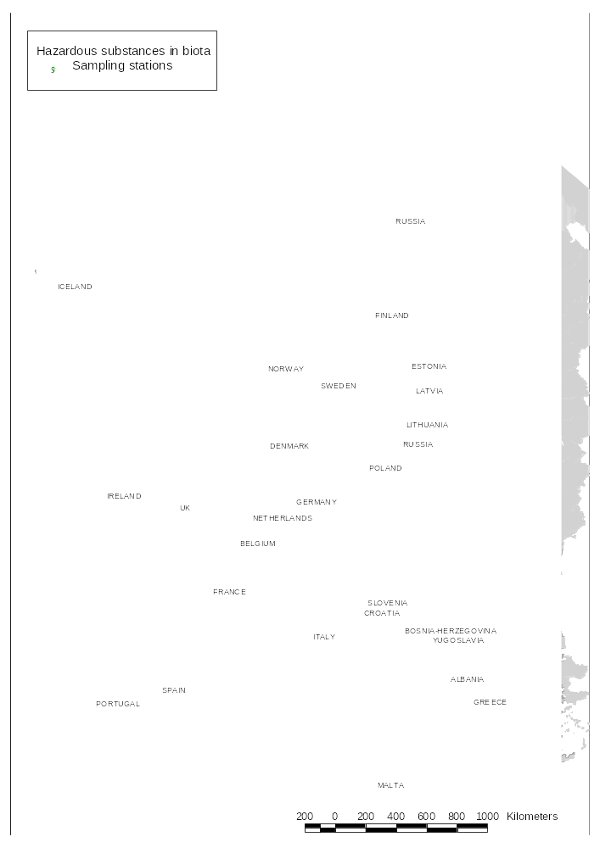
Figure 6.1 Map showing location of stations included in indicator calculations (median and/or trend) of concentrations of cadmium, mercury, lead, DDT, lindane or PCB₇ in mussels (blue mussel - Mytilus edulis, Mediterranean mussel - M. galloprovincialis) and fish (Atlantic cod - Gadus morhua, herring - Clupea harengus or flounder - Platichthys flesus) 1985-1999.

Temporal coverage for concentrations in biota
Temporal trend data for biota generally covers the period 1985-1999, but most series were far from complete (see Tables A.1-A.6). Many series cover only a small part this period, for others, there were large gaps, up to 9 years, of missing observations. In some areas, different stations were sampled in different years. The available data for each time series have been used for trend detection. The number of stations for each country and year varied from 0 to 30 stations monitored annually. For the Mediterranean, the French data covers the period 1985-1999, while Greek data were from 1993-1999.

Data analysis
Part of the OSPAR data set contains high and low estimates of riverine input values as tonnes per year per region. The lower estimate in the data base was calculated in such a way that any result below the detection limit was considered equal to zero, while for the upper estimate, the value of the detection limit was used. For the indicator of all inputs the average was calculated of the high and low input values. Using these average values for all regions the sum of direct and riverine input into the coastal waters of the North-East Atlantic in 1990 was calculated and set equal to 100 %. Next, yearly inputs and contributions to the inputs in the period 1990-1999 were expressed as percentages of the 1990 input. The same procedure was applied to atmospheric input. The results were shown in Figure 5.1 and Table 5.1. The apparent time trends may be influenced by changes in monitoring program or reporting practice over time, as the loads to some extent were calculated by summing the reported values, not correcting for sources where a specific parameter had not been measured. Also, the use of average of high and low estimates means that any changes over time in detection limits will be reflected in the apparent trends. A further analysis of the load data should be done to investigate this.

Data for mussels and fish were reported on different bases (i.e., wet weight, dry weight, or lipid weight). These data could be converted to another and more appropriate basis provided the relevant information was also available for the particular sample in question. Some of the variation in concentrations of hazardous substances can be reduced by normalising with respect to percent dry weight or percent lipid (fat) weight of the tissue measured. Concentrations were often submitted on a wet weight basis but the water content in tissues can vary considerably. Hence, it was often appropriate to convert concentrations to a dry weight basis, or to a lipid weight basis, as in the case of lipophilic substances such as DDTs, lindane, and PCBs. All ICES records were specified as dry, wet or lipid. Most data were on wet-weight basis (124117 records). Of these data, the dry-weight ratio was specified for 108141 records. 33438 records were on lipid basis, of these data, lipid content was given for 25883 records.

The ICES data usually contains both extracted lipid % and total fat weight as percent. For most of the records where both occur, they were quite similar, but there were a number of strong discrepancies, going both ways. In particular, records where total fat was much lower than extracted lipids should be considered suspect; there might have been problems with the fat determination. This problem in particular was important for data on flounder. In cases where it had been necessary to convert concentrations from lipid weight basis to dry-weight to harmonise values within time series for trend analysis, this had only been done if extracted lipids and fat-weight agrees within 20% when both were given, as it was not specified which of the fat determinations had been used as basis for the fat-based concentration. If only one fat parameter had a value, that value had been used to convert the concentration.

The available data were inspected, and data were converted to an appropriate basis that also seemed to give the best coverage over stations and time. This was considered separately for each species/tissue and parameter group. In the cases where the basis varied over time within station, data that could not be converted to the chosen basis from sample-specific information were discarded in the statistical analysis. It was decided not to use a general conversion factor (e.g. 20% wet weight for mussels) because this might introduce artificial time trends in many cases.

Some data sets were discarded because of insufficiently reported observations below detection limit that might bias the estimates. In such cases, whole data sets were discarded and not just below detection limit values.

For all data for mussels and fish, observations reported as below a defined detection limits were handled as ranges (0-detection limit), giving low-high ranges also for sums over parameters and for median values for several observations.

Raw data were aggregated into median values of the available data 1995-1999 in order to assess recent contaminant levels shown in the maps (e.g. Figures 6.2). Stations without any data after 1994 were not included in the maps. Medians were compared to "Low" and "High" concentrations (cf. Table 7.2).

For some Swedish ICES data covering the period 1986-1999, duplicates/triplicates were found with identical sample identifiers and sample descriptors (fat content, tissue weight etc.) but different contaminant levels. Such record sets have been aggregated into ranges min-max, to account for the possibility that they represent replicate analyses on the same sample.

Local time trend analysis
Time series were identified by station code where available, otherwise by location coordinates. Because of this, some data that constitute parts of the same time series may have been separated into different data series in the analysis because coordinates may vary for a station.

To do a statistical analysis of time trends on a station-by-station basis, raw data for concentrations were aggregated into yearly median values within each time series (with a few exceptions). The stations have varying amount of replicate samples per date, and varying number of dates per year. For each data series (species, tissue, location and contaminant), simple median values per year were calculated. For the French Mediterranean data on Mytilus galloprovincialis, log-transformed concentrations were analysed by variance analysis, using Station*Year and Season (1-4) as factors. The Seasons 1-4 were: day 30-70, 120-170, 210-250 and 300-340). Most of the samples were collected in February, May, August or September, respectively, but also from the succeeding months. Up to 1991, the sampling was more evenly distributed between all 12 months, but still concentrated within the 4 periods mentioned above. For all years, the sampling was distributed more or less equally over all 4 seasons. The extracted yearly values for the French Mediterranean data represent autumn levels. The yearly estimates from this analysis, with the affect of season removed, was used for trend analysis. For Greek data on metals in M. galloprovincialis, the trend tests were done using individual sample dates, as there were 2-4 sampling times a year, with seemingly little seasonal influence or serial correlation.

Monotone time trends were tested using Mann-Kendall statistics (ICES, 1999), modified by taking low-high ranges explicitly into account in counting concordant, discordant and tied observation pairs. Time trends were based on all available data from 1985 to 1999 for each time series - the time coverage was very variable between series. However, some of the trends shown may be based on mainly older data. Significance of trends was based on two-sided test with a nominal 5 % significance level, separately for each time series, without regard to serial correlation. Assessments of "no trend" (i.e. no statistically significant trend) may be due both to actual lack of trend and to insufficient data.

Regional time trend analysis
The general changes in concentrations for each sea region (Figure 7.1) were based on the yearly aggregate values (averages) for each combination of location, year, species and tissue. Details of the calculation of these yearly averages were given in the text above. The regional time trends have been extracted from these aggregates for each species, tissue and region. Only series with data for at least 3 years, and with data at least up to 1994 have been used. To diminish the effect on apparent time trends of changing geographical coverage between years, overall yearly average values were extracted by variance analysis (general linear model - GLM) with location and year as factors. The purpose of this was to separate the variation due to stations from the change over time, and achieve yearly averages that were adjusted for differences in geographical coverage between years. Some apparent changes in time may still be due to changes in geographical coverage between years. The analyses were done using scaled values with the average value of each series, to get a representative average of relative variation over time, regardless of absolute levels at each station.

The indicators in Figure 7.1 show concentrations as a percentage of the regional average for the 1990. Figure 7.1 only shows the trends based on upper estimate of the yearly average. The differences between lower limits and upper estimates were generally small or at least consistent through the time series. Some exceptions where relative large differences were found were: cadmium in Atlantic cod in 1992-1993, lead in blue mussels in 1991 and for Baltic herring in 1992. These deviations did not change the general picture of change of metal concentrations with time.

Present levels and trends (state) of hazardous substances
Concentrations of hazardous substances in blue mussels and fish constitute time integrating state indicators for coastal water quality. An advantage to using biota concentrations as indicators, as opposed to using water or sediment, are that they may be of direct ecological importance as well as have implications for human health and commercial interests in harvesting marine resources.

Regional time trend assessments
Figure 7.1 show aggregated time trends of concentrations in mussels and fish for each region as averages of the relative variation in time over locations with sufficient data for the period 1984-1999. The charts give visual indications of the general development; without any formal assessment of statistical significance. The trends were averages over stations with very different temporal coverage, and also with very different time change patterns. No attempt to weight the stations according to representativeness was made, due to lack of information. However, a visual comparison with indicators in Figure 6.1 and the relevant maps shown in Figures 7.2-7.24 indicated that the indicators were reasonable summaries of the development over a majority of the locations included.

The aggregated results indicated a decreasing trend for cadmium, mercury, lead, DDT, lindane and PCB₇ in mussels and fish from both the North-East Atlantic and the Mediterranean Sea. Of the 178 (DDT) to 286 (cadmium) site specific time series analysed for mussels 8-15% showed significant trends, most of which were decreasing. Only 25 time series for lindane were measured. All of these concerned mussels from the Mediterranean and 7 showed decreasing trends (Tables 7.2-7.4).

Due to the general lack of information from Denmark, France (Atlantic border), Portugal and United Kingdom (cf., Chapter 6), conclusions about the general levels and trends of the North-East Atlantic must be drawn with care.

Previous assessments of non-spatially aggregated data sets showed that most non-aggregated and site-specific time series on concentrations in organisms in the coastal waters of the North-East Atlantic show non-significant trends. This was also found in this assessment. It should be emphasised that this may be due to lack of sufficient data. Even so, there might still be substantial long-term trends. Statistically significant trends were found in this study mainly at locations in estuaries and fjords, which were closer to the sources of pollution.

The effectiveness of using of organisms as indicators for contaminant monitoring was hampered in part by limited spatial distribution for any given species. Furthermore, comparing results from different species was difficult mainly due to differences in bioaccumulation rates between species. The most comprehensive datasets available were for Atlantic cod (Gadus morhua).

OSPAR has addressed the difficult issue of coupling changes in concentrations found in biological indicators to changes in inputs, even when the study area is confined to a river mouth (OSPAR 1998). Even greater precaution is needed when considering a wider geographical area.

Figure 7.1 Change (%) in cadmium, mercury, lead, DDT, lindane and PCB in blue mussels (M. edulis) in the North-East Atlantic, and Mediterranean mussels (M. galloprovincialis) in the Mediterranean and Atlantic cod (Gadus morhua) in the North-East Atlantic and herring (Clupea harengus) in the Baltic 1985-1999. Data source: OSPAR, HELCOM, EEA-member countries.

Mussels | Fish
Cadmium
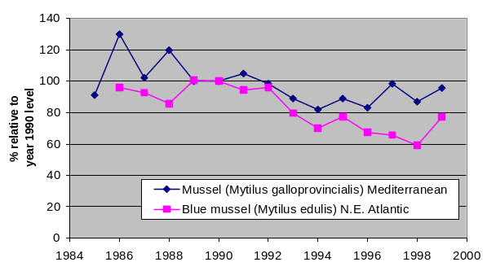 | 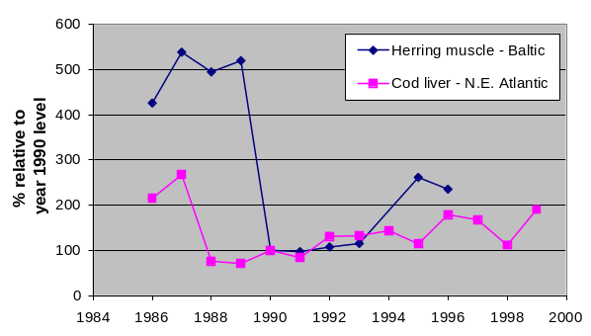
Mercury
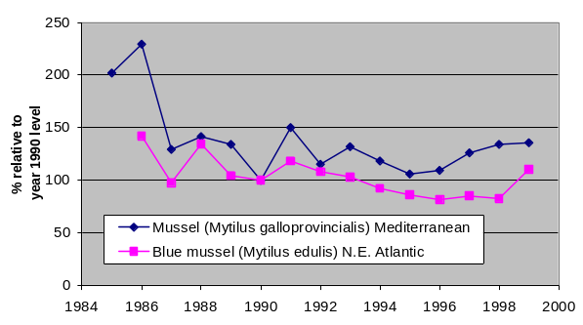 | 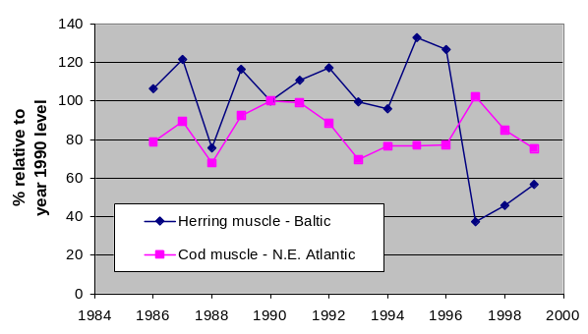
Lead
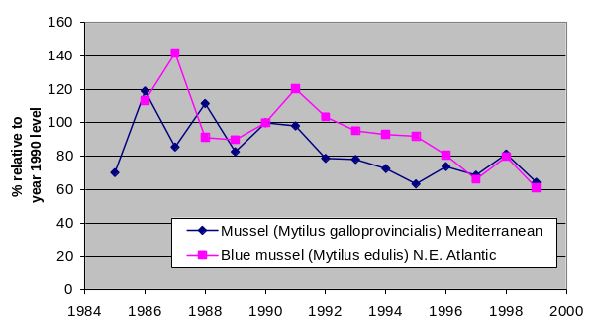 | 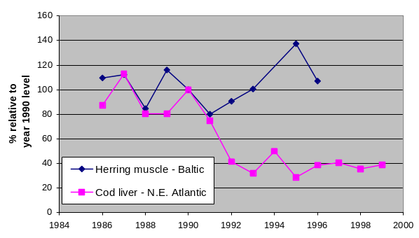
DDT
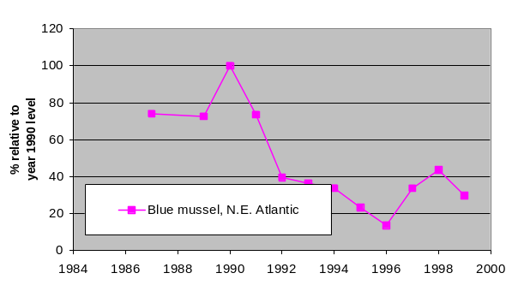 | 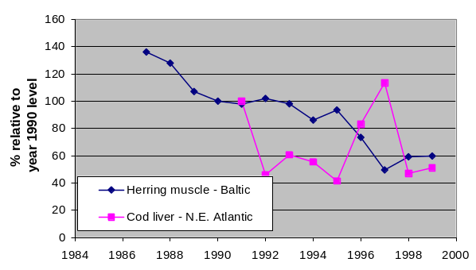
(Figure 7.1)

Lindane
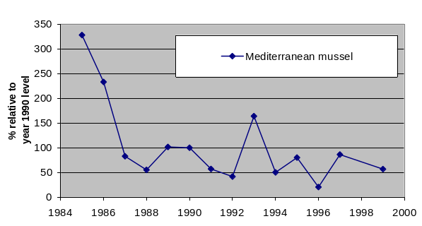 | no data
PCB
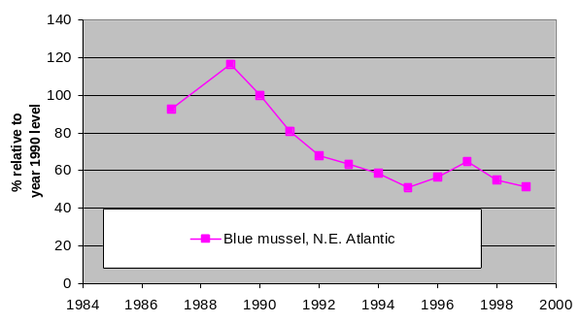 | 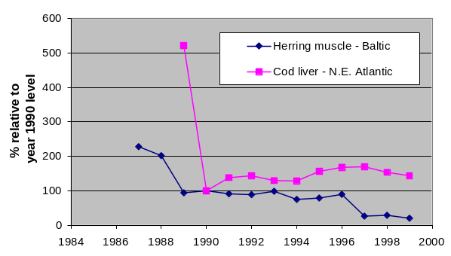

"Low" and "High" concentrations of contaminants
Background concentrations
Cadmium, mercury and lead occur naturally in the environment, which means that they can be found in background concentrations in all media. Organic contaminants DDT, lindane and PCB are synthetic substances and do not occur naturally and therefore background concentrations should be zero.

- Cadmium is naturally found in seawater at levels of 5-26 ng/L (OSPAR, 2000) and all marine organisms accumulate cadmium even in areas with no major local inputs. Suggested high background reference concentrations is 0.1 mg/kg for blue mussels (OSPAR, 1999) and 0.3 mg/kg wet weight for cod liver (Green & Knutzen, 2003).

- Natural concentrations of mercury in estuarine and coastal waters are typically around 20 ng/L and background concentrations in mussels (whole soft part) and fish (cod muscle) are 0.01 (OSPAR, 1999) and 0.05 mg/kg wet weight (Green & Knutzen, 2003), respectively.

- The natural concentrations of lead in seawater varies considerably between coastal and oceanic, being more than 100 ng/L and 30 ng/L, respectively (OSPAR, 1996). Background concentrations in blue mussels and fish liver (Atlantic cod) are as low as 0.2 (OSPAR 1999) and 0.1 mg/kg wet weight (Green & Knutzen, 2003). Levels for human consumption are set at approximately ten times that concentration.

- Although it is synthetic, lindane is found in seawater world-wide. The general background concentration is near 0.6 ng/L (Schreitmüller & Ballschmiter 1995). In blue mussels, background concentrations of lindane are 0.01 µg/g wet weight (OSPAR, 1999).

- PCBs are lipid soluble, have very low water solubility and are predominantly associated with particles in natural waters (SIME, 2001). Background concentrations of PCBs in blue mussels are 0.002 µg/g wet weight, for cod liver 0.1 µg/g wet weight and for herring muscle 0.15 µg/g wet weight.

- The pesticide DDT has been known as an environmental contaminant since the 1950s. Because of its physicochemical properties, it (or its derivates) can now be found in nearly all compartments of the biosphere. Background concentrations of DDT in blue mussels are suggested to be 0.001 µg/g wet weight and for cod liver 0.2 µg/g wet weight (Green & Knutzen, 2003) and for herring muscle 0.05 µg/g wet weight (Knutzen, 1987).

Classification of measured concentrations
To assess the concentration levels taken into account in this report it was helpful to establish a "low" and "high" concentration to compare to (Table 7.1). No environmental quality standards are available yet under the Water Framework Directive. Therefore, other ways for classification had to be found for this assessment. Limit values for concentration classes were found, in order of preference: as applied in EU-legislation, Marine Conventions, other international agreements, national assessments or as an arbitrary selection (10 times "Low" value). Except for the "High" concentration designated by EU-legislation, the limits have no legal application.

Natural background levels for the three metals have been used as low concentration limit. For the three organic substances, background reference concentrations of low diffuse pollution levels in otherwise pristine areas have been used as low concentration limit as well as OSPAR ecotoxicological assessment criteria, which are based on toxicity tests.

For "High" concentrations EU-legislation was used where possible. EU-legislation on foodstuffs provided "High" values for cadmium, mercury and lead in mussels and fish (221/2002/EC). Else, national limit values have been applied or a factor of 10 above the low concentration.

Observed concentrations were classified into three classes in relation to these limit values: 1. below low limit, 2. between low and high, 3. above high.

On this basis, many of the current concentrations (median of 1995-1999) in the North-East Atlantic for cadmium (81%), mercury (78%) and lead (53%) lie between "Low" and "High". This is unexpected considering that many stations are remote from known point sources and indicates that the OSPAR limits used are probably too low to be useful in designating problem areas. The background reference concentrations proposed by Green & Knutzen (2003) are 3-4 times higher (cf., Table 7.1) and might be more appropriate. The OSPAR limits for mercury and PCB in fish muscle may also be too high; 40-55% of the stations have concentrations between "Low" and "High".

Table 7.1 Limit concentration used for classification in maps in figures 6.2-6.24 and tables 6.2-6.4: Low/High concentration limits for spatial assessment of cadmium, mercury, lead, DDT, lindane and PCB. EU foodstuff limits are highlighted in grey shade. Except for EU legislation the limits have no legal application.

Name  and tissue | Latin name | Low/  High | mg/kg wet wt. | Reference | Comment
CADMIUM
Mussels | Mytilus sp.¹ | Low | 0.1 | OSPAR 1999 | Value rounded down from original  BRC ² of 0.11 mg/kg wet weight; low compared to 0.4 mg/kg wet weight (Green & Knutzen, 2003)
Mussels | Mytilus sp. | High | 1.0 | EU 2001 | Foodstuffs limit for "bivalve molluscs"  Regulation (EC) No. 466/2001
Atlantic cod, liver | Gadus morhua | Low | 0.3 | Green & Knutzen, 2003 | Based on 90 percentile of 1184 individuals from reference areas
Atlantic cod, liver | Gadus morhua | High | 0.5 | TemaNord 1994 | Danish limit for "fish liver"
Herring, muscle | Clupea harengus | Low | 0.01 | Knutzen 1987 | Upper limit to proposed range in background level
Herring, muscle | Clupea harengus | High | 0.05 | EU 2002 | Foodstuffs limit for fish muscle  Regulation (EC) No. 221/2002
MERCURY
Mussels | Mytilus sp.¹ | Low | 0.01 | OSPAR 1999 | BRC limit. A BRC of 0.04 ppm wet weight has been suggested (Green & Knutzen, 2003)
Mussels | Mytilus sp. | High | 0.50 | EU 2001 | Foodstuffs limit for "bivalve molluscs"  Regulation (EC) No.466/2001
Atlantic cod, muscle | Gadus morhua | Low | 0.05 | OSPAR 1999 | BRC limit. A BRC of 0.1 ppm wet weight has been suggested (Green & Knutzen, 2003)
Atlantic cod, muscle | Gadus morhua | High | 0.50 | EU 2001 | Foodstuffs limit for fish muscle  Regulation (EC) No. 466/2001
Herring, muscle | Clupea harengus | Low | 0.05 | Knutzen 1987 | Upper limit to proposed range in background level
Herring, muscle | Clupea harengus | High | 0.50 | EU 2001 | Foodstuffs limit for fish muscle  Regulation (EC) No. 466/2001
LEAD
Mussels | Mytilus sp.¹ | Low | 0.2 | OSPAR 1999 | Value rounded down from original BRC ² of 0.19 ppm w.w. A BRC of 0.6 ppm wet weight has been suggested (Green & Knutzen, 2003)
Mussels | Mytilus sp. | High | 1.5 | EU 2002 | Foodstuffs limit for "bivalve molluscs"  Regulation (EC) No. 221/2002
Atlantic cod, liver | Gadus morhua | Low | 0.1 | Green & Knutzen, 2003 | Based on 90 percentile of 1182 fish from reference areas
Atlantic cod, liver | Gadus morhua | High | 1.0 |  | Taken and 10 times LOW value
Herring, muscle | Clupea harengus | Low | 0.01 | Knutzen 1987 | Upper limit to proposed range in background level
Herring, muscle | Clupea harengus | High | 0.20 | EU 2002 | Foodstuffs limit for fish muscle  Regulation (EC) No. 221/2002
Table 7.1 (cont.)

Name  and tissue | Latin name | Low/  High | mg/kg wet wt. | Reference | Comment
DDT
Mussels | Mytilus sp.¹ | Low | 0.01 | OSPAR 1999 | EAC ³ limit for DDE. A BRC of 0.001 ppm wet weight has been suggested (Green & Knutzen, 2003)
Mussels | Mytilus sp. | High | 0.10 |  | Taken as 10 times LOW
Atlantic cod, liver | Gadus morhua | Low | 0.5 | OSPAR 1999 | EAC limit DDE. A BRC of 0.2 ppm wet weight has been suggested (Green & Knutzen, 2003)
Atlantic cod, liver | Gadus morhua | High | 5.0 |  | Taken as 10 times LOW
Herring, muscle | Clupea harengus | Low | 0.05 | Knutzen 1987 | Upper limit to proposed range in background level
Herring, muscle | Clupea harengus | High | 0.50 |  | Taken as 10 times LOW
LINDANE
Mussels | Mytilus sp.¹ | Low | 0.01 | OSPAR 1999 | EAC limit. A BRC of 0.001 ppm wet weight has been suggested (Green & Knutzen, 2003)
Mussels | Mytilus sp. | High | 0.10 |  | Taken as 10 times LOW
PCB₇
Mussels | Mytilus sp.¹ | Low | 0.002 | OSPAR 1999 | Value rounded up from original BRC of 0.0017 wet weight
Mussels | Mytilus sp. | High | 0.020 |  | Taken as 10 times LOW
Atlantic cod, liver | Gadus morhua | Low | 0.10 | MON 2001 | EAC limit. A BRC of 0.5 ppm wet weight has been suggested (Green & Knutzen, 2003)
Atlantic cod, liver | Gadus morhua | High | 2.5 | PNUN 1987 | Swedish PCB [total] limit for "fish liver" times 0.5
Herring, muscle | Clupea harengus | Low | 0.15 | Knutzen 1987 | Upper limit to proposed range in background level of PCB [total] times 0.75
Herring, muscle | Clupea harengus | High | 1.5 |  | Taken as 10 times LOW
¹) Blue mussel (Mytilus edulis) for the North-East Atlantic, Mediterranean mussel (M. galloprovincialis) for the Mediterranean
²) Background Reference Concentration
³) Ecotoxicological Assessment Criteria

Local assessment of concentrations and time trends
The maps 7.2 – 7.24 for European seas present for each substance:
- Overview of concentrations in mussels per sampling location,
- Overview of concentrations in fish per sampling location,
- Overview of time trend analysis in mussels per sampling location,
- Overview of time trend analysis in fish per sampling location.
For mercury, also inputs into the Baltic Sea are given in figure 7.10.

Cadmium
The regional assessments of time trend indicated a decreasing trend for cadmium in mussels from both the North-East Atlantic and the Mediterranean Sea (Figure 7.1). No general trends were evident for concentrations in cod liver or herring muscle.

The station-by-station overview of 1995-1999 (2001 for Black Sea) levels of cadmium for mussels (both Mytilus edulis and M. galloprovincialis) indicated that concentrations were elevated in the estuaries for large rivers (e.g. the Seine, northern France), in areas with point discharges (e.g. Sørfjord, western Norway) and in some harbours (Table 7.2, Figure 7.2). In addition, blue mussels in some areas, e.g. along the Norwegian north coast, appeared to be affected by local geology (natural high background concentrations). The only area from which mussels did not appeared to be suitable for human consumption was Sørfjord, Norway and at the locations shown along the Romanian coast in the Black Sea. The high level of cadmium in mussels from the Sørfjord was largely due to industrial activity (zinc smelter) in Sørfjord. Although not necessarily representative for the remainder of European coasts, levels elsewhere appeared to be intermediate. Concentrations in some of these areas, e.g. along the Norwegian North coast, appeared to be affected by higher local background, possibly due to natural variations in mineralogy.

In fish, the 1995-1999 levels never exceeded suggested "High" concentration (Figure 7.3). The data show that cadmium levels were generally low. One area in northern Iceland was an exception, possibly due to inputs from local geology.

Of the 286 temporal trends statistically analysed on station-by-station basis (197 for mussels, 86 for fish) only 27 were significant, 20 down and 7 up (Table 7.2, maps in Figures 7.4 and 7.5). For cadmium, inputs were decreasing (OSPAR, 2000) but the regional trend for mussels and fish (cf. Figure 7.1) did not indicate a clear trend, although a station-by-station analysis revealed a certain dominance of decreasing trends over increasing trends. Levels in some contaminated areas, e.g. the Seine estuary and Sørfjord, appeared to be decreasing. There also appeared to be a general decreasing trend of cadmium in mussels from the French Mediterranean coast. One exception was the Marseilles area, possibly with influence from the river Rhône, at some station of the Aegean Sea. Increasing levels elsewhere in Europe appeared to be associated with harbour areas. In general, cadmium levels in fish from the Skagerrak (the area between Norway, Sweden and Denmark) appeared to decrease. The results from the Rhine estuary (Belgium-Dutch border) and the inner Oslofjord illustrated that stations in close proximity may have conflicting results (cf. Figures 7.4 and 7.5).

Previous assessments for of non-spatially aggregated data sets on metals showed that most non-aggregated and site specific time series on cadmium concentrations in organisms in the coastal waters of the North-East Atlantic showed non-significant trends. This was also found in this assessment. It should be emphasised that this may be due to lack of sufficient data. There might still be substantial long-term trends. Statistically significant trends were found mainly at locations in estuaries and fjords, which were closer to the sources of land-based diffuse pollution.

Table 7.2 Subindicator summary assessment for cadmium in mussels and fish from the North-East Atlantic, Baltic Sea, Mediterranean Sea and Black Sea. See Table 7.1 for selection of indicator species and Low/High concentrations limits. (See also results in maps in Figures 7.2-7.4.)

 |  | Spatial variation |  |  | Time trends
Sea region | Subindicator | Total no. of stations | Number over Low | Number over High | Total no. of stations | Number  Down | Number  Up
North-East | Mussels | 119 | 102 | 6 ¹ | 160 | 10 | 3
Atlantic | Fish | 25 | 2 | 0 | 59 | 2 | 1
Baltic Sea | Mussels | 1 | 1 | 0 | 1 | 0 | 0
 | Fish | 10 | 0 | 0 | 30 | 2 | 0
Mediterranean | Mussels | 36 | 26 | 0 | 36 | 6 | 3
Sea | Fish | 0 |  |  | 0
Black Sea | Mussels | 3 | 3 | 3 | 0
 | Fish | 0 |  |  | 0
¹) Concerns only Sørfjord in western Norway

Map: Cadmium (Cd) in mussels

Figure 7.2 Cadmium (Cd) in mussels (Mytilus edulis - North-East Atlantic; M. galloprovincialis - Mediterranean and Black Sea), median mg/kg wet weight for 1995-1999 (2001 for Black Sea). See Table 7.1 for basis of classification. EU-legislation limit for cadmium in foodstuffs "bivalve molluscs is 1 mg/kg wet weight (EU, 2001b). (Based on data from OSPAR and EEA-member countries (Mediterranean), and data reported by Romania, see also Table 4.1). NB: larger symbols may obscure other symbols.).

Map: Cadmium (Cd) in liver of cod and muscle of herring

Figure 7.3 Map 2. Cadmium (Cd) in liver of cod (Gadus morhua) and muscle of herring (Clupea harrengus), median mg/kg wet weight for 1995-1999. See Table 7.1 for basis of classification. EU-legislation limit for cadmium in foodstuff muscle of fish is 0.05 mg/kg wet weight (EU, 2001b). (Based on data from OSPAR and HELCOM, see also Table A.1). NB: larger symbols may obscure other symbols.

Map: Cadmium (Cd) time trend in blue mussel

Figure 7.4 Cadmium (Cd) time trend in blue mussel (Mytilus edulis) in the North-East Atlantic and the Mediterranean mussel (M. galloprovincialis) 1985-1999 (cf. Table 7.2).

Map: Cadmium (Cd) time trend in liver of cod and muscle of herring

Figure 7.5 Cadmium (Cd) time trend in cod liver, herring liver/muscle, flounder liver, 1986-1999. (cf. Table 7.2).

Mercury
The regional assessments of time trend indicated a decreasing trend for mercury in mussels from both the North-East Atlantic and the Mediterranean Sea and no general trend was evident for concentrations in cod or herring muscle (Figure 7.1).
On a station-by-station basis the 1995-1999 levels of mercury in blue mussels in Europe were somewhat over background levels in most areas (Table 7.3, Figure 7.6). There were more locations with concentrations at background levels in remote areas than in the most industrialised regions (e.g. Iceland and northern Norway). The general picture indicates a diffuse exposure of coastal mussel populations to mercury, presumably mainly atmospheric, but with no real hot-spots. The results must be interpreted with care, however, since not all European coastal areas were included in the survey.

The concentrations of mercury in Atlantic cod muscle (Figure 7.7) showed a similar pattern as blue mussel. On a station-by-station basis levels were at background concentration in cod collected in areas remote from known point sources. Although Atlantic cod do not store much lipid in the muscle, most of the mercury accumulate in this tissue. The other fish species monitored, Baltic herring, accumulated little mercury in muscle. Levels of mercury in the Baltic appeared to be low (including the comparison with one location with cod data).

Of the 278 temporal trends analysed on a station-by-station basis (189 for mussels, and 89 for fish) only 20 were significant, 16 down and 4 up (Table 7.3, maps in Figures 7.8 and 7.9). For mercury, inputs were decreasing (OSPAR, 2000), but no clear regional trend was registered using mussel and fish indicators (cf. Figure 7.1). There was some dominance of decreasing trends over increasing trends, but most of the stations show no significant trend. In mussels in most areas, notably in the Mediterranean, there were decreases in the mercury concentrations. It was not clear why there were increasing trends of mercury at Gothenburg and at the outlet of the river Ems. As for blue mussels, there were decreasing levels of mercury in fish collected at various sites, including the German Bight. The only area with an increase was at the estuary of the river Oder, near Stettin, that empties into the Baltic Sea.
Through the last centuries, mercury has been used in a wide range of human applications (chlor-alkali industry, manufacturing, dentistry, metallurgy, electronic household appliances). Both retrieval and use of the metal has caused an increased mercury load in marine, freshwater and terrestrial environments. Today the main sources of the metal to the marine environment were atmospheric deposition, industrial outfalls and municipal sewage. Overall, atmospheric deposition appears to be important except near point sources and in estuaries draining industrialised regions.

Table 7.3 Subindicator summary assessment for mercury in mussels and fish from the North-East Atlantic, Baltic Sea, Mediterranean Sea and Black Sea. See Table 6.1 for selection of indicator species and Low/High concentrations limits. (See also results in maps in Figures 7.6-7.10.)

 |  | Spatial variation |  |  | Time trends
Sea region | Subindicator | Total no. of stations | Number over Low | Number over High | Total no. of stations | Number  Down | Number  Up
North-East | Mussels | 118 | 92 | 0 | 156 | 4 | 2
Atlantic | Fish | 28 | 12 | 0 | 63 | 3 | 0
Baltic Sea | Mussels | 1 | 1 | 0 | 1 | 0 | 1
 | Fish | 16 | 4 | 0 | 26 | 2 | 1
Mediterranean | Mussels | 32 | 31 | 0 | 32 | 7 | 0
Sea | Fish | 0 |  |  | 0
Black Sea | Mussels | 0 |  |  | 0
 | Fish | 0 |  |  | 0

Map: Mercury (Hg) in mussels

Figure 7.6 Mercury (Hg) in mussels (Mytilus edulis - North-East Atlantic; M. galloprovincialis - Mediterranean), median mg/kg wet weight for 1995-1999. See Table 7.1 for basis of classification. EU-legislation limit for mercury in foodstuffs "bivalve molluscs is 0.5 mg/kg wet weight (EU, 2001b). (Based on data from OSPAR and EEA-member countries (Mediterranean), see also Table A.2).). NB: larger symbols may obscure other symbols.

Map: Mercury (Hg) in muscle of cod and muscle of herring

Figure 7.7 Mercury (Hg) in muscle of cod (Gadus morhua) and muscle of herring (Clupea harrengus), median mg/kg wet weight for 1995-1999. See Table 7.1 for basis of classification. EU-legislation limit for mercury in foodstuff muscle of fish is 0.5 mg/kg wet weight (EU, 2001b). (Based on data from OSPAR and HELCOM, see also Table A.2). NB: larger symbols may obscure other symbols.

Map: Mercury (Hg) time trend in mussels

Figure 7.8 Mercury (Hg) time trend in blue mussel (Mytilus edulis) in the North-East Atlantic and the Mediterranean mussel (M. galloprovincialis) 1985-1999 (cf. Table 7.3).

Map: Mercury (Hg) time trend in muscle of cod, herring and flounder

Figure 7.9 Mercury (Hg) time trend in muscle of cod, herring and flounder, 1986-1999. (cf. Table 7.3).

Map: Mercury (Hg) input to the Baltic Sea, 1995 and mercury (Hg) concentrations in muscle of cod and muscle of herring

Figure 7.10 Mercury (Hg) input to the Baltic Sea, 1995 and mercury (Hg) concentrations in muscle of cod (Gadus morhua) and muscle of herring (Clupea harrengus), median mg/kg wet weight for 1995-1999. See Table 7.1 for basis of classification. EU-legislation limit for mercury in foodstuff muscle of fish is 0.5 mg/kg wet weight (EU, 2001b). (Based on data from OSPAR and HELCOM, see also Table A.2). NB: larger symbols may obscure other symbols.

Lead
The regional temporal trend assessment indicated a decreasing trend for lead in mussels from both the North-East Atlantic and the Mediterranean Sea and for cod in the North-East Atlantic (Figure 7.1). This indicated the effect of remedial measures on atmospheric deposition. No decreasing trend was evident for concentrations in herring muscle in the Baltic.

The station-by-station overview of 1995-1999 levels of lead revealed that it was found at background levels in blue mussels from areas remote from local or regional sources, but concentrations of the metal were above background level along most of the European coasts (Table 7.4, Figure 7.11). In contrast to the other metals of concern (mercury and cadmium), there were levels of lead in blue mussels above the limits for human consumption at a number of locations. The high level at the Norwegian west coast was caused by inputs from a zinc smelter in Sørfjord. The other sources also appeared to be associated with local point sources rather than riverine inputs.

Lead concentrations in cod liver were generally low. An exception was in the inner Oslofjord where values were higher but did not exceed 10 times the background concentration (Figure 7.12). Elevated levels may have been due to urban influence. Concentrations were intermediate in herring muscle (data from the Baltic only).

Of the 266 temporal trends statistically analysed on a station-by-station basis (194 for mussels, 72 for fish) 39 were significant, 30 down and 9 up (Table 7.4, maps in Figures 7.13 and 7.14). Inputs of lead were decreasing (OSPAR, 2000), but no clear overall trends were found using mussel and fish state-indicators. Although there was a certain dominance of decreasing trends over increasing trends on a station-by-station basis. Increasing concentrations were found in Ems and Gothenburg (as for mercury), as well as the Aegean sea (Figure 7.13). The reasons for these increases were not clear. Concentrations decreased at nearly all the Norwegian locations, the German Bight and in the Scheldt region (mouth of the Rhine). Statistically significant trends were found mainly at locations in estuaries and fjords, which were closer to the sources of land-based diffuse pollution.

In contrast to cadmium, lead is extensively recycled because it is associated with many products that are recycled. Its use as additive to petrol has decreased drastically over the past decade, there was a wide range of diffuse sources for lead in addition to point sources. Lead is used in e.g. batteries, ammunition, boat keels, weights (nets, etc), paints, electronic equipment and solder. Although many of the above products lend themselves to recycling, there is an obvious potential for diffuse emissions, e.g. through waste incineration and leaching from landfills. Mining and smelting of lead ore is a substantial local source of lead inputs to marine ecosystems.

Table 7.4 Subindicator summary assessment for lead in mussels and fish from the North-East Atlantic, Baltic Sea, Mediterranean Sea and Black Sea. See Table 6.1 for selection of indicator species and Low/High concentrations limits. (See also results in maps in Figures 7.11-7.14.)

 |  | Spatial variation |  |  | Time trends
Sea region | Subindicator | Total no. of stations | Number over Low | Number over High | Total no. of stations | Number  Down | Number  Up
North-East | Mussels | 116 | 61 | 8 | 156 | 12 | 2
Atlantic | Fish | 21 | 1 | 0 | 43 | 10 | 0
Baltic Sea | Mussels | 1 | 1 | 0 | 1 | 0 | 1
 | Fish | 10 | 8 | 0 | 29 | 3 | 0
Mediterranean | Mussels | 36 | 23 | 2 | 37 | 5 | 6
Sea | Fish | 0 |  |  | 0
Black Sea | Mussels | 3 | 3 | 3 | 0
 | Fish | 0 |  |  | 0

Map: Lead (Pb) in mussels

Figure 7.11 Lead (Pb) in mussels (Mytilus edulis - North-East Atlantic; M. galloprovincialis - Mediterranean and Black Sea), median mg/kg wet weight for 1995-1999 (2001 for Black Sea). See Table 7.1 for basis of classification. EU-legislation limit for lead in foodstuffs "bivalve molluscs" is 1.5 mg/kg wet weight (EU, 2002). (Based on data from OSPAR and EEA-member countries (Mediterranean) , and data reported by Romania, see also Table A.3). NB: larger symbols may obscure other symbols.

Map: Lead (Pb) in liver of cod and muscle of herring

Figure 7.12 Lead (Pb) in liver of cod (Gadus morhua) and muscle of herring (Clupea harrengus), median mg/kg wet weight for 1995-1999. See Table 7.1 for basis of classification. EU-legislation limit for lead in foodstuff muscle of fish is 0.2 mg/kg wet weight (EU, 2002). (Based on data from ICES, see also Table A.3). NB: larger symbols may obscure other symbols.

Map: Lead (Pb) time trend in mussels

Figure 7.13 Lead (Pb) time trend in blue mussel (Mytilus edulis) in the North-East Atlantic and the Mediterranean mussel (M. galloprovincialis) 1985-1999 (cf. Table 7.4).

Map: Lead (Pb) time trend in liver of cod, liver/muscle of herring and liver of flounder

Figure 7.14 Lead (Pb) time trend in cod liver, herring liver/muscle, flounder liver, 1986-1999. (cf. Table 7.4).

DDT
The regional assessment of time trend indicated a decreasing trend for DDT in mussels from the North-East Atlantic (Figure 7.1). The level in herring muscle in the Baltic was decreasing. The levels in Atlantic cod have varied considerably.

With respect to the station-by-station overview of 1995-1999 levels the of DDT in blue mussels was low all over Europe (Table 7.5, Figure 7.15). Levels above background have only been observed in mussels collected from a site in the Sørfjord, western Norway. The lack of change in DDT concentration in mussels at most sites presumably indicates that the current background level was maintained through ecosystem recycling or inputs through slow leaching or long-range transport.

Similarly to blue mussels, the concentrations of DDT in Atlantic cod liver was at background levels in most areas, even in the Baltic (Figure 7.16). Somewhat elevated concentrations, but below 10 times the background concentration, were found at three locations in Norway. The sites reflected both fresh discharges of DDT (by leaching from containers or waste) and leaching from old deposits.

For the Black Sea, there was too little data available to make assessments. The concentration of DDTs in mussels for the single location with data on the Romanian Coast were all in the intermediate range (map in Figure 7.15), but this may not be representative for the region.

Of the 178 temporal trends analysed (99 for mussels, 79 for fish) only 15 were significant, and 13 were down (Table 7.5, Figures 7.17 and 7.18). As expected, DDT concentrations in fish had decreased in most areas, including the Baltic and the Scheldt (Rhine estuary). An exception was cod from the Oslofjord and the Southeast coast of Iceland. There was no known reason for the increase found at the one site in eastern Iceland. As for the metals, substantial long-term trends might be undetected due to insufficient data. Statistically significant trends were found mainly at locations in estuaries and fjords, which were closer to the sources of land-based diffuse pollution.

Table 7.5 Subindicator summary assessment for DDT in mussels and fish from the North-East Atlantic, Baltic Sea, Mediterranean Sea and Black Sea. See Table 6.1 for selection of indicator species and Low/High concentrations limits. (See also results in maps in Figures 7.15-7.18.)

 |  | Spatial variation |  |  | Time trends
Sea region | Subindicator | Total no. of stations | Number over Low | Number over High | Total no. of stations | Number  Down | Number  Up
North-East | Mussels | 78 | 3 | 0 | 98 | 3 | 1
Atlantic | Fish | 26 | 4 | 0 | 55 | 3 | 1
Baltic Sea | Mussels | 0 |  |  | 1 | 0 | 0
 | Fish | 14 | 0 | 0 | 24 | 7 | 0
Mediterranean | Mussels | 0 |  |  | 0
Sea | Fish | 0 |  |  | 0
Black Sea | Mussels | 1 | 1 | 0 | 0
 | Fish | 0 |  |  | 0

Map: DDT in mussels

Figure 7.15 DDT (expressed as DDE+DDD) in mussels (Mytilus edulis - North-East Atlantic ; M. galloprovincialis - and Black Sea, median mg/kg wet weight for 1995-1999 (2001 for Black Sea). See Table 7.1 for basis of classification. (Based on data from OSPAR and EEA-member countries (Mediterranean), and data reported by Romania, see also Table A.4). NB: larger symbols may obscure other symbols.

Map: DDT in liver of cod and muscle of herring

Figure 7.16 DDT (expressed as DDE+DDD) in liver of cod (Gadus morhua) and muscle of herring (Clupea harrengus), median mg/kg wet weight for 1995-1999. See Table 7.1 for basis of classification. NB: larger symbols may obscure other symbols.

Map: DDT time trend in mussels

Figure 7.17 DDT (expressed as DDE+DDD) time trend in blue mussel (Mytilus edulis) in the North-East Atlantic 1985-1999 (cf. Table 7.5).

Map: DDT time trend in liver of cod, liver/muscle of herring and liver of flounder

Figure 7.18 DDT (expressed as DDE+DDD) time trend in cod liver, herring liver/muscle, 1986-1999. (cf. Table 7.5).

Lindane
The regional assessment of time trend for lindane in Mediterranean mussels indicated a decreasing trend (Figure 7.1). For the Black Sea, there was too little data available to make a regional assessment for this sea. The available data for the Black Sea were from a single location on the Romanian coast and was not representative for the region.

The station-by-station overview of 1995-1999 levels of lindane covered sites along the French Mediterranean coast and a single station on the Romanian coast of the Black Sea (Figure 7.19). An elevated level was only found at the Romanian station (Figure 7.19).

Of the 25 temporal trends (all mussel stations from the French Mediterranean coast) analysed, 7 were significant, all down (Table 7.6 and map in Figure 7.20). Substantial long-term trends might be undetected due to insufficient data. The French data indicated decreased concentrations in mussels in agreement with the known decrease in use of this pesticide.

Table 7.6 Subindicator summary assessment for lindane in mussels and fish from the North-East Atlantic, Baltic Sea, Mediterranean Sea and Black Sea. See Table 7.1 for selection of indicator species and Low/High concentrations limits. (See also results in maps in Figures 7.19-7.20.)

 |  | Spatial variation |  |  | Time trends
Sea region | Subindicator | Total no. of stations | Number over Low | Number over High | Total no. of stations | Number  Down | Number  Up
North-East | Mussels | 0 |  |  | 0
Atlantic | Fish | 0 |  |  | 0
Baltic Sea | Mussels | 0 |  |  | 0
 | Fish | 0 |  |  | 0
Mediterranean | Mussels | 25 | 0 | 0 | 25 | 7 | 0
Sea | Fish | 0 |  |  | 0
Black Sea | Mussels | 1 | 1 | 0 | 0
 | Fish | 0 |  |  | 0

Map: Lindane in mussels

Figure 7.19 Lindane in mussels (Mytilus galloprovincialis - Mediterranean and Black Sea), median mg/kg wet weight for 1995-1999 (2001 for Black Sea). See Table 7.1 for basis of classification.

Map: Lindane time trend in mussels

Figure 7.20 Lindane time trend in Mediterranean mussel (Mytilus galloprovincialis) 1985-1999 (cf. Table 7.6).

PCB
The regional assessment of time trend indicated a decreasing trend for PCB₇ in mussels from the North-East Atlantic and for herring muscle in the Baltic (Figure 7.1). After 1990, the levels in Atlantic cod have increased slightly. For this species, the abrupt reduction from high level in 1989 to more constant levels afterwards was probably an artifact, e.g. due to changes in geographical coverage that the general linear model (GLM) analysis had not been able to correct for.

The station-by-station overview of 1995-1999 levels of PCB₇ in blue mussel reflect the general exposure pattern for this group of substances. It also indicates that long-distance atmospheric transport was less important in temperate parts of Europe than regional or local sources. Aggregated levels (regional assessments) in cod had fluctuated since 1990 with no clear trend one way or the other (Figure 7.1). Concentrations of PCB₇s were generally found at natural high background levels in areas remote from industrial or urban inputs (Figures 7.21 and 7.22). High levels were found in estuaries draining large rivers, e.g. the Seine, Rhine and Ems. In addition, somewhat elevated concentrations were found along the entire northern coast of Spain with local hotspots in the industrialised river valleys. PCB₇ concentrations were also elevated in the area around the inner Oslofjord. Higher concentrations might be found in comparable estuaries around Europe, but limited data coverage (e.g. no UK data) precludes general assessment.

Data for PCB₇ concentrations in fish have a more limited geographical coverage than for blue mussel (Figure 7.22). The data basically shows that a species high in the food chain, such as cod, bioaccumulate PCBs to somewhat higher concentrations than e.g. blue mussel. Otherwise, the geographical pattern of PCB accumulation in cod fits well with that observed for blue mussel, with high concentrations in the inner Oslofjord. As for blue mussel, time trend data indicates generally decreased PCB₇ exposure of fish in some areas of northern Europe, especially the Baltic. The substantial number of stations with no change, however, suggested that decreasing PCB₇ input into the marine environment is a slow process. There was no available data for Mediterranean Sea.

A station-by-station statistical analysis included 208 temporal trends (122 for mussels, 86 for fish) only 18 were significant, all down (Table 7.7, maps in Figures 7.23 and 7.24). PCB₇ inputs in the North-East Atlantic were decreasing (OSPAR, 2000) and the results for mussels and fish (including the Baltic) also confirm this trend. The substantial number of stations where no trend was detected suggested that decreasing PCB₇ input into the marine environment is a slow process.

Table 7.7 Subindicator summary assessment for PCB₇ in mussels and fish from the North-East Atlantic and Baltic Sea. See Table 7.1 for selection of indicator species and Low/High concentrations limits. (See also results in maps in Figures 7.21-7.24.)

 |  | Spatial variation |  |  | Time trends
Sea region | Subindicator | Total no. of stations | Number over Low | Number over High | Total no. of stations | Number  Down | Number  Up
North-East | Mussels | 103 | 32 | 17 | 121 | 10 | 0
Atlantic | Fish | 24 | 15 | 2 | 70 | 4 | 0
Baltic Sea | Mussels | 1 | 0 | 0 | 1 | 0 | 0
 | Fish | 12 | 0 | 0 | 16 | 4 | 0

Map: PCB₇ in mussels

Figure 7.21 PCB₇ in mussels (Mytilus edulis - North-East Atlantic, median mg/kg wet weight for 1995-1999. See Table 7.1 for basis of classification. NB: larger symbols may obscure other symbols.

Map: PCB₇ in liver of cod and muscle of herring

Figure 7.22 PCB₇ in liver of cod (Gadus morhua) and muscle of herring (Clupea harrengus), median mg/kg wet weight for 1995-1999. See Table 7.1 for basis of classification. NB: larger symbols may obscure other symbols.

Map: PCB₇ time trend in mussels

Figure 7.23 PCB₇ time trend in blue mussel (Mytilus edulis) in the North-East Atlantic 1985-1999 (cf. Table 7.7).

Map: PCB₇ time trend in liver of cod, liver/muscle of herring and liver of flounder

Figure 7.24 PCB₇ time trend in cod liver, herring liver/muscle, flounder liver, 1986-1999. (cf. Table 7.7).

Responses/measures

Overall EU chemicals policy
To prevent future environmental hazardous substances problems such as those experienced with e.g. POPs, a strategy for future Chemicals Policy has been presented by the Commission, with the overriding goal of sustainable development (COM(2001) 88). The strategy mainly refers to the following four legal instruments on chemicals currently in force in the Community:

- Council Directive 67/548/EEC relating to the classification, packaging and labeling of dangerous substances, as amended,
- Council Directive 88/379/EEC relating to the classification, packaging and labeling of dangerous preparations, recently replaced by Directive 1999/45/EC,
- Council Regulation (EEC) No. 793/93/ on the evaluation and control of the risks of existing substances,
- Council Directive 76/769/EEC relating to restrictions on the marketing and use of certain dangerous substances and preparations.

The White Paper (COM(2001) 88) states that EU chemicals policy must ensure a high level of protection of human health and the environment as enshrined in the Treaty both for the present generation and future generations while also ensuring the efficient functioning of the internal market and the competitiveness of the chemical industry. Fundamental to achieving these objectives is the Precautionary Principle. Whenever reliable scientific evidence is available that a substance may have an adverse impact on human health and the environment, but there is still scientific uncertainty about the precise nature or the magnitude of the potential damage, decision-making must be based on precaution in order to prevent damage to human health and the environment. Another important objective is to encourage the substitution of dangerous by less dangerous substances where suitable alternatives are available.

To protect human health and promote a non-toxic environment the Commission (COM(2001) 88) proposes that existing and new substances should in the future, following the phasing in of existing substances until 2012, be subject to the same procedure under a single system. The proposed system is called REACH (Registration, Evaluation and Authorization of Chemicals). The requirements, including the testing requirements, of the REACH-system depend on the proven or suspected hazardous properties, uses, exposure and volumes of chemicals produced or imported. All chemicals above 1 ton should be registered in a central database. At higher tonnage, special attention should be given to long-term and chronic effects.

Furthermore the Commission (COM(2001) 88) proposes to implement a step by step process to address the ‘burden of the past’ and develop adequate knowledge for existing substances that industry wants to continue marketing. Given the vast number of existing substances on the market, the Commission proposes that first priority is given to substances that lead to a high exposure or cause concern by their known or suspected dangerous properties physical, chemical, toxicological or ecotoxicological. All such substances should be tested within five years and subsequently be properly assessed for their impact on human health and the environment.

EU policy on hazardous substances in water

Dangerous Substances Directive
Community policy concerning hazardous substances in European waters was introduced more than 25 years ago (in 1976) by Council Directive on water pollution caused by discharges of certain dangerous substances, the Dangerous Substances Directive (76/464/EEC). The Directive has the objective of regulating potential aquatic pollution by the vast number of chemicals already produced in Europe. The Directive covers discharges to inland surface waters, territorial waters, inland coastal waters and ground water. Furthermore, the Directive introduced the concept of List I and List II substances and the purpose was to eliminate pollution from List I substances and to reduce pollution from List II substances. Specific hazardous substances were placed on List I on the basis of their persistence, toxicity and bioaccumulation. Organochlorines, such as DDT (and metabolites) and hexaclorocyclohexane (lindane and other isomers), metals such as cadmium (and its components) and mercury (and its components) are found on List I. List II includes groups and families of substances that have deleterious effect in the aquatic environment. It also contains all individual List I substances that have not been regulated on Community level yet. For the relevant pollutants of List II, Member states must establish pollution reduction programmes, including quality objectives according to Article 7 of Dangerous Substances Directive.

In 1982, the Commission communicated a list to the Council that included 129 “candidate List I substances” on which three more substances were subsequently added. Eighteen individual substances of the “candidate List I” have been regulated in five specific directives (daughter directives to Dangerous Substances Directive), setting emission limit values and quality objectives on a Community level. The specific directives relevant to the contaminants assessed in this report are:

- Council Directive of 22 March 1982 on limit values and quality objectives for mercury discharges by the chlor-alkali electrolysis industry (Council Directive 82/176/EEC);

- Council Directive of 26 September 1983 on limit values and quality objectives for cadmium discharges (Council Directive 83/15/EEC);

- Council Directive of 08 March 1984 on limit values and quality objectives for mercury discharges by sectors other than the chlor-alkali electrolysis industry (Council Directive 84/156/EEC);

- Council Directive of 09 October 1984 on limit values and quality objectives for the discharges of hexachlorocyclohexane of which lindane is included (Council Directive 84/491/EEC);

- Council Directive of 12 June 1986 on limit values and quality objectives for discharges of certain dangerous substances in List I of the Annex to Council Directive 76/464/EEC, (Council Directive 86/280/EEC) as amended by Council Directives 88/347/EEC and 90/415/EEC.

Water Framework Directive
The Dangerous Substances Directive (76/464/EEC) is now integrated in the “Directive 2000/60/EC of the European Parliament and of the Council establishing a framework for the Community action in the field of water policy” (commonly known as the EU Water Framework Directive, WFD) adopted 23 October 2000. Article 16(3) of the directive has the objective to cease or phase out discharges, emissions and losses of priority hazardous substances, with the ultimate aim of achieving concentrations in the marine environment near background values for naturally occurring substances close to zero for man-made synthetic substances. This is to be achieved by 2020. Environmental Quality Standards have been proposed for the water column by the Commission consultant Fraunhofer institute for the 33 priority substances (EC, 2003). Similar progress for concentrations of hazardous substances in mussels and fish, for which there is considerable international monitoring activity, has not been met. These have to be established before the success of the directive can be measured.

The major part on Community pollution control policy related to hazardous substances is set out in Article 16 of the WFD ("Strategies against pollution of water") and the Commission has proposed a list of substances of major concern (the so-called ”priority substances”). The list identifies 33 substances, which are shown to be of major concern for European Waters (2455/2001/EC). The 33 priority substances have been grouped according to their "level of concern", taking particular account of their "level of hazard". The procedure proposed by the Commission for the identification of priority hazardous substances is outlined in Working Document ENV/191000/01, and is based on the best available knowledge. The main emphasis is put on available "hazard assessments", in particular work carried out under the OSPAR "Strategy with regard to Hazardous Substances", the classification and labelling of dangerous substances under Council Directive 67/548/EEC and the "Protocol on POPs" under the UN-ECE Convention on Long-Range Transboundary Air Pollution (signed 1984, in force 1988). Furthermore, the procedure considers the finalised risk assessments made under Council Regulation (EEC) 793/93 and Council Directive 91/414/EEC, and the information under the regulations of pollution by certain dangerous substances discharged into the aquatic environment under Dangerous Substances Directive and its five ‘daughter’ directives. The above-mentioned information was used to group the priority substances into clusters with increasing "levels of concern".

For the final assignment of a priority substance, "additional considerations" were taken into account to confirm or reject the status of the substance. The "additional considerations" included other relevant Community legislation or relevant international agreements, the production and use of the substance, the socio-economic impacts of a cessation or phase-out and the suspected endocrine disrupting potential of the substance.

The priority substances will be subject to cessation or phasing out of discharges, emissions and losses within an appropriate timetable that shall not exceed 20 years from the adoption of the Water Framework Directive (2000/60/EC), i.e. by 2020. Of the substances discussed in this report cadmium, mercury, lead and lindane are on the priority substances list, while DDT and PCB are not.

Specific EU policies on the six hazardous substances (marketing, use, emissions, food stuff limit values, environmental concentrations)
EU legislation relevant to cadmium relate to, e.g.: general restrictions on emissions (Dangerous Substances Directive (76/464/EEC)), waste management (concerns disposal of batteries – Directives 91/157/EEC, 93/86/EEC and 98/101/EC), limit values for discharges (Directive 83/513/EEC), concentration in foodstuffs (Directive 90/642/EC and Regulations (EC) Nos. 466/2001 and 221/2002) and the Water Framework Directive (EU) No. 2000/60.

A range of EU legislation is relevant to mercury including: general restrictions on emissions (Dangerous Substances Directive), waste water directives (e.g. Directives 91/689/EEC and 94/67/EEC), discharge directives (82/176/EEC, 84/156/EEC and 88/347/EEC), certain food stuffs (Regulation (EC) No. 466/2001) and the Water Framework Directive.

In addition to being included in directives on discharges (e.g. Directive 96/61/EC), EU legislation also relate to the use of lead in paints (Directive 76/769/EEC), concentration in gasoline (Directive 85/210/EEC), hazardous waste treatment (Directives 89/369/EEC and 94/67/EC), concentration in foodstuffs (Directive 90/642/EC, and Regulations (EC) Nos. 466/2001 and 221/2002) and the Water Framework Directive. Lead in air is regulated through a directive on air quality (e.g. Directive 82/844/EEC).

Water quality limits and quality objectives for discharges of hexachlorocyclohexane (including lindane) are primarily regulated by the Dangerous Substances Directive (76/464/EEC) for general restrictions on emissions and Council Directive 84/491/EEC. Lindane is included on List I of Dangerous Substances Directive (water pollution by discharges of certain dangerous substances). The use of Lindane is also regulated though the EU Pesticide Directive 91/414/EEC.

The disposal of PCB is primarily regulated by: general restrictions on emissions (Dangerous Substances Directive 76/464/EEC), the Council Directive 96/59/EC (Disposal of polychlorinated biphenyls and polychlorinated terphenyls). Limiting releases to water is e.g. the Water Framework Directive. In addition, Council Directive 85/467/EEC bans the marketing and use of PCBs. PCB is included on list II of Council Directive 76/464/EEC (Water pollution by discharges of certain dangerous substances).

Water quality limits and quality objectives for discharges of DDT are regulated by the Council Directive 86/280/EEC. DDT (and its metabolites) is also included on List I of Dangerous Substances Directive.

It should be noted that though EU legislation has set foodstuff limits for cadmium, mercury and lead in mussels and fish (Regulations (EC) Nos. 466/2001 and 221/2002), there are no EU foodstuff limits for DDT, lindane and PCB in these matrices.

International policies
Measures to reduce input of hazardous substances and to protect the marine environment are also being taken as a results of various initiatives on different levels outside of the EU including: UN Global Programme of Action for the Protection of the Marine environment against Land-Based Activities; Mediterranean Action Plan (MAP); Helsinki Convention 1992 on the Protection of the Marine Environment of the Baltic Sea Area (HELCOM); OSPAR Convention 1992 for the Protection of the Marine Environment of the North-East Atlantic, and AMAP, the Arctic Monitoring and Assessment Programme (1991).
OSPAR has made decisions or recommendations restricting the emissions of cadmium (OSPAR, 1985a, 1992a), mercury (OSPAR 1980a, 1982, 1985b, 1990) and lead (OSPAR 1992b). Furthermore,OSPAR (1980b) recommended that a standard of 0.3 mg/kg of mercury wet weight fish flesh should be the environmental standard for organisms compared to the EU limit of 0.5 mg/kg for foodstuffs for fish muscle. (466/2001/EC).
In the OSPAR work continues towards the reduction of discharges, emissions and losses of hazardous substances which could reach the marine environment, to levels that are not harmful to man or nature with the aim of their elimination. The Commission will implement this strategy progressively by making every endeavour to move towards the target of the cessation of discharges, emissions and losses of hazardous substances by the year 2020 (OSPAR 1998a). As targets have been formulated for emissions and the current indicator presents input loads into the coastal waters, only an approximate comparison is possible between the measured input and the reduction target aimed at emissions. The Ministers at the Fifth International Conference on the Protection of the North Sea in March 2002 stressed that increased efforts are necessary in order to meet the OSPAR target. HELCOM has adopted the Recommendation 19/5 in May 2001 for cessation of hazardous substance discharge/emissions by 2020, with the ultimate aim to of achieving concentration in the environment near background values for naturally occurring substances and close to zero for manmade synthetic substances.
Although DDT and PCBs are not on EU’s list of priority substances (2455/2001/EC), these substances are on the OSPAR list of 15 chemicals for priority action (OSPAR 1998a) and characterised as "severely hazardous" on UNEP's list of 31 chemicals in need of strict control (cf. www.pic.int). Furthermore, protocols have been agreed to prohibit the discharge of organohalogens, which includes PCBs, in the Mediterranean (CPM 1995b, 1996) and Black Sea (CPB 1992b, 1992c). The recent POPs Convention prohibits the production and use of PCBs and restricts the production and use of DDT.

Future development

Do we have sufficient data for this judgement?
This report assesses the inputs and concentrations in mussels and fish of only six hazardous substances for which there is sufficient data are available for an assessment. These substances are: cadmium, mercury, lead, DDT, lindane and PCB. Four of these are on the list of 33 that EU Water Framework Directive is addressing (cf., 2455/2001/EC).

Inputs
The study of time trends of inputs covers a relatively short period with comparable data. The usefulness of the results depends on sampling and analytical procedures, and on variations in both freshwater run-off and suspended solids content. For each river inflow there is a need for frequent flow measurements, frequent sampling and analyses of (often hardly detectable) hazardous substance concentration, and calculation of yearly input loads. Enough information is often difficult to obtain and as a consequence, the data in the OSPAR and HELCOM databases are incomplete, and the data on riverine inputs are not always reliable and intercomparable. Also some data on direct inputs in the databases are national estimates (i.e. not measured). Data on inputs before 1990 are not reliable and are therefore not used. The country by country contribution to inputs have been presented (Tables A.2 - A.6) and show large spatial and temporal gaps as well as some questionable regularities in the time series.

Determining atmospheric inputs also demands frequent sampling and adequate spatial coverage to obtain reliable estimates of inputs to the sea. For this report only data for metals for the North Sea was available. The atmospheric input data are estimated using wet deposition measurements, which could possibly lead to overestimates (OSPAR 1998b).

The OSPAR riverine input database is updated annually, except for atmospheric input data, which are updated at irregular intervals. The HELCOM database is also regularly updated. No data for the Mediterranean or the Black Sea is available. Better assessments could be attained if data from all EEA member countries would be available and if standardized European protocols/guidelines for monitoring would exist.

Concentrations
Validated data sets for concentrations of the hazardous substances in question are available from Belgium, France (Mediterranean coast), Germany, Greece, Iceland, Ireland, Netherlands and Norway. However, the lack of data from other countries (or areas in France) weakens the quality of regional assessment of general levels and trends in the North-East Atlantic or the Baltic, Mediterranean and Black seas. Although available data indicated some positive trends (decreasing inputs, lower concentration in mussels and fish) it is difficult to establish the significance of these. Aggregated data for regional assessments does not necessarily convey the uncertainty of the data on which the aggregation is based. In general terms, the more validated data are available the more reliable assessments that can be derived.

Some of the time series for biota are fairly good, while others have incomplete temporal coverage, or lack important information. Inadequate reporting of observations below the detection limit is a problem in some data sets. This is particularly important for contaminants where the detection limit has decreased over time due to analytical developments. Incomplete meta data about the basis of measurement (wet weight, dry weight, lipid weight) is another important deficiency in some data sets. For some data sets, the basis is different from one year to another, without the country providing adequate information about conversion factors for each sample. This limits the usefulness of the data sets for time trend analysis.

For mussels and fish spatial and temporal trend assessments depend on the choice of time series, which in turn depends on choice of sampling strategy, completeness and duration of sampling, and quality of the chemical analyses. For example, concentrations of hazardous substances in organisms may be sensitive to seasonal variations, age and sex of the organism (AMAP 2000). Sampling strategies generally aim to control the influence of these variables. How well these strategies are followed is paramount to the quality of the results. Due to relatively long half-lives of some hazardous substances in organisms, the slow change of expected exposure and large individual variability, long time series may be needed to clearly determine trends.

The assessment of concentration levels can be improved by using agreed European classification schemes. At the moment EU-legislation provides only limits for cadmium, mercury and lead in some foodstuffs. The Water framework Directive implementation will in future provide Environmental Quality Standards (first for water concentrations, later for concentrations in biota and sediments since these are more difficult to develop). A two level classification is envisaged under the Water Framework Directive: ‘Where a body of water achieves compliance with all the environmental quality standards it shall be recorded as achieving good chemical status (blue colour code in map). If not the water body shall be recorded as failing to achieve good chemical status (red colour cod in map).’

For time trend analysis, the Mann-Kendall test is a robust and widely accepted approach, but it has been applied here only on a series-by-series basis. For independent observations within and between time series, about 5% of trends will be deemed significant if in fact there is no trend. The time series analysed here may have both serial correlation in time and spatial correlation between locations, so the overall significance of trends cannot without reservations be based on the frequency of significant individual trends.

Do we have sufficient limit/target values and statistical trend methods to check the effective implementation of reduction measures?
Regulation of the hazardous substances on EU's priority list of substances concerns cessation or phasing out of discharges, emissions and losses by 2020. This concerns exposure from all sources of pollution including leaching from contaminated lands or seabeds. Harbour sediments are often highly contaminated and may represent a persistent exposure of contaminant to food webs. Of the substances in focus of this report, cadmium, mercury, lead and lindane are on the priority substances list. Directives concerning DDT and PCB relate to "discharges" and "disposal". There are well-documented cases where elevated concentrations of PCB and DDT have been found in mussels and fish remote from known point sources.

Directives for foodstuffs provide limits to judge the levels of some contaminants (cadmium, mercury and lead) for some indicator species in relation to protect human health. Suggested "Low" and "High" concentrations are derived from a variety of sources, both from international practices and from scientific research, using for example background reference levels or ecotoxicological assessment criteria. Unfortunately, these latter limit values have only scientific value and have not been given official status by OSPAR, which weakens their value in assessments. Determination of the effectiveness of measures would be further enhanced if statistical power of the assessment could be agreed internationally.

The persistence and biomagnifying characteristics of many hazardous substances warrant a need for clearer measures and target values of concentrations in indicator media and/or acceptable level of biological effects. Indicators for biological effects would be particularly useful to determine ecological impacts of hazardous substances, an assessment that is not really possible from chemical data alone.

As mentioned, Environmental Quality Standards have been proposed for the water column for the 33 Water Framework Directive priority substances (EC, 2003). Similar work needs to be done for the widely used mussel and fish state-indicators.

Recommendations
- The data availability on hazardous substances should be improved to assess more listed hazardous substances as the six presented ones and for these latter, the data availability needs to be improved and made more consistent.
- As basis for input indicators, a European database for atmospheric and direct and riverine inputs should be established following the waterbase approach of the European Environment Agency. The database should be able to accommodate spatially non-aggregated data so that "local" variations could be assessed individually and compared to local variations in other state indicators such as mussels and fish. Eurowaternet guidelines for priority dataflow on transitional, coastal and marine waters should take this into account.
- At the European level a harmonised monitoring strategy for measuring and calculating loads should be developed. There is also a need to standardise and harmonise sampling and analysing procedures. Regular annual reporting (on sampling conditions, meta data and on the representativeness of the samples) should be mandatory.
- The methods for time trend assessments should be further developed by, for example ICES, taking into account serial correlation in time, as well as spatial correlation between locations, to make regional assessments. A broader spectrum of methods should be considered (smoothers, parametric models). It should be investigated further how missing or incomplete data can be taken into account.
- There is a need at country level for more regular spatial and temporal trend monitoring of hazardous substances. At the European level a monitoring strategy for concentrations in sediment and biota in marine and coastal waters should be developed leading to standardised and harmonised sampling and chemical/statistical analytical procedures and yearly reporting. Long-time series from fixed representative stations for state-indicators sediment or organisms are essential for time trend assessment. Sampling the same stations each year will best ensure comparability between years. The implementation of the Water Framework Directive in coastal waters should give priority to measurements of priority substances in biota such as mussels and fish.
- Temporal trend assessment can be greatly improved by applying knowledge of local influences and consistent monitoring of representative stations where appropriate sampling strategies have been applied. More information about the purpose and context of monitoring with respect to hazardous substances (information on pressures and emissions) at the different locations would help in targeting the statistical analysis towards answering defined questions. For instance, locations strongly influenced by a point source (impact station), and with possible event-dominated variations in levels, should be considered separately from locations representing a general regional development (representative station).
- Development of management tools such as Environmental Quality Standards, background/reference concentrations (BCR) or ecotoxicological assessment criteria (EAC) for marine waters would enhance and speed up the evaluation process of hazardous substances for each indicator media involved.
- An improvement of the presented classification system for concentrations in biota is needed. The Water Framework Directive classification of chemical status will not cover all substances, which are hazardous to the marine environment. An extension of the Water Framework environmental quality standard system to hazardous substances monitored by Marine Conventions in sediment and biota is necessary.
- The development of indicators for biological effects of hazardous substances will contribute to the assessment of ecological impacts of groups of hazardous substances and combined toxicity. It will show potential impacts of more than the selected hazardous substances. Existing national and international programmes where biological effects are monitored need to be assessed with the aim to determine their feasibility in international monitoring.

Conclusions
- All assessed six hazardous substances (cadmium, mercury, lead, lindane, DDT and PCB) pose a serious risk to human health and the marine ecosystem since they are toxic, persistent and liable to bio-accumulate and DDT and PCBs are endocrine disruptors.

- The direct discharges and riverine inputs of cadmium, mercury, lead, lindane and PCB into the North-East Atlantic indicate decreasing trends in the period 1990-1999.

- The atmospheric inputs of cadmium, mercury and lead to the North Sea indicate as well decreasing trends in the period 1987-1995.

- The concentrations in marine organisms indicate decreasing trends for all six hazardous substances in mussels in the North-East Atlantic and the Mediterranean Sea. Decreasing trends for concentrations in fish in the North-East Atlantic and Baltic Sea are less obvious and lead in Baltic fish is increasing.

- Assessments of local levels and trends as presented in a series of maps show:
Cadmium: levels of cadmium for mussels (both Mytilus edulis and M. galloprovincialis) indicate that concentrations were elevated in the estuaries for large rivers, in areas with point discharges and in some harbours. No "High" concentrations were found for any fish. At seven coastal locations increasing trends in cadmium concentrations of mussels and fish were observed, and these were different from the observed hot spots.

Mercury: levels of mercury in blue mussels in Europe were somewhat over background levels in most areas. The general picture indicates a diffuse exposure of coastal mussel populations to mercury, presumably mainly atmospheric, but with no real hot-spots. Levels were at background concentration in fish in the North East Atlantic and Baltic Sea. Only four coastal locations showed increasing trends in mercury concentrations of mussels and fish.

Lead: levels of lead revealed that concentrations were at background levels in blue mussels from areas remote from local or regional sources, but concentrations of the metal were above background level along most coasts of Europe. At several locations levels of lead in blue mussels were above the limits for human consumption indicating several hot spot areas. Lead concentrations were generally low in the liver of Atlantic cod and in the herring muscle in the Baltic Sea. At nine coastal locations increasing trends in lead concentrations of mussels were observed, and these were in most cases different from the observed hot spots.

DDT: Concentrations of DDT in blue mussels and fish were low in the North-East Atlantic and Baltic Sea. Levels were generally "Low". No increasing trends were observed except for fish at one location.

Lindane: Data availability was limited to the Mediterranean and Black Sea. Levels of lindane in mussels along the French Mediterranean coast indicated low concentrations and no increasing trends.

Polychlorinated Biphenyls (PCB₇): levels of PCB₇ in blue mussel reflect the general exposure pattern for this group of substances and also indicates that long-distance atmospheric transport is less important in temperate parts of Europe than regional or local sources. Concentrations of PCB₇s in mussels in the North-East Atlantic are at several locations at “high levels” (more than 10 times above OSPAR background reference concentrations). Concentrations in fish in the Baltic Sea and northern North-East Atlantic Ocean show only one hot spot. Time trend analysis showed no increasing trends.

- Data quality of the six substances: The data sets used in this assessment are the best available data and have provided a reasonable basis for the assessment, but improvements should be made in future: The data sets do not cover all European Seas equally. Improvements are necessary for all seas, especially for the Black Sea, Mediterranean and Baltic Sea to give a proper European overview on concentration levels and trends. The data sets itself do not cover the same number of measurements each year and do not cover all years. More regular monitoring by countries is required to improve spatial and temporal data coverage, which is the basis for high quality assessments. The data sets on input data have methodological inconsistencies, which reduces their reliability.

- Data on other hazardous substances in the marine environment are not widely available. Some national monitoring is undertaken and some substances like TBT and PAHs are covered by Marine Convention monitoring, but there is no regular monitoring for all hazardous substances listed in the various legislations. The Water Framework Directive will provide data on its priority list substances for transitional and coastal waters. But for the marine environment, future assessments of other hazardous substances than the six ones covered in this report, will rely to a large extent on data provided by research or one-off surveys.

- Measures on the six substances cover marketing, use, emission, foodstuff limit values, environmental concentrations and are quite comprehensive. The substances are regulated for several years already. This is reflected in the overall decrease of concentrations of these substances in inputs and marine organisms. However, several other hazardous substances are listed by EU water Directives and Marine Conventions but are not in the same way regulated regarding marketing, use, emissions, food stuff limit values etc. The data availability of these other substances is too poor for present assessments, but trend might be less positive as in the present assessment.

Glossary
AI | Atmospheric input
ALA-D | δ-amino levulinic acid dehydrase inhibition (biomarker)
AMAP | Arctic Monitoring and Assessment Programme
BRC | Background Reference Concentration
CAMP | Comprehensive Atmospheric Monitoring Programme (under OSPAR)
Cd | Cadmium
CHL | Chlordane
COM | Commission of the European Communities
CPB | Convention on the Protection of the Black Sea against Pollution
CPM | Convention for the Protection of the Marine Environment and the Coastal Region of the Mediterranean (Barcelona Convention)
DDD | Ddichlorodiphenyldichloroethane (metabolite of DDT)
DDE | Dichlorodiphenyldichlororethylene (principle metabolite of DDT)
DDT | Dichlorodiphenyltrichloroethane (synthetic organochlorine insecticide)
DPSIR | Driving forces, Pressures, State, Impacts and Responses (a reporting framework)
DRI | Direct riverine input
EAC | Ecotoxicological Assessment Criteria
EC | European Commission
EEA | European Environmental Agency
EEC | European Economic Community
EQS | Ecological Quality Standard
ETC/MCE | European Topic Centre -Marine and Coastal Environment (under EEA)
EU | European Union
GDR | East Germany
GLM | General Linear Model
HCB | Hexachlorobenzene
HCH | Hexachlorocyclohexane
HELCOM | Helsinki Commission of the Convention for the Protection of the Marine Environment of the Baltic Sea
Hg | Mercury
ICES | International Council for the Exploration of the Sea
MAP | Mediterranean Action Plan
MARINEBASE | Database on aggregated data for the coastline of the Mediterranean, Atlantic, North Sea, Skagerrak, Kattegat and Baltic (under EEA)
MEDPOL | Long-term Programme for Pollution Monitoring and Research in the Mediterranean
MON | Working Group on Monitoring (under OSPAR)
NIVA | Norwegian Institute for Water Research
NRC | National Reference Centres
NSC | North Sea Conference
OSPAR | Oslo and Paris Commission of the Convention for the Protection of the Marine Environment of the North-East Atlantic
Pb | Lead
PCB | Polychlorinated biphenyls
PCB₇ | Sum of congeners: 28, 52 101, 118, 138, 153 and 180
POP | Persistent organic pollutants
PVC | Polyvinylchloride
QSR | Quality Status Report
REACH | Registration, Evaluation and Authorization of Chemicals
RID | Riverine Inputs and Direct Discharges
SIME | Working Group on Concentrations, Trends and Effects of Substance in the Marine Environment (under OSPAR)
TTR | Transthyretin
UK | United Kingdom
UNEP | United Nations Environment Programme
USA | United States of America
UV | Ultra violet
WFD | Water Framework Directive

References
1600/2002/EC. Decision No 1600/2002/EC of the European Parliament and of the Council of 22 July 2002 laying down the Sixth Community Environment Action Programme [6EAP]: Environment 2010: Our Future, Our Choice. The Sixth Environment Action Programme of the European Community 2001-2010. http://www.europa.eu.int/comm/environment/newprg/index.htm
1999/45/EC. Directive 1999/45/EC of the European Parliament and of the Council of 31 May 1999 concerning the approximation of the laws, regulations and administrative provisions of the Member States relating to the classification, packaging and labelling of dangerous preparations
2000/60/EC. Directive 2000/60/EC of the European Parliament and of the Council of 23 October 2000 establishing a framework for Community action in the field of water policy. [Water Framework Directive]. http://www.europa.eu.int/comm/environment/water/water-framework/index_en.html
221/2002/EC. Commission Regulation (EC) NO. 221/2002 of 6 February 2002 amending Regulation (EC) No. 466/2001 setting maximum levels for certain contaminants in foodstuffs. 3 pp.
2455/2001/EC. Decision No 2455/2001/EC of the European Parliament and of the Council of 20 November 2001 establishing the list of priority susbstances in the field of water policy and amending Directive 2000/60/EC [cf. Annex 10 of Water Framework Directive].
466/2001/EC. Commission Regulation (EC) No 466/2001 of 8 March 2001 setting maximum levels for certain contaminants in foodstuffs.
67/548/EEC. Council Directive 67/548/EEC of 27 June 1967 on the approximation of laws, regulations and administrative provisions relating to the classification, packaging and labeling of dangerous substances.
76/464/EEC. Directive 76/464/EEC - Water pollution by discharges of certain dangerous substances [Dangerous Substances Directive]. http://www.europa.eu.int/comm/environment/water/water-dangersub/index_en.html
76/769/EEC Council Directive 76/769/EEC of 27 July 1976 on the approximation of the laws, regulations and administrative provisions of the Member States relating to restrictions on the marketing and use of certain dangerous substances and preparations
793/93/EEC Council Regulation (EEC) No 793/93 of 23 March 1993 on the evaluation and control of the risks of existing substances
82/176/EEC.Council Directive 82/176/EEC of 22 March 1982 on limit values and quality objectives for mercury discharges by the chlor-alkali electrolysis industry.
82/844/EEC Commission Regulation (EEC) No 844/82 of 13 April 1982 amending Regulation (EEC) No 427/81 authorizing Greece to suspend the entire customs duties applicable on imports of beef and veal products
83/15/EEC. Council Directive of 26 September 1983 on limit values and quality objectives for cadmium disharges.
84/156/EEC. Council Directive 84/156/EEC of 8 March 1984 on limit values and quality objectives for mercury disharges by sectors other than the chlor-alkali electrolysis industry.
84/491/EEC Council Directive 84/491/EEC of 9 October 1984 on limit values and quality objectives for discharges of hexachlorocyclohexane.
85/210/EEC Council Directive 85/210/EEC of 20 March 1985 on the approximation of the laws of the Member States concerning the lead content of petrol.
85/467/EECCouncil Directive 85/467/EEC of 1 October 1985 amending for the sixth time (PCBs/PCTs) Directive 76/769/EEC on the approximation of the laws, regulations and administrative provisions of the Member States relating to restrictions on the marketing and use of certain dangerous substances and preparations.
86/280/EEC. Council Directive of 12 June 1986 on limit values and quality objectives for discharges of certain dangerous substances included in List I of the Annex to Directive 76/464/EEC.
88/347/EEC. Council Directive of 88/347/EEC of 16 June 1988 amending Annex II to Directive 86/280/EEC on limit values and quality objectives for discharges of certain dangerous substances included in List I of the Annex to Directive 76/464/EEC.
88/379/EEC. Council Directive of 7 June 1988 on the approximation of laws, regulations and administrative provisions relating to the classification, packaging and labeling of dangerous preparations.
89/369/EEC Council Directive 89/369/EEC of 8 June 1989 on the prevention of air pollution from new municipal waste incineration plants
90/415/EEC. Council Directive of 27 July 1990 amending Annex II to Directive 86/280/EEC on limit values and quality objectives for discharges of certain dangerous substances included in List I of the Annex to Directive 76/464/EEC.
90/642/EC Council Directive 90/642/EEC of 27 November 1990 on the fixing of maximum levels for pesticide residues in and on certain products of plant origin, including fruit and vegetables
91/414/EEC Council Directive 91/414/EEC of 15 July 1991 concerning the placing of plant protection products on the market.
91/689/EEC Council Directive 91/689/EEC of 12 December 1991 on hazardous waste.
94/67/EC Council Directive 94/67/EC of 16 December 1994 on the incineration of hazardous waste.
96/59/EC Council Directive 96/59/EC of 16 September 1996 on the disposal of polychlorinated biphenyls and polychlorinated terphenyls (PCB/PCT).
96/61/EC. Council Directive 96/61/EC Integrated Pollution Prevention and Control.
Acar, S., 2001. Regional Reporting for the Intergovernmental Review of the Global Programme of Action (GPA) 2001. http://www.gpa.unep.org/igr/Reports/BLACKSEA.htm
AMAP, 1998. AMAP assessment report: Arctic pollution issues. Arctic monitoring and assessment programme (AMAP), Oslo, Norway, 859 pp.
AMAP, 2000. Arctic Monitoring and Assessment Programme 2000, Arctic Pollution issues.
Bergman A., Olsson M. 1985. Pathology of Baltic grey seal and ringed seal females with special reference to adrenocortical hyperplasia: is environmental pollution the cause of a widely distributed disease syndrome? Finnish Game Res 44:47-62.
Bernhoft A., Wiig Ø., Skaare JU., 1997. Organochlorines in polar bears (Ursus maritimus) at Svalbard. Environ Pollut 95:159-175.
Bernhoft A., Skaare J.U., Wiig O., Derocher A.E., Larsen H.J.S., 2000. Possible immunotoxic effects of organochlorines in polar bears (Ursus maritimus) at Svalbard. J Toxicol Environ Health A 59:561-574.
Borgvang. S., Holth, T., Kroglund M., Hylland K., 2002. Inputs of identified hazardous substances to the North Sea. Norwegian Institute for Water Research. Report serial no. 4586-2002, 135 pp.
Brouwer A., Reijnders P.J.H., Koeman J.H., 1989. Polychlorinated biphenyl (PCB)-contaminated fish induces vitamin-A and thyroid-hormone deficiency in the common seal (Phoca vitulina). Aquat Toxicol 15:99-105.
BSC, 1992a. Bucharest Convention. Convention on the Protection of the Black Sea Against Pollution (21 April 1992). http://www.unep.ch/seas/blacksea/bsconv.html
BSC, 1992b. Protocol on The Protection of the Black Sea Marine Environment Against Pollution by Dumping (21 April 1992). http://www.unep.ch/seas/blacksea/bsdumppr.html
BSC, 1992c. Protocol on The Protection of the Black Sea Marine Environment Against Pollution from Land Based Sources (21 April 1992). http://www.unep.ch/seas/blacksea/bslbprot.html
BSC, 2002. State of the Environment of the Black Sea: Pressures and Trends 1996-2000". The Black Sea Commission.
http://www.blacksea-commission.org/Publications/SOE_English.htm.

Chou, L., Wollast, R., 1997. Biogeochemical behaviour and mass balance of dissolved aluminium in the western Mediterranean Sea. Deep-Sea Research II 44(3-4):741-768.
Collins A.G. 1975. Geochemistry of oilfield waters. Elsevier Scientific Publishers, New York. 496 pp.
COM(2001) 264. A sustainable Europe for a better world: A European Union Strategy for Sustainable Development [SDS]. Commission of the European Communities. http://www.europa.eu.int/comm/environment/eussd/index.html
COM(2001) 88. White Paper. Strategy for a future Chemicals Policy. Commission of the European Communities Brussels
de Voogt P., Brinkman U. A. Th. 1989. Production, properties and usage of polychlorinated biphenyls. In: Kimbrough R.D., Jensen A.A. (Eds), Halogenated biphenyls, terphenyls, naphthalenes, dibenzodioxins and related products, 2nd ed, Elsevier, Amsterdam, The Netherlands, pp 3-45.
EC, 1997. Air quality daughter directives. Position paper on lead. European Commission. http://europa.eu.int/comm/environment/air/pp_pb.pdf
EC, 2001. Ambient air pollution by mercury (Hg). Position Paper. European Commission. http://europa.eu.int/comm/environment/air/background.htm
EC, 2003. Overview table on comments on the environmental quality standards with indication on resolved and unresolved issues and proposed way foward. Presented by the Fraunhofer Institute. Expert Advisory Forum. Document EAF(F)-0402/FHI, 19 pp.
EEA, 1999. Environment in the European Union at the turn of the century. Environmental Assessment Series report no. 2, 446 pp.
EEA, 2001a. Marinebase. Database on aggregated data for the coastline of the Mediterranean, Atlantic, North Sea, Skagerrak, Kattegat and Baltic. European Topic Centre on Marine and Coastal Environment. EEA Technical report No 58. 47pp.
EEA, 2001b. Eutrophication in Europe's coastal waters. European Environmental Agency, Topic report 7/2001, 86 pp.
EEA/UNEP, 1999. State and pressures of the marine and coastal Mediterranean environment. Environmental Assessment Series report no. 5, 137 pp.
ENV/191000/01.??
EU, 2001a. Decision No 2455/2001/EC of the European Parliament and the Council of 20 November 2001 establishing the list of priority substances in the field of water policy and amending Directive 2000/60/EC. 5 pp.
EU, 2001b. Commission Regulation (EC) NO. 466/2001 of 8 March 2001 setting maximum levels for certain contaminants in foodstuffs. 13 pp.
EU, 2002. [See 221/2002/EC]
Fischer R.C., Krämer W., Ballschmiter K. 1991. Hexachlorocyclohexane isomers as markers in the water flow of the Atlantic Ocean. Chemosphere 23 889-900.
Green, N.W., Knutzen, J., 2003. Organohalogens and metals in marine fish and mussels and some relations to biological variables at reference localities in Norway. Marine Pollution Bulletin 46(3):362-374.
HELCOM, 1996. Third periodic assessment of the state of the marine environment of the Baltic Sea, 1989-93. Executive Summary. Balt. Sea Environ. Proc. No. 64 A, 25 pp. and B 252 pp.
HELCOM, 1998. The Third Baltic Sea Pollution Load Compilation, Baltic Sea Environment Proceedings. No. 70.
HELCOM, 1999. Annex 3: The state of the Baltic marine environment in 1999. Report of the 10th meeting of the Environmental Committee. Copenhagen, 4.8 October 1999.
Helle E., Olsson M., Jensen S., 1976. PCB levels correlated with pathological changes in seal uteri. Ambio 5:261-263.
Hickey J.J., Anderson D.W., 1968. Chlorinated hydrocarbons and eggshell changes in raptorial and fish-eating birds. Science 162:271-273.
ICES, 1999. ACME Report 1999 [see Chapter 6.3 and Annex 1] http://www.ices.dk/committe/acme/1999/99report/toc99.htm
ICES, 2000.Report of the Advisory Committee on the Marine Environment, ICES Co-operative Research Report no. 239.
Knutzen, J., 1987. Bakgrunnsnivåer av metaller i saltvannsfisk (Background levels of metals in marine fish). NIVA-report 2051, 66pp.
Li Y.F., McMillan A., Scholtz M.T., 1996. Global HCH usage with 1º × 1º longitude/latitude resolution. Environ Sci Technol 30:3525-3533.
Marine Strategy (not yet approved)
MON, 2001. Report from MON 2001 following consideration of the four "Joint assessment " cases presented to the meeting. Annex 5 of OSPAR Summary Record MON 2001 13 pp. + annexes.
Muir D., Braune B., DeMarch B., Norstrom R., Wageman R., Gamberg M., Poole K., Addison R., Bright D., Dodd M., Duschenko W., Eamer J., Evans M., Elkin B., Grundy S., Hargrave B., Hebert C., Johnstone R., Kidd K., Koenig B., Lockhart L., Payne J., Peddle J., Reimer K. 1997. Chapter 3. Ecosystems uptake and effects. In: Jensen J., Adare K., Shearer R. (Eds), Canadian Arctic Contaminants Assessment Report, Indian and Northern Affairs Canada, Ottawa.
Neff J.M. 2002. Bioaccumulation in marine organisms. Effects of contaminants from oil well produced water. Elsevier, Oxford, UK. 452 pp.
Nitrates Directive (91/676/EEC). Council Directive of 12 December 1991 concerning the protection of waters against pollution caused by nitrates from agricultural sources (91/676/EEC).
NSC, 2002. Progress report. Fifth International Conference on the Protection of the North Sea 20-21 March 2002 Bergen, Norway. 209 pp.
OSPAR, 1980a. PARCOM decision 80/2 on limit values for mercury emissions in water from existing and new brine recirculation chloralkali plants (exit of the purification plat). PARCOM II/11/1.
OSPAR, 1980b. PARCOM decision 80/1 on environmental quality standard for mercury in organisms. PARCOM II/11/1.
OSPAR, 1982. PARCOM decision on new chloralkali plants using mercury cells. PARCOM 4/9/1.
OSPAR, 1985a PARCOM decision 85/2 Programmes and measures of 31 December 1985 on limit values and quality objectives for cadmium discharges.
OSPAR, 1985b. PARCOM recommendation on limit values for mercury emission in water from existing brine resirculation chlor-alkali plants (exit of factory site). PARCOM 7/13/1.
OSPAR, 1990. PARCOM decision 90/3 of 14 June 1990 on reducing atmospheric emission from existing chlor-alkali plants.
OSPAR, 1992a. PARCOM recommendation 92/3 concerning limitatons of pollution from new secondary steel production and rolling mills.
OSPAR, 1992b. PARCOM recommendation 92/4 on the reduction of emissions from the electroplating industry.
OSPAR, 1996 Ecotoxicological Assessment Criteria. Report of the 3rd workshop, the Hague 25-29 November 1996.
OSPAR, 1998a. OSPAR Strategy with regard to Hazardous Substances. OSPAR Summary Record OSPAR 98/14/1, Annex 34, 24 pages.
OSPAR, 1998b. Integrated Assessment of inputs to the OSPAR Convention Area 1990-1996. (Outcome of INPUT Special Assessment Workshop, The Hague 26-27 March. Presented by the Netherlands. ASMO 98/5/9_E(L).)
OSPAR, 1999. Report on assessment of trends in the concentrations of certain metals, PAHs and other organic compounds in the tissues of various fish species and blue mussels: OSPAR Ad Hoc Working Group on Monitoring 1998. 44 pp + appendices (cf. p.10)
OSPAR, 2000. Commission 2000 Quality Status Report 2000: "Region I - Arctic Waters" 102 + xiv pp.; "Region II - Greater North Sea" 136 + xiii pp.; "Region III - Celtic Seas" 116 + xiii pp.; "Region IV - Bay of Biscay and Iberian coast" 134 - xiii pp.; "Region V - Wider Atlantic 110 + xiii pp. OSPAR Commission, London
OSPAR, 2001. Principles for the comprehensive atmospheric monitoring programme. OSPAR reference number 2001-7. 9pp.
Parsons E.C.M. 1998. Tracemetal pollution in Hong Kong: Implications for the health of Hong Kong’s Indo-Pacific hump-backed dolphins (Sousa chinensis). Sci Tot Environ 214. 175-184
PNUN, 1987. Bestämmelser om främmande ämnen i livsmedel (kontaminanter). Permanente nordisk utvalg for næringsmiddelspørsmål (PNUN). Rapport 1987:3 Nordisk jämförselse.
Ratcliffe D.A., 1967. Decrease in eggshell weight in certain birds of prey. Nature 215:208-210.
Reijnders P.J.H., 1986. Reproductive failure in common seals feeding on fish from polluted coastal waters. Nature 324:456-457.
Ross P.S., DeSwart R.L., Timmerman HH, Reijnders PJH, Vos JG, VanLoveren H, Osterhaus ADME, 1996. Suppression of natural killer cell activity in harbour seals (Phoca vitulina) fed Baltic Sea herring. Aquat Toxicol 34:71-84.
Ruus A., Ugland K.I., Espeland O., Skaare J.U., 1999. Organochlorine contaminants in a local marine food chain from Jarfjord, Northern Norway. Mar Environ Res 48. 131-146.
Ruus A., Ugland K.I., Skaare J.U., 2002. Influence of trophic position on organichlorine concentrations and compositional patterns in a marine food web. Environ Toxicol Chem 21. 2356-2364.
Schreitmüller, J., Ballschmiter, K. 1995. Air-water equilibrium of hexachlorocyclohexanes and chloromethoxybenzenes in the North and South Atlantic, Environ. Sci. Technol., 29, 207-215.
SIME, 2001. Draft OSPAR Background Document on Polychlorinated Biphenyls (PCBs), INPUT 01/5/7 - SIME 01/5/6-E, 29 p.
SIME, 2002. Draft OSPAR Background Document on Hazardous Substances Identified for Priority Action - Lindane (γ-HCH). (OSPAR)SIME 02/2/11-E, 31 pp.
Skaare J.U., Bernhoft A., Wiig O., Norum K.R., Haug E., Eide D.M., Derocher A.E., 2001. Relationships between plasma levels of organochlorines, retinol and thyroid hormones from polar bears (Ursus maritimus) at Svalbard J Toxicol Env Heal A 62: 227-241.
Subramanian A.N., Tanabe S., Tatsukawa R., Saito S., Miyazaki N., 1987. Reduction in the testosterone levels by PCBs and DDE in Dall’s porpoises of Northwestern North Pacific. Mar Pollut Bull 18:643-646.
Tanabe S. 1985. Distribution, behaviour and fate of PCBs in the marine environment. Lecture by the member awarded the Okada prize of the Oceanographical Society of Japan for 1985. J Oceanogr Soc Japan. 41 358-370.
Tanabe S. 1988. PCB problems in the future: foresight from current knowledge. Environ Pollut 50 5-28.
TemaNord, 1994, Harmonisering av bestëmmelser om frëmmande ämnen i livsmedel, TemaNord 1994:509. 71 pp.
UNEP/MAP, 1995a. Barcelona Convention. Convention for the Protection of the Marine Environment and the Coastal Region of the Mediterranean (revised 10 June 1995). http://www.unep.ch/seas/main/med/medconvii.html
UNEP/MAP, 1995a. Barcelona Convention. Convention for the Protection of the Marine Environment and the Coastal Region of teh Mediterranean (revised 10 June 1995). http://www.unep.ch/seas/main/med/medconvii.html
UNEP/MAP, 1995b. Mediterranean Dumping Protocol. Protocol for Prevention of Pollution of the Mediterranean Sea by Dumping from Ships and Aircraft or Incineration at Sea. (10 June 1995). http://www.unep.ch/seas/main/med/mdumpii.html
UNEP/MAP, 1996. Mediterranean Land-Based Sources Protocol. Protocol for Protection of the Mediterranean Sea against Pollution from Land-Based Sources and Activities. (7 March 1996). http://www.unep.ch/seas/main/med/mlbspii.html
Urban Waste Water Treatment Directive (UWWT) 91/271/EEC. Council Directive of 21 May 1991 concerning urban waste water treatment (91/271/EEC). http://www.europa.eu.int/comm/environment/water/water-urbanwaste/index_en.html
Voldner E.C., Li Y.F. 1995. Global usage of selected persistent organochlorines. Sci Total Environ 160/161 201-210.
Wagemann R., Innes S., Richard P.R. 1996. Overview and regional and temporal differences of heavy metals in Arctic whales and ringed seals in the Canadian Arctic. Sci Total Environ 186 41-66.

Annex: Available datasets on concentrations in biota

Table A.1 Number of stations included in indicator calculations (median and/or trend) of concentrations of cadmium in mussels (blue mussel - Mytilus edulis, Mediterranean mussel - M. galloprovincialis) and fish (Atlantic cod - Gadus morhua, herring - Clupea harengus or flounder - Platichthys flesus).

CADMIUM

 | 1985 | 1986 | 1987 | 1988 | 1989 | 1990 | 1991 | 1992 | 1993 | 1994 | 1995 | 1996 | 1997 | 1998 | 1999
MUSSELS
NE Atlantic
Belgium |  | 1 |  | 1 | 1 | 1 | 1 | 1 | 1 | 1 | 1 | 1 |  | 1 | 1
France |  | 8 | 13 | 13 | 8 | 16 | 7 | 7 | 8 | 11 | 11 | 11 | 6 | 6
Germany |  | 5 | 4 | 1 | 5 | 8 | 2 | 9 | 7 | 9 | 3 | 3
Iceland |  |  |  |  |  | 3 | 9 | 9 |  |  |  | 9 | 11 | 9 | 7
Ireland |  |  |  |  |  |  |  | 6 | 11 | 10 | 9 | 9
The Netherlands |  | 3 | 2 | 2 | 2 | 3 | 2 | 2 | 2 | 2 | 2 | 1 | 2 | 2 | 2
Norway |  | 8 | 13 | 13 | 13 | 19 | 22 | 24 | 26 | 27 | 30 | 26 | 20 | 18 | 18
Spain |  |  |  |  |  | 8 | 8 | 7 | 7 | 7 | 10 | 7 | 7 | 7 | 7
Sweden |  | 1 | 2 | 2 | 2 | 2 | 2 | 2 | 1 | 2 | 2 | 1
United Kingdom |  | 1 | 1
Mediterranean
France | 15 | 17 | 16 | 16 | 16 | 18 | 18 | 18 | 18 | 18 | 18 | 18 | 18 | 16 | 16
Greece |  |  |  |  |  |  |  |  | 4 | 3 | 5 | 11 | 15 | 5
COD
Belgium |  | 1 | 1 | 1 | 1 |  | 1 | 1 | 1 | 1 | 1 | 1 |  | 1
The Netherlands |  | 1 |  | 1
Norway |  | 2 | 4 | 4 | 4 | 7 | 7 | 7 | 6 | 9 | 11 | 8 | 8 | 8 | 8
Poland |  |  | 3 | 3 | 1 | 2 | 2 | 1 | 1
Sweden |  | 2 | 2 | 2 | 2 | 2 | 2 | 2 | 2 | 2 | 2 | 1
HERRING
Finland |  | 5 | 5 | 5 | 4 | 5 | 5 | 4 | 5 |  | 3 | 4
Poland |  |  | 3 | 3 | 5 | 3 | 3 | 1 | 1 | 1 | 1
Sweden |  | 5 | 5 | 4 | 5 | 5 | 5 | 5 | 5 | 5 | 5 | 2 | 1 | 1 | 1
FLOUNDER
Belgium |  | 1 | 1 | 1 | 1 | 1 | 1 | 1 | 1 | 1 | 1 | 1 |  | 1 | 1
Denmark |  | 2 | 2 | 2 | 1 | 1 | 1 | 2 | 2 | 1 |  | 1 | 1
France |  | 1 | 1 | 1 | 1 | 1 | 1 | 1 | 1 |  | 1 | 1
Germany |  | 4 | 3 |  | 6 | 4 |  | 8 | 8 | 4 |  | 2
The Netherlands |  | 3 | 3 | 3 | 3 | 3 | 4 | 5 | 3 | 3 | 3 | 2 | 3 | 3 | 3
Norway |  | 1 | 1 | 2 | 2 | 2 | 2 | 2 | 2 | 2 | 2 | 3 | 2 | 3 | 2
Sweden |  | 1 | 1 | 1 | 1 | 1 | 1 | 1 | 1 | 1

Table A.2 Number of stations included in indicator calculations (median and/or trend) of concentrations of mercury in mussels (blue mussel - Mytilus edulis, Mediterranean mussel - M. galloprovincialis) and fish (Atlantic cod - Gadus morhua, herring - Clupea harengus or flounder - Platichthys flesus).

MERCURY

 | 1985 | 1986 | 1987 | 1988 | 1989 | 1990 | 1991 | 1992 | 1993 | 1994 | 1995 | 1996 | 1997 | 1998 | 1999
MUSSELS
NE Atlantic
Belgium |  | 1 |  | 1 | 1 | 1 | 1 | 1 | 1 | 1 | 1 | 1 |  | 1 | 1
France |  | 8 | 13 | 13 | 8 | 16 | 7 | 7 | 8 | 11 | 11 | 11 | 6 | 6
Germany |  | 5 | 4 | 1 | 5 | 8 | 3 | 9 | 7 | 9 | 3 | 3
Iceland |  |  |  |  |  |  |  | 7 |  |  |  | 9 | 11 | 9 | 7
Ireland |  |  |  |  |  |  |  | 7 | 11 | 10 | 10 | 10
The Netherlands |  | 3 | 2 | 2 | 2 | 3 | 2 | 2 | 2 | 2 | 2 | 1 | 2 | 2 | 2
Norway |  | 8 | 13 | 13 | 13 | 18 | 21 | 25 | 26 | 26 | 30 | 26 | 20 | 17 | 17
Spain |  |  |  |  |  | 7 | 4 | 7 | 6 | 7 | 10 | 7 | 7 | 7 | 7
Sweden |  | 1 | 2 | 2 | 2 | 2 | 2 | 2 | 1 | 2 | 2 | 1
United Kingdom |  | 2 | 2
Mediterranean
France | 15 | 17 | 16 | 16 | 16 | 18 | 18 | 18 | 18 | 18 | 18 | 18 | 18 | 16 | 16
Greece |  |  |  |  |  |  |  |  | 4 | 3 | 5 | 6 | 7 | 1
COD
Belgium |  | 2 | 2 | 2 | 2 | 1 | 1 | 1 | 1 | 1 | 1 | 1 |  | 1
The Netherlands |  | 1 |  | 1
Norway |  | 2 | 4 | 4 | 4 | 7 | 7 | 7 | 6 | 9 | 11 | 8 | 8 | 8 | 8
Poland |  |  | 3 | 3 | 1 | 2 | 2 | 1 | 1
Sweden |  | 2 | 2 | 2 | 2 | 2 | 2 | 2 | 2 | 2 | 2 | 2
United Kingdom |  | 1 | 1 | 1 | 1 | 1 | 1 |  | 1 | 1 |  | 1
HERRING
Finland |  | 5 | 5 | 5 | 4 | 5 | 5 | 4 | 5 |  | 3 | 4
Poland |  |  | 3 | 3 | 3 | 3 | 3 | 1 | 1 | 1 | 1
Sweden |  | 5 | 5 | 4 | 5 | 5 | 5 | 5 | 5 | 5 | 5 | 4 | 1 | 1 | 1
FLOUNDER
Belgium |  | 2 | 2 | 2 | 2 | 2 | 1 | 1 | 2 | 1 | 1 | 1 |  | 1 | 1
Denmark |  | 2 | 2 | 2 | 2 | 1 | 1 |  | 2 | 1 |  | 1 | 1
France |  | 1 | 1 | 1 | 1 | 1 | 1 | 1 | 1 |  | 1 | 1
Germany |  | 4 | 3 |  | 6 | 4 |  | 8 | 8 | 4 |  | 2
The Netherlands |  | 3 | 3 | 3 | 3 | 3 | 4 | 5 | 3 | 3 | 3 | 2 | 3 | 3 | 3
Norway |  | 1 | 1 | 2 | 1 | 2 | 2 | 2 | 2 | 2 | 2 | 3 | 2 | 3 | 2
Sweden |  |  |  |  | 1 | 1 | 1 | 1 | 1 | 1

Table A.3 Number of stations included in indicator calculations (median and/or trend) of concentrations of lead in mussels (blue mussel - Mytilus edulis, Mediterranean mussel - M. galloprovincialis) and fish (Atlantic cod - Gadus morhua, herring - Clupea harengus or flounder - Platichthys flesus).

LEAD

 | 1985 | 1986 | 1987 | 1988 | 1989 | 1990 | 1991 | 1992 | 1993 | 1994 | 1995 | 1996 | 1997 | 1998 | 1999
MUSSELS
NE Atlantic
Belgium |  | 1 |  | 1 | 1 | 1 | 1 | 1 | 1 | 1 | 1 | 1 |  | 1 | 1
France |  | 8 | 13 | 13 | 8 | 16 | 7 | 7 | 8 | 11 | 11 | 11 | 6 | 6
Germany |  | 5 | 4 | 1 | 5 | 8 | 4 | 9 | 7 | 9 | 3 | 3
Iceland |  |  |  |  |  | 1 | 6 | 6 |  |  |  | 8 | 7
Ireland |  |  |  |  |  |  |  | 6 | 11 | 10 | 9 | 9
The Netherlands |  | 3 | 2 | 2 | 2 | 3 | 2 | 2 | 2 | 2 | 2 | 1 | 2 | 2 | 2
Norway |  | 8 | 13 | 13 | 13 | 19 | 22 | 24 | 26 | 27 | 30 | 26 | 20 | 18 | 18
Spain |  |  |  |  |  | 8 | 8 | 7 | 7 | 7 | 10 | 7 | 7 | 6 | 7
Sweden |  | 1 | 2 | 2 | 2 | 2 | 2 | 2 | 1 | 2 | 2 | 1
United Kingdom |  | 2 | 2

Mediterranean
France | 15 | 17 | 16 | 16 | 16 | 18 | 18 | 18 | 18 | 18 | 18 | 18 | 18 | 16 | 16
Greece |  |  |  |  |  |  |  |  | 3 | 3 | 9 | 10 | 7 | 5
COD
Belgium |  | 2 | 2 | 2 | 2 | 1 | 1 | 1 | 1 | 1 | 1 | 1 |  | 1
Norway |  | 2 | 4 | 4 | 4 | 7 | 7 | 6 | 5 | 6 | 6 | 4 | 6 | 6 | 6
Poland |  |  | 3 | 3 | 1 | 2 | 2 | 1 | 1
Sweden |  | 2 | 2 | 2 | 2 | 2 | 2 | 2 | 2 | 2 | 2 | 1
HERRING
Finland |  | 5 | 5 | 5 | 4 | 5 | 5 | 4 | 5 |  | 3 | 4 | 1
Poland |  |  | 3 | 3 | 5 | 3 | 3 | 1 | 1 | 1 | 1
Sweden |  | 5 | 5 | 4 | 5 | 5 | 5 | 5 | 5 | 5 | 5 | 2 | 1 | 1 | 1
FLOUNDER
Belgium |  | 2 | 2 | 2 | 2 | 2 | 1 | 1 | 1 | 1 | 1 | 1 |  | 1 | 1
Denmark |  | 2 | 2 | 2 | 1 | 1 | 1 |  | 1 | 1 |  | 1 | 1
France |  | 1 | 1
Germany |  | 4 | 3 |  | 6 | 4 |  | 8 | 8 | 4 |  | 2
Norway |  | 1 | 1 | 2 | 2 | 2 | 2 | 2 | 2 | 2 | 2 | 3 | 2 | 3 | 2
Sweden |  | 1 | 1 | 1 | 1 | 1 | 1 | 1 | 1 | 1

Table A.4 Number of stations included in indicator calculations (median and/or trend) of concentrations of DDT in mussels (blue mussel - Mytilus edulis) and fish (Atlantic cod - Gadus morhua and herring - Clupea harengus).

DDT

 | 1985 | 1986 | 1987 | 1988 | 1989 | 1990 | 1991 | 1992 | 1993 | 1994 | 1995 | 1996 | 1997 | 1998 | 1999
MUSSELS
Belgium |  |  |  |  |  | 1 | 1 | 1 | 1 | 1 | 1 | 1 |  | 1 | 1
France |  |  |  |  |  |  |  | 7 | 8 |  |  |  | 6
Germany |  |  |  |  |  |  |  | 6 | 6 | 9 | 3 | 4
Iceland |  |  |  |  |  |  | 8 | 8 |  |  |  | 10 | 11 | 10 | 9
Ireland |  |  |  |  |  | 20 |  |  | 11 | 14 | 5 | 8
Netherlands |  | 2 | 2 | 2 | 2 | 2 | 2 | 2 | 2 | 2 | 2 | 2 | 2 | 2 | 2
Norway |  |  |  |  | 12 |  |  | 23 | 21 | 23 | 25 | 24 | 23 | 17 | 21
Poland |  | 2
Sweden |  | 1 | 2 | 1 | 2 | 2 | 2 | 2 | 1 | 2 | 1 | 1
COD
Belgium |  |  |  |  |  |  |  | 1 | 1 | 1 | 1 | 1 |  | 1
Denmark |  |  |  |  |  |  |  |  |  |  |  |  | 1
Finland |  | 1
Iceland |  |  |  |  |  |  | 4 | 3 |  |  |  | 1 | 3 | 3 | 3
Norway |  | 2 | 2 | 4 | 14 | 7 | 7 | 7 | 7 | 9 | 11 | 8 | 8 | 8 | 8
Poland |  | 1 | 3 | 3 | 1 | 3 | 2 | 1 | 1
Sweden |  | 2 | 1 | 2 | 2 | 2 | 2 | 2 | 2 | 2 | 2 | 2
United Kingdom |  | 1 | 1 | 1 | 3 | 5 | 4 |  | 1 | 1 |  | 1
HERRING
Finland |  | 5 | 5 | 5 | 5 | 5 | 5 | 5 | 5 |  | 5 | 5
Iceland |  |  |  |  |  | 1 |  | 1
Poland |  | 1 | 3 | 3 | 3 | 3 | 3 | 1 | 1 | 1 | 1 |  |  | 1 | 1
Sweden |  | 5 | 5 | 4 | 5 | 5 | 5 | 5 | 5 | 5 | 5 | 5 | 1 | 1 | 1
United Kingdom |  |  |  |  |  |  | 3

Table A.5 Number of stations included in indicator calculations (median and/or trend) of concentrations of lindane in mussels (Mediterranean mussel - M. galloprovincialis).

LINDANE

 | 1985 | 1986 | 1987 | 1988 | 1989 | 1990 | 1991 | 1992 | 1993 | 1994 | 1995 | 1996 | 1997 | 1998 | 1999
MUSSELS
Mediterranean
France | 15 | 17 | 16 | 16 | 16 | 18 | 18 | 18 | 18 | 18 | 18 | 18 | 18 | 16 | 16

Table A.6 Number of stations included in indicator calculations (median and/or trend) of concentrations of PCB in mussels (blue mussel - Mytilus edulis) and fish (Atlantic cod - Gadus morhua, herring - Clupea harengus or flounder - Platichthys flesus).

PCB

Mussels | 1985 | 1986 | 1987 | 1988 | 1989 | 1990 | 1991 | 1992 | 1993 | 1994 | 1995 | 1996 | 1997 | 1998 | 1999
MUSSELS
Belgium |  |  |  |  |  | 1 | 1 | 1 | 1 | 1 | 1 | 1 |  | 1 | 1
France |  |  |  |  |  |  |  | 7 | 8 | 11 | 11 | 11 | 6
Germany |  | 1 |  |  | 2 | 5 | 1 | 6 | 6 | 8 | 3 | 2
Iceland |  |  |  |  |  |  | 7 | 7 |  |  |  | 7 | 9 | 7 | 6
Ireland |  |  |  |  |  |  |  |  | 9 | 9 | 2 | 5
The Netherlands |  | 3 | 2 | 2 | 2 | 2 | 2 | 2 | 2 | 2 | 2 | 1 | 2 | 2 | 2
Norway |  |  | 5 | 7 | 11 | 11 | 13 | 17 | 18 | 21 | 24 | 24 | 19 | 16 | 17
Spain |  |  |  |  |  | 6 | 6 | 7 | 7 | 7 | 9 | 7 | 7 | 7 | 7
Sweden |  |  |  | 1 | 2 | 2 | 2 | 2 | 1 | 2 | 1 | 1
COD
Belgium |  |  |  |  |  | 1 | 1 | 2 | 2 | 2 | 2 | 2 |  | 2
Norway |  |  |  |  | 3 | 14 | 14 | 14 | 12 | 18 | 22 | 16 | 16 | 16 | 16
Sweden |  |  | 2 | 2 | 2 | 2 | 2 | 2 | 2 | 2 | 2 | 2
HERRING
Finland |  | 2 | 2 | 4 | 4 | 5 | 5 | 3 | 5 |  | 3 | 3
Poland |  |  |  |  |  |  |  |  |  |  |  |  |  | 1 | 1
Sweden |  |  | 2 | 3 | 5 | 5 | 5 | 5 | 5 | 5 | 5 | 4 | 1 | 1 | 1
FLOUNDER
Belgium |  |  |  |  |  | 2 | 2 | 2 | 2 | 2 | 2 | 2 |  | 2 | 2
France |  |  |  | 1 | 1 |  | 1
Germany |  | 3 | 2 |  | 4 | 2 |  | 6 | 6 | 2
The Netherlands |  | 3 | 3 | 3 | 3 | 3 | 4 | 5 | 3 | 5 | 5 | 4 | 3 | 3 | 3
Norway |  |  |  |  | 2 | 4 | 4 | 4 | 4 | 4 | 4 | 6 | 4 | 6 | 4
Sweden |  |  |  | 1 | 1 | 1 | 1 | 1 | 1 | 1

PCB results assessed in this report are defined as PCB₇ or the sum of congeners: CB28, CB52, CB101, CB118, CB138, CB153 and CB180.
Brominated diphenylether (only pentabromodiphenylether), cadmium, chloroalkanes (C10-13), hexachlorbenzene, hexachlorobutadiene, HCH (lindane), mercury, nonylphenols, polyaromatic hydrocarbons (PAHs), pentachlorobenzene, tributyltin compounds.
Anthracene, atrazine, chlorpyrifos, Di (ethylhexyl) phthalate (DEHP), diuron, endosultan, fluroanthene, lead, naphthalene, octylphenol, pentachlorophenol, simazine, trichlorobenzenes, trifluralin.
The precautionary principle is contained in Article 174 of the Treaty and the subject of a Commission Communication of 2 February 2000. It applies when there is a preliminary objective scientific evaluation indicating reasonable grounds for concern that the potentially dangerous effects on the environment, human, animal or plant health may be inconsistent with the high level of protection chosen for the Community.)
Existing substances are substances in use within the EU before September 1981 and listed in European Inventory of Existing Commercial Chemical Substances (EINECS). EINECS contains 100,106 entries including chemicals, substances produced from natural products by chemical modifications or purification, such as metals, minerals, cement, refined oil and gas; substances produced from animals and plants; active substances of pesticides, medicaments, fertilizers and cosmetic products; food additives; a few natural polymers; some waste and by-products. They can be mixtures of different chemicals occurring naturally or as an unintentional result of the production process. ‘Existing’ substances do not include: synthetic polymers (which are registered in EINECS under their building block monomers), intentional mixtures, medical preparations, cosmetic preparations and pesticide preparations as intentional mixtures; food; feedstuffs; alloys, such as stainless steel (but individual components of alloys are included); most naturally occurring raw materials, including coal and most ores.
New substances: substances not in use in the EU before September 1981 and so not in EINECS. They must be notified before being placed on the market, after which they are registered in Existing List of Notified Chemical Substances ELINCS. New substances are governed by Directive 67/548, as amended by Directive 92/32.

