There are indications that improvement of sewage treatment along the French Mediterranean coastline and direct protection regulation of Posidonia oceanica (since 1988), has led to improvement of the meadows (up to 1990 50 % of the sites were in regression; from 1990-93 27 % were in regression; 46 % were stable and 27 % were in progression).

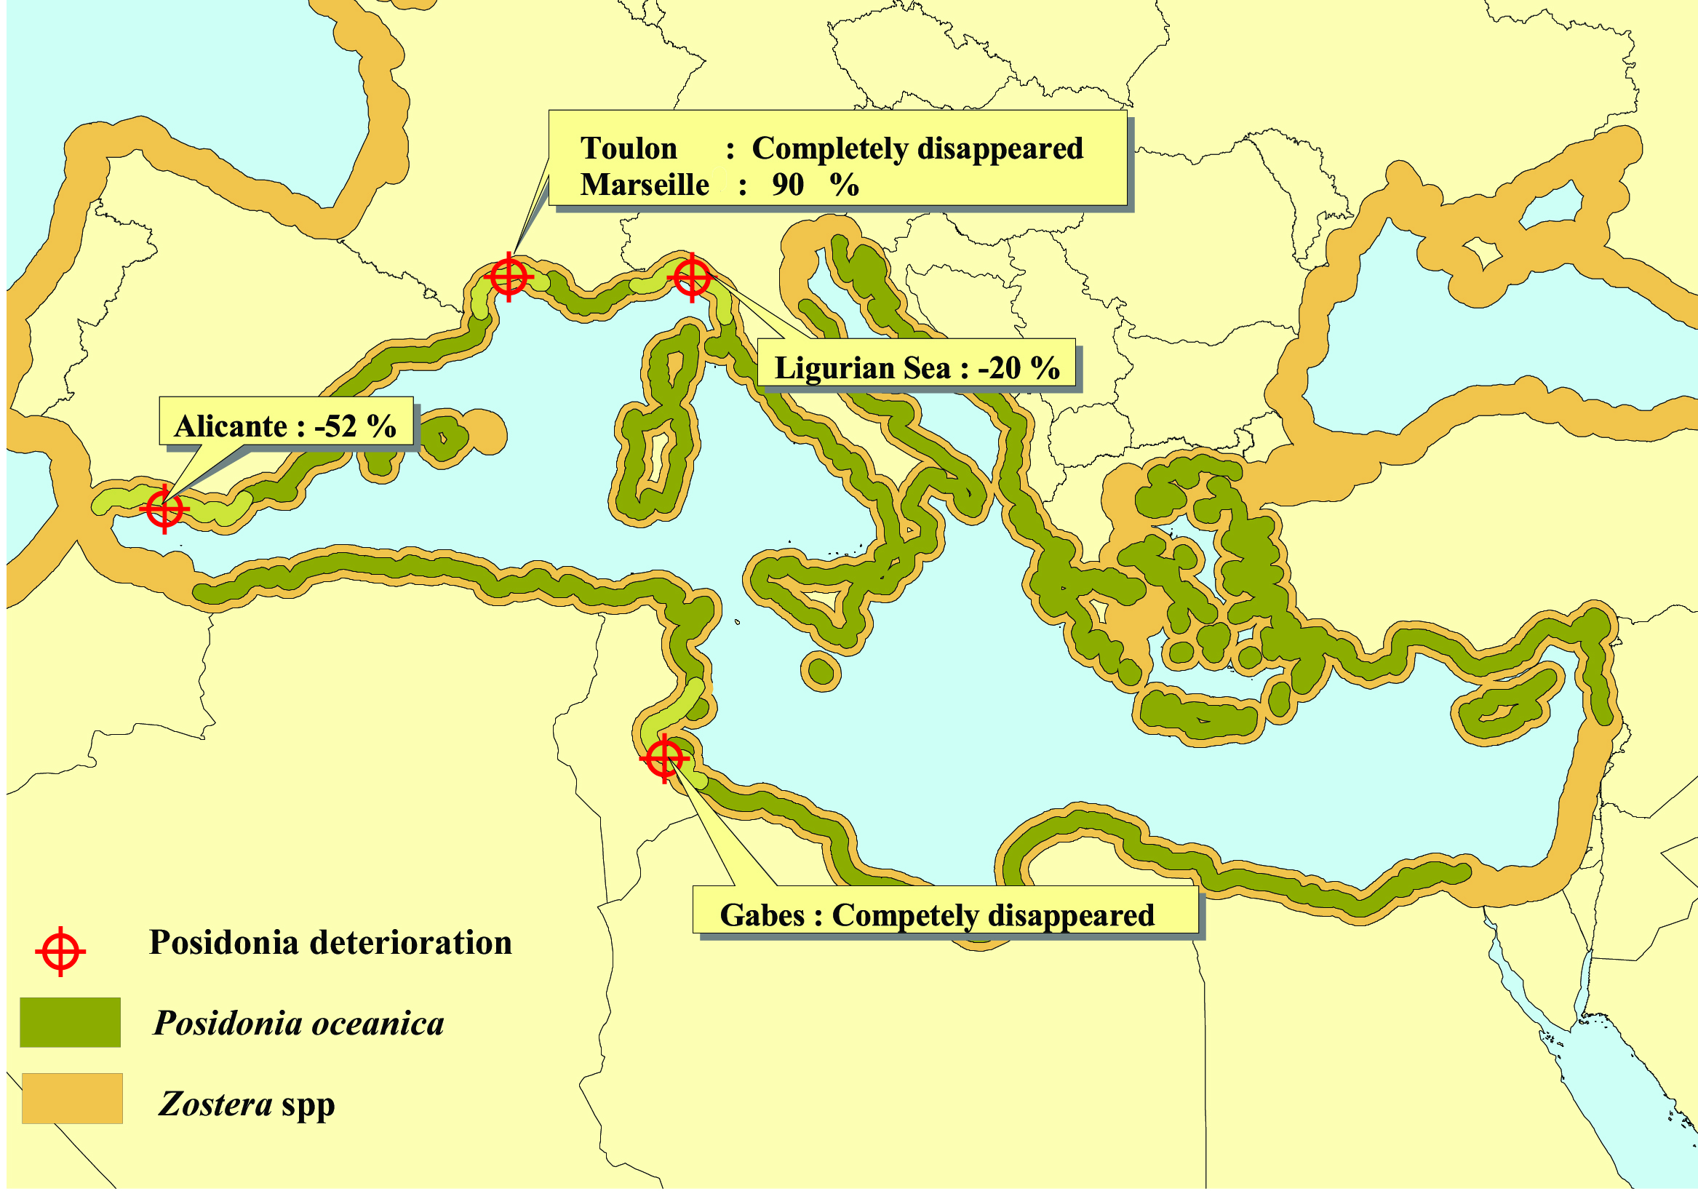
Figure 9.1: Distribution of the marine angiosperms Posidonia oceanica and Zostera spp.in the Mediterranean.
Source: EEA, 2004

