EEA/NSV/13/002 – ETC/ICM

Biological data analysis
Overview of the SoE freshwater biology data and
statistical analysis of trends in BQE status

Version: 1.0
Date: 18.12.2020
EEA activity: 1.5.1
ETC/ICM task 1.5.1.3 EEA freshwater indicators
Milestone 5: Further analysis of freshwater biology data

Prepared by / compiled by: Jannicke Moe, Anne Lyche Solheim, Jonas Persson, Kari Austnes
Organisation: NIVA

EEA project manager: PKR

Version history

Version | Date | Author | Status and description | Distribution
0.1 | 03/07/2020 | JMO, ALS, JOP, KAU | Pre-draft for ETC | To PKR, ALS, KAU, SBI, SIS
1.0 | 16/12/2020 | JMO, ALS, JOP, KAU | First draft for EEA | To PKR, SBI
1.1 | 18/12/2020 | JMO, ALS, JOP, KAU | First draft for EEA  (minor format corrections | To PKR, SBI
2.0 |  | JMO, ALS, JOP, KAU | Final draft for EEA | To PKR, SBI, CNE
3.0 |  | JMO, ALS, JOP, KAU | Final version for EEA | To PKR, SBI, SIS, CK

Abbreviations
ALS: Anne Lyche Solheim
CK: Christiane Katterfeld
JMO: Jannicke Moe
JOP: Jonas Persson
KAU: Kari Austnes
PKR: Peter Kristensen, EEA
SBI: Sebastian Birk
SIS: Stéphane Isoard, EEA

BOD: biological oxygen demand
BQE: biological quality element
DPSIR: driver - pressure - state - impact - response
EQR: ecological quality ratio
nEQR: normalised ecological quality ratio
RBMP: river basin management plans
SoE: state of environment
WFD: Water Framework Directive
WHO: World Health Organisation
Contents
1. Introduction 4
1.1. Background 4
1.2. Context description and policy target 5
1.3. Objective 6
2. Materials and methods 7
2.1. Biological quality elements 7
2.2. Other biological data and secchi depth 8
2.3. SoE data sources and processing 8
2.4. Analysis of biology data in EQR scale 12
2.5. Analysis of biology data in absolute scale 13
3. Results: biology data in EQR scale 15
3.1. Overview of reported EQR data 15
3.2. Temporal trends in nEQR value versus status class 20
3.3. Time series of nEQR aggregated to European level 23
3.4. Coupling of SoE biology and physico-chemical data 27
4. Results: Biological data in absolute scale 30
4.1. Overview of biology data in absolute scale 30
4.2. Secchi depth 30
4.3. Chlorophyll-a 33
4.4. Cyanobacteria 36
5. Development of a new biological indicator 38
5.1. Proposed content of a biological indicator 38
5.2. Conclusions 39
5.3. Next steps 40
6. References 40
7. Acknowledgements 41

Introduction

Background
The Water Framework Directive (WFD; EC, 2000) requires monitoring and assessment of ecological status of water bodies using biological quality elements (BQEs) and supporting abiotic quality elements. The biology represents the state and impact part of the DPSIR model for water management, and fills the gap relative to other EEA indicators on pressures, status and measures. The biological data can also be an important building block towards the development of a new aquatic biodiversity indicator across several EU directives and policies, following the actions agreed at the joint Water and Biodiversity EIONET workshop in June 2019.
The State-of-Environment (SoE) guidance was revised in 2009 to include reporting sheets for four biological quality elements: Phytobenthos and macroinvertebrates in rivers and phytoplankton and macrophytes in lakes. The guidance is available at: http://forum.eionet.europa.eu/nrc-eionet-freshwater/library/reporting_eionetwfd/guidance_2009pdf (page 87-95). The data dictionary for the reporting of BQEs is based on the SoE guidance but provides further specifications on data reporting. Collection of SoE biology data has been done first for 2 test years (2009-2010) plus the official years (2011-2019). The results reported in this document are based on all data reported during 2011-2019.
The data in Waterbase are collected through the EIONET reporting process and are therefore sub-samples of national data assembled for the purpose of providing comparable indicators of pressures, state and impact of waters on a Europe-wide scale. The data sets can be used for various EEA assessments, but are not intended for assessing compliance with any European Directive or any other legal instrument. Information on the sub-national scales should be sought from other sources.
A justification for the development of a freshwater biological indicator has been provided previously (Moe and Lyche Solheim, 2013). The work towards a biological indicator is now done in parallel with the development of a marine indicator based on transitional/coastal SoE biology data reported in 2019 (ETC/ICM AP2020 Task 1.6.1.1 deliverable no. 5 and Task 1.6.1.2, deliverable no. 8). Biological data from transitional and coastal water reported to WISE-2 in 2019 are therefore not analysed in this report.
The assessment of SoE biology data is also relevant for the focus on Biodiversity in the new EU Commission. An assessment based on the biological data can be expected to give added value compared to the assessment of the overall ecological status for river and lake water bodies reported in the WFD River Basin Management Plans (RBMPs) in several ways:
- Good ecological status is an objective of the WFD for rivers and lakes and should be assessed using primarily BQEs. The selected biological quality elements are those for which assessment methods are best developed by the countries implementing the WFD.
- Most of the biological indicators can provide direct information on the impacts of specific pressures, e.g. nutrient enrichment and organic pollution, hydromorphological pressures, acidification etc., and can therefore provide a link to the underlying causes for change in the ecological status of river and lake water bodies.
- The biological data can also be analysed as responses to the impacts indicated by data used in core set indicators for nutrients in freshwater (CSI020) and oxygen-consuming substances in rivers (CSI019).
- The normalised EQR values (ecological quality ratio on a scale from 0 to 1) provide more accurate measurement of ecological status than the categorical status class given in the WFD-RBMP reporting and can be used to assess changes within a status class, as well as between status classes.
- The annual reporting of the ecological status of the BQEs will allow the analysis of temporal trends with better time resolution compared to the WFD RBMP data, which is reported only once every six years.
- In 2014, the EEA member states were asked whether they would be willing to also report the EQR for fish in rivers, and most of them responded positively. This was done in the context of quality checking the SoE data and would be an important step to strengthen the biological response to hydromorphological changes in rivers. Some countries have started reporting EQR values for fish, but those data are not included in this analysis.

Context description and policy target
The indicator is directly related to specific policy targets of the Water Framework Directive (WFD) "good ecological status" of rivers and lakes and prevention of deterioration of ecological status, also including no deterioration from high to good or worse. The indicator can also be linked to other water related directives, e.g. the Nitrates Directive (91/676/EEC) dealing with pollution pressures from agriculture and the Urban Wastewater Directive (91/271/EEC), as well as to the Habitats Directive target of favourable conservation status for freshwater habitats and species and the EU Biodiversity strategy 2020 (and revision of that for the coming years). The recent assessment of the second RBMPs shows that diffuse pollution from agriculture is still one of the most important pressures on European rivers and lakes. Indicators showing the biological impacts of this pollution are essential to plan pollution reduction measures and assess their effectiveness in terms of improvements of ecological status. Most of the BQEs included in this dataflow are particularly sensitive to nutrients and/or organic pollution. The data on phytoplankton chlorophyll and total biomass can also be related to the OECD environmental quality criteria for lakes, and the data on Cyanobacteria can be compared to the WHO guidelines for cyanotoxins (WHO 1999), and thus be relevant also for bathing water quality.
The added value of the WISE-SoE biology data in comparison to other main relevant data sources is illustrated in a conceptual diagram (Figure 1). The biological data described in this report are available from approximately 8500 waterbodies. The majority of waterbodies have values from 1-5 years, while a few water bodies have series lasting 15 years. The number of waterbodies in the WFD database is an order of magnitude higher, but so far only from two reporting years. Moreover, the WISE-SoE biology data contain continuous values (normalised EQRs), while the WFD data contains only categorical status classes. For the WISE-SoE data, the longer series and the more detailed data type both increase the probability of detecting temporal trends with statistical significance.
Other data sources such as national monitoring data can provide even longer time series and higher resolution of information, such as abundance per species. However, compilation of raw species data is beyond the scope of EEA/ETC. National assessments of trends are based are available for selected waterbodies with long time series (e.g. from the Netherlands: https://www.pbl.nl/publicaties/nationale-analyse-waterkwaliteit-0), and could in principle be used for comparison of the trend analyses based on WISE-SoE. However, the probability of detecting a trend is highly dependent on the methodology and assumptions used in the analysis, which is likely to vary from country to country. Therefore, this report includes only results based on the harmonised analysis of normalised EQR values. Further comparison of national assessments for better understanding and explanation of trends in individual cases (e.g. the effect of programme of measures) can be considered within relevant tasks in 2021.
Figure 1. Illustration of the spatial and temporal extent and resolution of WISE-SoE biology data.
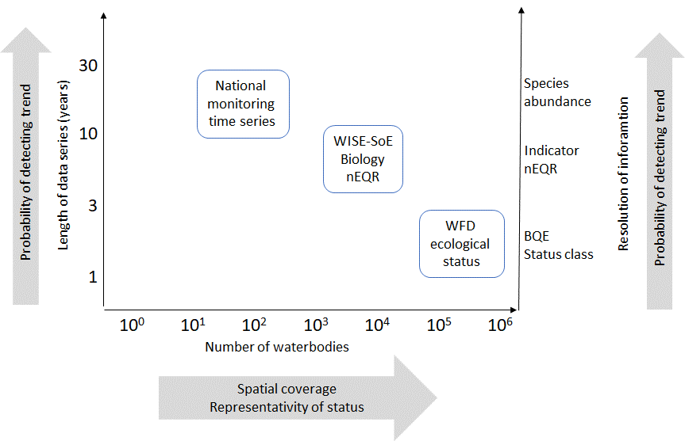 Note: The scales of this diagram is only meant to be illustrative, and the position and extent of the text boxes do not represent exact values.

Objective
The usefulness of SoE biology data for a biological indicator was assessed by Moe and Lyche Solheim (2013) based on the first two years of official biology data reporting (2010-2011). A new assessment was delivered in 2019 (ETC/ICM task 1.5.1.3, Milestone 4: Analysis of SoE biology data in relation to WFD data), with the objective to supplement this assessment by focusing on different aspects of showing temporal trends in ecological status within biological quality elements:
- Analysis of temporal trends in the SoE biology data (normalised EQR values for 4 biological quality elements), including changes within a status class
- Visualisation of temporal trends at the European scale
- Analysis of normalised EQR in relation to stressors, represented by SoE nutrients data
In the current document, the main objectives are:
- Evaluate the dataset, how and whether it can be used to get a European overview of trends in ecological status
- Evaluate the efforts made in 2019 to increase reporting
- Explain and illustrate the added value of SoE data (compared to the WFD status class data), e.g. the possibility to detect statistically significant trends and the information specified by impact type.
- Further elaborate the visualisations and analyses for a potential freshwater biology indicator in collaboration with the development of marine biological indicators (task 1.6.1.2, deliverable 11), with the aim to use similar analyses and visualisations, where relevant.
- Coupling of biological data and nutrients/BOD
The overviews and results presented in the 2019 report are updated with the newest available data from WISE-2 (sampling year 2018). The current document also highlights the changes in reported data since 2019.
The final policy-oriented objective of the biology data collection is the development of a new biological indicator, which should focus on changes in normalised EQR (ecological quality ratio) values, in order to detect trends in ecological quality even within a status class (equivalent to the SoE nutrients indicator detecting trends in water quality). The WFD reporting of status class for different BQEs is done only once every six years and can only show change when the status class has changed, which can take a rather long time. The annual reporting of SoE biology data may however allow trends to be shown much sooner and also within a status class, demonstrating effects of pressures and measures. Therefore, these data can be used to answer a key policy question: "Is the biological condition of European freshwaters improving?"

Materials and methods

Biological quality elements
The data include ecological status for phytobenthos and macroinvertebrates in rivers and phytoplankton and macrophytes in lakes, based on the ecological quality ratio (EQR values) as required by the Water Framework Directive (WFD). The EQR is a measure of the deviation from reference conditions for each biological quality element (BQE). The national metrics used to measure the EQR are normally based on a general response to increasing pressure seen as a decrease of the sensitive taxa usually dominating under reference conditions and an increase of tolerant taxa, and a change in abundance for some of the metrics (e.g. increase in phytoplankton chlorophyll).
Phytobenthos is used as an indicator for the impact of nutrient enrichment in rivers, based on changes in taxonomic composition of diatoms or non-diatom algae. Macroinvertebrates in rivers respond to several pressures, e.g. acidification, organic enrichment, hydromorphological pressures or general degradation, which is usually a mixture of point source pollution causing organic enrichment and hydromorphological pressures causing altered habitats.
Phytoplankton is a sensitive indicator for the impact of nutrient enrichment in lakes caused by diffuse and point source pollution. Macrophytes are also responding to nutrient enrichment caused by diffuse and point source pollution in lakes. In addition, macrophytes respond to siltation and to hydromorphological pressures, but the metrics reported are mainly those responding to nutrient enrichment.
The biology data include the status classes (high, good, moderate, poor, bad) for each determinand, as a mandatory element in the SoE data reporting. The status class also calculated by the ETC based on reported EQR values and the reported national classification system, as far as possible (see below).
The national EQR values reported by each country are normalised to a common scale by the ETC (see Methods). The normalised EQR values are comparable across countries. On the normalised scale, status class boundaries are equal for all countries (high: 0.8-1.0, good: 0.6-0.8, moderate: 0.4-0.6, poor: 0.2-0.4, bad: 0.0-0.2). An nEQR values identical to the boundary between two status classes is included in the worse status class.

Other biological data and secchi depth
Biological data are also reported in absolute scale (original metric scale) for certain determinands for phytoplankton: Chlorophyll a, Cyanobacteria biomass, Cyanobacteria proportion and Total phytoplankton biomass. These data are stored together with chemistry data in T_WISE6_AggregatedData. In total 20403 records are available from lakes in 36 countries during the years 1989-2018 (Table A1.1), including many long time series for Chlorophyll a (Table A1.2). These determinands can also be considered included in a potential biological indicator.
In addition, there are 16725 records of secchi depth from 32 countries (Table A1.1), including many long time series (Table A1.2).
There are also quite a lot of data reported for rivers, especially for chlorophyll a (23586 records from 28 countries, half of them from France). In this report, we have only used the data for lakes. Further dialogue with the countries are needed to clarify whether the river data are from actual rivers or from reservoirs or both. Only data from reservoirs are comparable to lakes.

SoE data sources and processing

Data sources
The EQR data were downloaded from the WISE-SoE production database (WISE-2 - Biological data in rivers, lakes, transitional and coastal waters) in the Common Work Space on 26.05.2020. Any changes made after that have not been taken into account. This database contains all officially reported and quality-assured biological data reported until 2020. Additional data may have been delivered but not passed the automatic quality checking in the Central Data Repository (https://cdr.eionet.europa.eu).
WISE-2 contains biological data in EQR scale from rivers and lakes (transferred from WISE-4) as well as from transitional and coastal waters (reported from 2019). WISE-6 contains other biological data and secchi depth, as well as all the other water quality data (e.g. nutrients/BOD, chemicals). The analysis reported here used data from the following tables:
- T_WISE2_BiologyEQRData. Data reported by monitoring site. Mandatory values: determinand status class, i.e. status class at the determinand level (impact-specific BQE). Recommended values: national EQR values and/or normalised EQR values (nEQR).
- T_WISE2_BiologyEQRDataByWaterbody. Data as above but aggregated to waterbody level.
- T_WISE2_BiologyEQRClassificationProcedure. National class boundaries used for calculation of nEQR values from the reported national EQR values for each determinand. (Some countries have multiple impact-specific determinands for the same BQE, e.g. for invertebrates responses to acidification, eutrophication and general degradation).
- T_WISE6_AggregatedData and DisaggregatedData. Biological data (Chlorophyll a, Total phytoplankton biomass, Cyanobacteria biomass and Cyanobacteria percentage) and Secchi depth data in absolute scale. The data were downloaded from the WISE-SoE production database in CWS on 26.05.2020 (WISE-6 AggregatedData and DisaggregatedData).
- T_WISE4_MonitoringSite_DerivedData. This table provides a link from monitoringSiteIdentifier to waterBodyIdentifier and coordinates (longitude and latitude).
From next year, the spatial information will be extracted and linked more efficiently from WISE-6 or other sources in the Common Workspace. This will probably result in more information for waterbodies needed for plotting in maps and for linking to chemistry.

Processing of biology data in EQR scale
Biological data in EQR scale were extracted from the tables T_WISE2_BiologyEQRData and T_WISE2_BiologyEQRDataByWaterbody. The number of records reported for each determinand is shown in Table 2.1a (also including records flagged for quality issues). The overview also includes the biology data from coastal and transitional waters (Table 2.1b), which will not further analysed here. For data from rivers and lakes, the determinands with status "valid" were included in the further analysis. The determinand InvertebrateEQR_A (response to acidification) has been re-validated after is was retired, following a request from data providers.
In addition, the three determinands PhytobenthosEQR_G, PhytoplanktonEQR_G and MacrophytesEQR_G were each merged with the corresponding determinands with suffix _E, respectively. The reason was that these two types of determinands seem to have been used interchangeably by some countries.
For all the BQEs, the last year reporting has substantially increased the amount of data, in particular for the eutrophication determinands for phytobenthos in rivers and phytoplankton and macrophytes in lakes. But also for invertebrates in rivers, considerably more data has been reported the last year. The increased reporting may be a result of the webinar organised by EEA last autumn to improve the dialogue with the countries concerning this data flow.

Table 2.1 Number of records reported for each biological quality element and determinands
(a) Rivers and lakes
Water  category | Biological quality element | Determinand code | Determinand label | Status | No. of records in database
RW | PP | EEA_11-03-0 | PhytoplanktonEQR_A | not req. | 45
RW | PP | EEA_11-04-1 | PhytoplanktonEQR_E | not req. | 81
RW | PP | EEA_11-01-8 | PhytoplanktonEQR_G | not req. | 57
RW | PB | EEA_124-03-8 | PhytobenthosEQR_A | retired | 68
RW | PB | EEA_124-04-9 | PhytobenthosEQR_E | valid | 7583
RW | PB | EEA_124-01-6 | PhytobenthosEQR_G | retired | 5966
RW | PB | EEA_124-02-7 | PhytobenthosEQR_H | retired | 5
RW | MP | EEA_123-04-6 | MacrophyteEQR_E | not req. | 52
RW | MP | EEA_123-01-3 | MacrophyteEQR_G | not req. | 75
RW | MI | EEA_13-03-6 | InvertebrateEQR_A | valid | 446
RW | MI | EEA_13-04-7 | InvertebrateEQR_E | retired | 1270
RW | MI | EEA_13-01-4 | InvertebrateEQR_G | valid | 13081
RW | MI | EEA_13-02-5 | InvertebrateEQR_H | retired | 173
RW | FI | EEA_14-05-1 | FishEQR | valid | 84
LW | PP | EEA_11-03-0 | PhytoplanktonEQR_A | retired | 277
LW | PP | EEA_11-04-1 | PhytoplanktonEQR_E | valid | 5580
LW | PP | EEA_11-01-8 | PhytoplanktonEQR_G | retired | 134
LW | PB | EEA_124-03-8 | PhytobenthosEQR_A | retired | 1
LW | PB | EEA_124-04-9 | PhytobenthosEQR_E | valid | 3
LW | PB | EEA_124-01-6 | PhytobenthosEQR_G | retired | 4
LW | PB | EEA_124-02-7 | PhytobenthosEQR_H | retired | 1
LW | MP | EEA_123-04-6 | MacrophyteEQR_E | valid | 1387
LW | MP | EEA_123-01-3 | MacrophyteEQR_G | retired | 417
LW | MI | EEA_13-01-4 | InvertebrateEQR_G | not req. | 196
LW | FI | EEA_14-05-1 | FishEQR | valid | 146
Total |  |  |  |  | 37 132

(b) Transitional and coastal waters
Water  category | Biological quality element | Determinand code | Determinand label | Status | No. of records in database
TW | PP | EEA_11-08-5 | PhytoplanktonEQR | valid | 116
TW | PB | EEA_124-04-9 | PhytobenthosEQR_E | not req. | 1
TW | MP | EEA_123-01-3 | MacrophyteEQR_G | not req. | 6
TW | MI | EEA_13-05-8 | InvertebrateEQR | valid | 244
TW | MA | EEA_122-02-1 | AngiospermsEQR | valid | 9
TW | MA | EEA_121-01-7 | MacroalgaeEQR | valid | 225
TW | FI | EEA_14-05-1 | FishEQR | valid | 26
CW | PP | EEA_11-08-5 | PhytoplanktonEQR | valid | 528
CW | PB | EEA_124-04-9 | PhytobenthosEQR_E | not req. | 2
CW | MI | EEA_13-05-8 | InvertebrateEQR | valid | 251
CW | MA | EEA_122-02-1 | AngiospermsEQR | valid | 84
CW | MA | EEA_121-01-7 | MacroalgaeEQR | valid | 127
Total |  |  |  |  | 1619
Note: the overview includes combinations of determinands and water categories that were not requested (not req.).
WISE-2 allows for reporting of biology data at the waterbody level in additional to monitoring site level. All EQR data reported at the monitoring site level were aggregated to waterbody and combined with the data reported at the waterbody level, before analysis. Moreover, aggregation to waterbody level facilitates comparison with WFD data, which are reported at waterbody level, as well as coupling to chemistry data, which may be reported from different monitoring sites within the same waterbody.
The normalisation requires information on the national classification system for the given determinand and for the national water body type for the station. All national EQR values reported by a country were transformed to normalised EQR values by the ETC-ICM, based on the following formula:
where LowerBoundaryEQR and UpperBoundaryEQR are the lower and upper status class boundaries in the national EQR scale, respectively, the factor 0.2 is the width of any status class at the normalised EQR scale and LowerBoundaryNormEQR is the lower class boundary in the normalised EQR scale. The calculation is illustrated in this figure in the WISE-4 Data Dictionary: http://dd.eionet.europa.eu/visuals/Biology_20110617.jpg.
Normalised EQR values were calculated for all records as far as possible, based on the available information. Reported nEQR values were used for records where nEQR could not be calculated. Normalised EQR value were aggregated to BQE level by average across determinand within the BQE. The nEQR values were further aggregated from station level to waterbody level by average. The ecological status of waterbodies was then updated from this aggregated nEQR value.
In some cases, the reported status class was not consistent with the status class that could be calculated from the reported national and/or normalised EQR values. All records with such quality issues have been flagged in the working database (see Annex 3), so that the quality issues can later be communicated to the data providers and potentially solved.
To maximize the number of waterbodies for aggregated time series plots and for trend analysis, we followed the procedure for interpolation and extrapolation of missing yearly values used for CSI019 and CSI020. Gaps of up to three years within a data series have been interpolated as the average of the previous and following years. Likewise, gaps of up to three years at the beginning or end of a series were extrapolated to be identical as the first or last available value.

Processing of biology data in absolute scale
Both aggregated and disaggregated data were used in the analysis. To illustrate the results for the recent years, mean values for chlorophyll a and secchi depth per site were calculated from the yearly mean values reported for the period 2011-2018. For Cyanobacteria biomass, the yearly maximum values were averaged per site for the period 2011-2017. For a few sites and years where the maximum Cyanobacteria biomass was not reported, we were able to calculate it by multiplying %Cyanobacteria with total phytoplankton biomass using disaggregated data.
We did some QC of the dataset, removing duplicates and removing outliers, which had the "QC_OUTLIER_LIMIT" in the column “metadata_statements”, as long as there was no “A” on the column “metadata_observationStatus”.

Analysis of biology data in EQR scale

Temporal trend analysis
All data analysis performed in the open-source software R (R Core Team, 2020). Trend analyses were carried out with the non-parametric Mann-Kendall test (MacLeod, 2011) for all records with minimum 4 years of data. The test requires minimum 4 observations, but at least 8-10 observations are recommended for reliable results. The trend analyses were performed for BQE status class, for EQR and for nEQR values respectively.
The Mann-Kendall method is a non-parametric test that has been extensively used for environmental time series. Mann-Kendall is a test for monotonic trend in a time series y(x), which in this analysis is either the EQR value or the status class (y) as a function of year (x). The test is based on Kendall's rank correlation, which measures the strength of monotonic association between the vectors x and y. In the case of no ties in the x and y variables, Kendall's rank correlation coefficient, tau, may be expressed as tau=S/D where S = sum_{i<j} (sign(x[j]-x[i])*sign(y[j]-y[i])) and D = n(n-1)/2. S is called the score and D is the maximum possible value of S. The tests reported here are two-sided (testing for both increasing and decreasing trends). Data series with p-value < 0.05 are reported as significantly increasing or decreasing ('strong trends'), while data series with p-value >= 0.05 and < 0.10 are reported as marginally significant ('weak trends'). The results for each BQE are summarised by country. The test analyses only the direction and significance of the change, not the size of the change. It is also possible to measure the size of the change by the Sen slope, which has been used for the indicator Nutrients in freshwater since 2013.

Relationship between chemical and EQR data
Biological data (nEQR values) were linked to the most relevant chemistry data as follows.
- Phytobenthos in rivers: Total phosphorus in rivers
- Invertebrates in rivers: Biological oxygen demand (BOD5) in rivers
- Phytoplankton in lakes: Total phosphorus in lakes
- Macrophytes in lakes: Total phosphorus in lakes
Biology and chemistry data were linked by the same waterbodyIdentifier and the same year. For a more detailed analysis, the individual impact-specific determinands of a BQE (e.g. InvertebrateEQR_G and InvertebrateEQR_A) can be analysed against chemistry data representing specific impact types (e.g. BOD5 and pH, respectively).

Analysis of biology data in absolute scale
The data were used to show bar plots and timeseries per country applying the same method as used for nutrients and BOD data. For timeseries, we also aggregated all the consistent timeseries to the European level. For maximum Cyanobacteria biomass, we also show the single site values as a dot plot, but do not show timeseries due to too few consistent time-series.

For the bar plots, we propose a set of classes based on scientific literature values (see more details below). The classes are needed to show the relative distribution of the data, using the same colour scale as those used for the nutrients and BOD indicators.

For chlorophyll a, we estimated class boundaries corresponding to the total phosphorus classes used for lakes in the SoE Nutrients indicator. The estimation was done by applying the published regression of chlorophyll vs total phosphorus in Phillips et al. 2008, which is based on thousands of lakes across Europe. The regression formula is:

Log Chl = -0,455+1,026LogTP (r²=0.78) for lakes with a TP< 100 µg/l.

For the highest class-boundary, having a TP-boundary of 200 µg L-1, we reduced the chlorophyll boundary estimated from this regression from 81 to 70 µg L-1, because the regression curve levels off above this concentration (see figure 4 in Phillips et al. 2008). The resulting chlorophyll boundaries are given in Table 2.2, but the lowest class was split in two classes and the two highest ones were merged in the bar plots in order to get a better representation of the data.

Table 2.2 Chlorophyll boundaries estimated from total phosphorus boundaries
Chlorophyll boundaries, µg L⁻¹ | Corresponding total phosphorus boundaries, µg L⁻¹
4 | 10
8 | 20
20 | 50
40 | 100
70 | 200

For Cyanobacteria biomass, we used the two boundaries published by Carvalho et al. 2013, which are derived from the WHO guidelines for cyanotoxins and cell numbers (WHO 1999), termed low and medium risk level. However, these were derived using a cell diameter corresponding to 6 µm, which does not represent smaller taxa, such as Microcystis, having a cell diameter of 4-5 µm. When using the smaller cell diameter, the WHO low risk level appears at 1 mg L⁻¹ biomass. This value also corresponds to the good/moderate class boundary for maximum Cyanobacteria biomass in the Norwegian classification system and is quite close to the summer mean Cyanobacteria biomass in the UK classification system (0,56 mg L⁻¹). Moreover, we also added an even lower boundary of 0.2 mg L⁻¹, corresponding to the WHO vigilance level. Both these low boundaries (0.2 and 1 mg L⁻¹) have been intercalibrated as part of the lake phytoplankton classification systems for the WFD (Annex B in Lyche Solheim et al. 2014). Table 2.3 provides the suggested Cyanobacteria biomass boundaries based on the explanation above.

Table 2.3 Cyanobacteria maximum biomass class boundaries, based on WHO guidelines
Class boundaries, mg L⁻¹ | Corresponding WHO level
0.2 | Vigilance level
1 | Low risk level using a small celled taxon, e.g. Microcystis
2 | Low risk level using a larger celled taxon, e.g. Dolichospermum
10 | Medium risk level using a larger celled taxon

For Secchi depth, the class boundaries are proposed based on limnological expert judgement and are only meaningful for assessing eutrophication in lakes with low inorganic turbidity and low humic content. The boundaries proposed are 0.5 m, 2 m, 4 m, 8 m, which are suitable to capture the range of data reported.

Results: biology data in EQR scale

Overview of reported EQR data
The total amount of data has increased considerably with the last reporting. This increase is shown in the last row of Table 3.1 and Table 3.2 and is further described and discussed in section 3.1.2 below.

Geographical distribution
WISE-2 now contains ecological status class values for almost 8000 river waterbodies from 26 countries and more than 1600 lake water bodies from 21 countries (Table 3.1). The dataset is strongly dominated by PL, UK and FR for rivers, and more evenly by PL, LT, UK, IE, SE and NL for lakes.
Most countries that report status class of biological determinands, also report ecological quality ratio (EQR): approximately 7500 for rivers and 1500 for lakes. A few countries have still reported only status class (CH, DE and PT). A few countries have reported more normalised EQR than national EQR values (NO and SI).
Normalised EQR values are now available for the vast majority of waterbodies with status class reported: 89% of the rivers and 93% of the lakes (either reported or calculated from national EQRs) (Table 3.1). However, for a substantial number of records there are inconsistencies between reported status class and (normalised) EQR values. Modification of these records have carried out by the ETC, but these should be confirmed or corrected by the data providers.
Table 3.1 Number of waterbodies reported per country, for rivers and lakes
Country code | River waterbodies |  |  | Lake water bodies
 | status class | EQR | nEQR | status class | EQR | nEQR
AT | 75 | 75 | 75 | 27 | 26 | 27
BE | 375 | 375 | 375 | 5 | 5 | 5
BG | 111 | 111 | 111 | 11 | 11 | 11
CH | 79
CY | 30 | 29 | 30 | 1 | 1
DE | 28 |  |  | 38
DK | 32 | 32
EE | 225 | 225 | 215 | 15 | 15 | 14
ES | 791 | 791 | 679
FI | 71 | 71 | 67 | 48 | 48 | 48
FR | 1279 | 1279 | 1275 | 3 | 3 | 3
HR | 48 | 48 | 48 | 4 | 4 | 4
IE | 184 | 184 | 184 | 155 | 152 | 155
IT | 342 | 337 | 301 | 18 | 17 | 4
LT | 417 | 417 | 417 | 331 | 331 | 331
LU | 6 | 6 | 5
LV | 41 | 21 | 21 | 6 | 6 | 6
NL | 56 | 56 | 41 | 100 | 100 | 97
NO | 153 | 87 | 148 | 68 | 13 | 61
PL | 1793 | 1793 | 1778 | 475 | 475 | 475
PT | 68 |  |  | 1
RO | 120 | 120 | 120 | 14 | 14 | 13
SE | 56 | 56 | 56 | 123 | 123 | 123
SI | 22 |  | 19 | 13 | 2 | 13
SK | 32 | 32 | 32
UK | 1499 | 1422 | 1070 | 155 | 148 | 105
Total | 7933 | 7567 | 7067 | 1611 | 1494 | 1495
Change from 2019 | +17% | +16% | +10% | +15% | +12% | +16%
Note: "status class": number of waterbodies with status class reported (mandatory). "EQR": number of waterbodies with national EQR value reported (recommended). "nEQR": number of waterbodies with normalised EQR either reported or calculated based on the reported national EQR values and classification systems. The national classification system of CH (Switzerland) is not necessarily WFD-compliant.
The maps (Figure 2) display the latest BQE status (or potential) class of each waterbody. The left panel shows the reported determinand status class for valid determinands and aggregated to the BQE level, while the right panel shows the BQE status class calculated based on available nEQR values. The lack of coloured points in the right panel is due to lack of reported EQR data or class boundaries in only a few cases (e.g. CH, DE, DK). The missing values are usually due to missing coordinates, inconsistencies in the spatial information or other technical issues. The reasons will be investigated more closely for each country. The map of invertebrates in rivers does not include the determinand InvertebrateEQR_A (response to acidification), due to the limited geographic representativity (UK, DE, NO, SE).

Figure 2 Map of waterbodies with BQE status class
(a) Phytobenthos in rivers: reported status class  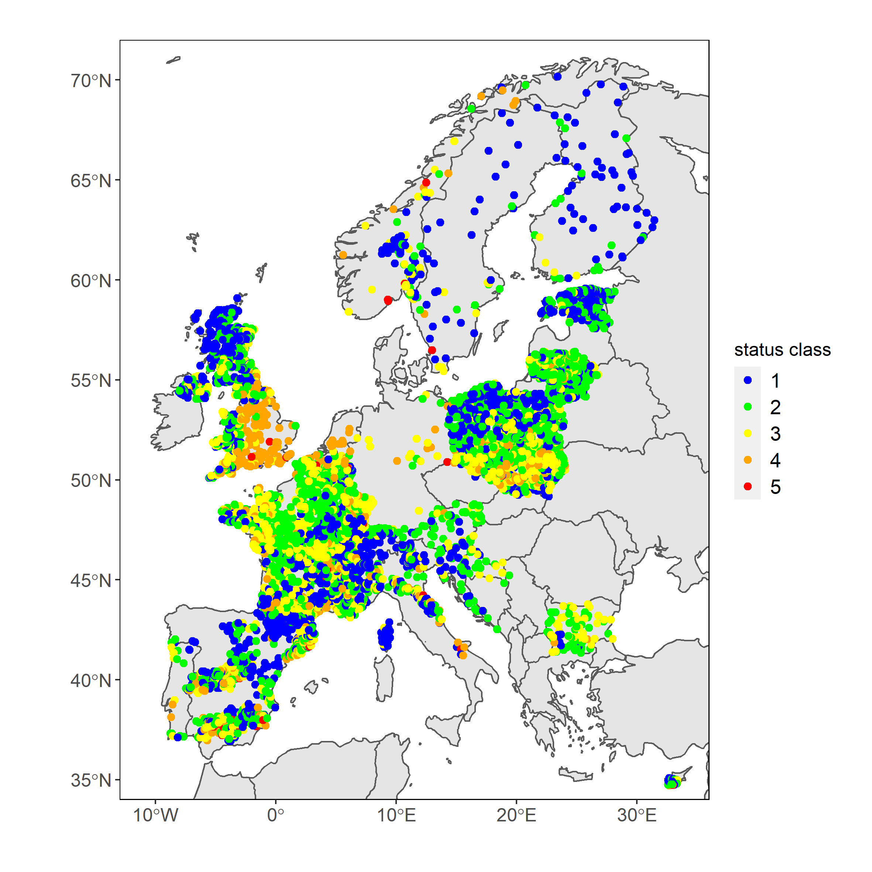 | (b) Phytobenthos in rivers: status class from nEQR  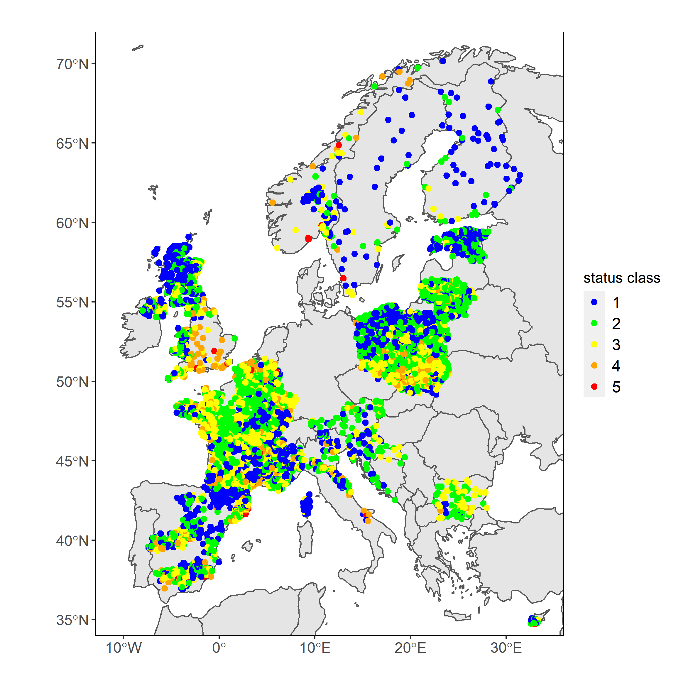
(c) Invertebrates in rivers: reported status class  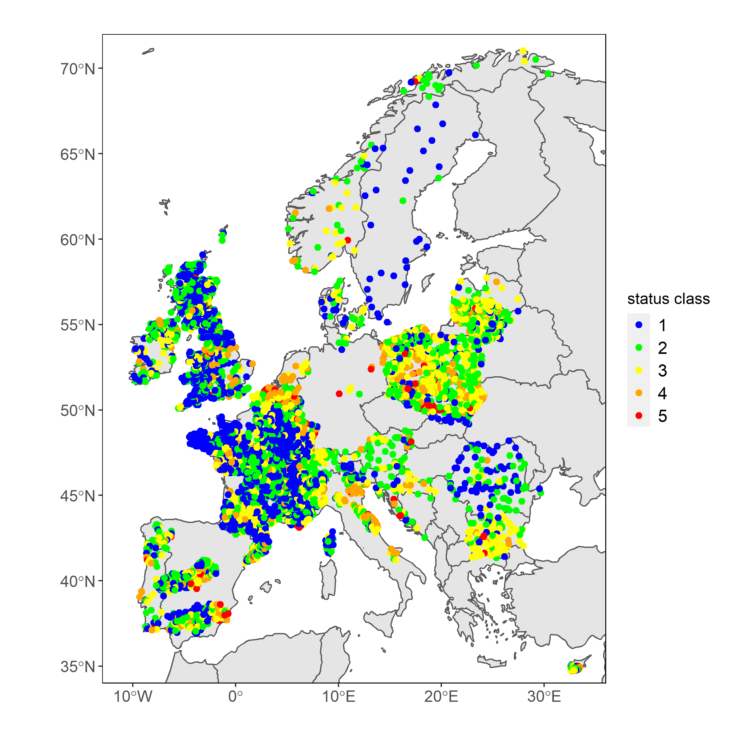 | (d) Invertebrates in rivers: status class from nEQR  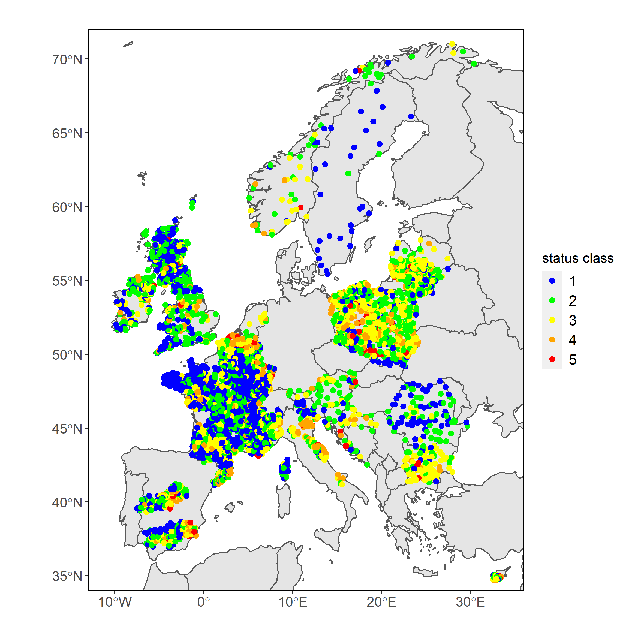
(e) Phytoplankton in lakes: reported status class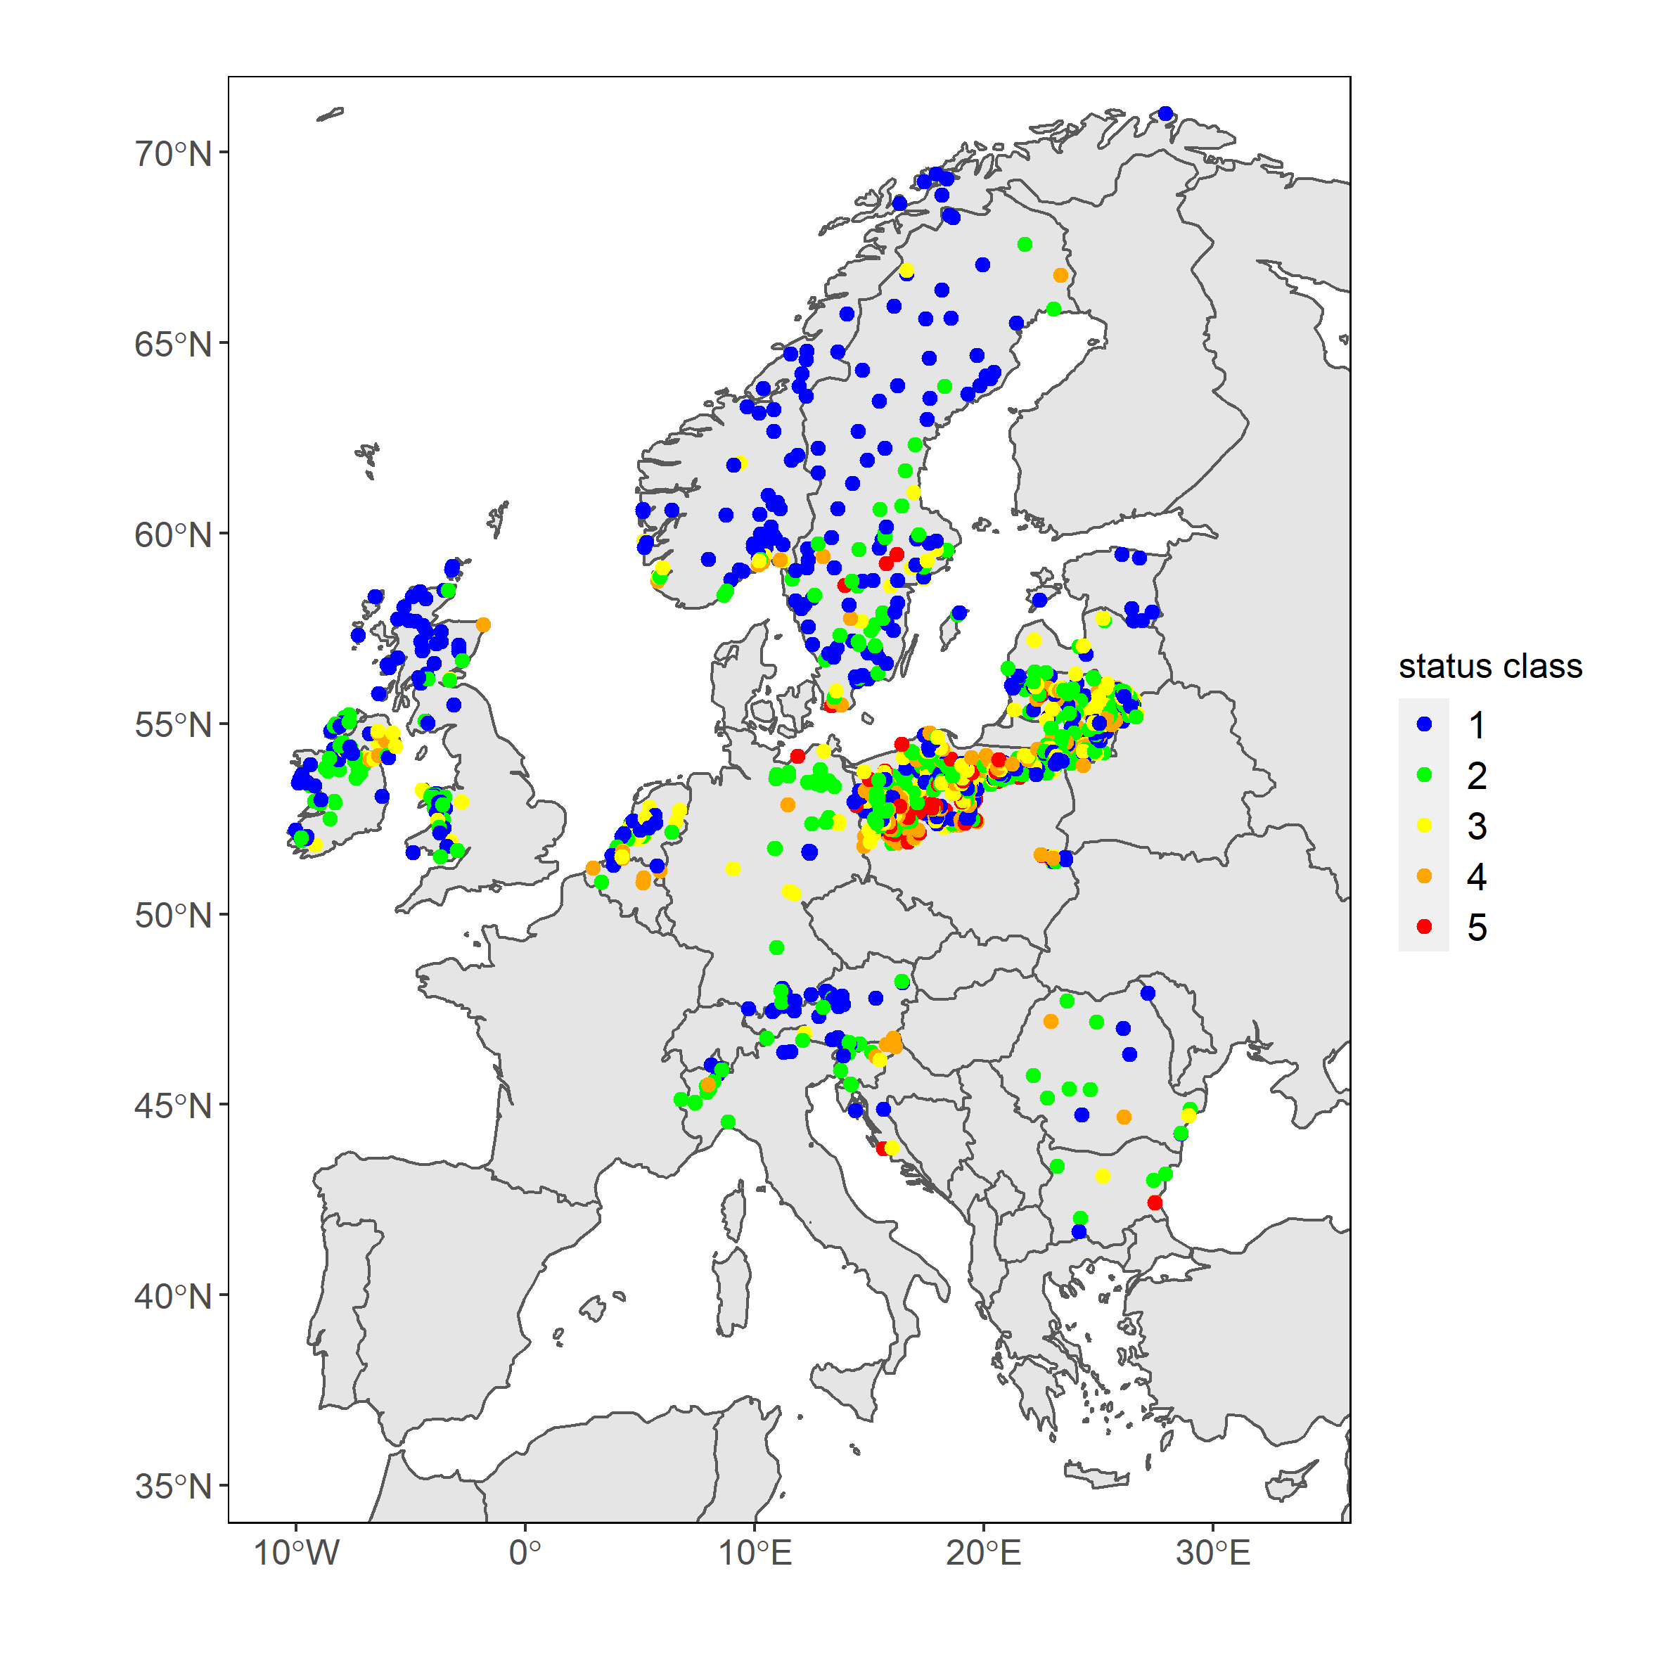 | (f) Phytoplankton in lakes: status class from nEQR  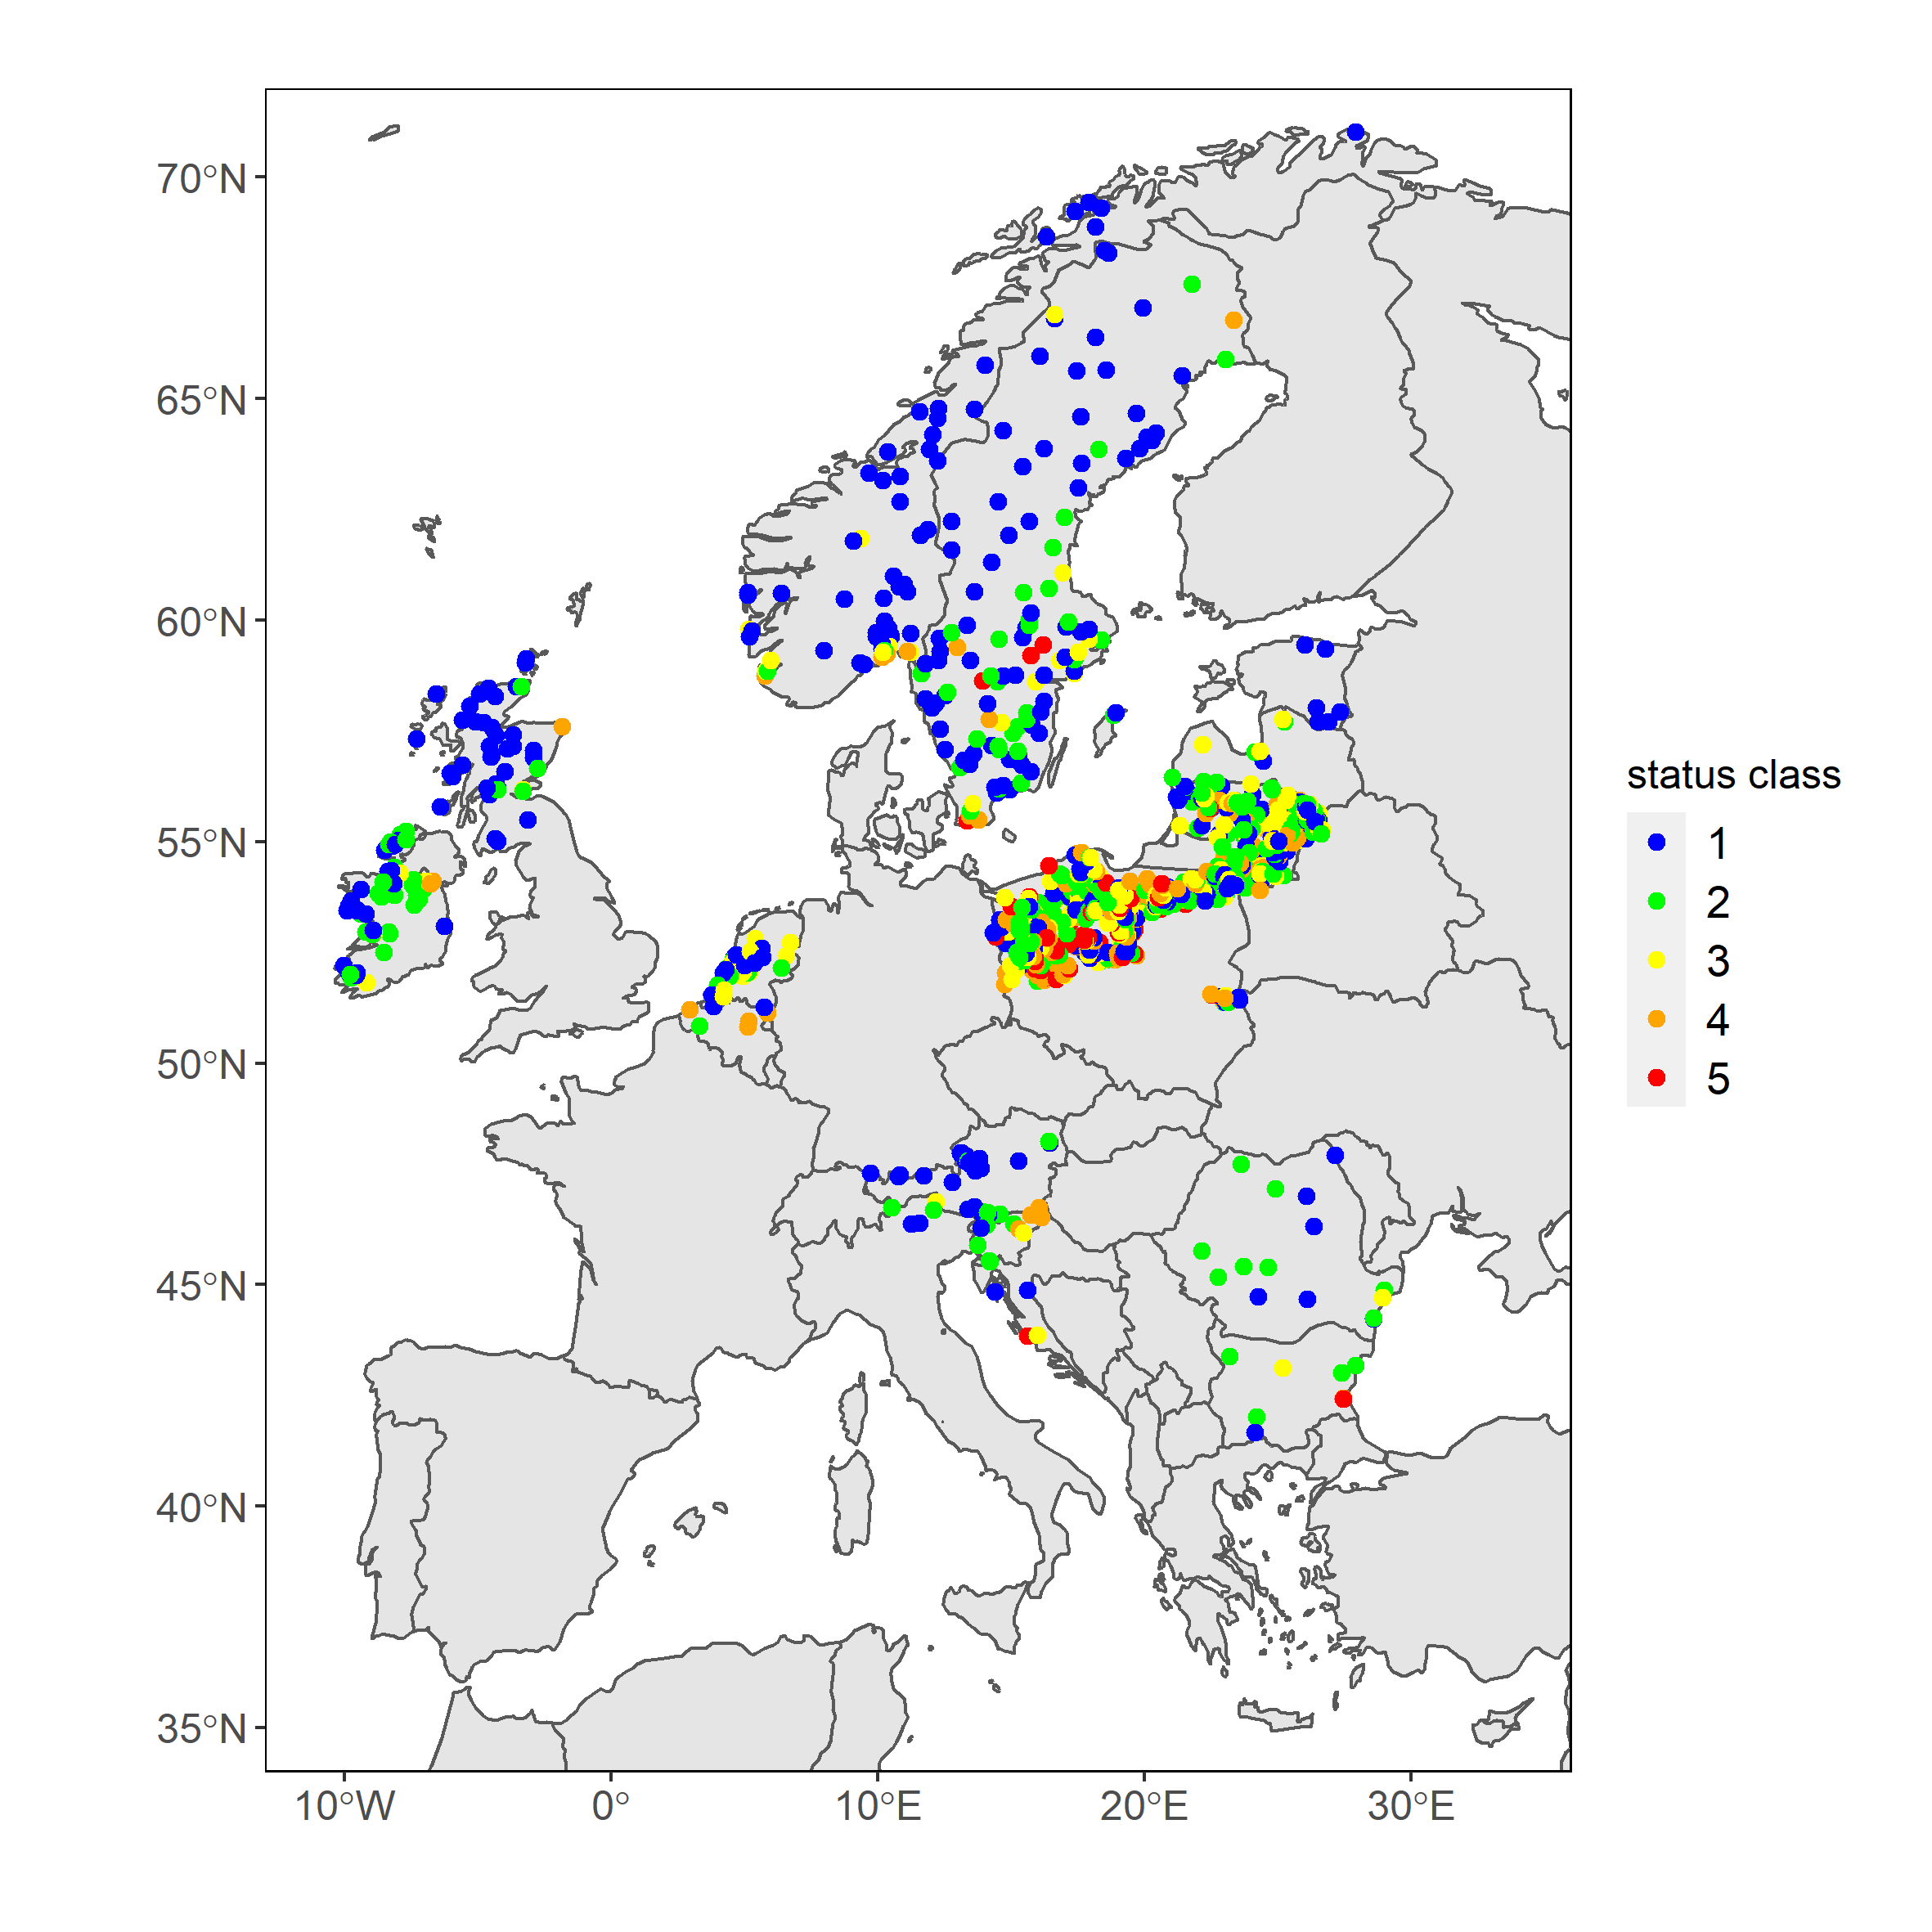
(g) Macrophytes in lakes: reported status class  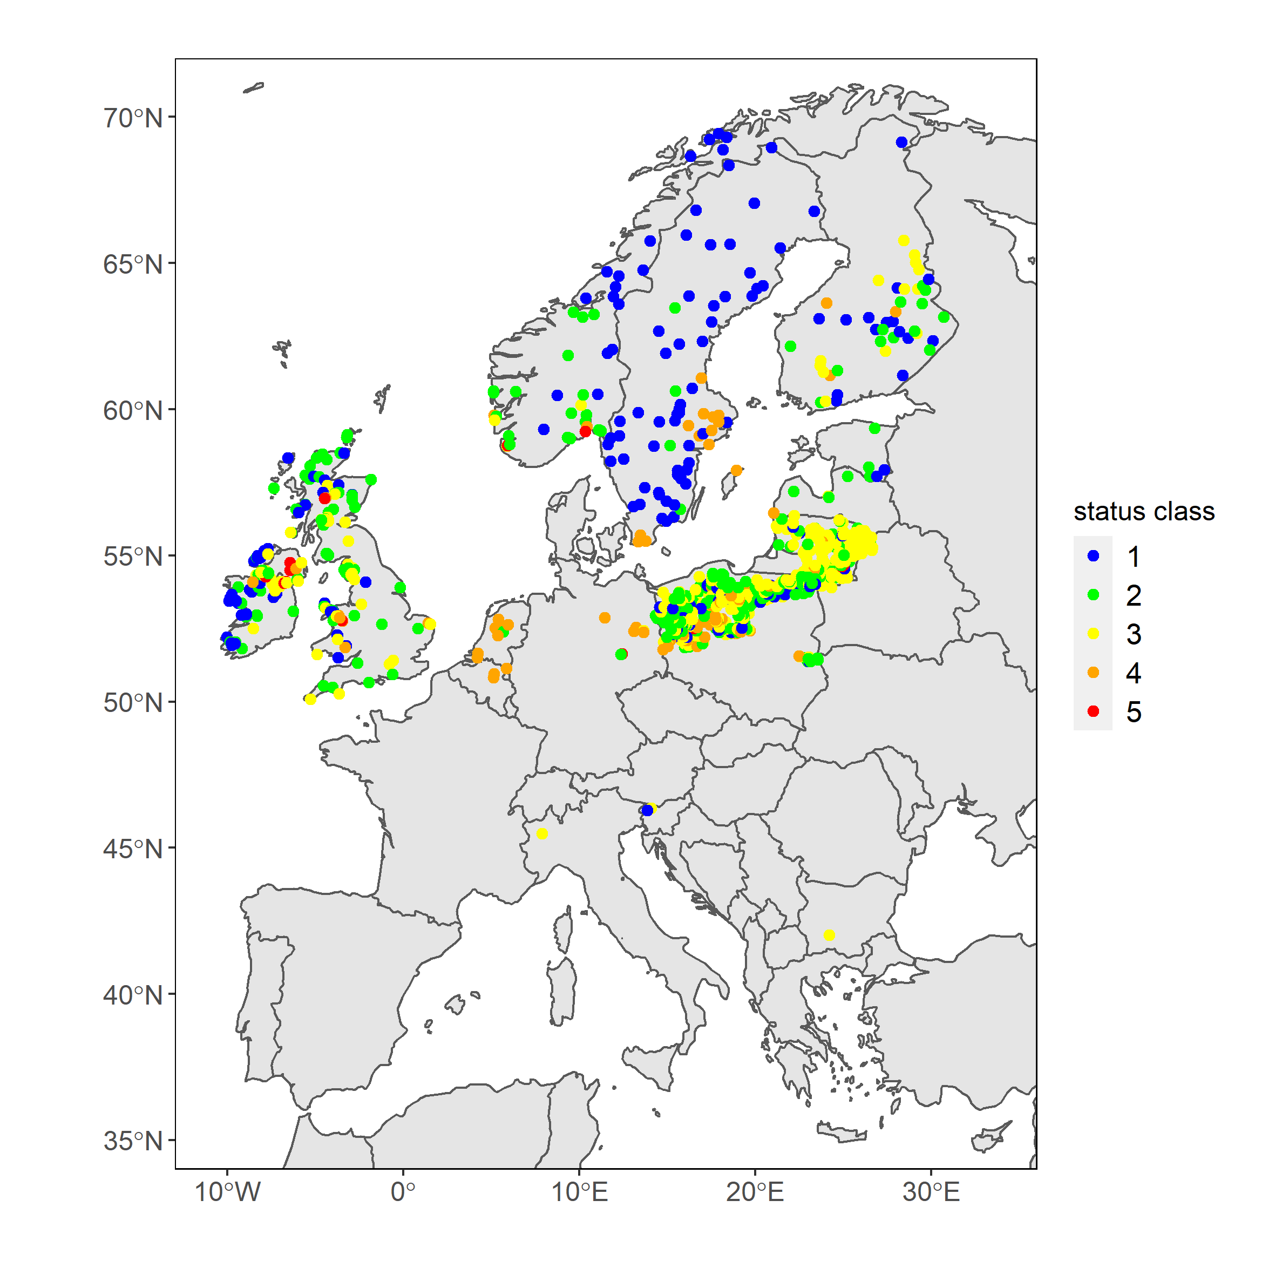 | (h) Macrophytes in lakes: status class from nEQR  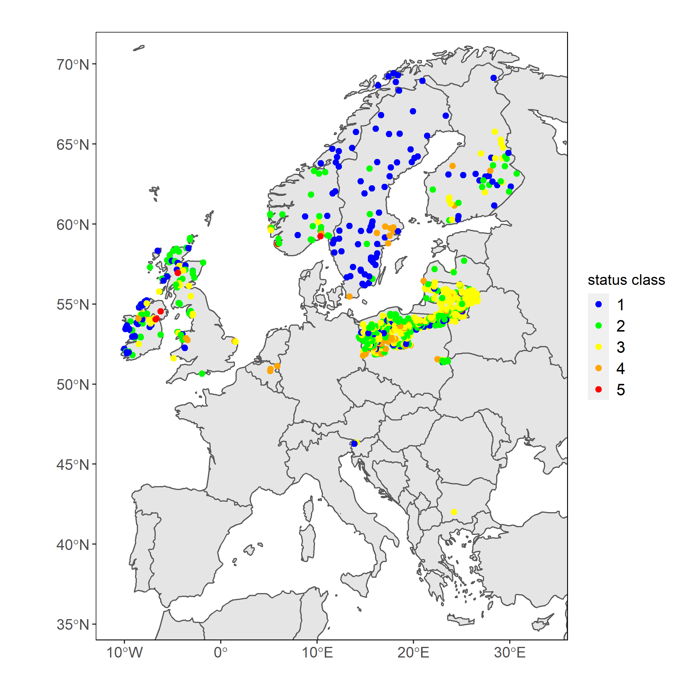
Note: Left panel: status class for all stations with reported status class; right panel: status class for the subset of stations with normalised EQR values (nEQR). Colour code: blue = High, green = Good, yellow = Moderate, orange, red = Bad. Colour code for artificial and highly modified waterbodies with incomplete class boundaries: green = good potential, orange = moderate/poor/bad.

Temporal distribution
The official biology data reporting started in 2011 (with records from sampling year 2010), after two years of test reporting in 2009-2010. WISE-2 contains biological data mainly from sampling years 2004 to 2018 (Table 3.2). The number of records (aggregated to waterbody level) is highest from sampling year 2010 (the official start) to 2015. The number of waterbodies dropped markedly for the sampling years 2016-2017, for all BQEs. For the latest sampling year (2018), however, the number of waterbodies increased substantially again, for all BQEs. Considering the high percentage increase in the total number of records since the 2019 report, in particular for phytoplankton, it is obvious that the newly reported records are not only from the sampling year 2018, but also from previous years.
Table 3.2 Count of records of status class, national EQR values and normalised EQR values, for the four selected BQEs during the sampling years 2004-2018
Year | Phytobenthos in rivers |  |  | Invertebrates in rivers |  |  | Phytoplankton in lakes |  |  | Macrophytes in lakes
 | status class | EQR | nEQR | status class | EQR | nEQR | status class | EQR | nEQR | status class | EQR | nEQR
2004 | 1 | 1 | 1 | 136 | 136 | 136 | 102 | 102 | 102
2005 | 50 | 50 | 50 | 77 | 77 | 77 | 101 | 101 | 101 | 11 | 11
2006 | 60 | 60 | 60 | 110 | 110 | 105 | 107 | 107 | 102
2007 | 162 | 162 | 158 | 180 | 180 | 167 | 120 | 119 | 115 | 58 | 58 | 49
2008 | 224 | 224 | 184 | 326 | 326 | 222 | 128 | 128 | 122 | 43 | 40 | 5
2009 | 300 | 295 | 178 | 456 | 443 | 240 | 149 | 139 | 121 | 46 | 46
2010 | 2212 | 2137 | 1668 | 1981 | 1940 | 1469 | 300 | 238 | 217 | 184 | 178 | 129
2011 | 2005 | 1958 | 1750 | 2017 | 1924 | 1442 | 471 | 415 | 371 | 183 | 178 | 141
2012 | 1118 | 1032 | 863 | 1307 | 1161 | 1027 | 422 | 348 | 408 | 201 | 185 | 174
2013 | 1280 | 1270 | 1097 | 1266 | 1256 | 1116 | 509 | 449 | 444 | 175 | 173 | 161
2014 | 1631 | 1238 | 1536 | 1683 | 1236 | 1102 | 583 | 468 | 485 | 335 | 281 | 322
2015 | 1147 | 1138 | 1045 | 1015 | 1009 | 920 | 580 | 453 | 498 | 308 | 305 | 285
2016 | 688 | 681 | 471 | 948 | 923 | 664 | 348 | 271 | 289 | 75 | 51 | 70
2017 | 463 | 426 | 404 | 566 | 514 | 537 | 355 | 238 | 330 | 70 | 61 | 65
2018 | 1312 | 1303 | 1137 | 1467 | 1458 | 1301 | 460 | 352 | 422 | 124 | 124 | 123
Total | 12653 | 11975 | 10602 | 13535 | 12693 | 10525 | 4735 | 3928 | 4127 | 1813 | 1691 | 1524
Change | +17% | +17% | +7% | +21% | +22% | +12% | +86% | +83% | +85% | +30% | +30% | +28%
Notes: Records are aggregated to the BQE and waterbody level. The row "Total" corresponds to the total number of records grouped by BQE. The row "Change" shows the increase in total number of waterbodies since the 2019 report. Not included: one series of phytobenthos values 1992-2003; 3 values of macrophytes 2003.
The length (number of years) of the data series is shown in Table 3.3. The majority of waterbodies have values reported for one year only. The waterbodies with minimum 4 years of reported EQR values still comprise a rather low proportion of the waterbodies included in WISE-2: from 4% (macrophytes) to 21% (phytoplankton) of the waterbodies.

Table 3.3 Number of time series of different lengths with BQE status class, national EQR values and normalised EQR values for the four selected BQEs during the sampling years 2004-2018
No. of years | Phytobenthos in rivers |  |  | Invertebrates in rivers |  |  | Phytoplankton in lakes |  |  | Macrophytes in lakes
 | status class | EQR | nEQR | status class | EQR | nEQR | status class | EQR | nEQR | status class | EQR | nEQR
1 | 3364 | 3309 | 3170 | 3498 | 3317 | 2944 | 664 | 661 | 571 | 895 | 875 | 884
2 | 1988 | 1928 | 1895 | 1268 | 1214 | 1139 | 337 | 238 | 326 | 237 | 244 | 220
3 | 644 | 589 | 476 | 507 | 476 | 415 | 98 | 97 | 82 | 56 | 31 | 18
4 | 220 | 157 | 132 | 363 | 329 | 250 | 111 | 42 | 88 | 30 | 21 | 7
5 | 148 | 136 | 103 | 202 | 168 | 117 | 33 | 42 | 19 | 16 | 15 | 12
6 | 56 | 58 | 47 | 238 | 217 | 101 | 98 | 56 | 77 | 9 | 9 | 6
7 | 93 | 91 | 36 | 80 | 76 | 61 | 18 | 4 | 2 | 2 | 2 | 2
8 | 37 | 34 | 21 | 132 | 132 | 121 |  |  |  | 1 | 1 | 1
9 | 21 | 21 | 20 | 20 | 20 | 20 | 8 | 8 | 3
10 | 10 | 10 | 10 | 13 | 13 | 15 | 1 | 1 | 1
11 | 15 | 15 | 15 | 5 | 5 | 3 | 6 | 4 | 6
12 | 2 | 2 | 2 | 8 | 8 | 8 | 7 | 7 | 7
13 |  |  |  | 1 | 1 | 1 | 6 | 6 | 6
14 |  |  |  |  |  |  | 15 | 15 | 15
15 |  |  |  |  |  |  | 84 | 84 | 84
Total | 6598 | 6350 | 5927 | 6335 | 5976 | 5195 | 1486 | 1265 | 1287 | 1246 | 1198 | 1150
Change | +13% | +13% | +7% | +24% | +23% | +13% | +27% | +14% | +18% | +22% | +20% | +21%
Notes: Records are aggregated to waterbody level. The row "Total" corresponds to the total number of waterbodies. The row "Change" shows the increase in total number of waterbodies since the 2019 report. Not included: one series of phytobenthos values 1992-2003; 3 values of macrophytes 2003;

The webinar on WISE-2 reporting for data reporters organised by EEA in October 2019 has possibly encouraged the data providers to increase the number of records reported, both for the latest year and from previous years to complete gaps in time series. The number of data series could still be further increased if more countries continue reporting for a larger set of waterbodies. There is also a possibility that some records are still blocked in the Central Data Repository.

Temporal trends in nEQR value versus status class
Temporal trend analyses of nEQR values were carried out for all waterbodies with minimum four years of nEQR values after interpolation (and minimum three years before interpolation). For comparison, trend analyses of BQE status classes were performed for the same selection of waterbodies, although a higher number of series with >=4 years was available for status class data than for nEQR values (see Table 3.3).
For each BQE, the determinands included represent eutrophication and/or general degradation. For the determinand InvertebrateEQR_A (responding acidification), 66 series with >=4 years from UK, NO and SE were available after interpolation. However, only two of these series had >=4 observed values. This determinand was therefore not included in this analysis, but can be included next year.
The trend analyses for BQE status class and nEQR values are summarised for each BQE in Figure 3. In all cases, the use of nEQRs gave a higher number of significant trends than the use of status class. This is the case both for trends of deterioration (pink bars) and improvement (turquoise bars). The number of waterbodies with the different types of trends are summarised by country in Annex 2.
Figure 3 Percentage of waterbodies showing a significant temporal trend
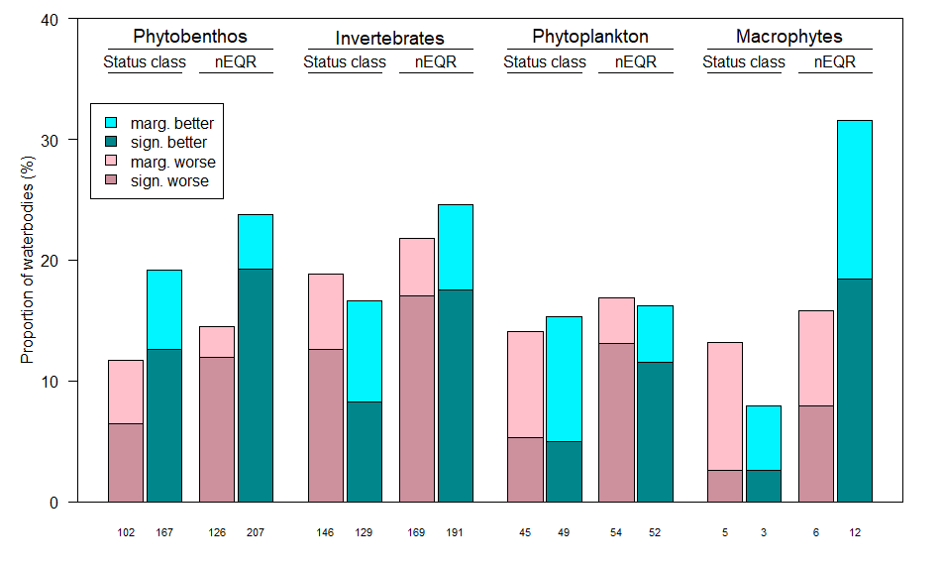
Notes: Percentage of waterbodies showing a negative or positive trend (significant or marginal, respectively) in BQE status class and in nEQR, for all four BQEs. The percentage is calculated from the subset of waterbodies with minimum 3 nEQR values before interpolation and minimum 4 nEQR values after interpolation A significant trend is defined by p < 0.05; a marginal trend is defined by 0.05 < p < 0.10. The number below each bar shows the number of waterbodies in this group of trend results.
The temporal trends identified in (Figure 3) are summaries per BQE and country in Tables A2.1-4, while the geographical distribution of these trends are displayed in the maps of Figure 4.
Figure 4 Geographical distribution of temporal trends in status and nEQR
(a) Phytobenthos in rivers: trends in status class  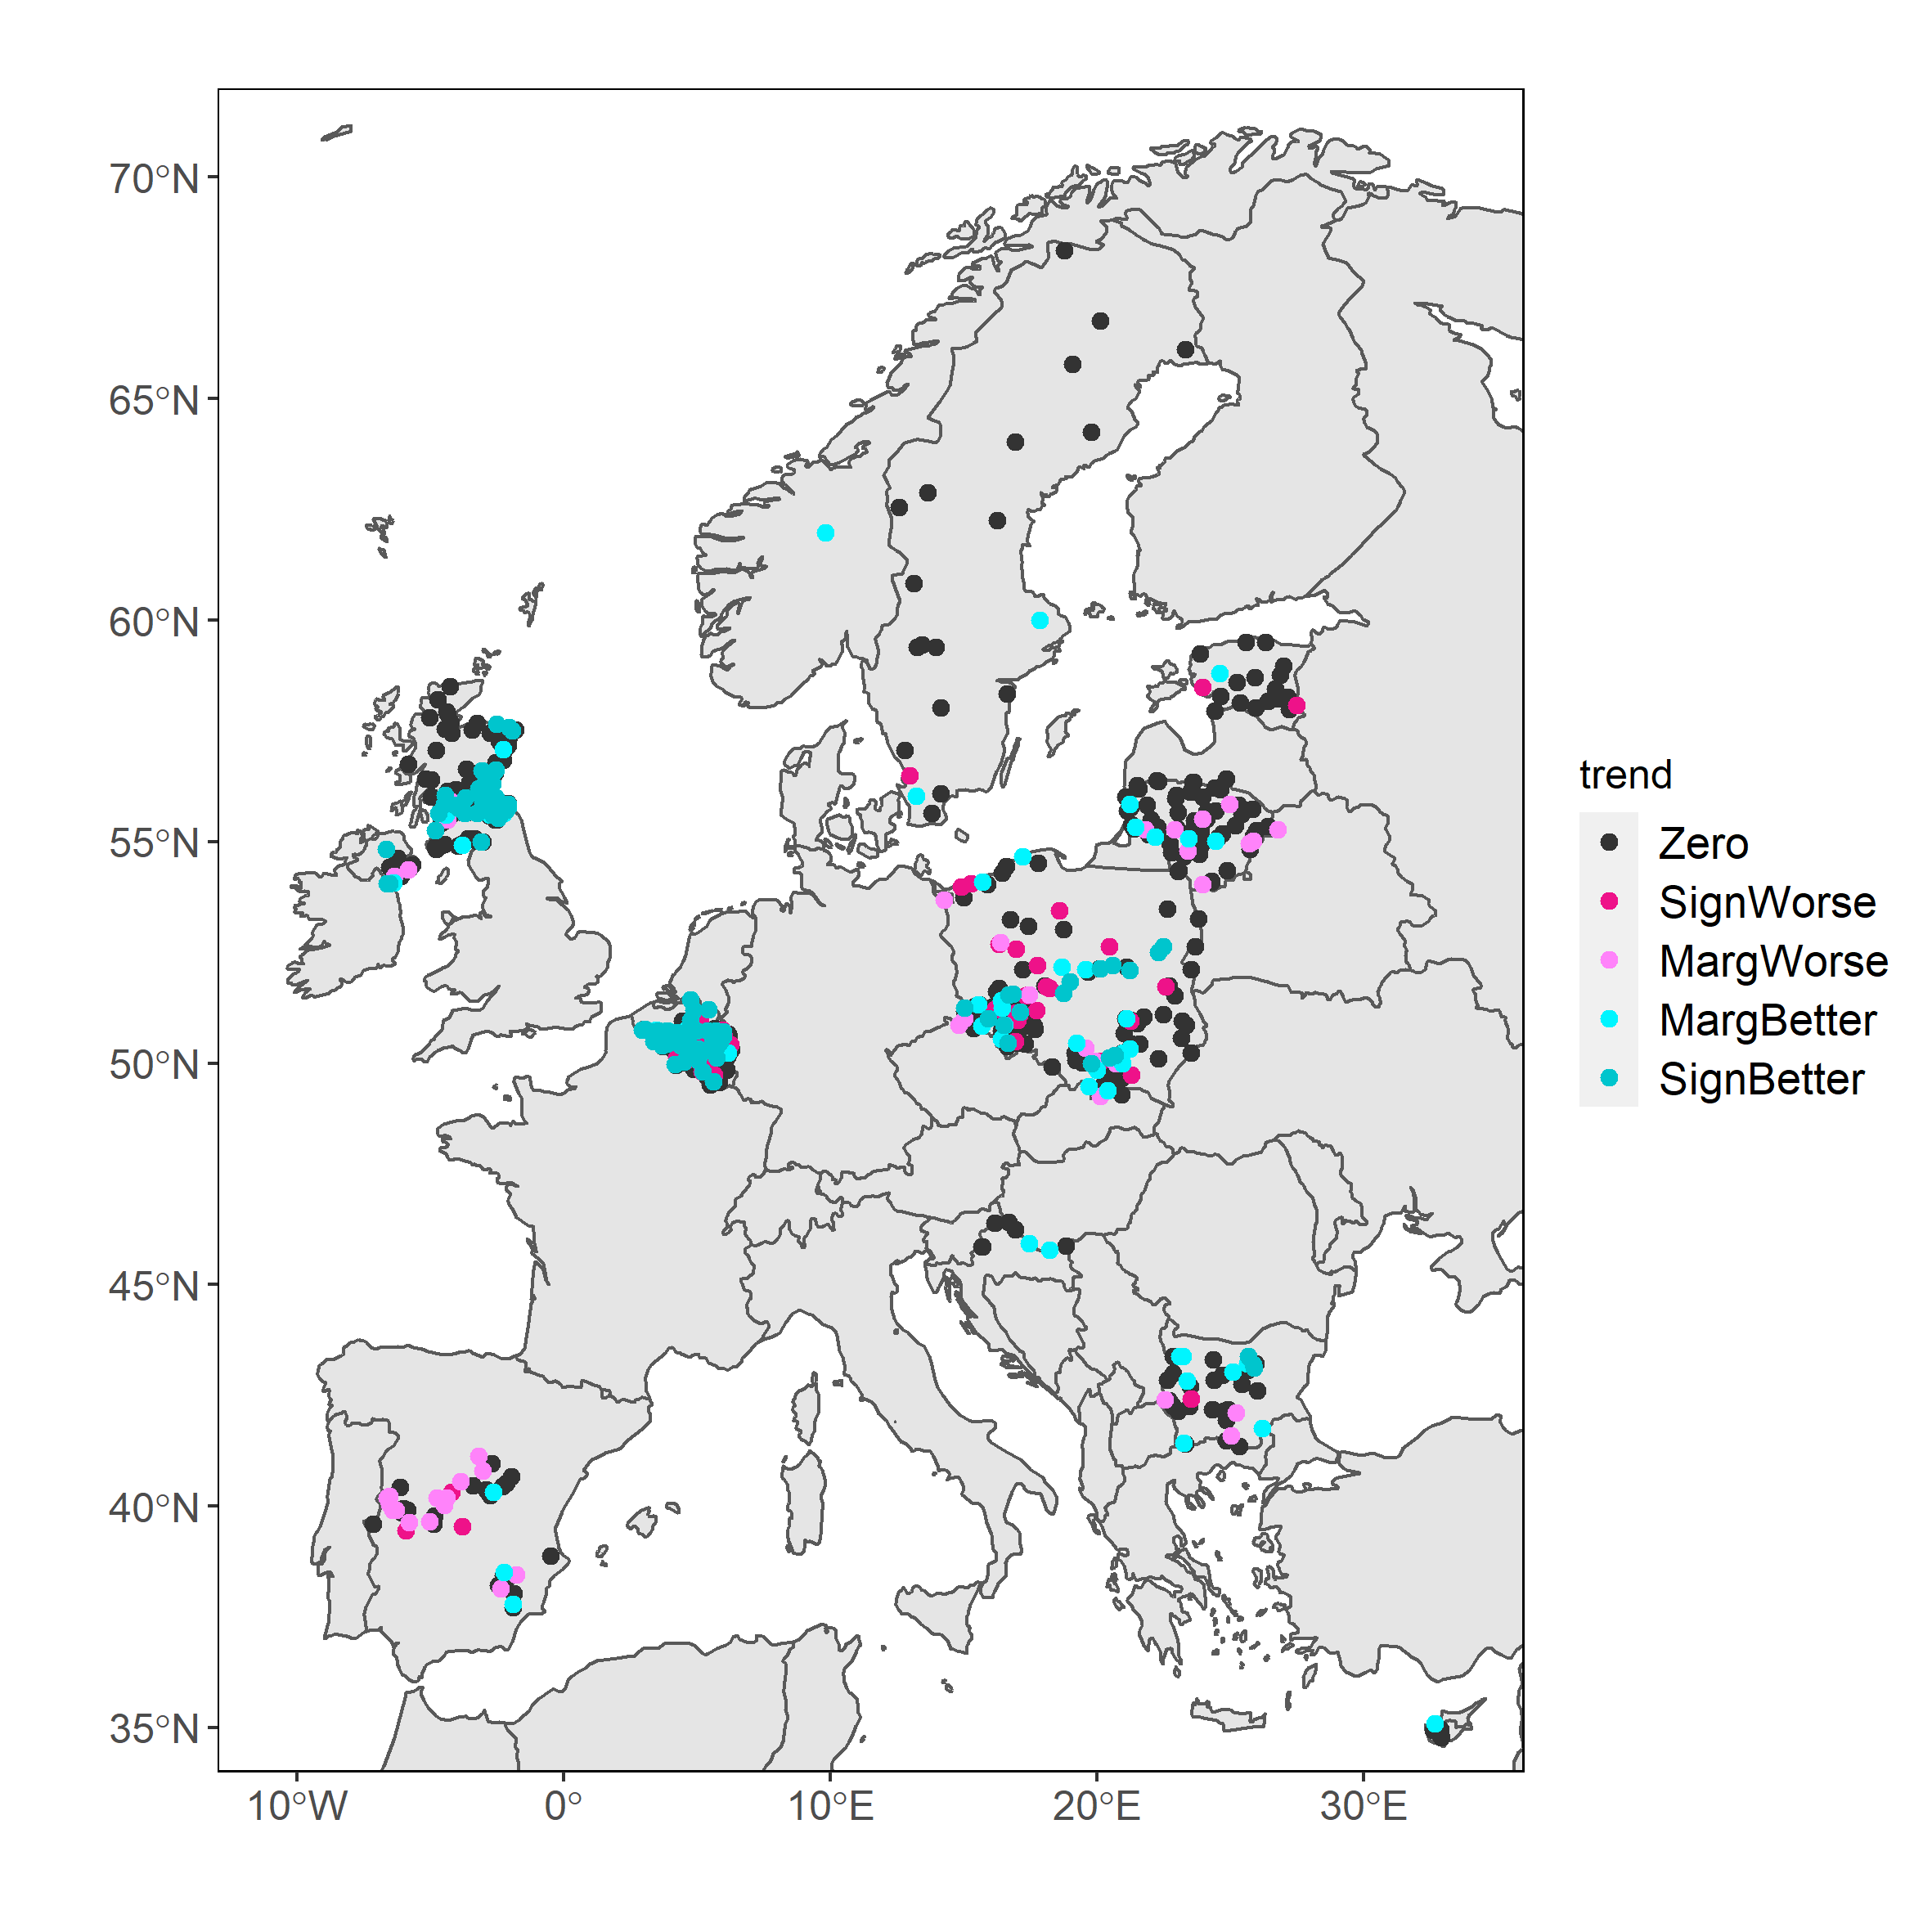 | (b) Phytobenthos in rivers: trends in nEQR  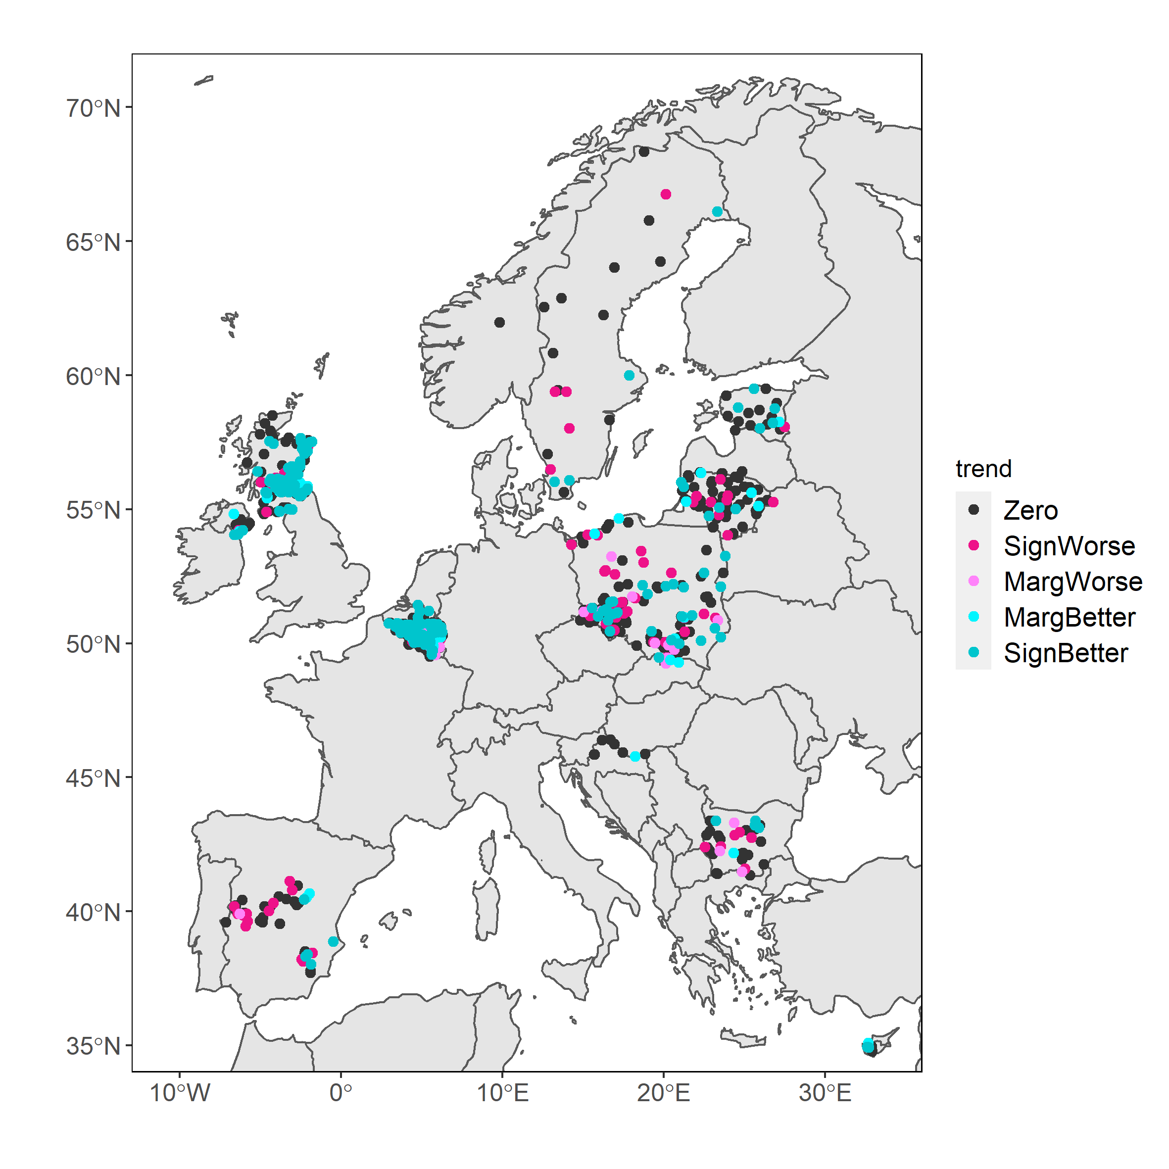
(c) Invertebrates in rivers: trends in status class  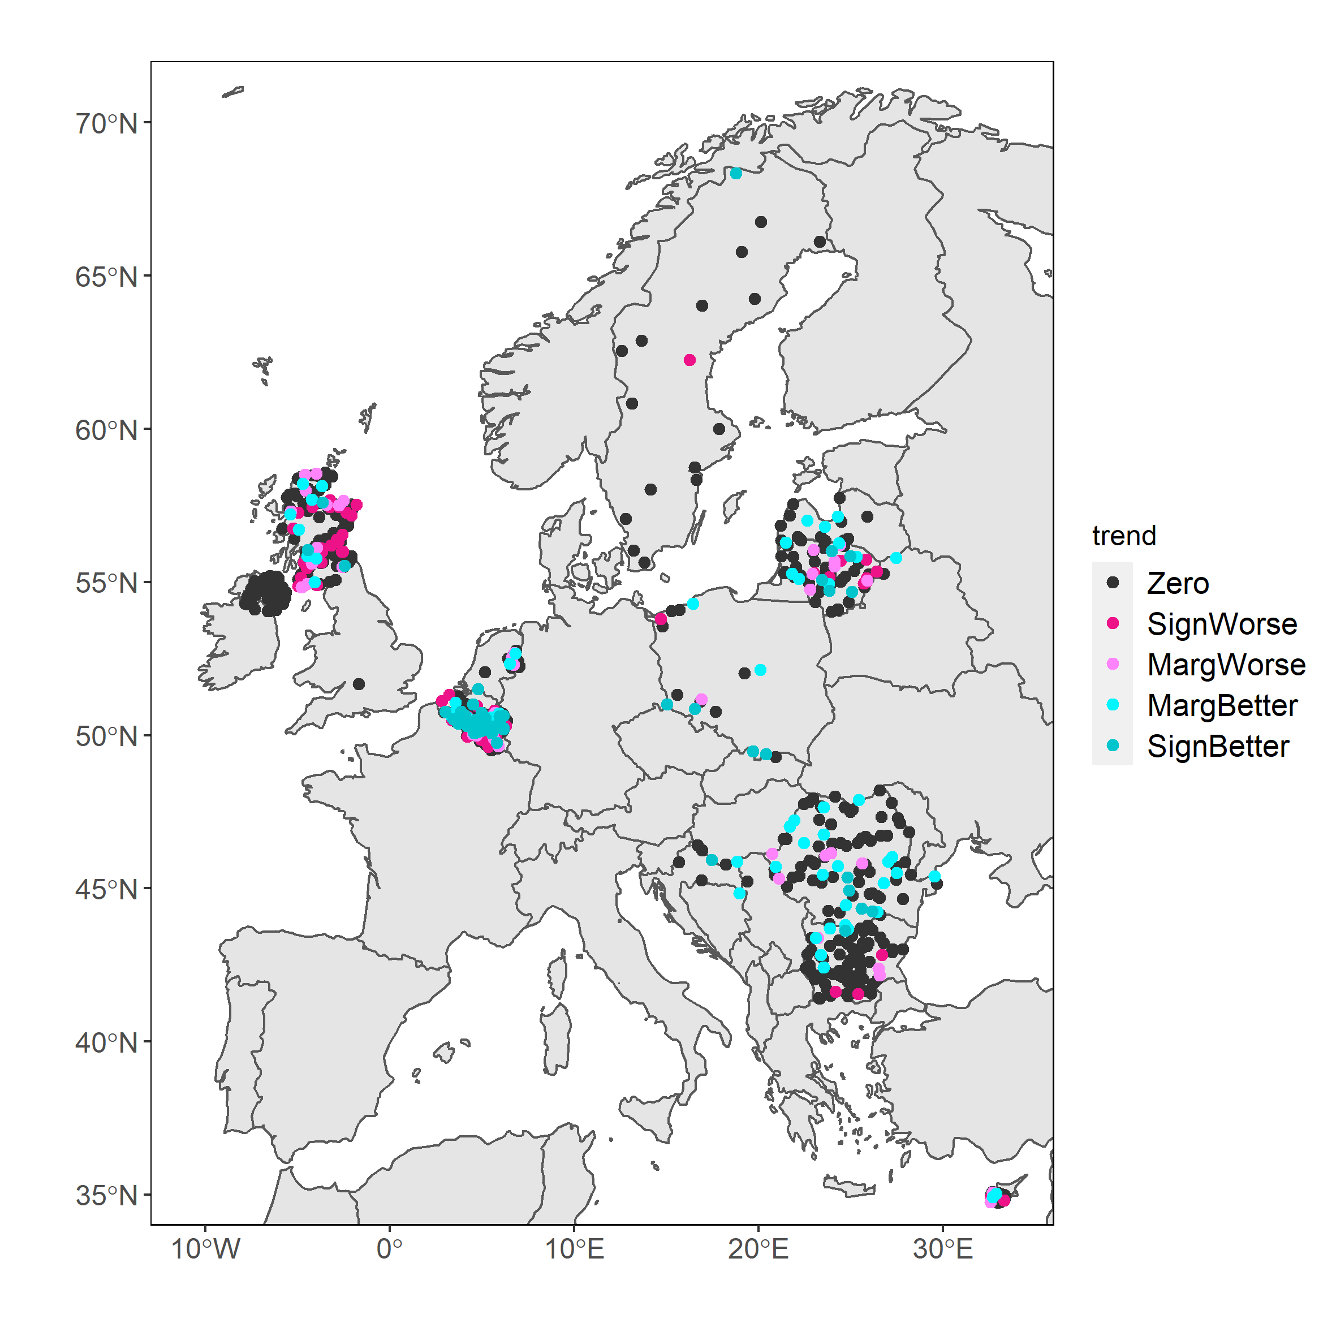 | (d) Invertebrates in rivers: trends in nEQR  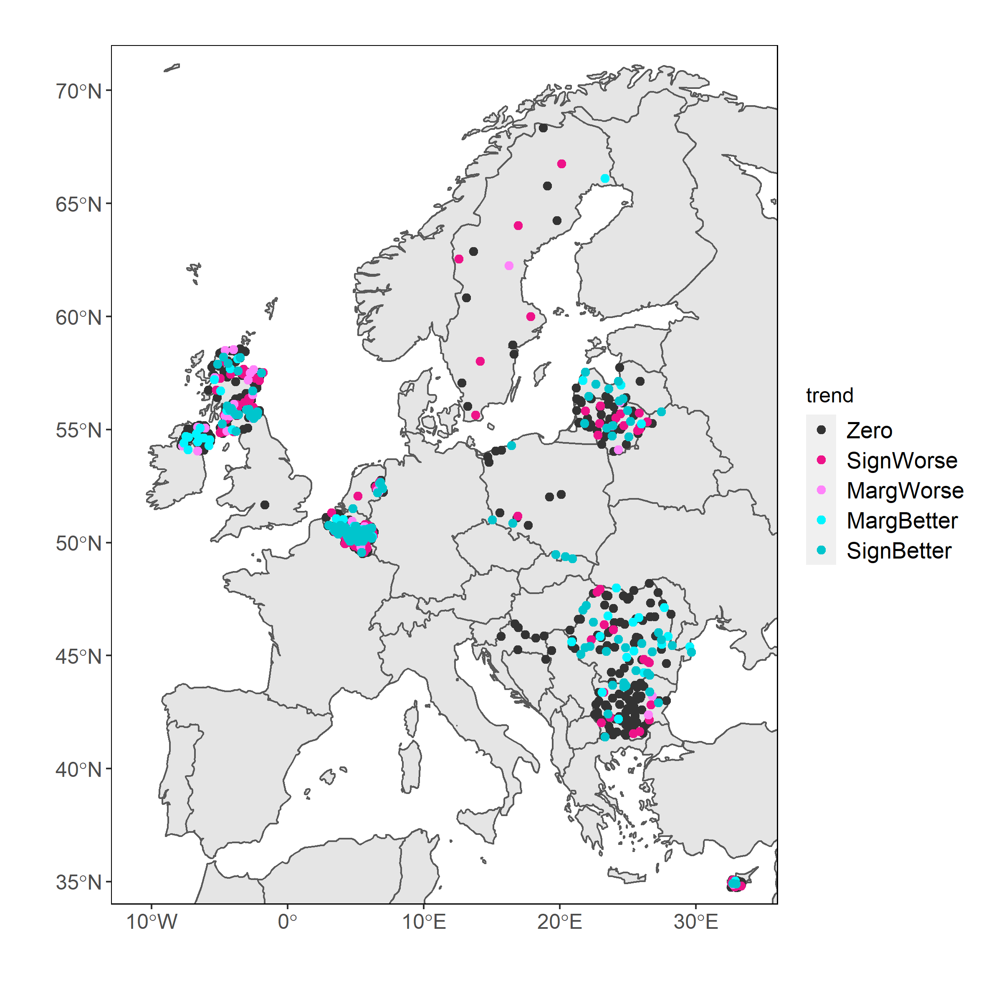
(e) Phytoplankton in lakes: trends in status class  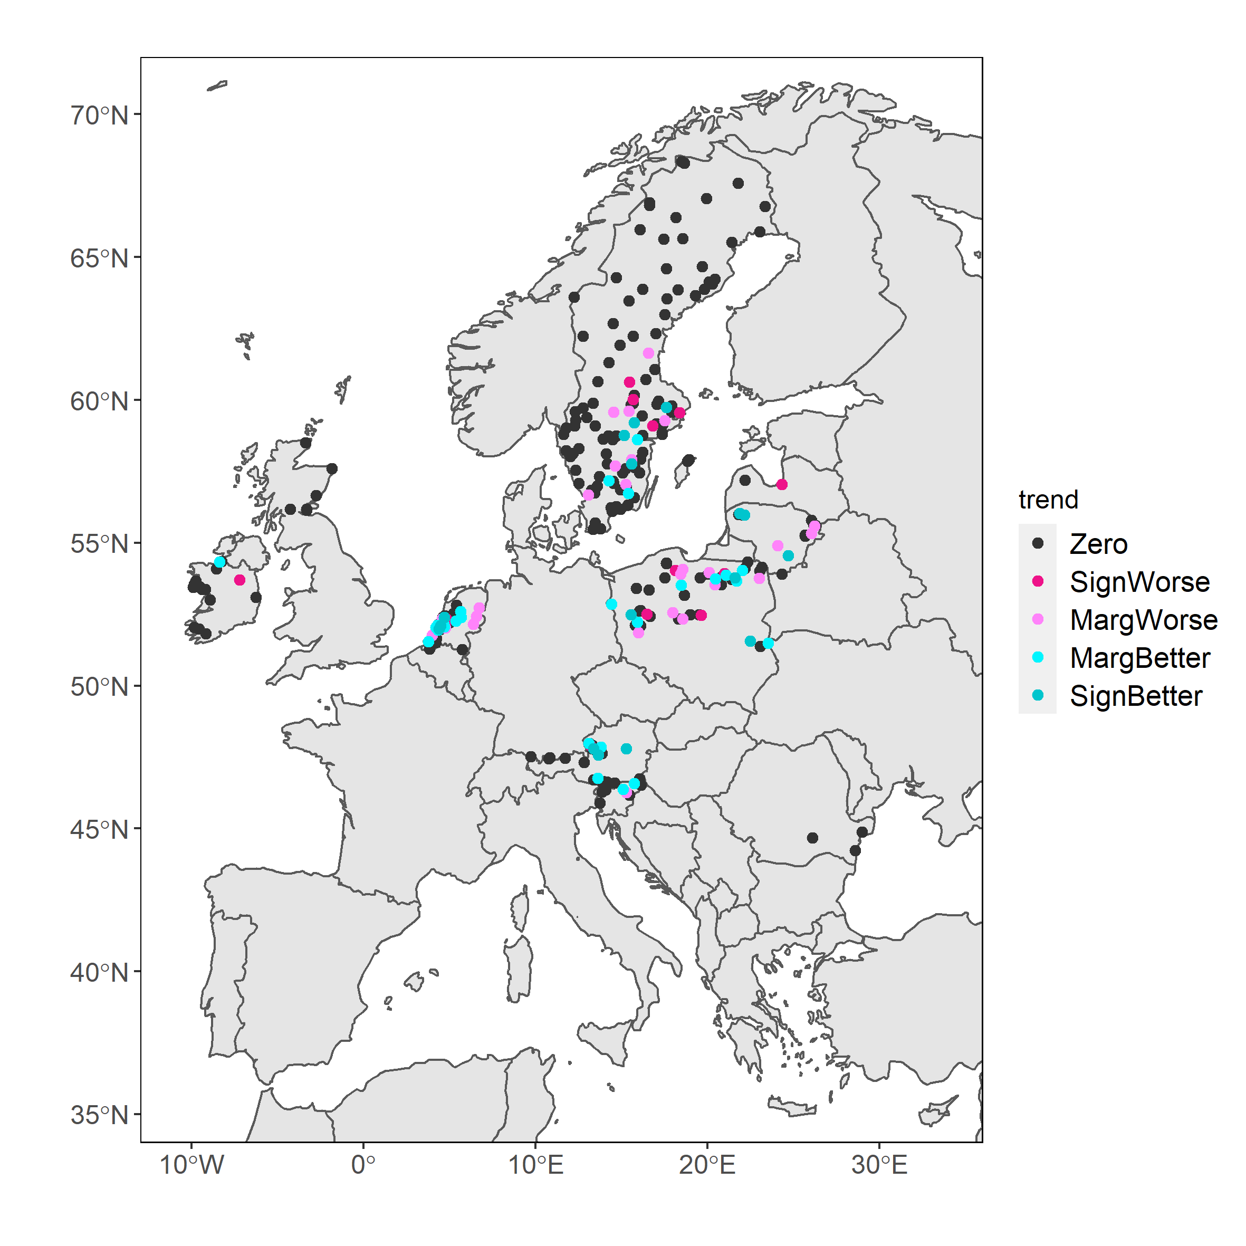 | (f) Phytoplankton in lakes: trends in nEQR  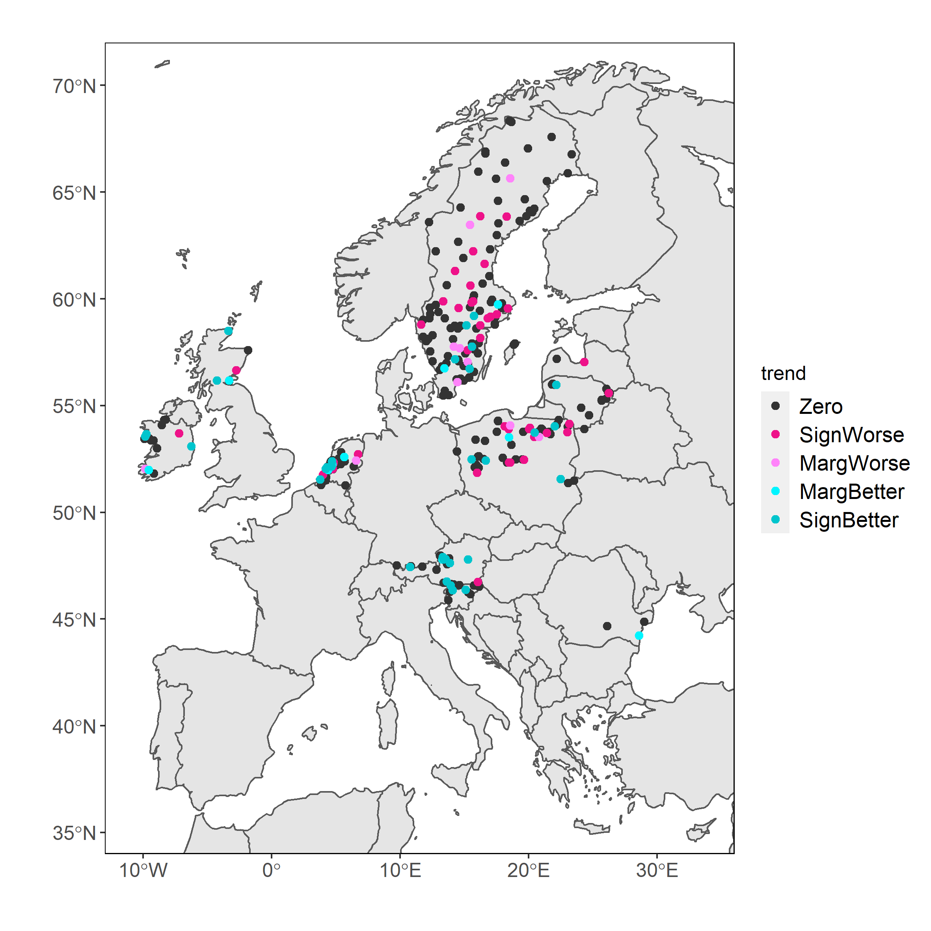
(g) Macrophytes in lakes: trends in status class  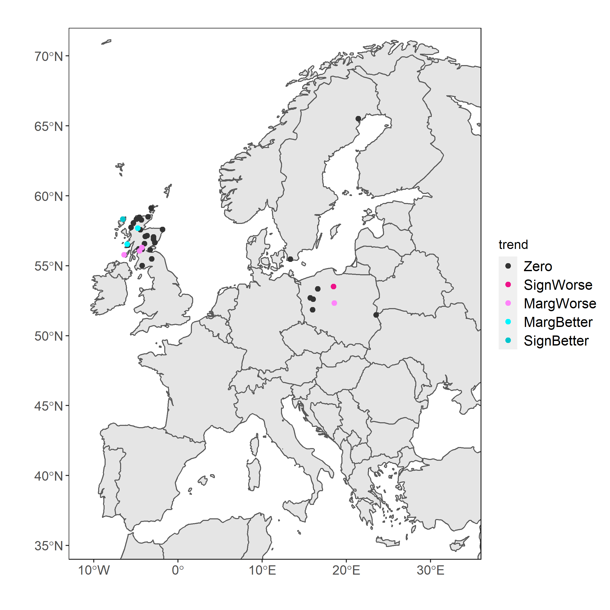 | (h) Macrophytes in lakes: trends in nEQR  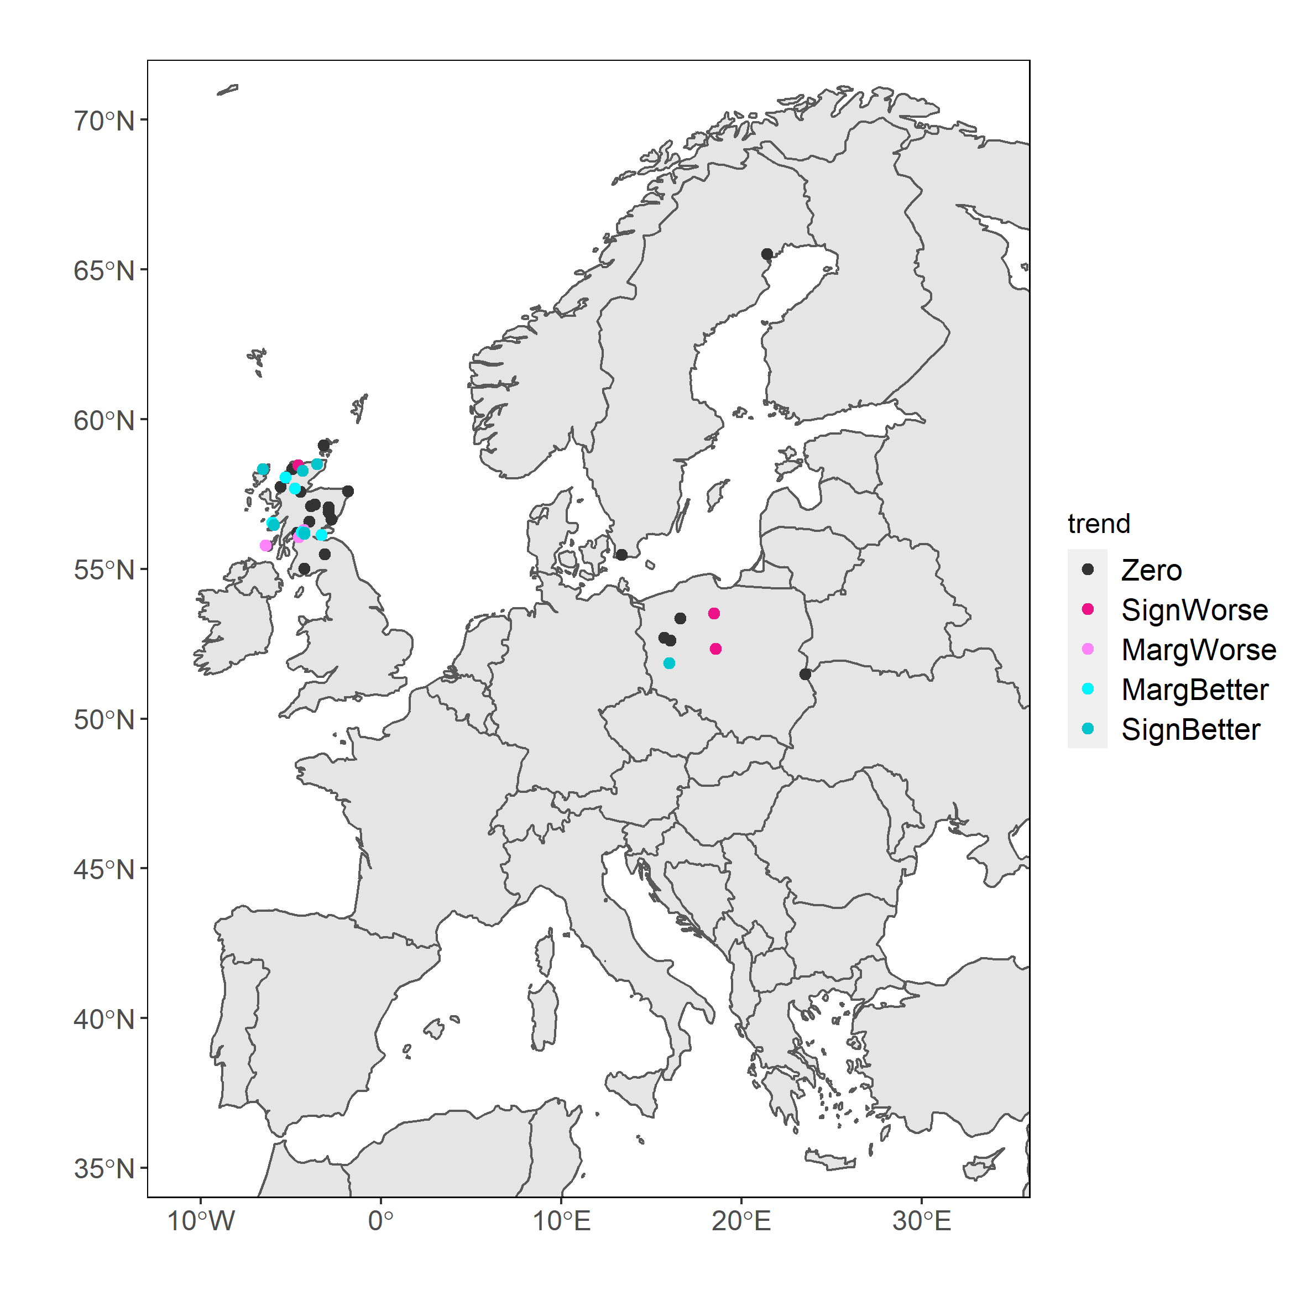

Trend analyses could alternatively have been based on the reported national EQR values, which would have given a slightly higher number of series than the normalised EQR values.

Time series of nEQR aggregated to European level
We have demonstrated the usefulness of the SoE biology data for analysing temporal trends of individual waterbodies. A longer-term aim is to make use of these data also for analysing temporal trends at the European level. This section shows examples of how the time series for individual water bodies can be aggregated to different levels: European level (Figure 5), by geographic regions of Europe (Figure 6) and by initial status class (Figure 7). The selection of data series includes only waterbodies nEQR values for all eight years 2011-2018 after interpolation (described in section 2.3).
When aggregated to the European level (Figure 5), the time series so far display only weak tendencies. Invertebrates in rivers show a decrease from the upper range to the lower range of good status, which is the WFD management target. This tendency would not have been possible to document from reporting of ecological status class only. For the three botanical BQEs, the aggregated time series do not display any no clear or monotonous trend.
A notable pattern in this figure is the dominance of Good status for all BQEs. This average nEQR is higher than expected based on the ecological status classes reported under the WFD for the single BQEs (EEA 2018). The reason may be that the reported SoE data are mainly from waterbodies included in the surveillance monitoring programmes. These programmes do not include many waterbodies in less-than-good status, as the latter is mainly subject to operational monitoring. This bias causes a disproportionately high number of waterbodies in high or good status in the SoE data.
Figure 5 Time series of nEQR aggregated to European level
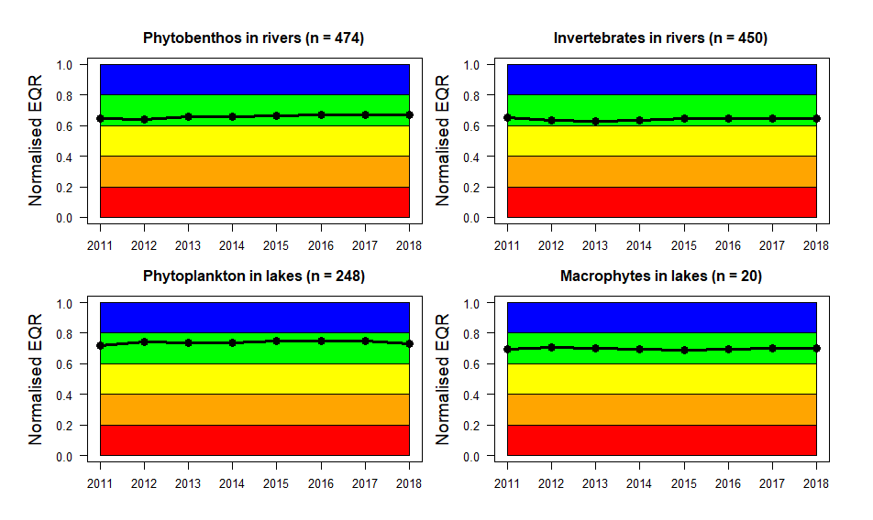
Notes: Complete time series (no gaps after interpolation) of normalised EQR values for the years 2011-2018, aggregated to the European level. The numbers above the plots show the total number of waterbodies with complete time series for each BQE.

The time series aggregated by geographic region (Figure 6) reveal more differences. For example, the invertebrate nEQR values reported from Eastern Europe show a decreasing trend from the mid-range to the lower range of Good status, approaching the Good/Moderate boundary. Moreover, invertebrates nEQR values reported from Southern Europe show a decreasing trend from High to the upper range of Good status, but this trend is based on 3 series only. (More series of invertebrates have been reported from Southern Europe recently, but most series have length up to 5 years, and are therefore not yet included in this figure). The average invertebrate nEQR values in Western Europe, which is the region with the highest number of series, has been fluctuating below the Good/Moderate boundary until 2015 and remained just above boundary since 2016.
As another example, phytoplankton values reported from Eastern Europe started in the upper range Moderate status, and barely reached Good status in the period 2013-2016. Since 2017, the nEQR values have returned to the upper range of Moderate status. In this example, reporting of WFD status classes only show Good status for the period 2013-2016, without revealing that the ecological status was still very close to the Good/Moderate boundary, implying a high risk of decline back to Moderate status.

Figure 6 Time series of nEQR aggregated by geographic region
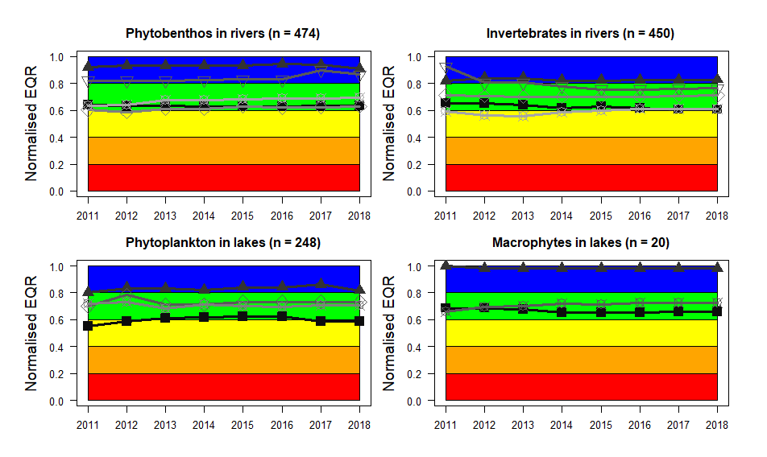
Geographic region | Phytobenthos  n = 199  n = 12  n = 3  n = 30  n = 230 | Invertebrates  n = 70  n = 13  n = 3  n = 143  n = 221 | Phytoplankton  n = 62  n = 117  n = 0  n = 3  n = 66 | Macrophytes  n = 12  n = 1  n = 0  n = 0  n = 7
Notes: Time series of normalised EQR values for the years 2011-2018 aggregated by geographic regions of Europe. The numbers above the plots show the total number of waterbodies for each BQE. The number of waterbodies per geographic region for each BQE is given below the figure.

The number of complete series per BQE is unevenly distributed among the regions of Europe. Western Europe has the highest number of both phytobenthos (n = 230) and invertebrates (n = 221) in rivers. A high number of series from rivers are also reported from East (phytobenthos: n = 199) and Southeast (invertebrates: n = 70). Northern Europe has the most series of lake phytoplankton (n = 117). However, the count of complete series depends on the criteria set; for example, setting the start year to 2012 will result in a higher number of series.
When time series are aggregated by the initial status class of the series (Figure 7), the recovery or deterioration can be compared for waterbodies with different initial ecological status (i.e. status in year 2011). For example, waterbodies initially in high status show a tendency for decline towards the high/good boundary, especially for invertebrates in rivers (n = 91) and macrophytes in lakes (although less reliable due to the low number; n = 3). Waterbodies with initial good status show a stable tendency within this status class, for all BQEs. For waterbodies with initial moderate status, all BQEs show a positive tendency towards good status (and into good status for macrophytes, but with only n = 3). Considering groups with n > 10, the most conspicuous tendencies are for waterbodies with initial poor status for phytobenthos (n = 37), invertebrates (n = 42) or phytoplankton (n = 17); all BQEs show improvement into or very close to good status. Lakes phytoplankton with initial bad status (n = 17) have even improved to cross the Moderate/Poor boundary.
Figure 7 Time series of nEQR aggregated by initial status class
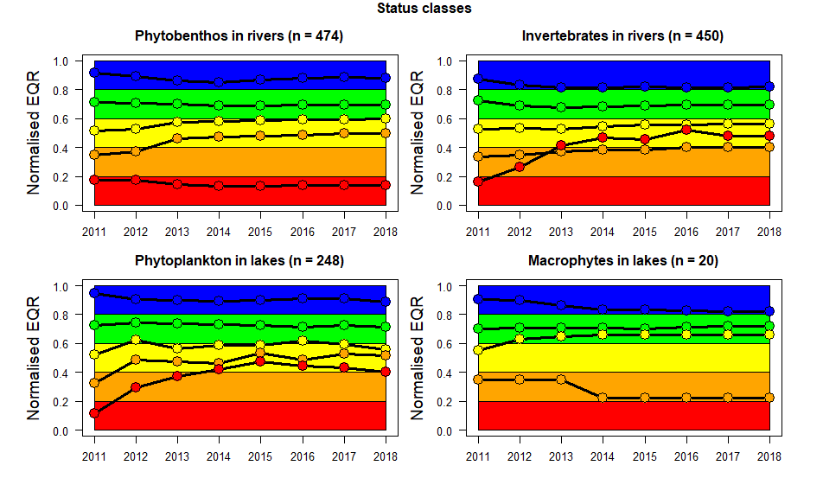
Status class  High  Good  Moderate  Poor  Bad | Phytobenthos  n = 69  n = 204  n = 162  n = 37  n = 2 | Invertebrates  n = 91  n = 175  n = 136  n = 42  n = 6 | Phytoplankton  n = 105  n = 72  n = 37  n = 17  n = 17 | Macrophytes  n = 3  n = 13  n = 3  n = 1  n = 0
Notes: Time series of normalised EQR values for the years 2011-2018 aggregated by the initial status class. The numbers above the plots show the total number of waterbodies for each BQE. The number of waterbodies per initial status class for each BQE is given below the figure. The initial status class of each waterbody is set from 2011, although some waterbodies have values reported also from earlier years.

Obtaining a representative picture of pan-European trends across will require time series from a higher number of waterbodies than what has reported until now, and better representativity both across geographic regions and across the different status classes. Nevertheless, these figures give an indication of the type of results and trends that can be obtained from the reported SoE biology data at the nEQR scale. The examples show that assessments can be meaningful at least for geographic regions or for initial status classes with a high number of complete series.

Coupling of SoE biology and physico-chemical data
The nEQR values represent biological responses to nutrient pollution (expressed as Total Phosphorus) or organic pollution (expressed as BOD). The grey curve shows a fitted logistic regression model. For all four BQEs, the nEQRs show a clear negative relationship with the selected physico-chemical variable, although with large variation (Figure 8). To better account for the temporal and spatial variation separately, the regression analyses can be performed e.g. with a hierarchical model, with temporal variation (years) grouped within waterbodies. The new broad waterbody typology (Lyche Solheim et al. 2019) can also be incorporated to account for spatial variation.
The linked physico-chemical and biological data can also be used to address more specific questions. For example, a reduction of nutrients and BOD can be observed at the European scale (CSI020/C4); is this temporal trend reflected in the biological data in terms of increasing nEQR-values (or reduced chlorophyll a concentrations)?

Figure 8 Normalised EQR values versus selected physico-chemical indicators
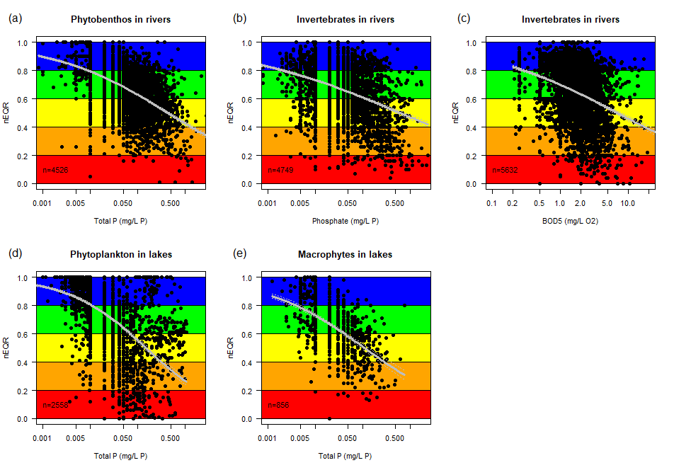
Notes: Scatterplot of nEQR versus selected physico-chemical indicators, for all years and all waterbodies that could be linked to physico-chemistry data. (a) Phytobenthos in rivers vs. Total P, (b) Invertebrates in rivers vs. phosphate, (c) Invertebrates in rivers vs. BOD5, (d) Phytoplankton in lakes vs. Total P, and (e) Macrophytes in lakes vs. Total P. The n = shows the number of observations.

The determinand InvertebrateEQR_A (response to acidification) can be analysed against pH, if this chemical variable becomes available in the chemical Indicator dataset.

The ECOSTAT core group for assessing the standards reported by countries for physico-chemical quality elements has also started to use the biological data (nEQRs) to investigate whether the standards are likely to support good ecological status for sensitive BQEs. Figure 9 below shows an example based on nEQRs for phytobenthos in rivers versus SoE total phosphorus data in the same waterbodies aggregated to different broad river types. Here, the nEQR data are aggregated to >0.6 (high and good status) and <= 0.6 (moderat or worse status). The results show that the total phosphorus concentration is lower in water bodies with phytobenthos in high or good status than in those with moderat or worse status for that BQE. The difference in total P concentration between those two groups of status classes is quite small in some river types, but quite large in others. The figure also shows that the reported total P standards are higher than the concentrations that would be in line with good status in many of the broad types. The ECOSTAT core group will use these results in a report for further guidance and communication with the countries in 2021.

Figure 9 River TP standards compared with nEQR values for phytobenthos
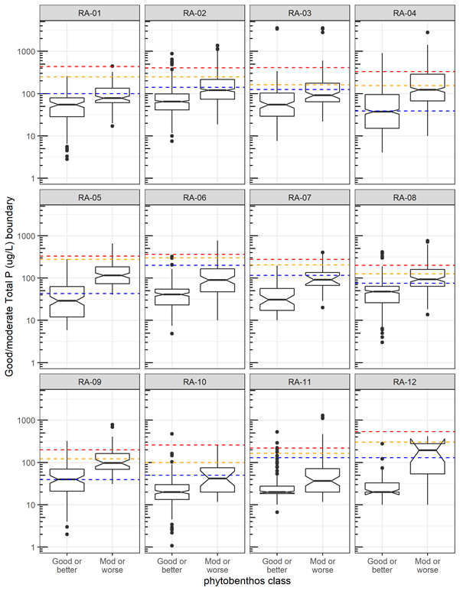
Notes: River TP standards (dotted lines) overlain on box plots showing the range of TP concentration for sites classified by phytobenthos based on nEQR values available in WISE (90th quantile=red, 75th quantile=orange, median=blue),excluding standards based on quantiles, grouped by aggregated river type. (Figure provided by G. Phillips).

Results: Biological data in absolute scale

Overview of biology data in absolute scale
In the following, we show results for secchi depth, chlorophyll a and Cyanobacteria maximum biomass, according to the data given in A1.1 and A1.2. Cyanobacteria maximum biomass is a measure of the intensity of harmful algal blooms in lakes.

Secchi depth
Secchi depth is a measure of lake transparency, which responds to phytoplankton biomass, as well as to humic substances and mineral particles (inorganic turbidity). Transparency or clarity of water is often perceived by the public as an intuitive indicator of water quality.

Country overview (mean 2011-2018)
The results given in Figure 10 Secchi depth (m) in lakes show the secchi depth both for the total number of sites reported and for a subset of sites after excluding those with high concentration of humic substances (corresponding to TOC or DOC above 15 mg L⁻¹).

The overall picture shows < 4 m secchi depth in most of the reported lake sites in most countries and < 2 m for more than half of the lake sites in many of the countries. The countries with the largest secchi depth are Austria and Norway, as well as Croatia and Iceland (the latter two countries having only one site reported). Bulgaria and Germany have >4 m secchi depth in roughly half of their reported lake sites. At the other end of the scale are Belgium, Denmark, Estonia, Greece, Latvia, the Netherlands, Poland, Serbia, Slovenia and Spain, all having < 2 m secchi depth in the majority of the lake sites reported. The picture is quite similar regardless of excluding or including the polyhumic lakes.

Figure 10 Secchi depth (m) in lakes
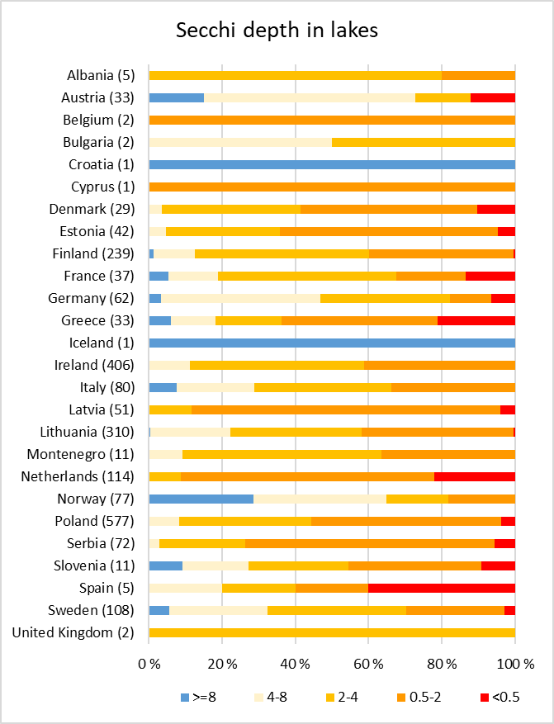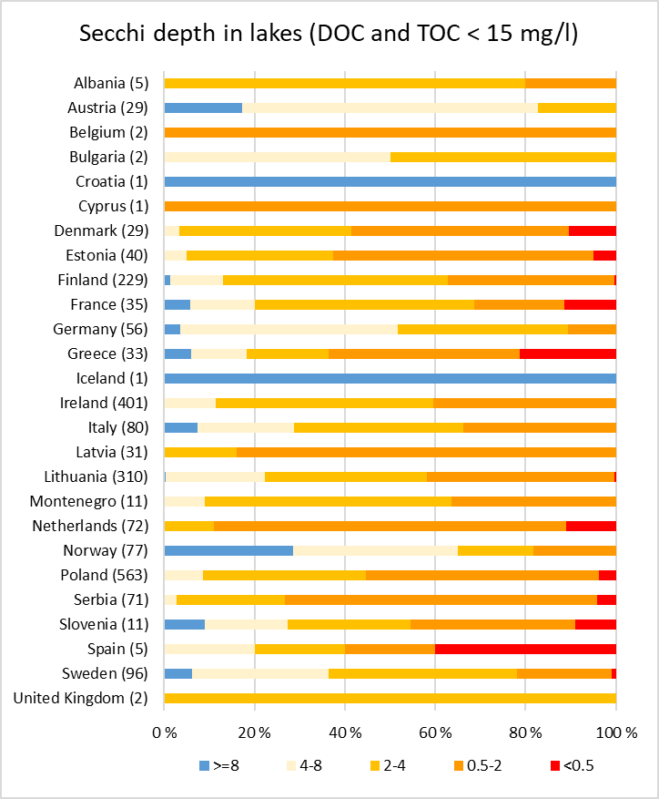
Notes: Average of mean secchi depth (m) per year per site for 2011-2018 (some years may be missing).

Time-series
Timeseries data are shown for long (27 years) and shorter (15 years) periods for all countries with consistent timeseries (Figure 11). The results are shown for all the data with consistent time series, not excluding the polyhumic lakes.

For the long series, most countries show a slight deterioration of secchi depth, except Denmark, which shows a slight improvement. Sweden is the only country with a high number of lakes with long timeseries for this parameter (82 lakes). For the shorter time series, there are few clear patterns in any direction, except Norway showing a clear deterioration from 9 m in the first years to 7 m in the last years (2 lakes only). This deterioration may be caused by increasing humic substances (brownification) (de Wit et al. 2016). The German lakes show some improvement the last couple of years (7 lakes only).

Figure 11. Secchi depth (m) time-series for single countries.
- 27 years
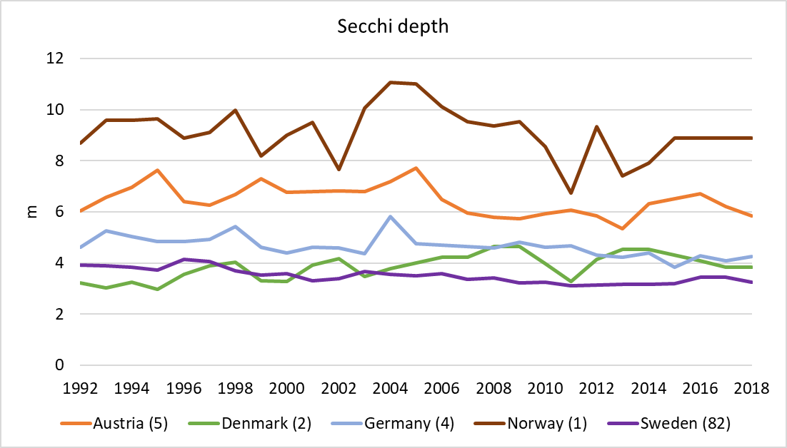

b) 15 years
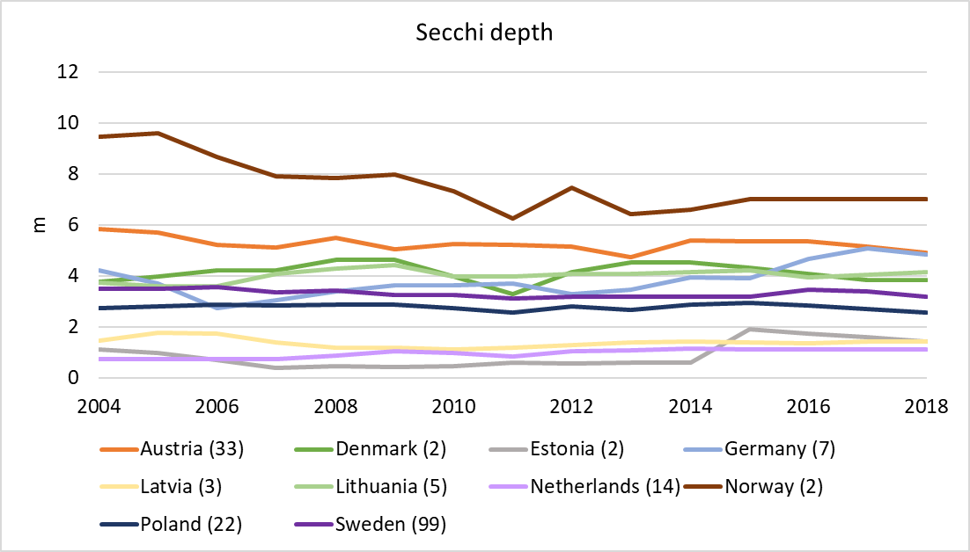

The European results (Figure 12) indicate a slight deterioration of secchi depth, but mainly reflects the Swedish lakes, which are totally dominating the dataset. This deterioration can be caused by the increase in humic substances (brownification) that has occurred in Scandinavia during the two last decades and is due to less acid rain and more rain flushing out a lot of humic substances from forested catchments.

Figure 12. Secchi depth (m) time-series Europe
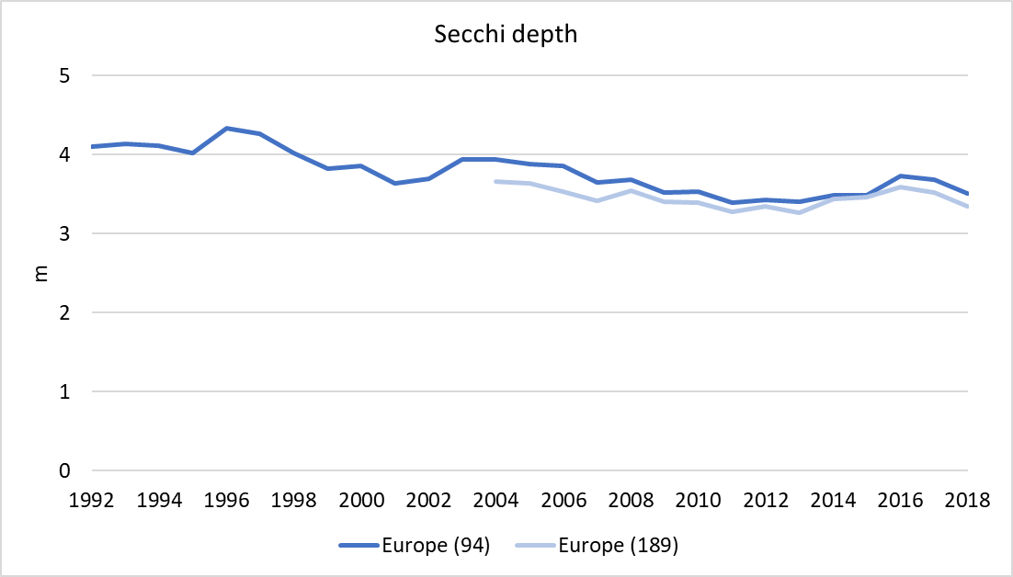

Chlorophyll-a
Chlorophyll-a is a measure of phytoplankton biomass. Chlorophyll-a has been monitored for many decades in lakes and is clearly correlated to nutrients, in particular to total phosphorus (e.g. Phillips et al. 2008).

Country overview (2011-2018)
A large proportion of the lakes reported has low concentration of chlorophyll a (< 4 µg L⁻¹) in many countries (Figure 13). The countries having the highest proportion of lakes with high chlorophyll concentrations (> 20 µg L⁻¹) are Bulgaria, Cyprus, Denmark, the Netherlands, Poland and Romania, probably reflecting high nutrient concentrations due to agricultural run-off and/or urban wastewater. This can be further assessed by comparing the nutrients indicator with these results (may be done in the final version if time and resources allow).

Figure 13. Chlorophyll-a concentration (µg L⁻¹) in lakes.
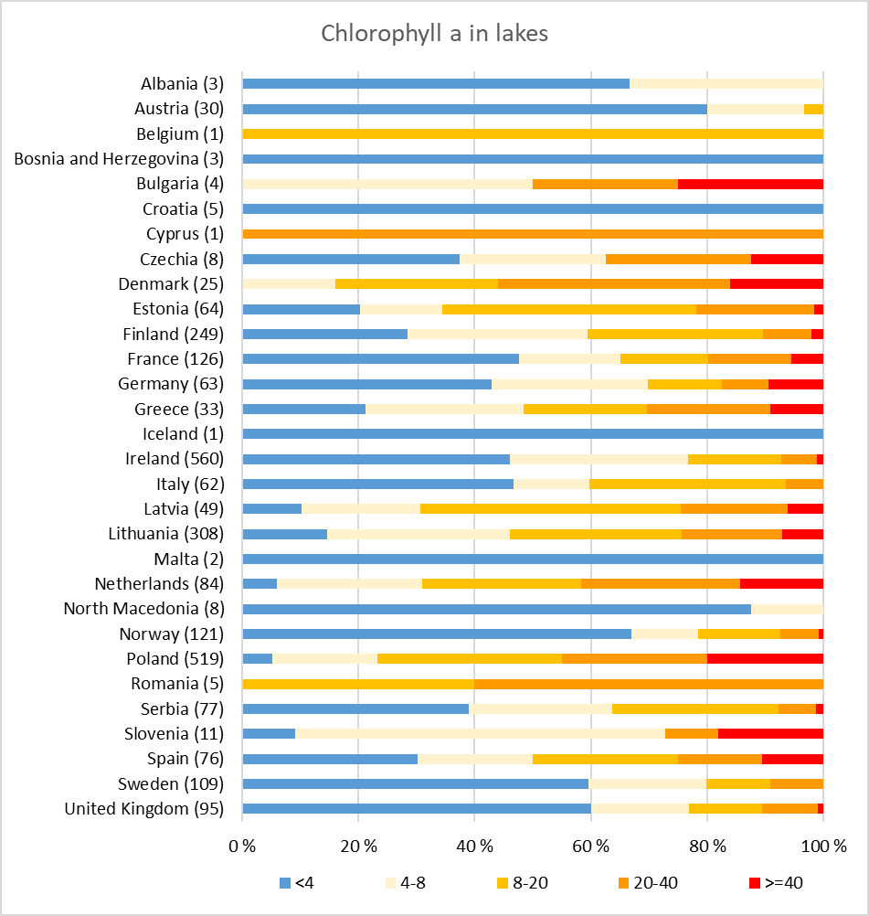
Notes: Average of mean per year per site for 2011-2018 (some years may be missing).

Time-series
Timeseries data are shown for long (27 years) and shorter (15 years) periods for all countries with consistent timeseries (Figure 14). For most of the countries, there are no clear pattern in the timeseries. In a few countries, the chlorophyll-a indicates decreasing concentrations in the long timeseries (e.g. Denmark, the Netherlands and Germany), while the opposite is true for some countries in the shorter timeseries (e.g. Sweden). However, further trend analysis is needed to assess the significance of these patterns.

Figure 14. Chlorophyll a time-series for single countries
- 27 years
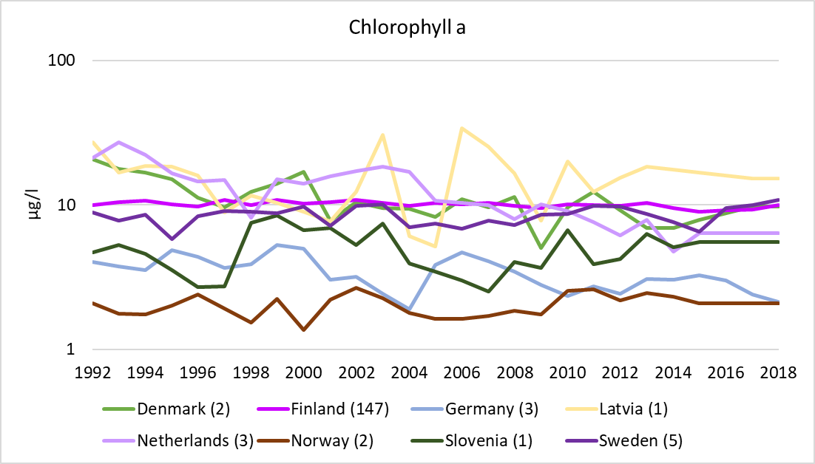

- 15 years
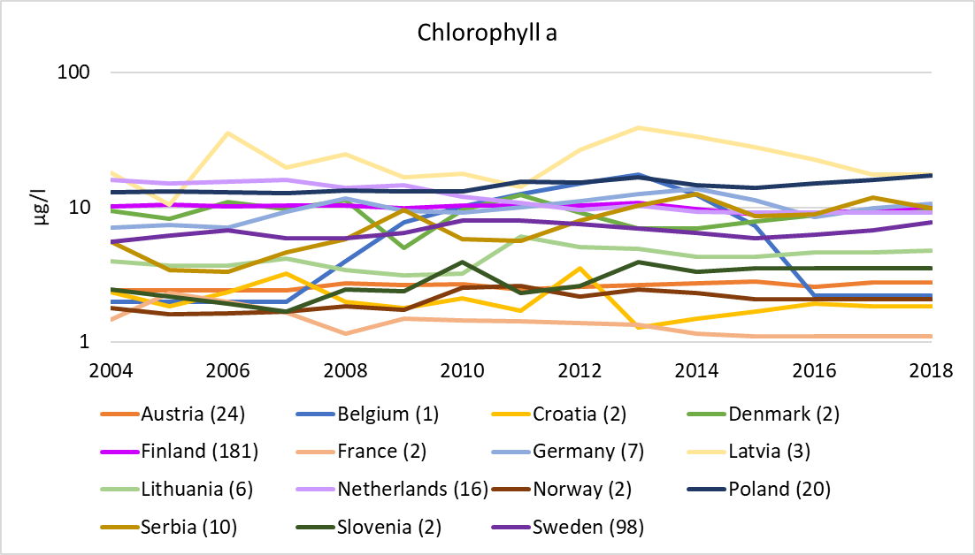

In the aggregated European timeseries (Figure 15), the chlorophyll-a concentration seems to be decreasing in the long timeseries, but for the shorter timeseries there is no clear pattern. The European timeseries are totally dominated by lakes from Finland and Sweden.

These data should be compared to the nutrients data in lakes for further assessments of causes.

Figure 15. Chlorophyll a time-series Europe
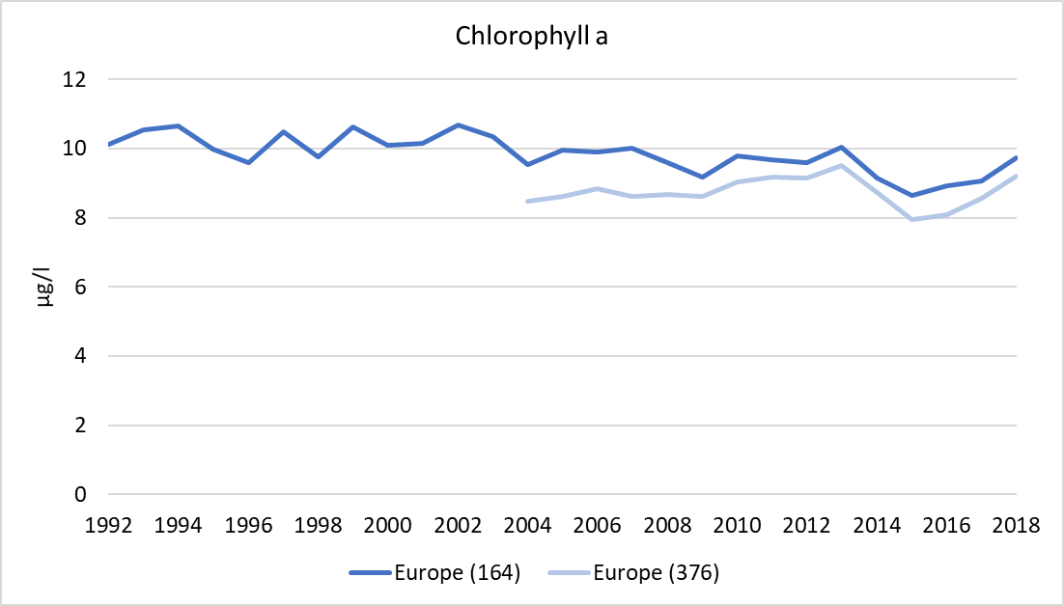

Cyanobacteria
Cyanobacteria may cause harmful blooms in mesotrophic and eutrophic lakes, which may have negative impacts on ecological status and biodiversity in lakes and also threaten public health (WHO 1999). Such blooms have increased in recent years in many lakes all over the world (Ho et al. 2019), suggesting that further nutrient reduction measures are needed to achieve good status and acceptable water quality for many different ecosystem services.

Cyanobacteria biomass has so far been reported from only five countries (Denmark, Estonia, Greece, Lithuania and Norway), but values can be calculated for three more countries based on reporting of total phytoplankton biomass and percentage of Cyanobacteria (Finland, Italy and Sweden). However, to assess bloom intensity, the maximum values per year are needed. These are available for the five countries reporting Cyanobacteria biomass, while from the additional three countries, the maximum values can only be calculated from disaggregated data. Unfortunately, only aggregated data are available for the three countries. Two more countries (Spain and UK) reported percentage of Cyanobacteria, but not total phytoplankton biomass, thereby preventing the calculation of maximum Cyanobacteria biomass. For Denmark, a lot of the data reported (314 records) could not be used to assess the maximum Cyanobacteria biomass, due to only one sample per year for most of the sites.

Further dialogue is needed with the countries to encourage more of them to report Cyanobacteria biomass, and to report this metric from more of their lakes.

The data that could be used for further assessments are shown in Figure 16. The maximum Cyanobacteria biomass exceeds the WHO low risk level for all the sites reported by Estonia, and for a large proportion of the sites in Denmark and Greece. However, for Denmark, the data are from only 7 lake sites, which cannot represent the whole lake population. Lithuania, which has reported the largest dataset and therefore probably has the most representative data, exceeds the WHO low risk level for one third of their lakes. Norway has less than 10% of the reported lakes exceeding the WHO low risk level, but the data reported are from only 13 lakes and cannot be representative for the whole lake population.

Figure 16. Cyanobacteria maximum biomass (mg L⁻¹): a) dot plot showing each site; b) bar plot showing relative distribution of biomass classes
a)
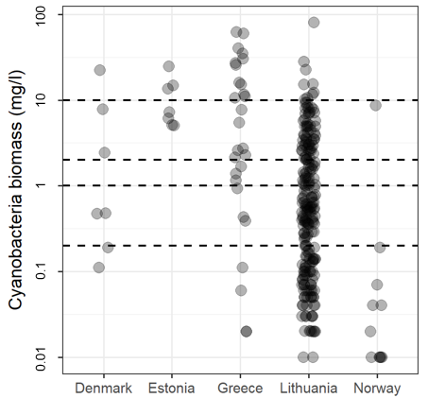
b)

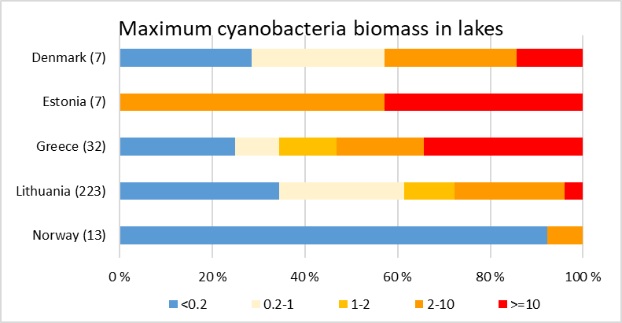

Notes: Average of maximum biomass per year per site for 2011-2018 (some years may be missing). Numbers in parenthesis in figure b shows total number of sites reported for each country.

Development of a new biological indicator
The content below will be used as a starting point for the new ETC project in 2021 on scoping the use of aquatic biological indicators across the WFD water categories. The feedback from EEA to the draft report will also be used to further develop a biological indicator.

Proposed content of a biological indicator
The biological data (normalised EQR values) accumulated in Waterbase since 2010 together with the other biological data concerning phytoplankton Cyanobacteria biomass and chlorophyll-a (much longer timeseries since 1989 are available for chlorophyll-a) provide the potential for a new EEA indicator. The time series can be used to answer questions such as:
- Can we see any progress in biology in rivers and lakes in response to the decrease in nutrients and BOD concentrations?
- Are further mitigation measures needed to reduce the risk for Cyanobacterial blooms threatening public health?
- Are further measures to reduce pressures needed to achieve progress in the biological conditions in rivers and lakes?
- Is there a time lag in the biological response to the decrease in nutrients and organic pollution?
- Will the European Green Deal make progress faster towards restoration of biodiversity in rivers and lakes?
A biological indicator can be developed with a similar structure as the existing indicator "Nutrients in freshwater" (referred to as CSI020/C4) (https://www.eea.europa.eu/data-and-maps/indicators/nutrients-in-freshwater/nutrients-in-freshwater-assessment-published-6), but could be region-specific and/or type-specific (using the broad types), as the levels of pressures and status differ among regions and among broad types (Lyche Solheim et al. 2019).
The content presented in a biological indicator can for example be as follows.

- Time series plots (cf. Figure 5) for each BQE for individual countries, cf. CSI020/CF Figure 3 Trends in nitrate concentration. This will require interpolation of years without data, to avoid bias resulting from missing values. Trends can be shown for respectively short and long series (e.g. 2010-2014 and 2010-2019). This can also be done for biological data in original metric format, i.e. chlorophyll and cyanobacteria (Tables A1.1 and A1.2).
- Time series plots for each BQE aggregated e.g. by geographical regions or broad waterbody types of Europe, in a similar layout as CSI020/C4 figure "Nitrate concentrations in rivers in different sea regions of Europe". This can also be done for biological data in original metric format, e.g. chlorophyll and cyanobacteria (Tables A1.1 and A1.2).
- Summary of statistical trend analysis, in tables (cf. CSI020/C4 tables with trend analysis) and/or barplots (cf. Figure 3).
- WISE interactive maps cf. CSI020 map "Nitrates in rivers". WISE maps were published in 2015 for each of the four BQEs and can be updated with more recent data:
- https://www.eea.europa.eu/data-and-maps/explore-interactive-maps/phytobenthos-in-rivers
- https://www.eea.europa.eu/data-and-maps/explore-interactive-maps/macroinvertebrates-in-rivers
- https://www.eea.europa.eu/data-and-maps/explore-interactive-maps/phytoplankton-in-lakes
- https://www.eea.europa.eu/data-and-maps/explore-interactive-maps/macrophytes-in-lakes
WISE maps can also be produced for Chlorophyll-a and Cyanobacteria biomass, as well as for secchi depth in lakes (and reservoirs).

The current biological WISE maps have the following description (example for phytobenthos in rivers): "The map shows the ecological status or potential of European rivers, expressed using a specific biological quality element (BQE), namely phytobenthos, reported by EEA member countries via WISE. The ecological status class is assessed by each country according to their national classification system, following the principles established by the Water Framework Directive (WFD). The assessment may be based by one or more samples taken during the year of reporting. The map displays the latest reported information under the WISE SoE reporting, so the year of reference may vary. Note that under the WFD reporting, the ecological status or potential based on all BQEs combined is represented by the BQE with the worst class - the "one-out-all-out" principle - which does not apply here, given that only one BQE is represented and that the reporting is done annually. The purpose of the map to enable the user to compare values per country or per monitoring station, depending on the scale of visualisation."
In addition, the biological indicator work will build upon and further develop the draft tableau dashboards developed by EEA for internal use for displaying biological data. (The details of these tableaus are not further discussed in this report).

Conclusions
- Biological data from river and lakes have been reported by most European countries (36). Of these, the vast majority have reported national EQRs (ecological quality ratios) and/or normalised EQRs.
- The total number of records (countries x years) at EQR scale are more than 7000 for rivers and 1500 for lakes, while for data reported on absolute scale, there are more than 17000 lake records for chlorophyll and more than 700 records for Cyanobacteria biomass.
- The reporting of biology data at EQR scale increased substantially for sampling year 2018 (reported during 2019-2020) after a major decreased during the sampling years 2016-2017. A likely cause for this recent increase is the well-attended webinar on WISE-2 reporting and more feedback to the countries on the possible uses of the data.
- The number of sites and years show large variations among countries, indicating challenges concerning geographical representativity (see next steps for actions to improve this).
- The biological determinands show significant relationships with the selected general physico-chemical quality elements (Total-P and BOD), although with large variation for various reasons.
- Trend analysis (timeseries with minimum four values) is a more robust and reliable method for detecting change in ecological status than comparison of two before-after values (corresponding to WFD data).
- Trend analysis of nEQR values detect more trends than trend analysis of ecological status classes.
- Time series aggregated by European region or by the initial status class reveal more trends than series aggregated to the European level. However, a more balanced number of time series is needed for more reliable results.

Next steps
- The benefits of the biological data will be described in a scoping paper including both freshwater and marine biological data in the autumn 2020.
- Two important action point to enhance the biological data reporting are to present and discuss the challenges and benefits of using these data with the countries, e.g. at EIONET workshops or other workshops (WG-DIS-subgroup on indicators and ECOSTAT) in order to increase their motivation to report biological data from more water bodies and also improve the quality of the data. Increased capacity within EEA is also needed to correct mistakes done by the data providers.
- To get more representative data, reflecting the actual distribution of status classes, the countries should be encouraged to report more data from water bodies in less than good status, which are mainly included in the operational monitoring programmes.
- With continued and increased reporting of EQR data, these data series can be used as an indicator of trends in biological responses to different pressures on European waterbodies.
- Reported national EQR values cannot always be converted to nEQRs, mostly because information on the national classification system is lacking or is not compatible with the data model. Therefore, the data providers should be encouraged to calculating and reporting normalised EQR values in addition to or instead of national EQRs.
- The dataflow can be expanded with fish in rivers and lakes, which would be a better indicator of impacts of hydromorphology than the other BQEs.
- Data on chlorophyll and cyanobacteria in original metric scale can also be included, as these are clear indicators of eutrophication in lakes. For chlorophyll, there are already long time series available. These data can also be linked to Copernicus data for lakes and are relevant both for biodiversity, climate change impacts combined with nutrient pollution and for ecosystem services (Ho et al. 2019).
- The biological data would provide a better aquatic SEBI (Streamlined European Biodiversity Indicator) than the currently used abiotic indicators. The overall ecological status is not a good option because it is less comparable across countries than the BQE status, due to different combination rules for BQEs vs. supporting quality element, and since overall ecological status is reported only once every six years.
- Transfering most of the processing, analysis and visualisation of biology data from local databases to the common workspace and dynamic tableaus will ensure a more efficient, transparent and updated presentation of the biological indicator.

References
Carvalho, L., C. McDonald, C. de Hoyos, U. Mischke, G. Phillips, G. Borics, S. Poikane, B. Skjelbred, A. Lyche Solheim, J. Van Wichelen & A. C. Cardoso, 2013. Sustaining recreational quality of European lakes: minimizing the health risks from algal blooms through phosphorus control. J. Applied Ecology, 50: 315–323, doi: 10.1111/1365-2664.12059
De Wit HA, Valinia S, Weyhenmeyer GA, Futter MN, Kortelainen P, Austnes K, Hessen DO, Raike A, Laudon H, Vuorenma J (2016) Current browning of surface waters will be further promoted by wetter climate. Environ. Sci. Technol. Lett. 3(12): 430-435.
EC [European Commission] 2000, Directive 2000/60/EC of the European Parliament and of the Council establishing a framework for the Community action in the field of water policy. The Water Framework Directive (WFD)
EEA [European Environment Agency] 2018. European waters - assessment of status and pressures. EEA Report No 7/2018. ISSN 1977-8449.
Ho, J.C., Michalak, A.M., Pahlevan, N. 2019. Widespread global increase in intense lake phytoplankton blooms since the 1980s. Nature: doi:10.1038/s41586-019-1648-7.
Lyche Solheim, A., Phillips, G., Drakare, S., Free, G., Järvinen, M., Skjelbred, B., Tierney, D., Trodd, W., 2014. Water Framework Directive Intercalibration Technical Report. Northern Lake Phytoplankton ecological assessment methods. 01/2014; Report EUR 26503 EN, doi:10.2788/70684. Publisher: Luxembourg: Publications Office of the European Union, Editor: Sandra Poikane, ISBN 978-92-79-35455-7.
Lyche Solheim, A., Globevnik, L., Austnes, K., Kristensen, P., Moe, J., Persson, J., Phillips, G., Poikane, S., van de Bund, W., Birk, S., 2019. A new broad typology for rivers and lakes in Europe: Development and application for large-scale environmental assessments. Science of the Total Environment, 697: doi.org/10.1016/j.scitotenv.2019.134043. (online version available at: https://www.sciencedirect.com/science/article/pii/S0048969719340203)
McLeod, A.I., 2011, Kendall: Kendall rank correlation and Mann-Kendall trend test. R package version 2.2. https://CRAN.R-project.org/package=Kendall
Moe, J., Lyche Solheim, A., 2013, Ecological status for biological quality elements in rivers and lakes - towards a new indicator to assess ecological impacts of specific pressures. Deliverable for ETC/ICM task 1.4.3.a: Update of indicators and their assessments, Milestone 4: Biological indicators. Version 3.2 (04.09.2014). http://forum.eionet.europa.eu/nrc-eionet-freshwater/library/eionet-workshops/copenhagen-eionet-workshop-september-2013/documents/background-documents/biology-assessment
Phillips, G., Pietilainen, O.-P. Carvalho L., Solimini A. , Lyche Solheim A., Cardoso, A. C. 2008. Chlorophyll–nutrient relationships of different lake types using a large European dataset. Aquat Ecol (2008) 42:213–226. DOI 10.1007/s10452-008-9180-0
R Core Team, 2020, R: A language and environment for statistical computing. R Foundation for Statistical Computing, Vienna, Austria. URL https://www.R-project.org/.
WHO 1999 guidelines on algae and cyanobacteria in freshwaters: http://www.who.int/water_sanitation_health/bathing/srwe1-chap8.pdf

Reference checked: Jannicke Moe and Anne Lyche Solheim 03.07.2020

Acknowledgements
We thank Geoff Phillips. hired as consultant by JRC for ECOSTAT nutrient activity work, for kindly sharing Figure 9 for use in this report.

Other biological data & secchi depth
Table A1.1 Biological metrics and secchi depth in lakes in original scale: count of records per country (across all years from 1989-2018)
Determinand | Secchi depth | Chlorophyll a | Cyanobacteria biomass | Cyanobacteria percentage | Total phytoplankton biomass
Country code | m | µg L⁻¹ | mg L-1 | % | mg L⁻¹
AL | 18 | 3
AT | 661 | 271
BA | 10 | 18
BE | 29 | 24
BG | 11 | 15 |  | 1 | 5
CH |  | 112
CY | 5 | 7
CZ |  | 39
DE | 501 | 476 |  |  | 53
DK | 509 | 288 | 314 | 314 | 314
EE | 257 | 113 | 10 |  | 13
EL | 120 | 127 | 90 | 90 | 90
ES | 12 | 336 |  | 71
FI | 5185 | 5813 |  | 64 | 65
FR | 89 | 244
HR | 18 | 41
HU | 93 | 222
IE | 1359 | 2121
IS | 6 | 6 |  | 1 | 1
IT | 862 | 920 |  | 4 | 6
LT | 551 | 562 | 303 | 27 | 27
LV | 200 | 211 |  |  | 71
ME | 43
MK |  | 23 |  |  | 1
MT |  | 4
NL | 612 | 476
NO | 148 | 214 | 14 | 82 | 156
PL | 1271 | 1119
PT | 2 | 4
RO | 1 | 10 |  |  | 6
RS | 468 | 481
SE | 3391 | 2252 |  | 277 | 277
SI | 136 | 106 |  |  | 11
SK |  | 7
TR | 5 | 5
UK | 152 | 892 |  | 83
Total | 16725 | 17562 | 731 | 1014 | 1096

Table A1.2 Biological metrics and secchi depth in lakes in original scale: count of records per year (across all countries)
Deter-minand | Secchi depth | Chlorophyll a | Cyanobacteria bimass | Cyanobacteria percentage | Total phytoplankton biomass
Year* | m | µg L⁻¹ | mg L⁻¹ | % | mg L⁻¹
1989 | 340 | 240 | 15 | 15 | 15
1990 | 340 | 251 | 15 | 15 | 15
1991 | 354 | 268 | 15 | 15 | 15
1992 | 361 | 258 | 15 | 15 | 15
1993 | 370 | 267 | 15 | 15 | 15
1994 | 386 | 263 | 15 | 15 | 15
1995 | 388 | 274 | 15 | 15 | 15
1996 | 414 | 398 | 15 | 15 | 15
1997 | 425 | 408 | 15 | 15 | 15
1998 | 441 | 413 | 16 | 16 | 16
1999 | 438 | 403 | 16 | 16 | 16
2000 | 493 | 476 | 16 | 16 | 16
2001 | 513 | 462 | 16 | 16 | 16
2002 | 582 | 554 | 16 | 16 | 18
2003 | 628 | 590 | 16 | 16 | 16
2004 | 625 | 628 | 15 | 15 | 17
2005 | 751 | 680 | 15 | 15 | 17
2006 | 703 | 648 | 15 | 15 | 15
2007 | 713 | 723 | 15 | 79 | 83
2008 | 784 | 786 | 10 | 10 | 12
2009 | 649 | 810 | 6 | 15 | 20
2010 | 843 | 1038 |  | 225 | 156
2011 | 860 | 867 | 23 | 154 | 140
2012 | 872 | 876 | 30 | 162 | 219
2013 | 802 | 924 | 104 | 34 | 48
2014 | 823 | 927 | 100 | 28 | 50
2015 | 886 | 1246 | 31 | 30 | 30
2016 | 270 | 690 | 72 |  | 37
2017 | 280 | 672 | 64 | 1 | 18
2018 | 391 | 522 |  |  | 1
Total | 16725 | 17562 | 731 | 1014 | 1096
* phenomenonTimeReferenceYear

Summary of trend analyses for nEQR data
Tables A2.1-4 show the results of trend analysis based on nEQR values grouped by BQE and country. The total number includes all waterbodies with minimum 4 years after interpolation

Table A2.1 Summary of trend analyses per country: phytobenthos in rivers
Country code | No. of water bodies | Very negative (p<0.05) | Marginally negative (p<0.10) | No trend | Marginally positive (p<0.10) | Very positive (p<0.05)
BE | 231 | 24 | 6 | 127 | 11 | 63
BG | 38 | 6 | 3 | 24 | 1 | 4
CY | 5 |  |  | 2 | 1 | 2
EE | 19 | 1 |  | 12 | 1 | 5
ES | 45 | 15 | 1 | 22 | 2 | 5
HR | 6 |  |  | 5 | 1
LT | 70 | 9 |  | 52 | 4 | 5
LU | 2 |  | 1 | 1
NO | 1 |  |  | 1
PL | 177 | 35 | 11 | 95 | 6 | 30
SE | 21 | 5 |  | 12 |  | 4
SI | 2 |  |  | 2
SK | 16 | 2 |  | 14
UK | 143 | 7 |  | 74 | 12 | 50
Sum | 776 | 104 | 22 | 443 | 39 | 168

Table A2.2 Summary of trend analyses per country: invertebrates in rivers
Country code | No. of water bodies | Very negative (p<0.05) | Marginally negative (p<0.10) | No trend | Marginally positive (p<0.10) | Very positive (p<0.05)
BE | 295 | 60 | 11 | 159 | 10 | 55
BG | 78 | 7 | 2 | 60 | 2 | 7
CY | 20 | 4 | 1 | 12 | 1 | 2
HR | 9 |  |  | 9
LT | 67 | 12 | 3 | 44 | 1 | 7
LV | 16 |  |  | 6 | 2 | 8
NL | 23 | 4 | 2 | 11 | 2 | 4
PL | 16 | 1 |  | 9 |  | 6
RO | 100 | 10 |  | 56 | 14 | 20
SE | 17 | 6 | 1 | 9 | 1
SK | 18 |  | 1 | 14 | 1 | 2
UK | 212 | 28 | 16 | 122 | 21 | 25
Sum | 871 | 132 | 37 | 511 | 55 | 136

Table A2.3 Summary of trend analyses per country: phytoplankton in lakes
Country code | No. of water bodies | Very negative (p<0.05) | Marginally negative (p<0.10) | No trend | Marginally negative (p<0.10) | Marginally positive (p<0.05)
AT | 29 |  |  | 26 | 3
IE | 256 |  |  | 256
LT | 4 |  |  | 4
LV | 309 |  |  | 308 | 1
NL | 6 | 1 |  | 5
PL | 49 |  |  | 49
RO | 464 |  | 3 | 460 | 1
SE | 5 |  |  | 5
SI | 108 | 16 | 4 | 83 | 3 | 2
UK | 13 |  |  | 12 | 1
Sum | 776 | 104 | 22 | 443 | 39 | 168

Table A2.4 Summary of trend analyses per country: macrophytes in lakes
Country code | No. of water bodies | Very negative (p<0.05) | Marginally negative (p<0.10) | No trend | Marginally negative (p<0.10) | Marginally positive (p<0.05)
PL | 7 | 2 |  | 4 |  | 1
SE | 2 |  |  | 2
UK | 29 | 1 | 3 | 14 | 5 | 6
Sum | 38 | 3 | 3 | 20 | 5 | 7

Workflow for EQR data

The main steps of data processing performed for EQR data is illustrated in Figure A3.1. The data processing includes quality checking, flagging of data with quality issues, filtering, aggregation and extraction into flat tables for analysis, plotting and summaries. The overview indicates only the main steps, the number of records in the resulting tables, and the purpose of these tables for further processing, analysis and plotting.

The data processing described here is carried out in a local MS Access database by J. Moe, where the real number of queries is much higher than illustrated in the diagram; an overview is given in Figure A3.2. All queries can be documented as SQL. In parallel, F. Nery has started developing scripts for the same type of processing directly in the Common Workspace. The production of indicator tables in the CWS means that they can be used directly for figures and maps in dynamic tableaus extracted directly from Waterbase, and the process will be more transparent. We aim to harmonise these two workflows and transfer as much as possible to the CWS during 2021. This might also include trend analyses performed in R.

Figure A3.1. Flowchart for processing of EQR data
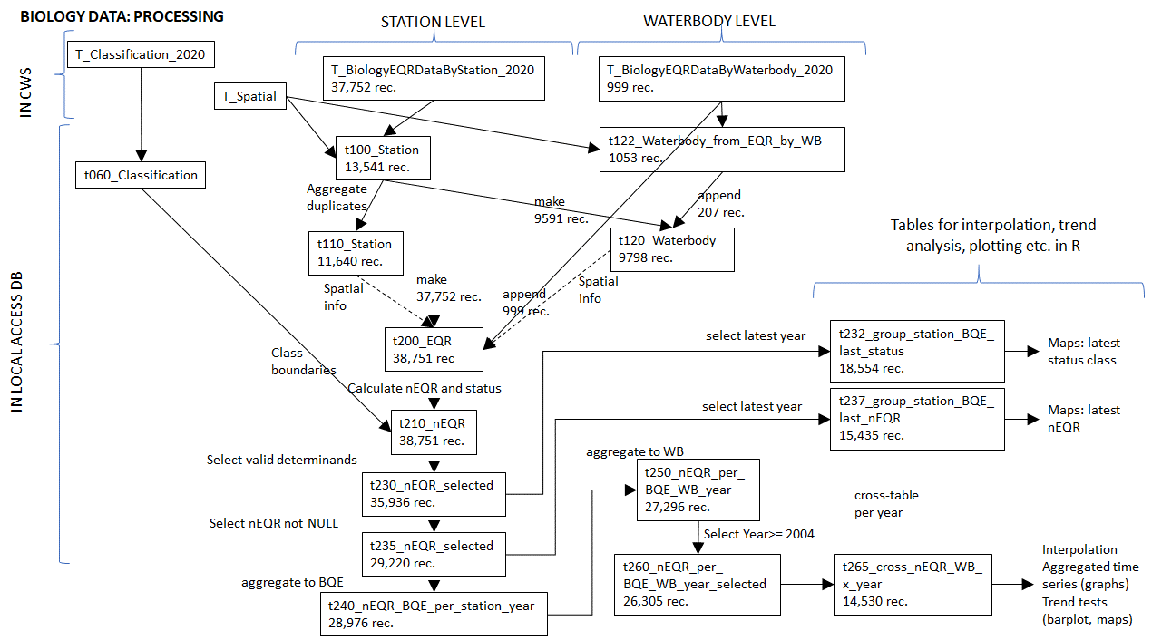
Figure A3.2. List of MS Access tables and queries for processing of EQR data
