NRC FLIS webinar on Horizon Scanning UK experience
Fiona Lickorish (UK) Head of the Institute for Environment, Health, Risks and Futures / Principal Research Fellow - Horizon Scanning & Futures, Cranfield University
Monday 13th October 2014, 11.00 – 13.00 CET
NOTE: Webinar will be recorded for later broader use
Draft Agenda

Webinar IT platform will open for joining at 10:30 (CET)
Participants should check system compatibility and ensure WebEx runs on their PC a few days before this time so that issues can be resolved (see Guidelines)

Webinar objectives:

• To provide a platform for the presentation of recent and current horizon scanning methods and initiatives in the UK
• To provide an opportunity for members of NRC FLIS to learn from the experience of horizon scanning in the UK from a leading expert in the field
• To provide an opportunity for participants to discuss horizon scanning methods and share knowledge and experience
• To trial the use of webinars as a tool for further use by NRC FLIS, e.g. for meetings and to share knowledge and experience

Time (CET) | Agenda item
10.30 - 11.00 | Log-in and set up (see short technical guidance below)  The webinar platform will be open from 10:30 CET so that all participants have successfully joined the webinar for a prompt start at 11:00.  Note: you will need an access code which will be sent to you by email. Please have it to hand when logging in.
11:00 – 11:10 | Webinar introduction and technical briefing  Owen White, moderator
11:10 – 11:20 | Introduction to the webinar, welcome and objectives  EEA host – Teresa Ribeiro or Anita Pirc-Velkavrh
11:20 – 12:00 | Presentation: Horizon Scanning – experience from the UK  Fiona Lickorish. Head of the Institute for Environment, Health, Risks and Futures / Principal Research Fellow - Horizon Scanning & Futures, Cranfield University
12:00 – 12:45 | Moderated discussion and questions (see 3.5.3 in Annex 1)  Questions collected by moderator / discussion  Note: this session may be shorter depending on extent of questions and discussion
12:45 – 13:00 | Reflections and closing remarks  Teresa Ribeiro or Anita Pirc-Velkavrh

Short technical guidance
(see longer version: Annex 1)

In the week before the webinar: please check technical compatibility of your computer equipment as described!

- Computer with internet – the presentations and video stream of presenters will run via in your web browser using Cisco WebEx. Optionally, you may use a webcam too, so other participants can see you in case you take the floor to speak. The system automatically uses any webcams properly installed on your computer.
BEFORE the webinar:
- A few days BEFORE the webinar, please check whether your computer and its settings are ready to run WebEx. Use the same (!) computer which you will be using and the same web browser: http://www.webex.com/test-meeting.html
  - We advise to select the ‘Run a temporary application’ as the best option when the browser opens as indicated here:

- Should you face any technical problems, check or ask for your in-house technical support to check browser and system compatibility and required plug-ins here: https://eea.webex.com/docs/T27L/mc0805l/en_US/support/xplatform.htm

- Audio – it is highly recommended to use a headset for audio during the webinar.

- Please do sort out any technical issues a few days BEFORE the webinar as we cannot assist you right before or during the webinar. Should you have problems which you cannot solve, please contact Thanh Le (Thanh.Le@eea.europa.eu) for help.

ACCESS the webinar:
- Once the host of the web-conference starts the event, it is possible to join the web-conference. The entry page requires providing the following information:
- First name,
- Last name,
- E-mail,
- Event password.

The following figure shows the entry page for the testing event called “SENSE-2 Meeting Test – 3”.

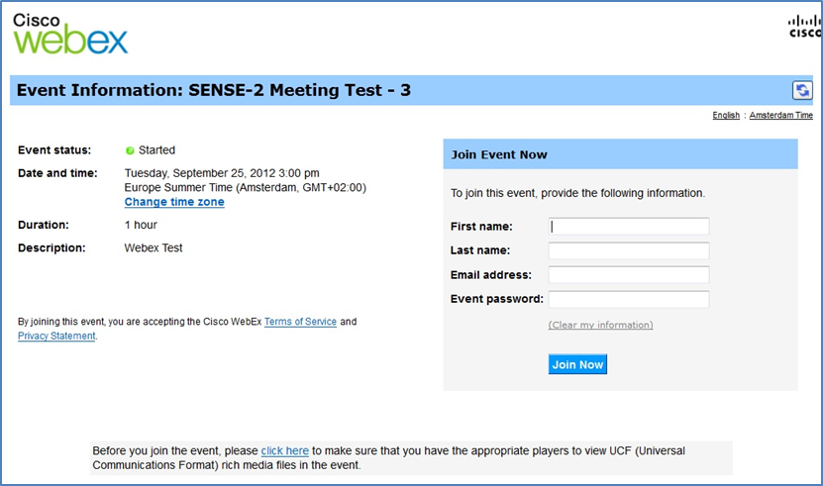
Figure 1: Entry page into Webex Event Centre as attendee

Setting Voice connection
- The participants entering the web-conference system are asked to join the integrated voice conference.

Confirm with Yes!

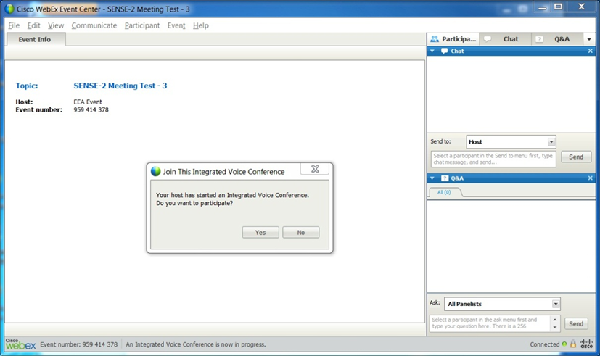
Figure 2: Integrated Voice Conferene - Confirmation

DURING the webinar:

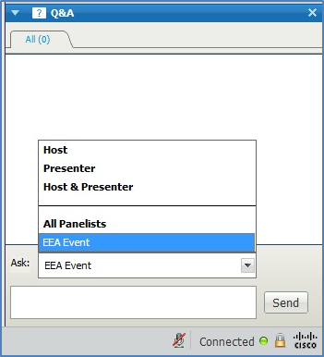
Figure 3: Q&A Panel

- This panel is available for the attendees to ask questions DURING the presentation. The attendees should send questions to the:

  - Host and presenter

For more detailed instructions please see Annex 1 in the email attachement.

