Technical instructions for participating in the webinar

Participate in the event

Login in and general running of the webinar

Once you click on the appropriate hyperlink sent to you in the invitation, please log in using the event password. Once logged in, the screen should show on the left side the presentation in progress while on the right hand side you will have the communication window which should look something like this (for attendees):
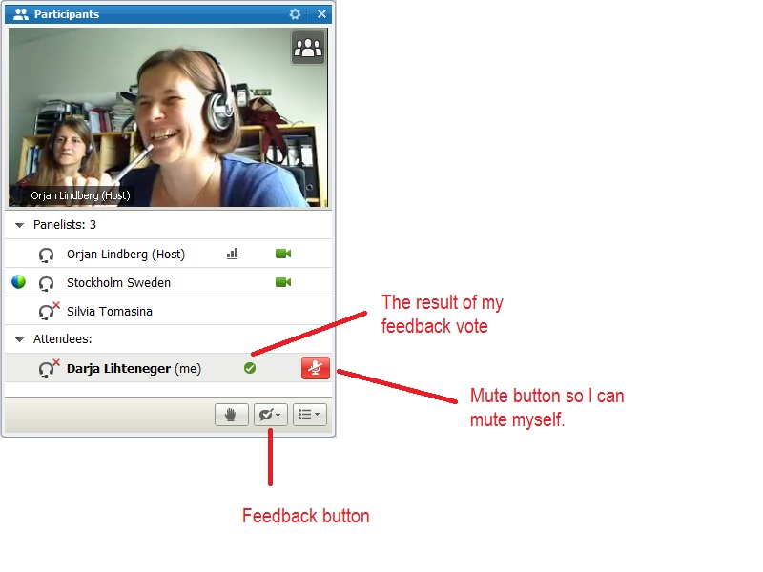
As you can see, we had a lot of fun trying the platform to ensure that everything runs smoothly!
You can use the tools available in this window to communicate with the event host or the presenters in different ways (see details below).
The webinar will be run in the following way. First there will be the presentations as per the agenda included in the background document. During the presentations, attendees can only ask questions via Q&A window. After the presentations, there will be a Q&A session where we will try to answer first the questions sent to us via the Q&A window and then allow attendees to ask further questions via audio (VoIP).
The roles of the host, panellists/presenters and attendees and the rules of engagement in the event

The role of the host
The host will moderate the event. As such, we will keep track of the presenters as well as attendees who express the interest to raise the question either via the Q&A option or by audio by raising the hand (see more details in the section on the roles for the attendees). In order to ensure a good quality sound and image, there will be one speaker at a time and only one video at a time. The host passes the floor to presenters and attendees and can mute any participant should there be a need to for the good order during the event.

The role of the presenters and panellists
The presenters will make their presentation available on the screen to the rest of participants. Also the presenter is allowed to communicate via video. Because the software is designed as such that the video follows the sound (in other words the video can switch between the presenter and the participants uncontrollably if there are more people speaking at the same time), there will be only one video (the current presenter) and all the rest of the participants (including the host) will be muted. The system is set up in such a way that all participants are muted at entry. It would be advisable that the presenters use the “Share file” option for their presentation so that the presentation can be instantly downloadable by the participants during the event.

The role of the attendees
Attendees will have the possibility to see and hear the presentations and the presenter. Attendees can ask questions in two ways:
- Using the Q&A session and select “to the host”; I strongly advise not to send questions directly to the presenter or to all participants to avoid creating confusion;
- Using voice-over IP (internet). To do that, the attendees should click the button with the hand (please see the picture above) and the host will know the attendee is requesting permission to talk so will unmute the respective attendee.
Because we may be receiving a number of questions in different ways, a concise and short question will be highly appreciated.
To ensure that we have enough bandwidth for a good quality video and sound streaming, the attendees are not expected to intervene via video. Therefore all that is needed is a computer and a headset with microphone. We highly recommend using headsets rather than speakers to avoid high interference. This is all the more important since we do not have a telephone conference facility set up so the only way to communicate audio would be via VoIP.

Guidelines for CISCO Webex Event Center Web-conference/event System

Information
Web conference system: Cisco WebEx® Event Center
http://www.webex.com/

Main roles of the participants in the Webex Event Center web-conferencing system
Webex Event Center web-conferencing system defines different roles of the users – participants in the web conference. Different functionalities are available depending on the role. The main roles are:

Role | Description
host | The participant who schedules, starts, manages, and ends the event and designates the roles.  The event host initially is the presenter. After the invited panelists join the event, the host can pass the presenter control to any of the panelists at any time during the event.
presenter | The participant, with the presenter control symbol , who is responsible for sharing and presenting information during the event.
panelist | The participant who is primarily responsible for assisting the presenter and participating in presentation.
attendee | The participant who mainly listens or watches and does not present information during the event.

Joining the event as attendee

Access information
Access information will be distributed to all the invited participants by e-mail. This information includes:
- Information about the web-conference (title, date, time),
- URL,
- Password,
- Other related information.

Access page
Once the host of the web-conference starts the event, it is possible to join the web-conference. The entry page requires providing the following information:
- First name,
- Last name,
- E-mail,
- Event password.

The following figure shows the entry page for the testing event called “SENSE-2 Meeting Test – 3”.

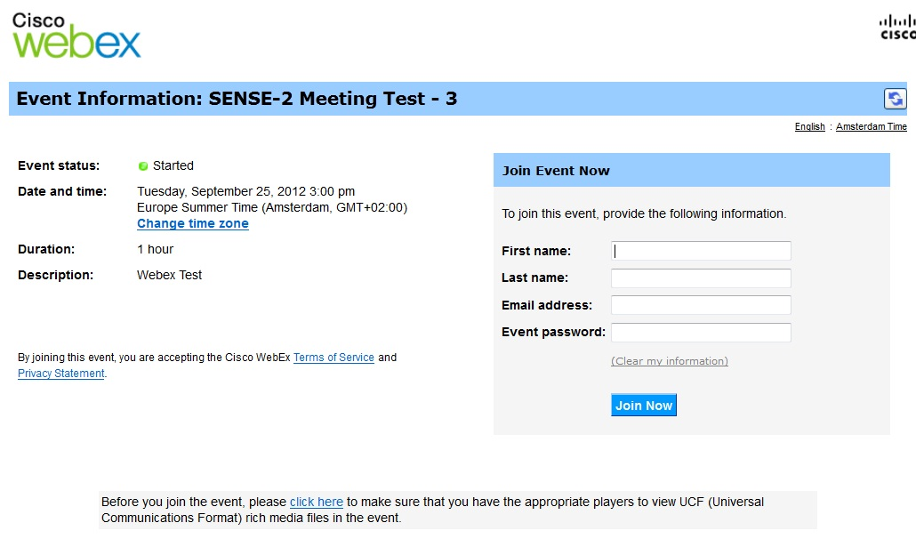
Figure 1: Entry page into Webex Event Center as attendee

It is also possible to enter additional information in the fields “First name” and “Last name”, like: organisation abbreviation or country (code or name).

To have a better overview of the attendees, it is proposed to enter additional information together with the last name. The proposed additional information includes: short organisation name or abbreviation and the country name or code.

For example – entering additional information into field “Last name” (the names are fictionally):
- First name: John
- Last name: Smiths, ABC Institute, DK

Voice connection
Setting Voice connection
Webex Event Center provides VoIP connection only!
The participants entering the web-conference system are asked to join the integrated voice conference.
Confirm with Yes!

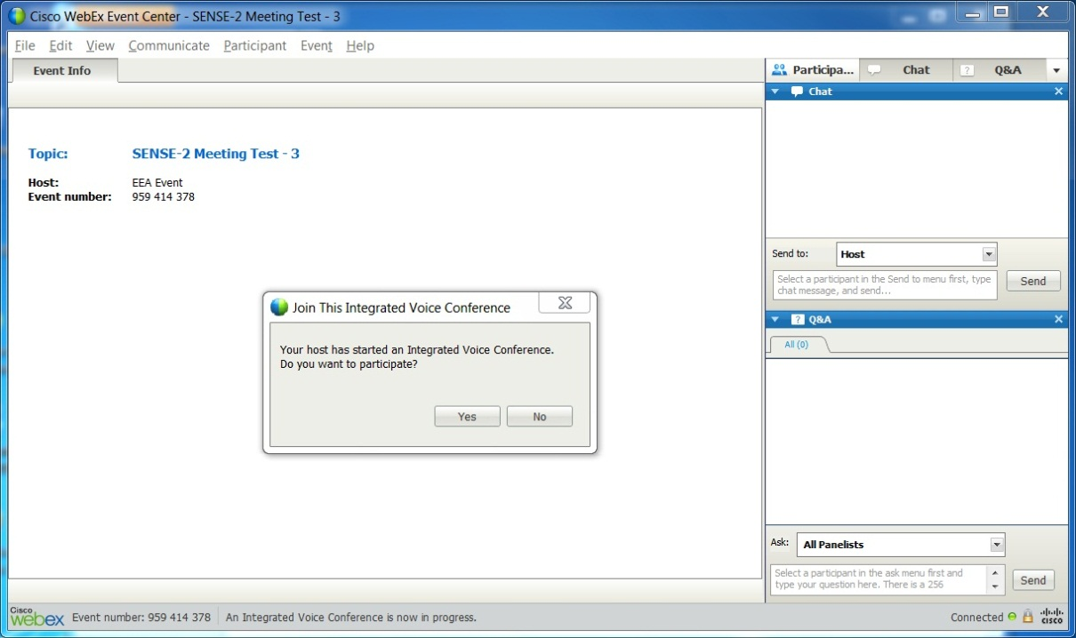
Figure 2: Integrated Voice Conference – Confirmation

Speaker / Microphone Audio Test
It is available through the menu: Communicate > Speaker/Microphone Audio Test.

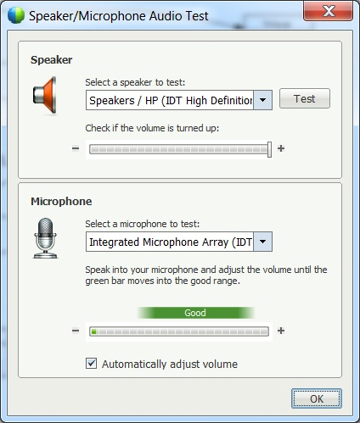
Figure 3: Speaker / Microphone Audio Test

Application viewer (content viewer)
The application viewer is divided into the main event viewer displaying the presentation and additional panels used to see the list of the participants and for communicating / interacting during the web conference. The application viewer is shown on the next picture.

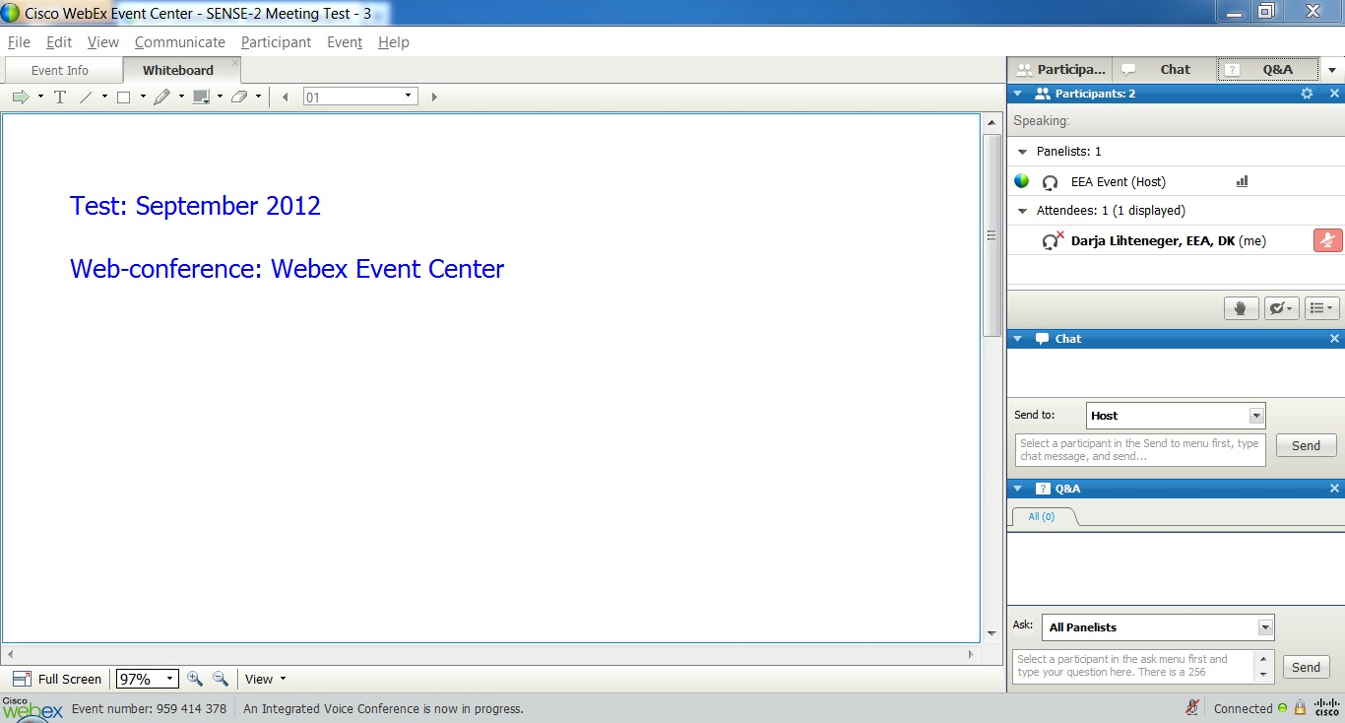
Figure 4 : Webex – Application viewer (content viewer)

Using specific panels: Participants, Chat, Questions & Answers
Three specific panels are available:

Panel | Description
Participants | Provides the list of all participants: panellist and attendees, who is host and who is currently presenting the presentation (symbol for the presenter: )
Chat | Allows sending text messages between the participants. Uses as informal way of communication.
Q&A | Questions and Answers. Allows asking questions different participants. Used as formal way of communication.

Participants Panel
Participants panel provides the list of all participants (panellists, attendees, information who is host and who is presenter) and different functions.

Function | Indicator | Description
Mute / unmute microphone
Raise hand |  | When microphone is muted and the participant cannot unmute his/her own microphone can use indicator “Raise hand”. Based on the symbol of raised hand, the host can unmute the participant (one or more)). Pressing indicator again will lower the hand.
Feedback |  | Indication on the presentation (Yes, No, Too slow, Too fast, etc.)
Switch between the participant list and video thumbnail views |  | Change of display from list to thumbnails and reverse.

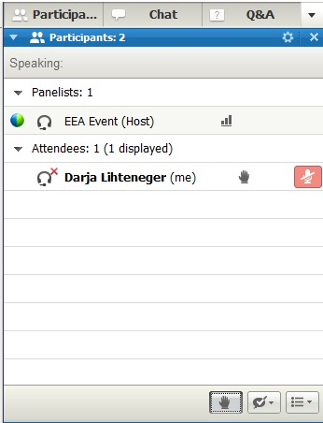
Figure 5: Participants Panel

Chat Panel (this function is not used for the “Horizon scanning” webinar)
Chat is useful during an event if you want to:
- send brief information to all participants,
- send a private message to another participant,
- ask a question but do not want to use the Q & A option, which provides a formal procedure for asking and answering questions.

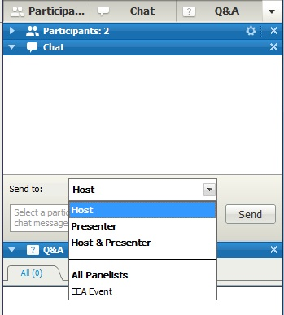
Figure 6 : Chat panel

Q&A Panel
This panel is available for the attendees to ask questions during the presentations. The attendees can send questions to the:
- host,
- presenter,
- host and presenter,
- all panellists or
- to the specific panellist.
Questions can be answered directly during the session. All the questions and answers can also be saved which allows later answering to the unanswered questions during the web conference or they can be used for the documentation purposes.

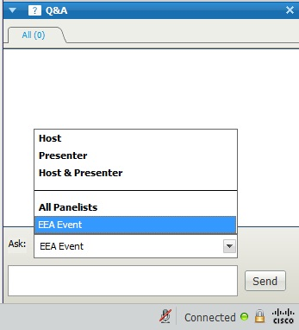
Figure 7: Q&A Panel

Full Screen View
You can maximize the size of a page, slide, or whiteboard in the content viewer to fit your monitor's entire screen. A full-screen view replaces the normal Event window view. You can return to a normal view at any time. All participants have the possibility to switch between the normal event window view (content viewer) and the full screen view.

The button on the bottom left corner of the screen allows switching the display to the full screen view:

The navigation bar in the full screen view is available on the top of the screen and it is hidden unless you put the mouse over the top of the screen to show the navigation bar. Pressing the Return button on the navigation bar or ESC on keyboard switches back to the normal event window view (out of full screen view).
The navigation bat displays the functions which are available with regard to the participants’ roles. The navigation bar for the host includes more functions than the navigation bar for the attendees.

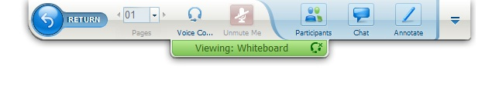
Figure 8: Full screen mode – navigation bar / attendees functions

